AS SOCIO-CULTURAL STUDIES

CONTEMPORAY ISSUES PART 2

STRUCTURE OF UK SPORTS

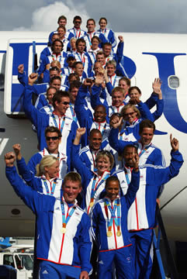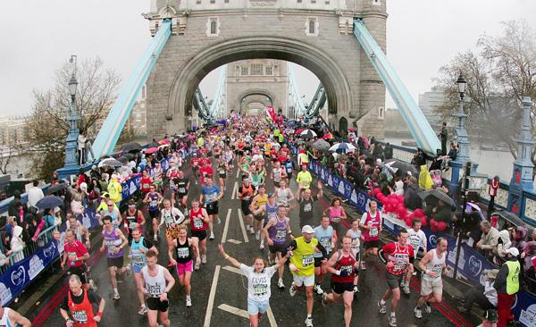

G451:

Name_______________________

Tutor________________________

Excellence and Mass Participation in the UK

You need to name and explain each layer of the performance pyramid. Remember this is not the world class pathway pyramid.

Insert performance pyramid from page 279.

Draw structure of sports in the United Kingdom and label each of the main sections.

UK sports

UK sport has several different roles and you need to remember at least 4 of them.

Using the book look at page 265 and identify the three main roles of UK sport. You must now try and get your partner to remember two of yours and you have to remember two of theirs. Use mental imagery or story telling to assist you.

You have two minutes to choose and write them down and three minutes to remember them. GO!

1)______________________________________________

2)______________________________________________

3)______________________________________________

4)______________________________________________

One of the main points that UK sport supports is a drive towards medals for 2012 for this they use the TASS. Explain what a TASS is? See page 265. Furthermore, tell me which other county have a very successful talent identification programme.

_____________________________________________________

_____________________________________________________

_____________________________________________________

_____________________________________________________

NATIONAL INSTITUE OF SPORT

Throughout the exam you will be asked to describe something and then explain it. You must be able to do both for higher marks. For even higher marks you must compare or analyze depending on the command word in the question.

Stage 1 Describe the English institute of sports.

Exam tip: This should be a sentence or two max telling me broadly what the National institute of sport is. Find this sentence on page 266 of your book.

______________________________________________________________

______________________________________________________________

______________________________________________________________

Stage 2 Now can you explain what it does? This has to be in more detail giving me the function and the ideas behind the institute. Use page 266 and 267.
______________________________________________________________

______________________________________________________________

______________________________________________________________

______________________________________________________________

Exam tip: You need to read all you can about the institute and then decide what the relevant points are. For example, what does the institute provide, what is it supposed to achieve, how does it perform?

Stage 3 Analysis Now you can either compare the answer to other related topics or you can analyze trying to understand the pros and cons of such a programme. For example, compare the EIS to UK sports and explain the differences.
______________________________________________________________

______________________________________________________________

______________________________________________________________

Name the other British Isles Institutes for sport. And describe what all the Sports Institutes have in common.

______________________________________________________________

One of the answers you might have come up with would be that there might be less funding for mass participation if all the money from the lottery is going to develop facilities for elite athletes.

This is where the HOME COUNTYS COME INTO ACTION.

You have already taken notes in your last booklet (part 1 contemporary issues).

Exam Tip: You don’t need to know all the detail about each one of these organizations.

Q However, can you tell me what the Home countries role is? This is asking for a description so try and find a single sentence or sentences that outline the key role.
A_____________________________________________________________

______________________________________________________________

Q Give three bullet points of what sport England wants and what sports England does.
___________________________ _____________________________
____________________________ _____________________________
____________________________ ____________________________

Government initiatives

Government initiatives are ideas from the government. Government departments related to sports are the

D
C
M
S

And the department for Children, schools and families.

The national Curriculum is directed from the government.

Fast task: 2 min outline the characteristics of the National curriculum.
______________________________________

______________________________________
______________________________________

PESSCLS is the PE SCHOOLS SPORTS AND CLUB LINKS STRATEGY.

SSC IS THE SPECIALIST SPORTS COLLEGES

SSP SCHOOL SPORTS PARTNERSHIP

SPORTS MARK COLLEGE

SCHOOLS SPORTS PARTNERSHIP

GIFTED AND TALENTED

STEP INTO SPORTS

SWIMMING

CLUB LINKS

SPORTING PLAYGROUND

Playground leaders from year 5-6 are encouraged.
Encourage young people to be more involved in sports leadership.

Raise the profile of swimming in the curriculum.

Helps promising young performers.

High quality PE is linked with clubs in the community.
Schools that specialize in P.E and Sports.
Cluster of schools that centre around a hub site to share expertise.

NATIONAL GOVERNING BODIES

Exam tip: you will not get a general exam question on the role of NGB; however, you will need to identify some initiatives or strategies.

For most NGB the strategies will be mass participation and develop the best players to progress up the ranks.

Task: Using the internet investigate a NGB of your choice. Identify the aim and the initiatives that are in place to develop mass participation or development of excellence.

Research tip; you must research beyond the NGB web site. Type in LTA initiatives and you will find several articles regarding strategies and initiatives.

_______________________________________________________________________________________________________________________________________________________________________________________________________________________________________________________________________________________________________________________________________________________________________________________________________________________________________________________________________________________________________________________________

CONTEMPORARY ISSUES SECTION 3

Fast task: Complete the sporting triangle

Describe what opportunity, provision and esteem are

Opportunity provision and esteem will vary depending on what level of participation you are expecting.

O.P.E.

What does ‘ACCESS’ mean?

 |  | Explanation | Egs
 | OPPORTUNITY
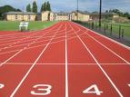 | PROVISION
 | ESTEEM

Using OPE can you explain how the home country’s are trying to develop sport.

_______________________________________________________________________________________________________________________________________________________________________________________________________________________________________________________________________________________________________________________________________________________________________________________
______________________________________________________________________________________________________________________________________________________

Opportunity for mass participation and sporting excellence:

This should exist for everyone in the UK. However, this is not the case. Within society there are different groups.

Can you identify some of those groups?
__________________________
__________________________
__________________________
__________________________

There are certain hierarchical layers to society which can at times prevent some and push others towards either mass participation or the pursuit of excellence. Put the groups you have above in order of greatest opportunity to the least.
_________________________
_________________________
_________________________
_________________________

It’s perceived that the White Anglo Saxon Protestants or WASPS are at the top or white middle class males. Asian women are perceived to be at the bottom of the opportunity and provision scale.

Discrimination

A word that I’m sure you are all familiar with; however, can you describe what it is? Don’t give me an example, tell me what it is.
________________________________________________________________________________________________________________________________________________________________________________________________________________________________________________________________________________________________________________________

Within our lives there will be many influences to how much participation we have in sports. Using the next page fill in the gaps giving factors that affect participation.

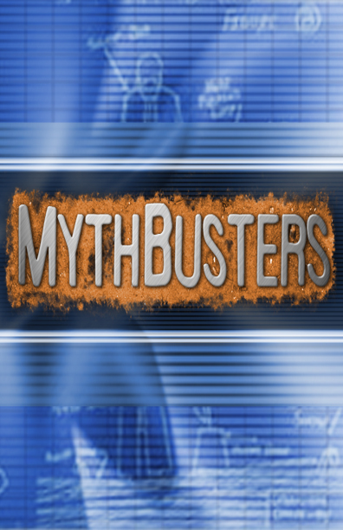

1) We are going to look at several groups within society and identify potential stereotypes or myths.

2) Furthermore, you must identify how society and culture have an impact of the group mentioning possible barriers.

3) Finally what are the measures in place to increase participation and sporting excellence?

Young People

1) All young people are lazy = stereotype
Computer games
________________________

2) Massive drop out from participation after school
Lack of money
Fatigue from college
Negative attitude towards P.E because turned off by P.E lessons.
Body conscious

- The National curriculum has changes recently to include all
PESSCL
UK sports

Within your groups you have to pick one of the groups below and investigate the myths around them and identify the impact of society and the potential barriers for participation.

Elderly People

1Myths and stereotypes
__________________________________________________________________________________________________________________________________________________________________________________________
2 The impact of social and cultural factors, including possible barriers.
_________________________________________________________________________________________________________________________________________________________________________________________________________________________________________________________________________

3. Possible measures to increase participation
___________________________________________________________________________________________________________________________________________________________________________________________________________________________________________________________________________________________________________________________________________________________________________________
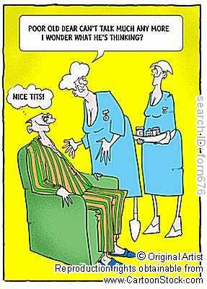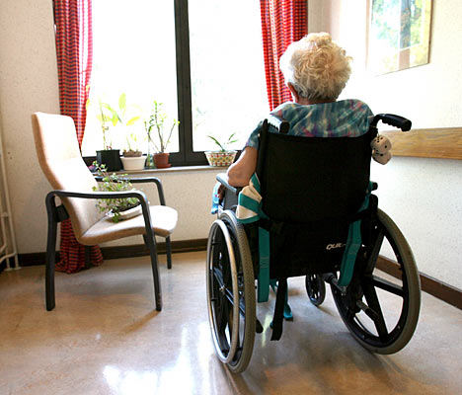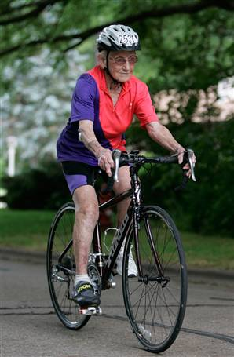

Women
1Myths and stereotypes
____________________________________________________________________________________________________________________________________________________________________________________________________________________

2 The impact of social and cultural factors, including possible barriers.
_________________________________________________________________________________________________________________________________________________________________________________________________________________________________________________________________________

3. Possible measures to increase participation
___________________________________________________________________________________________________________________________________________________________________________________________________________________________________________________________________________________________________________________________________________________________________________________

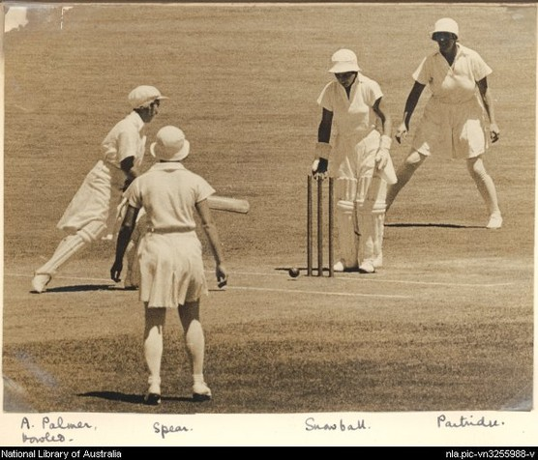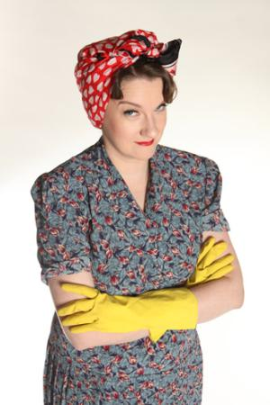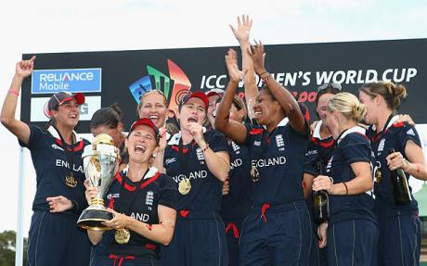

Ethnic minority
_________________________________________________________________________________________________________________________________________________________________________________________________________

1Myths and stereotypes

2 The impact of social and cultural factors, including possible barriers.
_________________________________________________________________________________________________________________________________________________________________________________________________________________________________________________________________________

3. Possible measures to increase participation
___________________________________________________________________________________________________________________________________________________________________________________________________________________________________________________________________________________________________________________________________________________________________________________

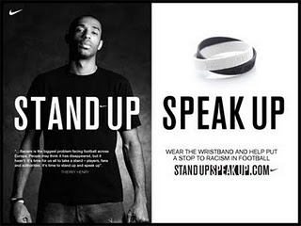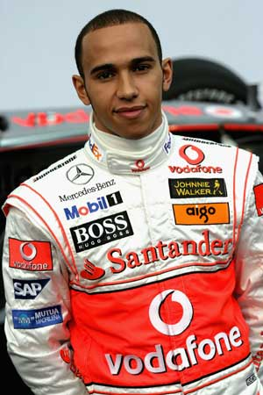

People with disabilities

1Myths and stereotypes
____________________________________________________________________________________________________________________________________________________________________________________________________________________________________________________________________________

2 The impact of social and cultural factors, including possible barriers.
_________________________________________________________________________________________________________________________________________________________________________________________________________________________________________________________________________

3. Possible measures to increase participation
___________________________________________________________________________________________________________________________________________________________________________________________________________________________________________________________________________________________________________________________________________________________________________________

