Assessment 2

Answer sheet

A level PE

|  |  |  |  |  |  |  |  |
| --- | --- | --- | --- | --- | --- | --- | --- |
| **Name :** | | | | | | **MEG :** | |
| **Total** | **/ 24** | | **%** |  | **Grade** | |  |
| **Staff Comments :**  **+**  **-** | | | | | | | |
| **what will I score:** | | **Student Comments** | | | | | |
|  | |  | | | | | |

1. In order for a muscle to contract, one or more motor units will be stimulated and will follow the ‘all or none’ law.

**(iv)** Describe the structure of a motor unit.

|  |
| --- |
| **(consists of) a motor neurone and a number of muscle fibres** |

**(v)** What is the ‘all or none’ law?

**When stimulated) all the fibres within a motor unit contract completely or not at all**

**(vi)** What is the effect of stimulating more motor units?

**Increase in strength and/ or greater force of contraction**

**(3)**

1. Name **the** agonist and **the** antagonist at the hip at the point of take off during a vertical jump.

**Gluteus maximus**

**Iliopsoas**

[**2 Marks**]

1. **Fig.2 shows a gymnast holding a position on the rings.** 

**Fig 2.**

Name two muscles in the rotator cuff group which aid the stability of the shoulder joint.

Supersinatus, infraspinatus, teres minor, Subscapularis

[**2 Mark)**

1. **Fig.3** shows a person lowering into the crucifix.

[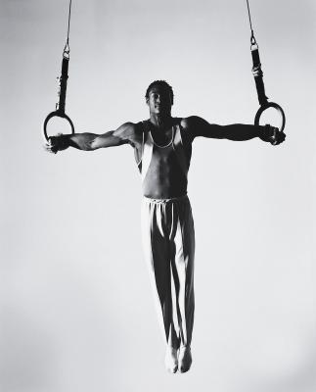](http://www.google.co.uk/url?sa=i&rct=j&q=&esrc=s&source=images&cd=&cad=rja&uact=8&ved=0ahUKEwjF2rnx_q7PAhUJPBQKHRAbB_8QjRwIBw&url=http://livehealthy.chron.com/train-iron-cross-gymnastics-9661.html&bvm=bv.133700528,d.ZGg&psig=AFQjCNHPoAbEfvv5VdWQUuSBXizoVV4jbQ&ust=1475046577593962)

**Fig 3.**

State the type of contraction *lowering* the crucifix and state the muscle that is working.

**Eccentric contraction of the latimus dorsa**

[**2 Marks**]

1. Consider the following statements:

**“Horizontal flexion is the movement of the limbs away from the midline of the body parallel to the ground.”**

**“Rotation is the movement whereby articulating bones turn about their longitudinal axis in a screwdriver action.”**

1. Which of the following is true?

**Put a tick (☑) in the box next to the correct answer.**

1. Both Statements are true.  **☐**

**B.** The first statement is true, the second is false. **☐**

**C. The first statement is false, the second is true. ☐**

**D.** Both statements are false.  **☐**

**[1 Mark]**

1. **Fig.1 shows a performer completing a sit-up**.

**Fig 1.**

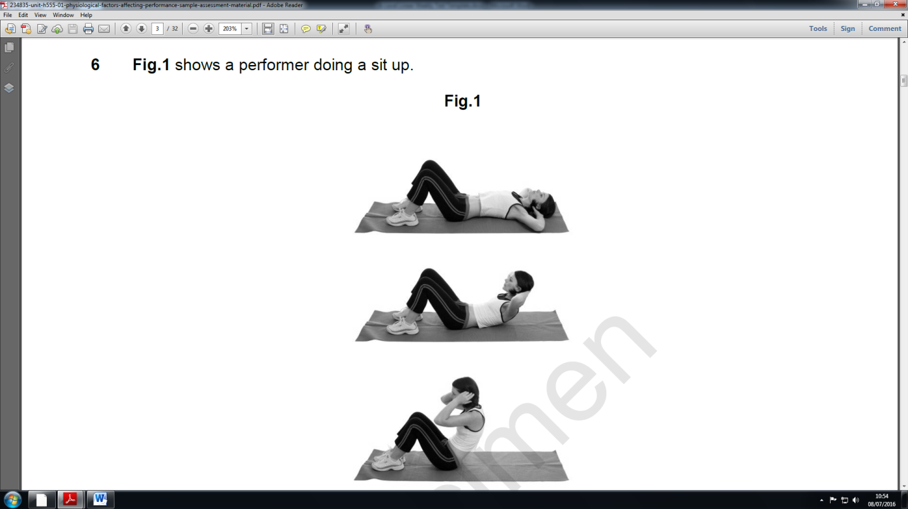

1. Complete the table below to show movements that take place in the vertebrae column during the upward and downward phases.

|  |  |  |  |
| --- | --- | --- | --- |
| **Phase** | **Agonist** | **Movement Produced** | **Type of contraction** |
| Upward | Rectus abdominus | Flexion | Concentric |
| Downward | Rectus Abdominus | Extension | Eccentric |

**[3 Marks]**

1. Two netballers were arguing about the positioning of netball and the muscle fibres.

Discuss the suggestion from their teacher that there are many factors to consider and that they may both be correct.

**State that all three fibre types can be recruited = 1**

**Explanation of FG = 1**

**Explanation of SO = 1**

**Explanation of FOG = 1**

**If linked to sporting scenario = 1 E.g., while throwing the ball you are using FG**

**because it is anaerobic and can use PC stores.**

**[5]**

1. The muscle fibre type that would be used during a maximal strength contraction is fast glycolytic (type lib). Give 2 structural and 2 functional characteristic of this fibre

See page of the text book for tables

**(4 marks)**

1. Using your understanding of the energy systems state the relevant recovery time ratios for slow oxidative and fast glycolytic muscle fibres with a sporting example.

**1:1 or 1:.5 for example 1 minutes run to 1 minute rest**

**1:3 30 secs sprint to 90 secs rest. (2 marks)**

**Total = 24/**