ANSWER SHEET ASSESSMENT 15

1. **The skeletal pump mechanism is one way of helping to maintain venous return.**

**Describe three other mechanisms involved in venous return.**

**Explain the importance of the skeletal pump mechanism during an active cool-down.**

[5]

Skeletal pump mechanism.

**1 mark per point max 3:**

• valves in the veins allows blood to travel in one direction only - back to the heart;

• respiratory pump mechanism. Pressure/volume changes in thoracic cavity during breathing puts pressure on the abdominal veins moving blood back to the heart;

• venoconstriction of veins/venomotor tone. Smooth muscle in the vessel walls helps to move blood back to the heart;

• gravity moves blood from areas of the body that are above the heart.

**1 mark per point max 2 for importance of maintaining the skeletal pump mechanism:**

• contracting muscles squeeze walls of blood vessels forcing blood back to the heart;

• prevents blood pooling/sudden drop in blood pressure;

• helps remove waste products/carbon dioxide/lactic acid.

1. **Which one of the following muscles contracts during the forced expiration of air?**

**Put a tick (✓) next to the correct answer.**

**A.** Diaphragm

**B.** Rectus abdominis

**C.** External intercostals

**D.** Scalene

1. **During exercise the mechanics of breathing change.**

**Explain the role of the sternocleidomastoid muscle in respiration during exercise.**

contraction (of sternocleidomastoid) during inspiration

causes rib cage to move up/out

causes a greater increase in volume of thoracic cavity

causes a greater drop in pressure in lungs causes more air to be drawn into/enter lungs

relaxation (of sternocleidomastoid) during expiration

allows rib cage to move down/in

**[4]**

**(d) Describe the short term effects of exercise on gas exchange at the alveoli.**

**[4]**

Four marks from:

(during exercise) blood in capillaries at the lungs has a lower partial pressure of oxygen (AO2) air in alveoli/lungs has higher ppO2

(AO1) gases diffuse from an area of high to low concentration

(AO1) (therefore) more oxygen diffuses from alveoli to blood

(AO2) blood in capillaries at lungs has higher ppCO2

(AO1) air in alveoli has lower ppCO2

(AO1) (therefore) more CO2 diffuses from the blood to the alveoli (AO2)

1. **Define minute ventilation and give an average value during maximal exercise. ( 2 marks)**

(definition)

* The volume of air inspired or expired in one minute/TVxf=VE (value)

Range 80- 180 L/min

1. **Minute ventilation is defined as the volume of air inspired or expired in one minute. (4 marks)**

Sketch a graph below to show the minute ventilation of a swimmer completing a 20-minute submaximal swim. Show minute ventilation: prior to the swim, during the swim, for a ten minute recovery period.

**Prior**

1. Starting value below 20 L/min

2. Anticipatory rise prior to exercise

**During**

3. Rapid rise (60-120L/min)

4. Slower rise/plateau (60-120L/min)

**Recovery**

5. Rapid decrease at end of exercise

6. Slower decrease towards resting value   
(Refer to diagram)



1. **Explain how the respiratory centre uses neural control to produce changes in the mechanics of breathing. [4 marks]**

* RCC stimulated by (submax 1):
* Prorioceptors detect movement
* Baroreceptors monitor (blood) pressure! lung stretch receptors
* Chemoreceptors detect changes in pH, blood chemistry!oxygen tension
* Thermoreceptors detect changes in temperature

RCC responds by:

* Regulated by inspiratory!expiratory (Apneustic!Pneumotaxic) centres
* Which sends nerve impulses (via phrenic/intercostals nerves)
* To the respiratory muscles
* Increased rate and depth of breathing

1. **Efficient respiration is an important factor for effective performance in sport. Describe in detail the process of gaseous exchange either at site A lungs: at site B working muscles . (4 marks)**

Description [NB credit one only] (sub submax 4)

At site A (Lungs)

* external respiration/alveolar-capillary membrane/exchange of gases between air and blood/via diffusion
* the movement (through a semi-permeable membrane) from areas of high pressure to areas of low pressure
* the partial pressure of the oxygen in the blood is less than that in the alveoli
* oxygen travels from the alveoli to the blood
* carbon dioxide travels from the blood to the alveoli
* the partial pressure of carbon dioxide in the blood is greater than that in the alveoli

OR

At site B (Tissues)

* internal respiration/tissue-capillary membrane/exchange of gases between blood and tissues/via diffusion
* the movement (through a semi-permeable membrane) from areas of high pressure to areas of low pressure
* oxygen travels from the blood to the tissues
* the partial pressure of oxygen in the blood is greater than that in the tissues
* carbon dioxide travels from the tissues to the blood
* the partial pressure of carbon dioxide in the blood is less than that in the tissues

1. **How is oxygen exchange increased at the muscle tissues (gas diffusion) during the training run? Why is this beneficial to performance? (5 marks)**

1. **5 marks max (4 marks sub max)**

(How exchanged)

1 High partial pressure of oxygen (PO2) in blood

2 Lower/decreased PO2 in muscle (cell)

3 Increased diffusion/concentration gradient

4 Increase in temperature allows increased release of oxygen from  
haemoglobin/increased dissociation of oxygen

5 Bohr Effect/increase in acidity/increased CO2/carbonic acid/lactic  
acid/lower pH of blood allows greater release of oxygen from   
haemoglobin

6 Myoglobin is used to transport/store more oxygen (to mitochondria)

**(Why beneficial) (2 marks sub max)**

7 Delays OBLA/delays fatigue

8 Increased energy production/increased intensity/increased duration  
of exercise

**For a performer at rest, describe carbon dioxide diffusion at the alveoli. (3 marks)**

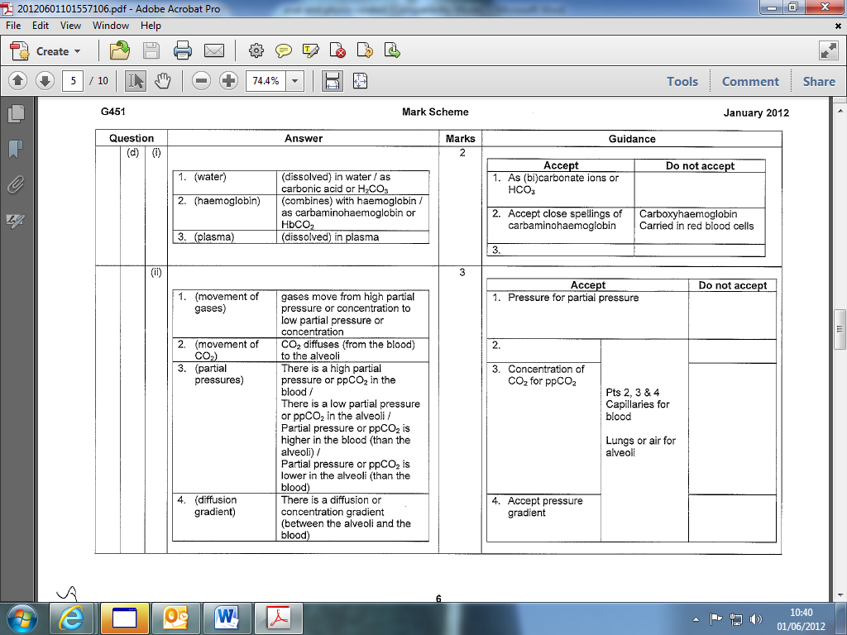

1. 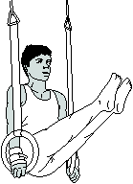The performer has moved from an anatomical position into the frontal raise. (4)

|  |  |  |  |  |
| --- | --- | --- | --- | --- |
| Joint | Joint Type | Movement | Agonist | Antagonist |
| **Hip** |  |  |  |  |