Physiological Factors Affecting Performance ASSESSMENT 13
NAME:___________________

Q1 Give an average value for cardiac output for a performer at rest and during maximal exercise.

[2 Marks]
At rest ...
- Cardiac output or Q is 5l/min
• for an average adult and trained performer
- • (max) 20-40l or l/min for trained performer
• (max) 20-30l or l/min for average adult

Q2 Describe how the heart’s conduction system controls the contraction and relaxation phases of the cardiac cycle.
[5 Marks]
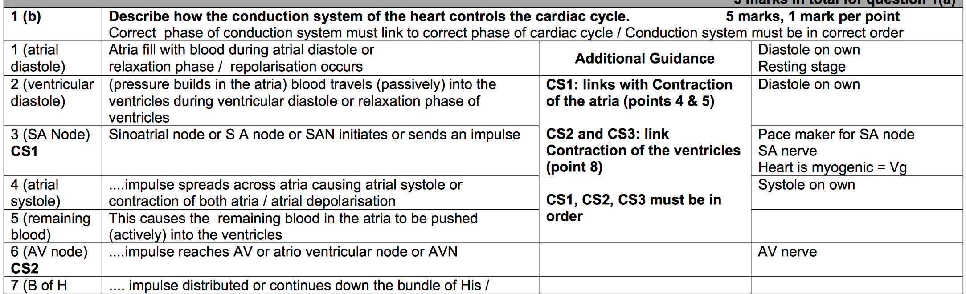

Q4 Define stroke volume and give a resting value for the average adult.
[2 Marks]
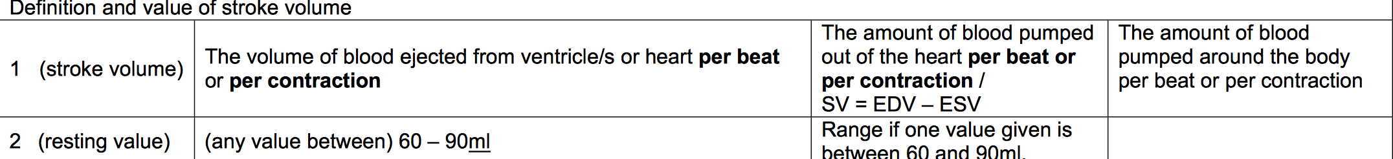
Q5 Explain how the body controls the increased distribution of blood to the working muscles during exercise.
[5 Marks]
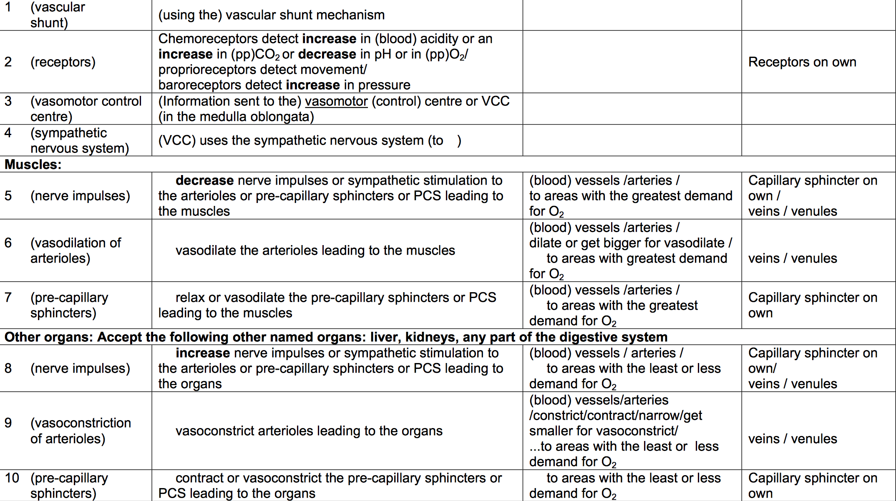

Q6 Heart rate changes for an athlete during sub-maximal exercise.
Describe the neural mechanisms which cause heart rate to change during exercise.
[4 Marks]
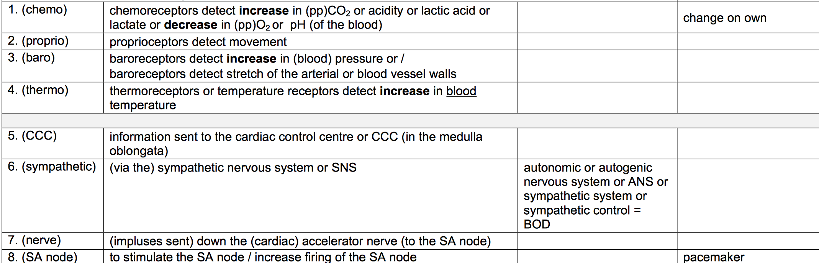

Q7 Venous return is the transport of deoxygenated blood to the right side of the heart.
Identify two mechanism s which help to maintain venous return during exercise.

[2 Marks]
Pocket valves
Respiratory pump
Smooth muscle within vessel walls
gravity
muscle tone
Describe the types of transfer that can occur when learning and performing movement skills. (4)
Positive Transfer Description
2. Where one skill / movement helps the learning (and performance) of another
Negative Transfer Description
4. Where one skill / movement hinders the learning (and performance) of another
Pro-active
Where a previously learned skill affects the (current) learning and/or performance of another skill
Retroactive Transfer (learning now affecting a previously learned skill)
Where the current learning of a new skill affects the performance of a previously learned skill
Bilateral Transfer
This is transfer from limb to limb (e.g. arm to arm / leg to leg)

