AS Revision session

You must use two revision strategies per essay. Which ones would you choose. You can just not bother trying the new ones and stick to what you know, but like retroactive learning, a new skill can help an old one.

- Look, cover, write, check repeat and peer test
- Acronym and peer testing
- Mind map vie example application scenarios
- Auditory recording on phone and peer testing
- Key word reduction, (take a sentence and reduce it to key words) chunking and note key words
- Highlighting mark scheme and underlining in colour and peer testing
- Teach each other

Make a point and explain it concisely, support with and EG
Opening sentence make a point, closing shows opinion
Interpret the question, what is the qualifier, what is the subject?

In spite of strict bans, some performers still take performance-enhancing drugs. Discuss why do some performers take performance enhancing drugs, Describe possible consequences of the use of drugs in sport and possible solutions to the problem of drugs in sport
10
Physiological | 1. To build muscles/increase energy/increase oxygen transportation.
Physiological | 2. Lose weight/ Gain weight/enable harder training/to mask injury/recover from injury/lengthen career.
Psychological | 3. Increase aggression/increase motivation/control arousal/steady nerves/ psychological strength.
Social | 4. Increase monetary value of winning/kudos of winning/fame/high status/society only remembers winners.
Social | 5. Win at all costs ethic/worth the risk to be the best/fear of losing.
Testing | 6. Testing is only random/ineffective testing
deterrent | 7. Poor deterrents/Poor punishments.
Education | 8. Don’t think that drugs will affect their health.
Pressure | 9. Peer group/family/coach/society pressure eg sponsors
Other | 10. Because others are taking drugs/level playing field.

Possible consequences
Possible consequences: | Do not accept one word answers – descriptions required.
1.(physiological.) | Enhanced performance by improving strength or speed or other suitable eg
2.(fame/fortune) | (Chance for) fame or fortune
3.(role models) | Poor role modelling by giving a bad example
4.(reputation) | undermines spirit of sport/ lowers interest in sport/  / gives sport a bad name/ lowers status of sport/bad publicity/loss of sponsorship/ruined career
5.(unfair) | A false or unfair result or record / performer gains unfair advantage
6.(physiological) | Physiological damage/danger to health/ possibility of addiction or lowered life expectancy or death/accept example/s such as liver disorders or heart disease or sexual or gynaecological problems
7.(psychological) | Psychological damage/mood swings/behaviour problems/increased aggression/onset of depression/or other suitable example
8 .(law / punishment) | Law breaking  / ban or fine or being stripped of medals or other punishment.

Possible solution
Possible solutions:
9. (punishment) | Stricter punishments /Olympic life bans/standardisation of punishments/ /harsher consequences/return of medals or funding/ fines/ lose sponsorship / lose prize money
10. (testing) | Stricter or random or targeted or more or better or regular testing/out of season testing/more money for testing/more research into testing
11. (education) | Educate coaches or performers /make coaches or performers aware of dangers or aware of moral issues /education at schools or clubs /100% ME
(WADA) | WADA / standardise (worldwide) doping policy (especially by NGBs)
13. (role models) | role models or Sports Ambassadors to publicise or encourage drugs free sport/ ‘name and shame’
14. (counter cult) | Legalise performance enhancing drugs
15. (research) | More research into dangers
Make a point and explain it concisely, support with and EG
Opening sentence make a point, closing shows opinion
Interpret the question, what is the qualifier, what is the subject?

Discuss the relationship between sport, sponsorship and the media.
10
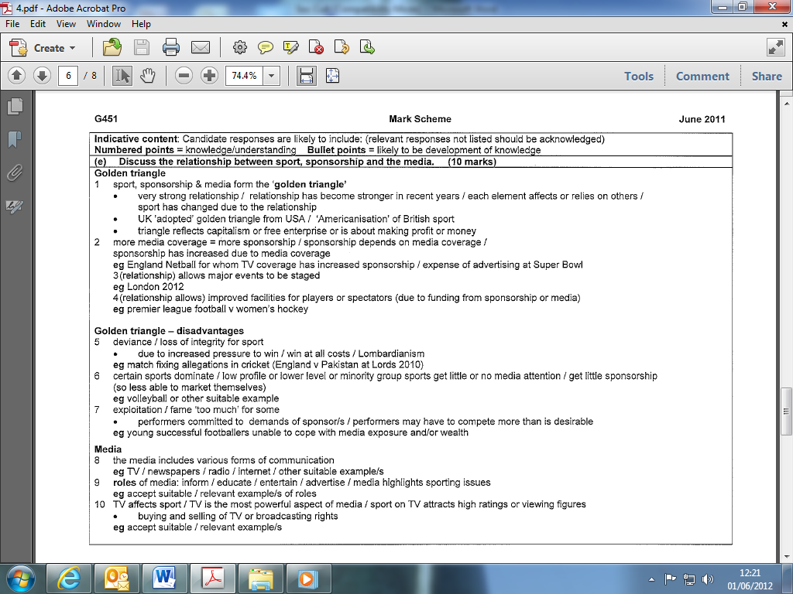

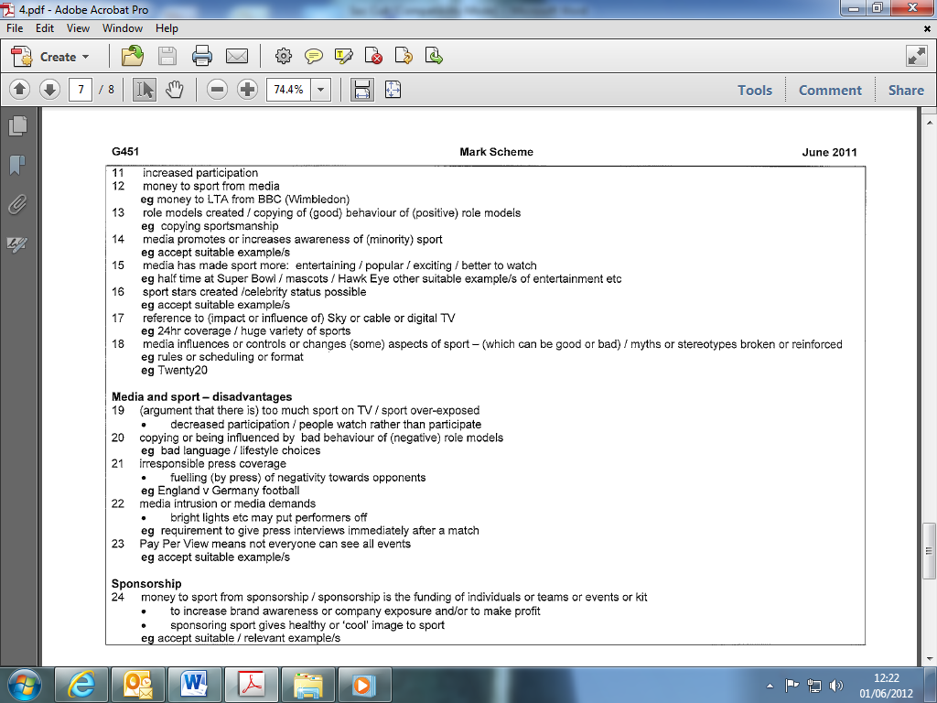
Make a point and explain it concisely, support with and EG
Interpret the question, what is the qualifier, what is the subject?
Opening sentence make a point, closing shows opinion

Violence by spectators and players is a contemporary sporting issue. Discuss violence in sport with reference to both causes and solutions.
10

Causes of violence: Players and Spectators
- (frustration) frustration with match officials or other suitable example of frustration
- (emotional intensity) emotional intensity or importance of result or pressure/pre-match hype or psyche-up/position in league or cup or competition/monetary reward.
- (abuse/provocation) provocation or abuse or 'cheating' or rule breaking by opponents or team mates or (where relevant) from crowd/violence on pitch/racism
- (punishment) lack of punishment or deterrent
- (religion/tradition) religion/traditional rivalry/local derby/team loyalty
Causes of violence: Players
- (weapons) (potential) 'weapons' e.g. sticks or clubs
- (nature of game) nature of game/body checking or contract e.g. ice hockey or rugby
- (kit) kit or equipment that 'de-humanises' or protects
Causes of violence: Spectators
- (alcohol/drugs) alcohol/drugs
- (numbers) overcrowding /poor spectator provision/poor policing or stewarding.
- (hooligans) hooligans at football/organised violence
- (mass culture) mass culture/peer pressure/tribal nature of event/loss of individual identify or diminished
- responsibility within crowd/limited alternative outlets for energy
Possible solutions: Players:
- (rule changes) Rule changes
- (punishment) More severe punishments/accept suitable example
- (education) Education/emphasis on fair play/position as role models emphasised
- (officials) More officials/more authority for officials
- (technology) Technology/video playbacks
Possible solutions: Spectators:
- (Deterrents) Stricter deterrents or punishments (eg. remove season tickets)
- (control of alcohol) Control of alcohol
- (facilities) Improve spectator facilities/separation of fans/home and away fans to leave separately
- (CCTV) Use of CCTV or other security measures
- (liaison) Liaison of police from different areas or countries
- (family) Promotion as family entertainment/family sections within crowd

