MARK SCHEME FOR EXTENSION TEST ON CARDIAC CYCLE

- .

(i) Define stroke volume and give a resting value for the average adult. (2 marks)

- Cardiac output increases during physical exercise. Explain how intrinsic control mechanisms cause cardiac output to increase during exercise. (5 marks)

- Draw a graph to show how the cyclist’s cardiac output changes in the following phases of the aerobic training session.
Prior to exercise Exercise Session Recovery period (5 marks)
(One mark must be from three areas to attain maximum)
- Resting value 5L/min approx (4-6L/min)
- Anticipatory rise before exercise
- Sharp increase
- Plateau between 10-2OLImin
- Initial sharp decline with slow decline towards resting level

- Whilst exercising a greater volume of blood is ejected during ventricular systole. Why is this beneficial to performance? [I mark]
2More oxygen/blood supplied to muscles
3Greater amounts of carbon dioxide/waste products removed/delay OBLA
4Delays fatigue/maintains/prolongs aerobic performance

- Explain how the body controls the increased distribution of blood to the working muscles during exercise (6 marks)

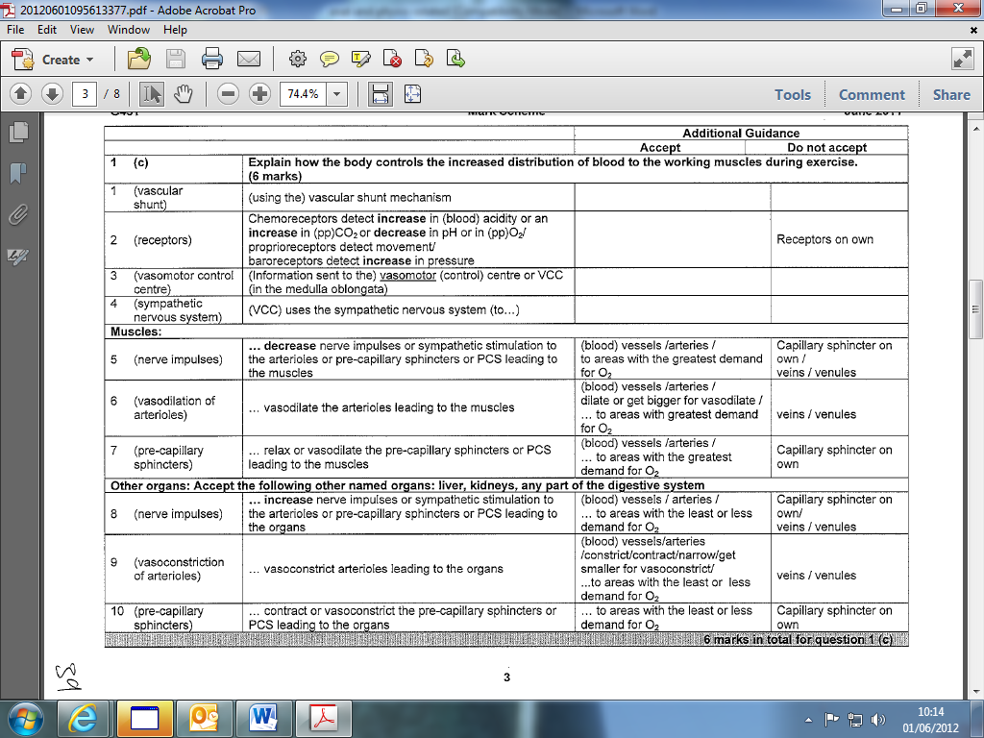

- How do neural factors regulate heart rate during physical activity and during a period of gradual recovery. (5 marks)

During activity
- Chemoreceptors detect decreases in O2/ pH of the blood/increases acidity /CO2/Lactic acid
- Proprioreceptors detect movement
- Baroreceptors detect increases in blood pressure
- Messages are sent to the cardiac control centre/ CCC (in the medulla oblongata)
- Stimulate CCC
- S/A node stimulated / the (cardiac) accelerator nerve
- SA node reference only when linked to physical activity(not recovery)
- The sympathetic nervous system increases heart rate

During recovery
- Chemoreceptors detect increases in the O2/ pH of the blood/ decreases in acidity /co2/Lactic acid
- Proprioreceptors detect reduction in movement
- Baroreceptors detect decreases in blood pressure
- Messages are sent (to the S/A node) via the vagus nerve
- The parasympathetic nervous system decreases heart rate.

