**Social Cultural Studies relating to participation in Physical Activity.**

**The Olympic Games**

**Unit G452**

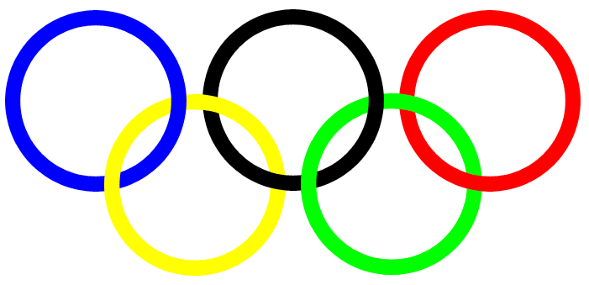

Student _____________ Teacher__________

Work Pack 2011

**Learning objective.**

By the end of this booklet you should have an understanding and notes of:

|  |  |  |
| --- | --- | --- |
| In the third part of this chapter you will learn about | Learnt | revised |
| The vision of Baron Pierre de Coubertin in establishing the modern Olympic Games on 1896 |  |  |
| The principles, aims and philosophy of the Olympic Games |  |  |
| The British Olympic association and the International Olympic Committee – two bodies that are central to Olympic organisation and administration |  |  |
| Commercialisation of the games after 1984 |  |  |
| London 2012 – opportunity and implication for UK sport and society |  |  |
| The Olympics as a vehicle for national building, when sport is used as a political tool, e.g. in China |  |  |

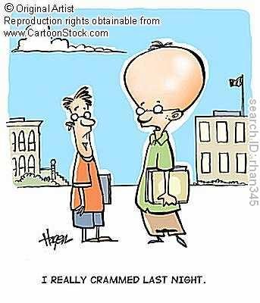

**The vision of Baron de Coubertin**

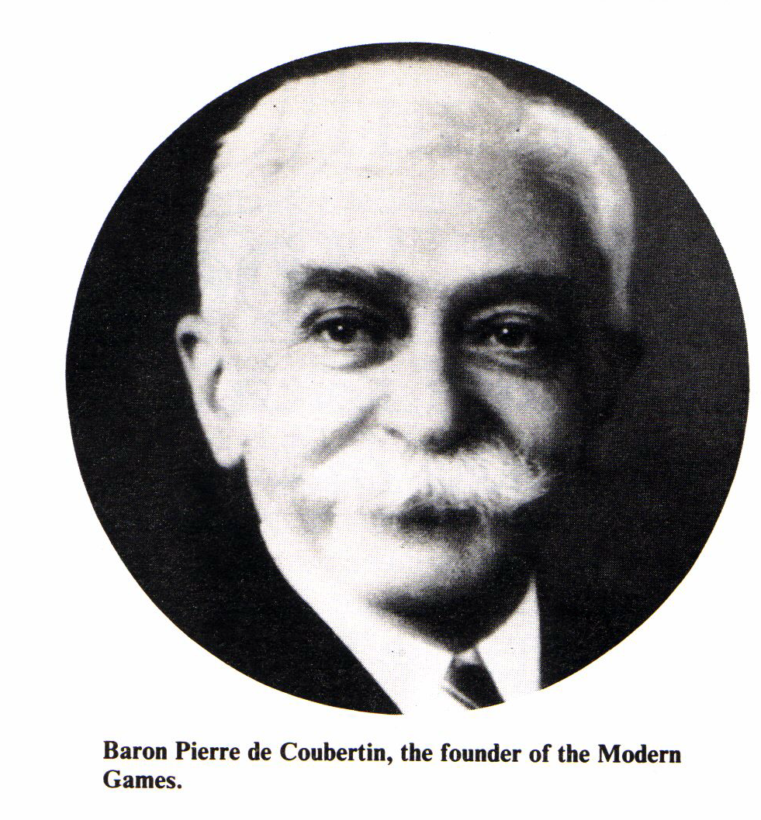

“The question you must ask is why did I Baron Pierre De Coubertin decide to reform the Olympic Games?”

.................................................................................................................................................................................................................................................................................................................................................................................................................................................................................................................................................................................................................................................................................................................................



Mr Robert Dover started the Cotswold games. Some have called it the Dover Games which were in 1600. They stopped in 1800 due to rowdiness and violence.

________________________________________________________________________________________________________________________________________________________________________________________________________________________________________________________________

[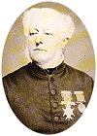](javascript:void(null))Dr William Penny Brookes was born in Much Wenlock in 1809. He founded the Wenlock games in 1850 and invited Baron de Coubertin to see the games in 1889.

Identify the characteristics William Brookes was interested in developing.

________________________________________________________________________________________________________________________________________________________________________________________________________________________________________________________________

Public School



.......................................................................................................................................................................................................................................................................................................................................................................................................................................................................................................................................................................................................................................................................................................................................................................................................................................................................................................................................

**The principle aims and philosophy of the Olympic Games.**

***“The most important thing in the Olympic Games is not to win but to take part, just as the most important thing in life is not the triumph but the struggle. The essential thing is not to have conquered but to have fought well.”***

**Baron Pierre de Coubertin,**

**founder of the Modern Olympic Movement 1896**

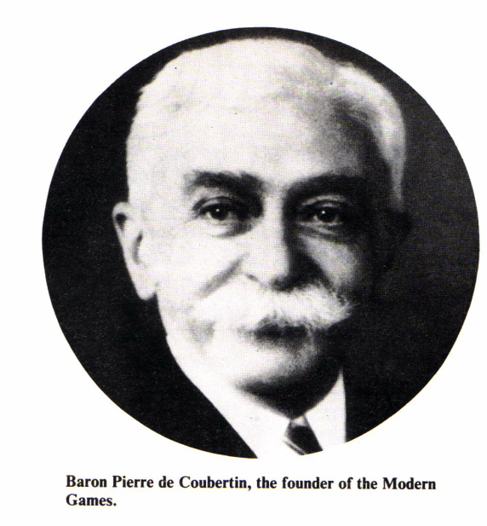

**The aim**: Baron Pierre De Coubertin explains himself that:

(page 314) can you rewrite into modern English

_________________________________________________________________________________________________________________________________________________________________________________________________________________________________________________________________________________

**The Philosophy of the Olympic Games**

**The philosophy of the Modern Olympic games.**

Can you write down what the five coloured rings represent and what does the white background on the flag stand for?

.......................................................................................................................................................................................................................................................................................................................................................................................................................................................................................................................................................................................................................................................................................................................................................................................................................................................................................................................................



***Citius, Altius Fortius***

**The Philosophy of the Olympic Games**

......................................................................................................................................................................................................................................................................................................................................................................................................................................................................................................................................................................................................................................................................................................................................................................................................

**Amateurism**

...................................................................................................................................................................................................................................................................................................................................................................................................

**Fair Play**

...................................................................................................................................................................................................................................................................................................................................................................................................

Why did two cyclist cause uproar at the 1896 games? What does this say about the ethics regarding the Olympics?

________________________________________________________________________________________________________________________________________________________________________________________________________________________

Re-read the sections on page 314 and 315 and make a small spider diagram on the following principles.

Background, philosophy, amateurism, fair play, oath.

|  |
| --- |
| Exam tip: Note down if you think that these principles are still relevant today. Give an example that suggests this is not the case. |

................................................................................................................................................................................................................................................................................................................................................................................................................................................................................................................................................................................................

**Winter and Summer Format**

You will not be asked direct closed question on the summer and winter format, however, it is vital that you understand the background and format of the largest international event in the world.

................................................................................................................................................................................................................................................................................................................................................................................................................................................................................................................................................................................................

................................................................................................................................................

**The IOC**

**The British Olympic association and the International Olympic Committee – two bodies that are central to Olympic organisation and administration**

Using the list of functions of the IOC on page315 put the top 5 in order of importance.

1. ____________________________________________
2. ____________________________________________
3. ____________________________________________
4. ____________________________________________
5. ____________________________________________

Can you describe and explain what the BOA is and it’s main role?

________________________________________________________________________________________________________________________________________________________________________________________________________________________________________________________

__________________________________________________________________________________________________________________________________________________________________________________________

*Tip now compare this against the list at the back of this booklet.*

**Commercialisation of the Olympics**

**A change in attitude to mirror the change in society.**

Baron de Coubertin said that “the Olympics can not live in a bubble of its own ethics”. (1900).

................................................................................................................................................................................................................................................................................................................................................................................................................................................................................................................................................................................................

................................................................................................................................................

Notes: **Reasons for the change in attitude from amateur to a more commercial approach.**



**Amateurism**

Reasons for the change in attitude from amateur to a more commercial approach.

................................................................................................................................................................................................................................................................................................................................................................................................................................................................................................................................................................................................

................................................................................................................................................

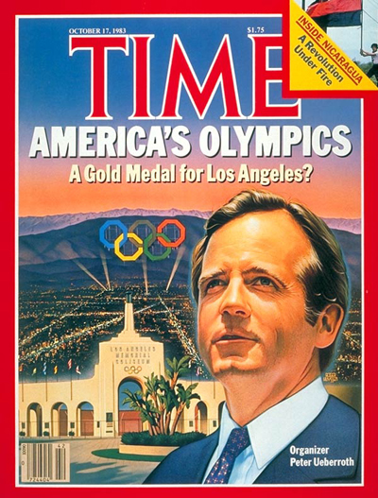

**LA Games 1984** What were the main things that Peter Ueberroth did to change the Olympics? See page 317-318.

* .
* .
* .
* .
* .

Peter Ueberroth brought high impact commercialism to the Olympic Games.

Write a paragraph that sums up how Peter Ueberroth changed the way the Olympics was funded.

................................................................................................................................................................................................................................................................................................................................................................................................................................................................................................................................................................................................

................................................................................................................................................

................................................................................................................................................................................................................................................................................................................................................................................................................................................................................................................................................................................................

................................................................................................................................................

**Class discussion:**

**On your tables discuss the merits of the arguments in task 4 on page 318-319 Explain whether you think commercialism is a good thing or not. Use the diagram below to highlight the positive aspects.**

Use the diagram to highlight the positive aspects of commercialism on the Olympics.

Use the diagram below to highlight the negative aspects of commercialism on the Olympics

**Homework task**

Take it further task on page 319.

1. Read the article on page 319-320 and write out the main point for each of the paragraphs.
2. Make an evaluative comment or critical judgement on each of his key points

_____________________________________________________________________________________________________________________________________________________________________________________________________________________________________________________

_____________________________________________________________________________________________________________________________________________________________________________________________________________________________________________________

_____________________________________________________________________________________________________________________________________________________________________________________________________________________________________________________

_____________________________________________________________________________________________________________________________________________________________________________________________________________________________________________________

_____________________________________________________________________________________________________________________________________________________________________________________________________________________________________________________

_____________________________________________________________________________________________________________________________________________________________________________________________________________________________________________________

_____________________________________________________________________________________________________________________________________________________________________________________________________________________________________________________

**Olympic Games as a chance to show your country to the world.**

**Why** would you want to host the Olympic Games?

If the Olympics are so good for the country, local area and sports then why are some people against the Olympics being in London?

* **____________________________________________**
* **____________________________________________**
* **____________________________________________**
* **____________________________________________**
* **____________________________________________**

**The Olympics as a political Tool**

It’s now widely accepted that politics and the Olympic Games are linked. Some say that the Sydney and Athens games were purely sporting events but could this be said for other games?

Looking at East Germany in 1976 what was their motives to succeed?

__________________________________________________________________________________________________________________________________

______________________________________________________________________________________________________________

Berlin in 1936

__________________________________________________________________________________________________________________________________

______________________________________________________________________________________________________________

Munich in 1972

__________________________________________________________________________________________________________________________________

______________________________________________________________________________________________________________

Even LA in 1984

_________________________________________________________________

______________________________________________________________________________________________________________

**China and Beijing**

Read page 326 and 327 and answer the question in what way did Beijing Summer Olympics 2008 showcase China to the rest of the world.

**2012 London Olympics**

Using the information on the power point, answer the question, what are the possible advantages and drawback of hosting the Olympics? Think politically as well as about local issues.

Key tip: Make a plan using the critical thinking grid?

|  |  |  |
| --- | --- | --- |
| **Issues** | **Example/ Explain** | **Counter argument/other point of view.** |
|  |  |  |
|  |  |  |
|  |  |  |
|  |  |  |

**The International Olympic Committee** (IOC) was founded in Paris on June 23, 1894 and is now based in Lausanne. Switzerland.

* It is an international, non-governmental, non-profit organisation and receives no public money.
* It is funded by profits from marketing and TV broadcasting rights.
* Members of the IOC include athletes, administrators, lawyers and journalists.
* Members are ambassadors of the IOC representing the organisation in their countries. They are not delegates representing their countries at the IOC.
* The main responsibility of the IOC is to supervise the organisation of the summer and winter Games.
* It tries to ensure that commercialisation of the Games is well managed and controlled and that events are not exploited to the detriment of the Olympic Games.
* It makes decisions about future Olympic Games.
* It makes decisions on any changes to the Olympic Charter.
* It works in areas such as sport science and sports medicine; women in sport; Olympic education; ‘Sport for All’ and environmental issues affecting sport.
* It supports and supervises the running of each Olympic Games by National Olympic Committees (NOCs) such as the BOA
* It owns all rights to the Olympic symbols, flag, motto, anthem and Olympic Games.

The BOA:

* promotes the Olympic Games and the Olympic Movement throughout the UK.
* promotes good public relations.
* organises an Olympic day in the UK.
* works on Olympic bids.
* appoints official sponsors for 2012 Games in London.
* fund raises
* supports the ‘performance lifestyle advice’ given to athletes by UKSI..
* helps athletes and NGBs prepare for and perform at the Games.
* helps to select Team GB
* enters Team GB for events
* organises visits to the host city prior to each Games
* manages Team GB including organising transport and team wear.

Identify possible benefits of hosting the 2012 summer Olympic Games in Britain.

[5]

................................................................................................................................................................................................................................................................................................................................................................................................................................................................................................................................................................................................

................................................................................................................................................

................................................................................................................................................................................................................................................................................................................................................................................................................................................................................................................................................................................................

................................................................................................................................................

................................................................................................................................................................................................................................................................................................................................................................................................................................................................................................................................................................................................

Explain the commercialisation of the Olympic Games since 1984 and how the Olympic Games can be a vehicle for nation building.

[10]

................................................................................................................................................................................................................................................................................................................................................................................................................................................................................................................................................................................................

................................................................................................................................................

................................................................................................................................................................................................................................................................................................................................................................................................................................................................................................................................................................................................

................................................................................................................................................

................................................................................................................................................................................................................................................................................................................................................................................................................................................................................................................................................................................................

................................................................................................................................................................................................................................................................................................................................................................................................................................................................................................................................................................................................

................................................................................................................................................

................................................................................................................................................................................................................................................................................................................................................................................................................................................................................................................................................................................................

................................................................................................................................................

................................................................................................................................................................................................................................................................................................................................................................................................................................................................................................................................................................................................

................................................................................................................................................................................................................................................................................................................................................................................................................................................................................................................................................................................................

................................................................................................................................................

................................................................................................................................................................................................................................................................................................................................................................................................................................................................................................................................................................................................

................................................................................................................................................

................................................................................................................................................................................................................................................................................................................................................................................................................................................................................................................................................................................................