AS P.E WORK PACK
2013
NORTH AMERICA.

AMERICAN FOOTBALL

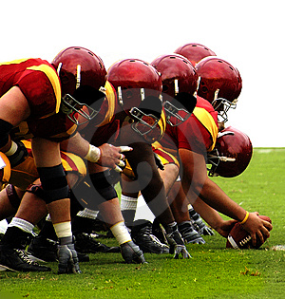

Name:____________

Teacher:__________

Key terms

Key term | Learned | Revised
Lombardi ethic

Counter culture

Franchise

Frontier Spirit

American dream

Commercialism

Immigration

Topographic

Gridiron

Ivy league

Radical ethic

By the end of this booklet candidates should be able to:

  - describe characteristics of the USA young, capitalist nation; relatively large population;

  - explain the nature of sport in the USA win ethic; commercialism; vehicle for achieving ‘the American Dream’

  - Analyse the game of American football (origins, nature of game including violence, commercialism).

The American nation as we know it today is relatively new. There have been several major reasons for the country turning out the way it has. In this pack we will investigate what they are.

- Young country.
______________________________________________________________
______________________________________________________________
______________________________________________________________
______________________________________________________________
______________________________________________________________
______________________________________________________________

- Large population
______________________________________________________________
______________________________________________________________
______________________________________________________________
______________________________________________________________
______________________________________________________________
______________________________________________________________

- Capitalist
______________________________________________________________
______________________________________________________________
______________________________________________________________
______________________________________________________________
______________________________________________________________
______________________________________________________________

Historical capitalist

In the 1900 America was producing more than other country in the world thus increasing their wealth. This healthy start and an individual attitude to development. An attitude that meant that each person was responsible for their own success and development. This forged the economic system of individual enterprise.

This system is known as capitalism and is dominated by individuals or shared ownership of business for profit. This desire for wealth and accumulation of material directly influences the nature of sport in the USA. Sport is business.

Frontier Spirit and origins of the Win ethic

Immigrant settlers increased the population but also brought different cultures and games which were adapted to the new country.
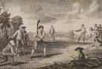

Name three sports that originated in the USA.
_______________________________
_______________________________
_______________________________

Name three sports that originated from the settlers.
_______________________________
_______________________________
_______________________________

- What characteristic do you think were needed to cross the great frontier?
_____________________
_____________________
_____________________
_____________________
_____________________
_____________________
_____________________

- Where else in America can you identify these characteristics?

___________________________
____________________________
_____________________________

- What happened to the Native American’s and their games?
__________________________________________________________________
__________________________________________________________________
_________________________________________________________________
___________________________________________________________________

The nature of sports in the USA.
The win ethic

Who is this?

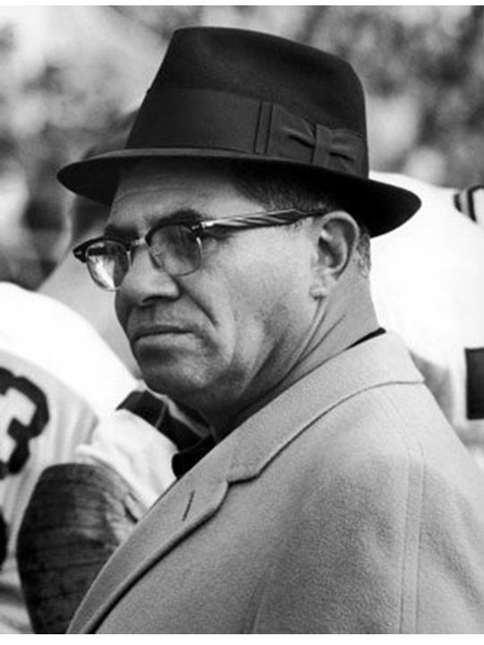
WINNING ISN’T _______________________________________________________________________________________________. This is now called the _______________________
Ethic.
Hi I’m_________________________________________________________________________________________________________________________________________

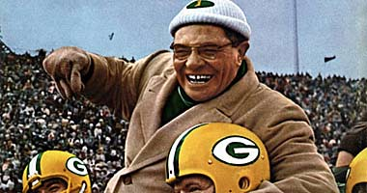

What is the Win ethic?
________________________________________________________________
________________________________________________________________
________________________________________________________________
________________________________________________________________

Examples of the win ethic.
____________________________________________________
____________________________________________________

How is this reflected in sports in America?
________________________________________________________________
________________________________________________________________
________________________________________________________________
________________________________________________________________
________________________________________________________________

Sports ethics

Clearly not all sports are based around the win ethic (Lombardi ethic).
There are also the counter culture and the radical ethic.

Counter culture ____________________________________________________________________________________________________________________________________________________

The radical ethic is __________________________________________________________________________

Which ethic do you think suits you? _____________________

Sporting culture | Sport

Looking at the sports below which ethic do you think best fits with which sport?

In pairs can you explain if there are some sports that might cross over more than one ethic?
________________________________________________________________________________________________________________________________________________________________________________________________________________________________________________________________________________________________________________________________________________________________________________________________________________________
___________________________________________________
___________________________________________________

Different sports can have different ethics

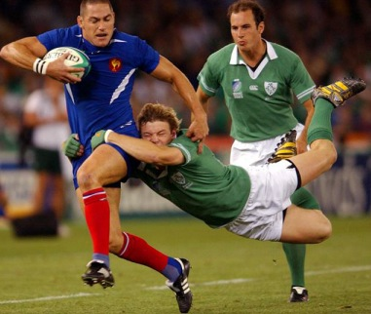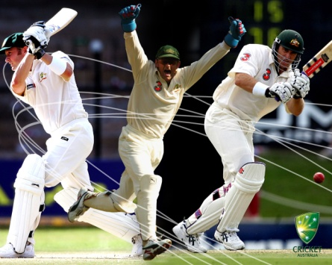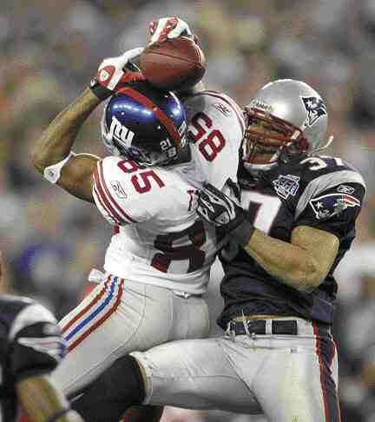

Commercialism

In the USA sport not just means business it is business! At every level it’s driven by commercialism. To turn everything into objects, images, and services sold for the purpose of generating profit, this is one of the driving forces in American sports right from the very start. So let’s look at this.

We have a Win ethic, and a desire to create profit (capitalism) and a desire to turn everything into a profit (commercialism)! No wonder they are very competitive.

Commercialism

1.school_______________________________________________________________________________________________________________________________________________________________________________________________________________________

2._______________________________________________________________________________________________________________________________________________________________________________________________________________________

3._______________________________________________________________________________________________________________________________________________________________________________________________________________________

4._______________________________________________________________________________________________________________________________________________________________________________________________________________________

5._______________________________________________________________________________________________________________________________________________________________________________________________________________________

6._______________________________________________________________________________________________________________________________________________________________________________________________________________________

7.______________________________________________________________________________________________________________________________________________________________________________________________________________________

Positive aspects of Commercialism | Negative aspects of Commercialism

Where in the UK can you see evidence of the American commercial approach to sport? (Here you’re looking for examples)
- .
- .
- .
- .
- .
- .

What are the advantages and disadvantages of college sport being highly competitive?
___________________________________________________________________________________________________________________________________________________________________________________________________________________________________________________________________________________________________________________________
______________________________________________________________________________________________________________________________

Should English school sports be more like the American model of a professional approach? (VLE Forum Post)
__________________________________________________________________________________________________________________________________________________________________________________________________________________________________________________________________________________________________________________________________________________________________________________________

Where does the term living the dream come from?

LIVING THE AMERICAN DREAM

- Not class system
- providing opportunity to those with drive, determination and talent
- .
- .
- .

Can you think of any sporting examples of rags to riches?

- _______________________________
- _______________________________
- _______________________________
- _______________________________
- _______________________________

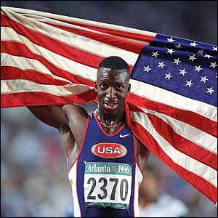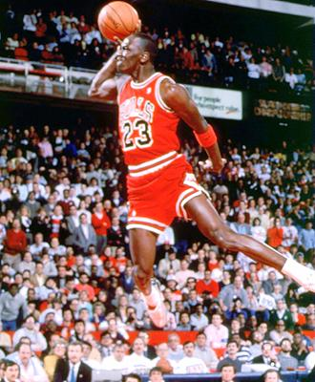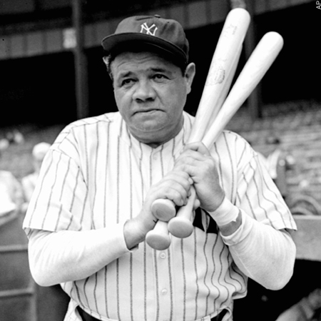

Key words or phrases.
Zero to Hero

Another rags to riches story. “I was running around, wasn't coming home at night, and my mom threatened to send me to a boys' school in Missouri,” recalls Dat Nguyen, Dallas Cowboys standout middle linebacker. “I wanted to stay with my folks, so I had to find something else to do.”
The biggest obstacle to playing football wasn't his mother's fears about injury, however. It was his size. The Vietnamese American boy was small compared to the other boys playing the sport. But he was shown the way by older brother Hung who, at 5-4 and 140 pounds, was even smaller but played center for Rockport-Fulton High. Dat managed to put on some precious pounds by eating as often as possible at the home of best friend Jimmy Hattenbach whose mother served heaping helpings of rich American food.
By the time Dat was running through his college options, recruiters were over the size thing. He was recruited by Division 1 powerhouses like UCLA and Michigan. Dat chose Texas A&M so he could pursue agricultural sciences. And he pursued his studies with far more seriousness than most football stars, racking up a solid GPA while setting an Aggie record with 517 career tackles over 51 consecutive starts. He finished his senior year with a career-high 147 tackles and became the only player in school history to lead Texas A&M in tackles four seasons running.
Those impressive stats earned him some impressive accolades. He was named Big 12 Male Athlete of the Year by the Dallas Morning News. He was the national and Big 12 Defensive Player of the Year his senior year. He won the Lombardi Trophy. Best of all, he was drafted in the third round by the Dallas Cowboys despite his size (5-11, 221 pounds). What everyone was beginning to see was that Nguyen's ability to read a play more than made up for his size and mediocre foot speed.
“It was a great feeling when I got drafted, especially having been such a huge Dallas fan when I was growing up,” said Nguyen. “I'm an Asian-American who is now playing America's sport, for America's team — what more can you ask for? That's like a storybook!”
What makes the story complete is the remarkable success Nguyen has seen as one of the NFL's smallest middle linebackers. After two seasons of playing on special teams and backup positions, in 2001 he was promoted to starter at the middle linebacker position. That season he started all 16 games and led the team in tackles. Not even a wrist injury in 2002 could keep him from receiving his well-earned reward: a 6-year $13 million contract.

His story begins back in a war-ravaged Sudan where, once their father Aldo had been imprisoned for speaking out against the political regime, the Deng family escaped to Egypt.
There they began to play basketball under the watch of former NBA centre Manute Boland, once his parents had gained political asylum, they moved to Croydon. It was in South London that Luol turned to football and basketball, as opposed to crime.
‘There’s no doubt that without sport I could have ended up like some of my friends at the time,’ he admitted. ‘I did a few things as a kid I now regret. It was hard to say “no” when there was so much peer pressure. Some of my friends are not doing so well now. Some are in prison, some have been stabbed. I was lucky.’ Luol was a good enough footballer to be invited to trials for England Under 16’s — but he never turned up. ‘I’d set my sights on going to America and becoming the best basketball player possible,’ he said. ‘I played football for Croydon Borough, including a few times with Ian Wright’s son, but my sister wanted to go to an American college and my parents would only let her go if I went with her. Besides, I didn’t want to take my GCSEs. I remember my football coach was mad at me when I told him the news. But I guess it worked out in the end.’
You can say that again. ‘I appreciate everything that’s ever happened to me,’ he said. ‘I am blessed and I owe so much to so many, not least my family. I don’t recall the bombs in Sudan, being one of the youngest, but my brothers and sisters do, and it was they who brought me up until we could all come over to Croydon. Of course the American collegiate and basketball system has also helped me greatly — but I have never forgotten what Britain has done for me and my family.
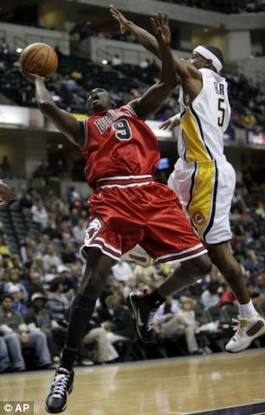

American football origins of the violent game
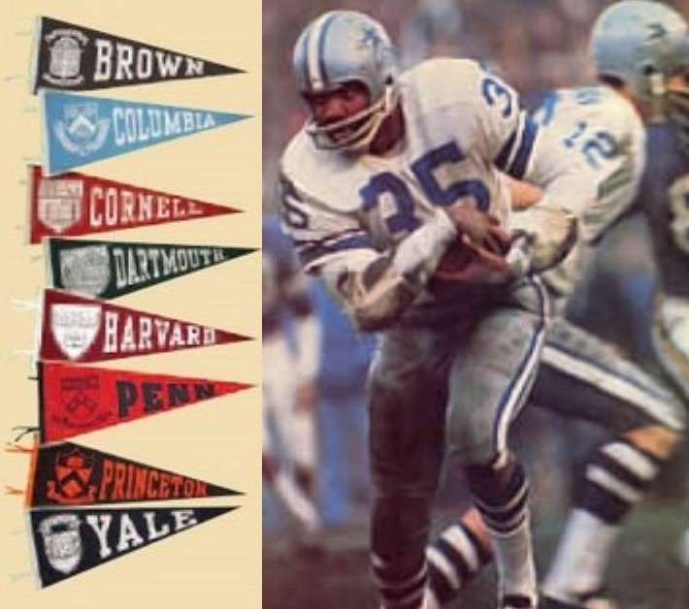
The Ivy League _____________________________
_________________________________________
_________________________________________
_________________________________________
_________________________________________
_________________________________________
_________________________________________
_________________________________________

Reasons for changes to football
_________________________________________
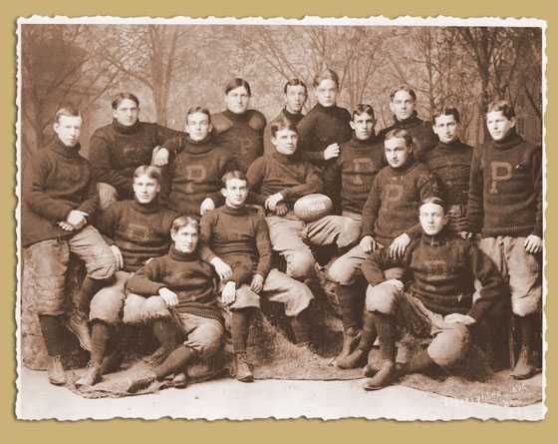
_________________________________________
_________________________________________
_________________________________________
_________________________________________
_________________________________________
_________________________________________
_________________________________________

Characteristics of American football in the Ivy League
__________________________________________________________________________________________________________________________________________________________________________________________________________________________________________________________________________________________________________________________________________________________________________________________

Could you name more than two of the top universities in the Ivy League?

Fact: in the 1910 season six players were killed in which resulted in the changes to the rules of the game. At the same time as America football’s development, in English public schools mob football was developing as well.

American football and Commercialism

Characteristics of American football

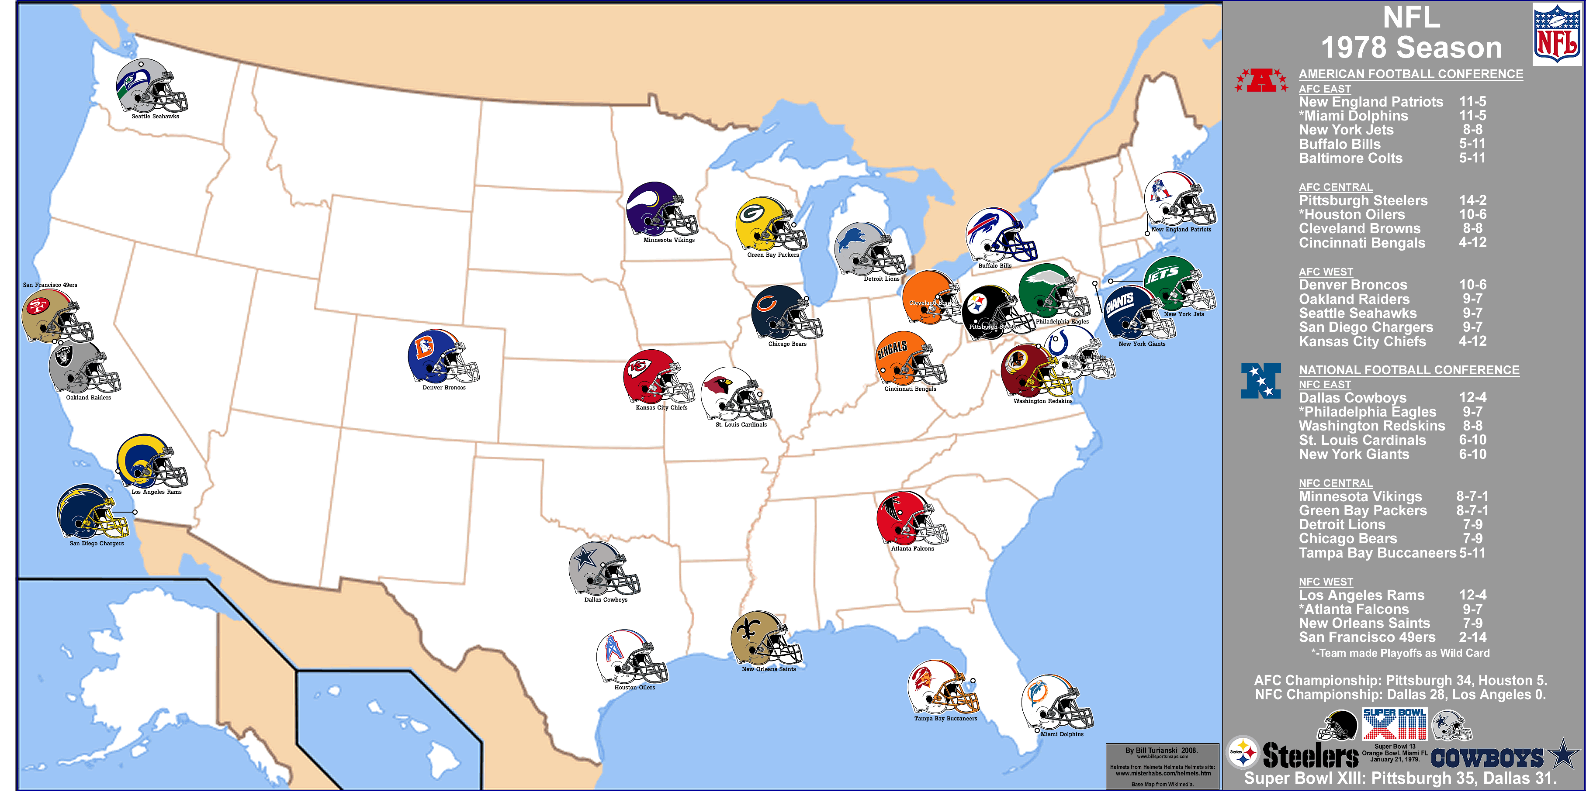

_____________________________________________________________________________________________________________________________________________________________________________________________

_____________________________________________________________________________________________________________________________________________________________________________________________

_____________________________________________________________________________________________________________________________________________________________________________________________

_____________________________________________________________________________________________________________________________________________________________________________________________

Where is commercialism evident in the Super bowl?
______________________________________________________
_______________________________________________________________________________________________________________________________________________________________________________________________________________________________________________________
Friday Night Lights

Watch the video and identify the characteristics of the Lombardi ethic. Make notes on other aspects of American sports in college such as commercialism.
___________________________________________________________________________________________________________________________________________________________________________________________________________________________________________________________________________________________________________________________

___________________________________________________________________________________________________________________________________________________________________________________________________________________________________________________________________________________________________________________________

________________________________________________________________________________________________________________________________________________________________________________________________________________________________________________________________________________________________

AS Physical Education –10-mark planning framework
Question Title

Introduction – key points (be clear on how many main and sub parts there are to the question. This will help with paragraphs, structure and organisation. Remember your introduction is not a re-write of the question)
- .
- .
- .

Paragraph detail – key points to make / develop | Knowledge and  understanding – have I made  a number of relevant points?  Analysis / critical evaluation  – have I developed or ‘picked  apart’ some of my points?  Practical examples up to the  present day if relevant.  Technical / specialist  vocabulary – have I  consistently used vocabulary  that illustrates my  engagement with the  subject?  Quality of written  communication – is my  spelling, punctuation,  grammar of the highest  quality I can manage?
Paragraph detail – key points to make / develop ... | Knowledge and understanding –  have I made a number of  relevant points?  Analysis / critical evaluation –  have I developed or ‘picked  apart’ some of my points?  Independent opinion and  judgement with practical  examples –  Technical / specialist vocabulary  – have I consistently used  vocabulary that illustrates my  engagement with the subject?  Quality of written communication  – is my spelling, punctuation,  grammar of the highest quality I  can manage?

Paragraph detail – key points to make / develop | Knowledge and  understanding – have I made  a number of relevant points?  Analysis / critical evaluation  – have I developed or ‘picked  apart’ some of my points?  Practical examples up to the  present day if relevant.  Technical / specialist  vocabulary – have I  consistently used vocabulary  that illustrates my  engagement with the  subject?  Quality of written  communication – is my  spelling, punctuation,  grammar of the highest  quality I can manage?
Paragraph detail – key points to make / develop ... | Knowledge and understanding –  have I made a number of  relevant points?  Analysis / critical evaluation –  have I developed or ‘picked  apart’ some of my points?  Practical examples  Technical / specialist vocabulary  – have I consistently used  vocabulary that illustrates my  engagement with the subject?  Quality of written communication  – is my spelling, punctuation,  grammar of the highest quality I  can manage?

Paragraph detail – key points to make / develop | Knowledge and  understanding – have I made  a number of relevant points?  Analysis / critical evaluation  – have I developed or ‘picked  apart’ some of my points?  Practical examples up to the  present day if relevant.  Technical / specialist  vocabulary – have I  consistently used vocabulary  that illustrates my  engagement with the  subject?  Quality of written  communication – is my  spelling, punctuation,  grammar of the highest  quality I can manage?
Paragraph detail – key points to make / develop ... | Knowledge and understanding –  have I made a number of  relevant points?  Analysis / critical evaluation –  have I developed or ‘picked  apart’ some of my points?  Independent opinion and  judgement with practical  examples –  Technical / specialist vocabulary  – have I consistently used  vocabulary that illustrates my  engagement with the subject?  Quality of written communication  – is my spelling, punctuation,  grammar of the highest quality I  can manage?

P | Make your POINT (BLACK)
E | EXPLAIN your point (RED)
E | EGs – develop the point with Egs (GREEN)
D | Develop your explanation (BLUE)
Write in FULL sentences.
Use accurate technical language.
IF asked – give +/- (2 sides to a discussion).

Key term | Learned | Revised
Lombardi ethic

Counter culture

Franchise

Frontier Spirit

American dream

Commercialism

Immigration

Topographic

Gridiron

Ivy league

Radical ethic

