**Revision question on muscles and movement**

1. Name **the** agonist and **the** antagonist at the hip at the point of take off during a vertical jump.

Gluteus Maximus

Iliopsoas

[**2 Marks**]

1. **Fig.2 shows a gymnast holding a position on the rings.**



**Fig 2.**

Name two muscles in the rotator cuff group which aid the stability of the shoulder joint.

Teres major

Subscapularis

Supraspinatus

Infraspinatus

[**2 Mark)**

1. **Fig.3** shows a person in the crucifix.

[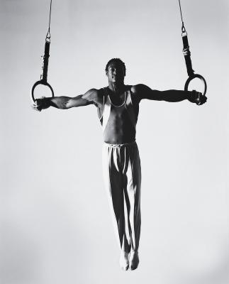](http://www.google.co.uk/url?sa=i&rct=j&q=&esrc=s&source=images&cd=&cad=rja&uact=8&ved=0ahUKEwjF2rnx_q7PAhUJPBQKHRAbB_8QjRwIBw&url=http://livehealthy.chron.com/train-iron-cross-gymnastics-9661.html&bvm=bv.133700528,d.ZGg&psig=AFQjCNHPoAbEfvv5VdWQUuSBXizoVV4jbQ&ust=1475046577593962)

**Fig 3.**

State the type of contraction at the shoulder ***lowering*** *into* the crucifix and state the muscle that is working.

Eccentic contraction of the latimus dorsi

[**2 Marks**]

1. Consider the following statements:

**“Horizontal flexion is the movement of the limbs away from the midline of the body parallel to the ground.”**

**“Rotation is the movement whereby articulating bones turn about their longitudinal axis in a screwdriver action.”**

1. Which of the following is true?

**Put a tick (☑) in the box next to the correct answer.**

1. Both Statements are true.  **☐**

**B.** The first statement is true, the second is false. **☐**

**C.** The first statement is false, the second is true. ***☐***

**D.** Both statements are false.  **☐**

**[1 Mark]**

1. **Fig.1 shows a performer completing a sit-up**.

**Fig 1.**

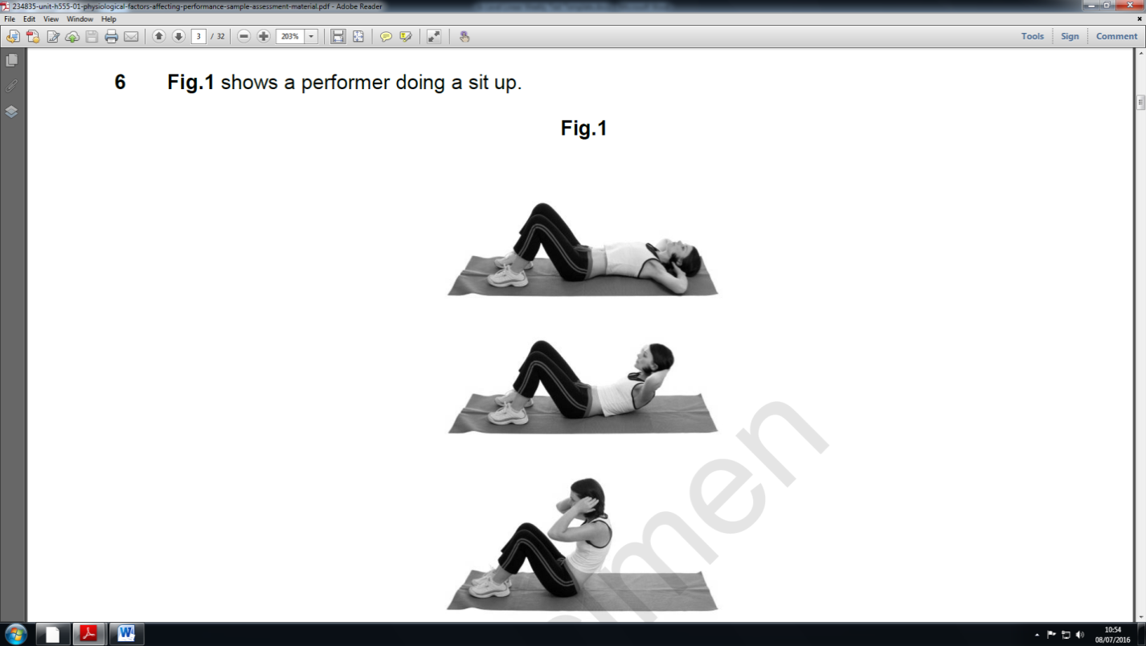

1. Complete the table below to show movements that take place in the spine during the upward and downward phases.

|  |  |  |  |
| --- | --- | --- | --- |
| **Phase** | **Agonist** | **Movement Produced** | **Type of contraction** |
| Upward | Rectus abdominals | Flexion | Concentric |
| Downward | Rectus abdominals | Extension | Eccentric |

**[3 Marks]**

1. **State the movement at the ankle joint of the striking foot at the point of contact and name the agonist muscle responsible for creating the movement. (6)**

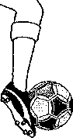 **Fig. 1**

|  |  |  |  |  |  |  |
| --- | --- | --- | --- | --- | --- | --- |
| **Joint** | **Joint Type** | **Movement** | **Agonist** | **Antagonist** | **Type of Contraction** | **Plane of movement** |
| Ankle | Hinge | Planta flexion | Gastrocnemius/Soleus | Tibialis anterior | concentric | Sagittal |

**7. Use your anatomical and physiological knowledge to complete the table below for the athlete’s elbow during the upward phase of the bicep curl. 3 marks, 1 for each element of the table completed correctly. Accept first answer only. (4 marks)**

|  |  |  |  |  |
| --- | --- | --- | --- | --- |
| Joint | Joint Type | Movement | Agonist | Antagonist |
| Elbow | Hinge | flexion | Biceps Brachia | Triceps brachia |

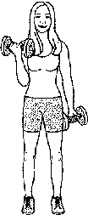

1. **Fig.1 shows a gymnast holding a position on the rings. (5 marks)**

**a) Use your anatomical and physiological knowledge to complete the table below for the hip joint**

**b) The gymnast in Fig. 1 must keep his shoulders in a fixed position. Name two muscles in the rotator cuff group which aid the stability of the shoulder joint.**

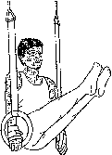**Fig. 1**

|  |  |  |  |  |  |
| --- | --- | --- | --- | --- | --- |
| **Joint** | **Joint Type** | **Movement** | **Agonist** | **Antagonist** | **Plane** |
| **Hip** | **Ball and socket** | **Flexion** | **Iliopsoas** | **Gluteus maximus** | **Sagital** |

|  |  |
| --- | --- |
| Supraspinatus | **Infraspinatus** |
| **Subscapularis** | **Teres major** |
|
|
|

1. **Fig. 1 shows the muscles responsible for movement of the elbow joint. Name the type of joints found at the elbow. Name the movements possible at the elbow. (4)**

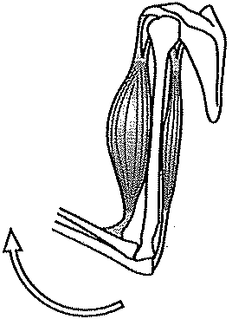**flexion** 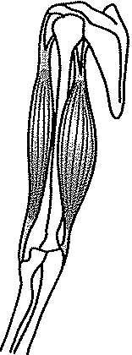

**Hinge and flexion and extension**

**Radio-ulna joint and rotation**

1. **The diagram below shows a player performing a basketball lay-up shot. Use your anatomical and physiological knowledge to complete the table below for the player’s right knee. (4 marks)**



|  |  |  |  |  |  |
| --- | --- | --- | --- | --- | --- |
| **Joint** | **Joint Type** | **Movement** | **Agonist** | **Antagonist** | **Type of Contraction** |
| Knee | hinge | flexion | Hamstring/ rectus femoris *et al* | Semimembranosus *et al* | concentric |

[5]

1. **The figure below shows a netball player using the elbow joint during the execution phase of a shot Identify and complete the table below.**

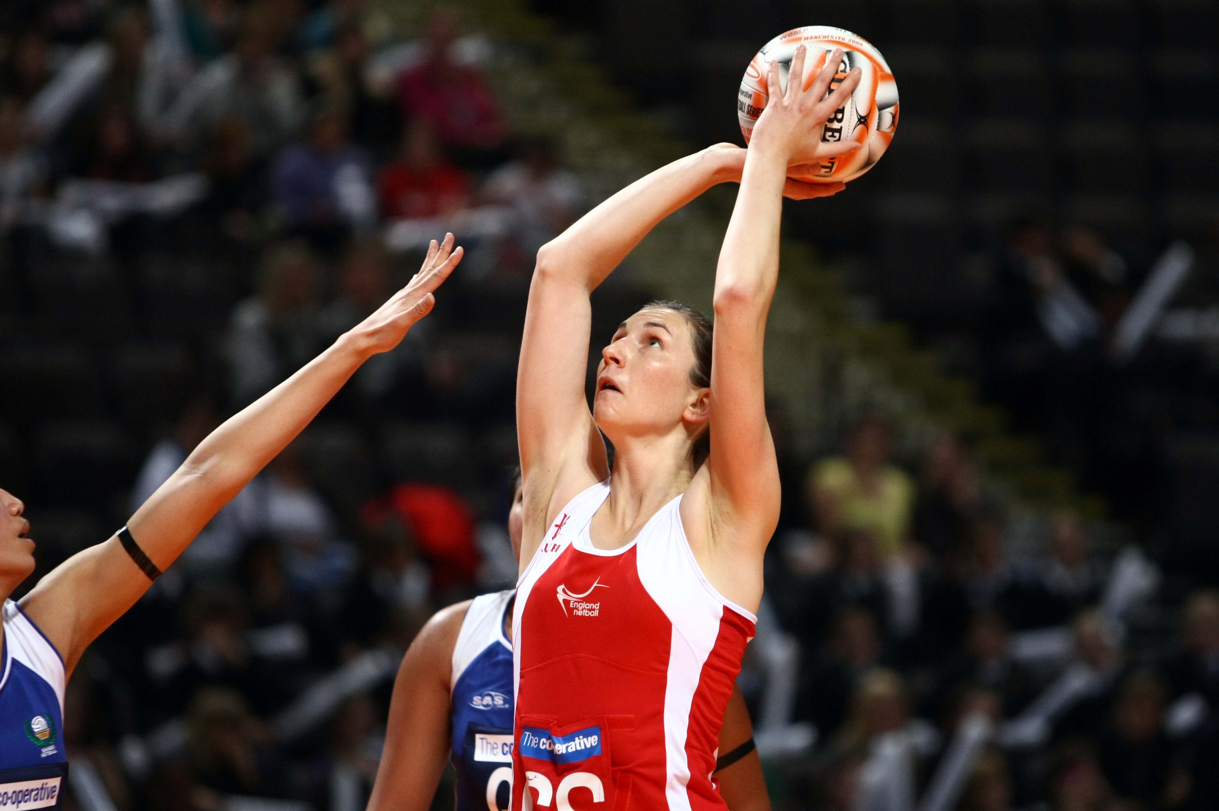

|  |  |  |  |  |  |  |
| --- | --- | --- | --- | --- | --- | --- |
| **Joint** | **Joint Type** | **Movement** | **Agonist** | **Antagonist** | **Type of Contraction** | **Plane of movement** |
| Elbow | Hinge | Extension | Triceps brachia | Bicep Brachia | Concentric | sagital |

1. **The figure below shows an athlete during the take off phase of the long jump. Complete the joint analysis of the athlete’s left ankle joint. [5 marks]**

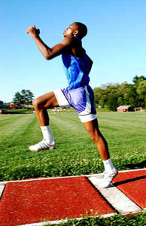

|  |  |  |  |  |  |  |
| --- | --- | --- | --- | --- | --- | --- |
| **Joint** | **Joint Type** | **Movement** | **Agonist** | **Antagonist** | **Type of Contraction** | **Predominant muscle fibre involved** |
| Knee | Hinge | Extension | Gastrocnemius/ soleus | Tibialis anterior | Concentric | FG |

1. Use the ***upward*** motion in the picture to complete the following joint analysis for the hip joint. [4 marks]

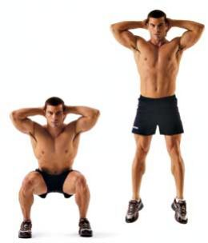

|  |  |  |  |  |
| --- | --- | --- | --- | --- |
| **Joint Type** | **Movement** | **Agonist** | **Antagonist** | **Type of Contraction** |
| Ball and socket | Extension | Iliopsoas | Gluteus maximus | Concentric |

1. Use this picture to help you complete the following movement analysis of the elbow joint during **lowering phase** (4 marks)

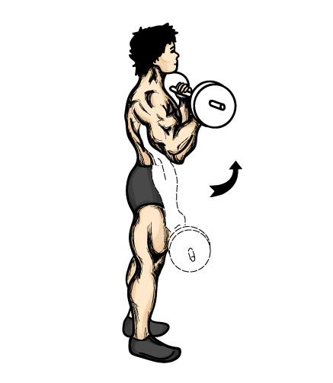

|  |  |  |  |  |  |
| --- | --- | --- | --- | --- | --- |
| **Joint Type** | **Movement** | **Agonist** | **Antagonist** | **Type of Contraction** | **Plane of movement** |
|  | extension | Bicep brachia | Triceps brachia | eccentric | sagittal |

1. **Use Fig 2 to help you complete the following movement analysis of the spine during extension. (2 marks)**

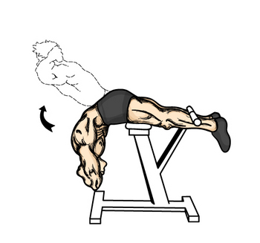

|  |  |  |  |  |
| --- | --- | --- | --- | --- |
| **Joint classification** | **Movement** | **Agonist** | **Antagonist** | **Type of Contraction** |
| Cartilaginous | Extension | Erector spina | Rectus abdominals | Flexion |