Revision Motor unit exam question

- Draw and label a motor unit. (3)

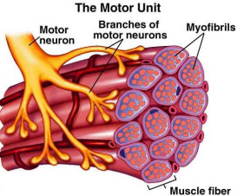

Circle your answer. What two structures meet at the neuromuscular junction?
(a) T tubules and SR;
(b) sarcolemma and T tubules;
(c) an axon and the SR;
(d) an axon and the sarcolemma;
(e) an axon and thick myofilaments

In order for a muscle to contract, one or more motor units will be stimulated and will follow the ‘all or none’ law.

Describe the structure of a motor unit. (2)
Motor neurone and number of muscle fibres

What is the ‘all or none’ law? (1)
When stimulated all of the muscles fibres within the motor unit contract or none at all.

What is the effect of stimulating more motor units? (2)
Increase strength and force of contraction

