Scenario arousal activity sheet

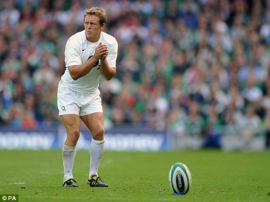
Using the drive theory explain what will happen to the performance of the athlete. What are the factors that will affect his performance and how will the arousal be exhibited?
…………………………………………………………………………………………………………………………………………………………………………………………………………………………………………………………………………………………………………………………………………………………………………………………………………………………………………………………………………………………………………………………………………………………………………………………………………………………………………………….………………………………………………………………………………………………………………………………………………………………………………………………………………………………………………………………………………………………………………………………………………………………………………………………………………………………………………………………………………………………………………………………………………………………………………………………
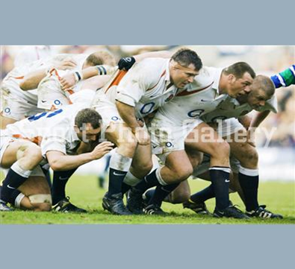
Using the inverted U theory can you explain the three possible levels of arousal and how this will impact on the performance? Use the rugby scrum in your example.
…………………………………………………………………………………………………………………………………………………………………………………………………………………………………………………………………………………………………………………………………………………………………………………………………………………………………………………………………………………………………………………………………………………………………………………………………………………………………………………….………………………………………………………………………………………………………………………………………………………………………………………………………………………………………………………………………………………………………………………………………………………………………………………………………………………………………………………………………………………
Describe the two types of arousal, somatic and cognitive. Use an example to describe when this might take place.
…………………………………………………………………………………………………………………………………………………………………………………………………………………………………………………………………………………………………………………………………………………………………………………………………………………………………………………………………………………………………………………………………………………………………………………………………………………………………………………….

Notes:

