Sport and society

20th century
1900-1999

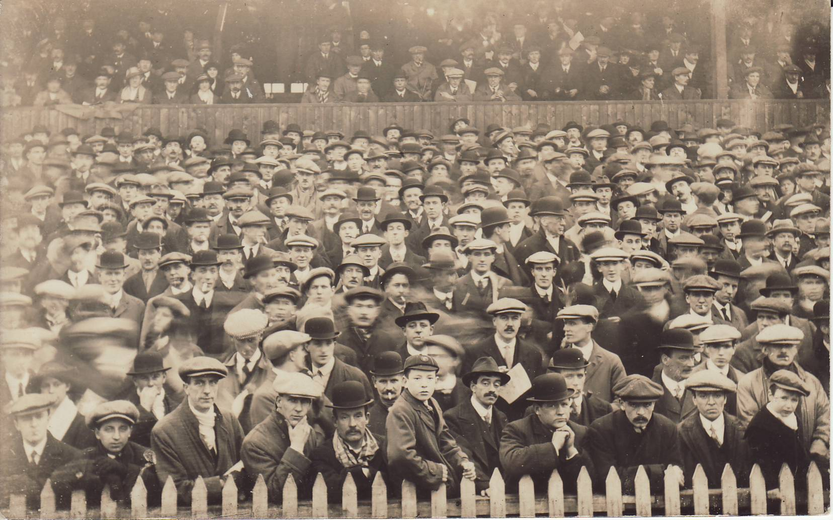

A level PE

NAME: ,

Learning objectives

At the end of this booklet you should be able to: | Notes | Learned
Know the social factors that shaped the characteristics of sport in 20th Century
Amateurism and professionalism
Gender changing status of women
Law and order
Education
Availability of time
money
transport

Background: what was it like in the 20th century?
………………………………………………………………………………………………………………………………………………………………………………………………………………………………………………………………………………
……………………………………………………………………………………………………………………………………………………………………………………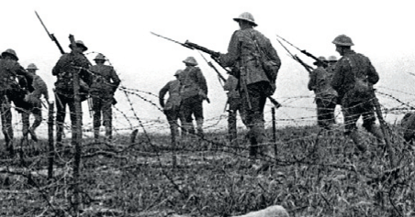

- .
- .
- .
- .
- .
- .

Class/ Gender, Law and order

What can we tell about society from this picture?
_______________________________________________________________________________________________________________________________________________________________________________________________________________________________________________________________________________________________________________________________________________________________________________________

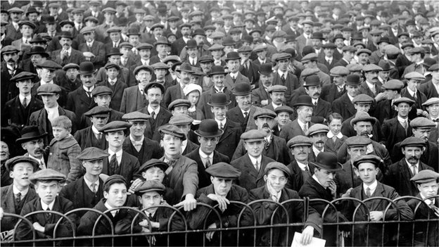

Education

________________________________________________________________________________________________________________________________________________________________________________________________________________________________________________________________________________________________________________________________________________________________________________________________________________________________________________________________________________________________________________________________________________________________________________________________________________________
Grammar School

____________________________________________________________________________________________________________________________________________________________________________________________________________________________________________________________________________________________________________________________________

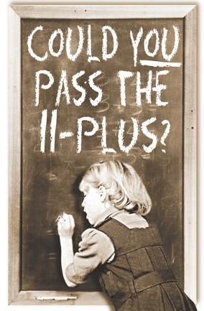
What was the 11+ ask your parents

Secondary modern School
______________________________________________________________________________________________________________________________________________________________________________________________________________________________________________________________________________________________________________________________________________________________________________________

Secondary technical

____________________________________________________________________________________________________________________________________________________________________________________________________________________________________________________________________________________________________________________________________

Time Money and space
____________________________________________________________________________________________________________________________________________________________________________________________________________________________________________________________________________________________________________ 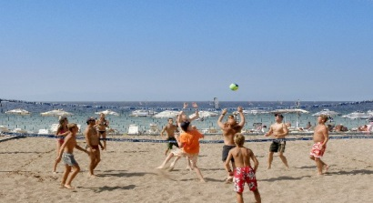
______________________________________________________________________________________________________________________________________________________________________________________________________________________________________________________________________________________________________________________________________________________________________________________
Transport

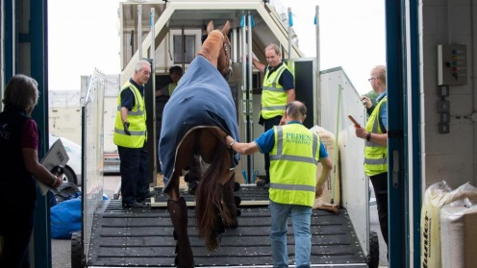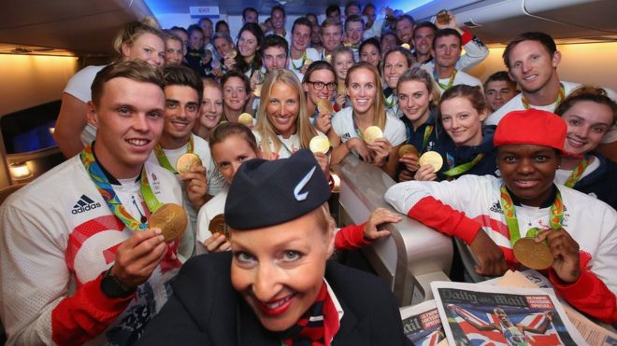

How has transport impacted of sport and recreation?
_________________________________________________________________________________________________________________________________________________________________________________________________________________________________________________________________________________________________________________________________________________________________________________________________________________________________________________________________________________________________________________________________________________________________________________________________________________________________________________________________________________________________________________________________________________________________________________________________________________________________________________________

