Learning outcome | I understand this | I can recall this | I need to revisit this
I know the three types of levers.
I know the mechanical advantages and disadvantages of the levers.
I know the calculations and definitions of the principles of linear motion.
I know what angular motion is. I know how angular motion is created. ( I know what an eccentric force is).
I know the axis of rotation
I know how to calculate angular displacement 0/ angular velocity. (w)
I know how to create angular velocity. (w)
I know what a moment of inertia is and what impacts the MI. I know this represents MI (kgm2) = ∑m (kg) x r2 (m2)

I know the relationship between MI and w.
I know what Angular Momentum (kgm2 rad/s) = moment of inertia (kgm2) x angular velocity (rad/s)

I know how angular momentum is created
I know what Angular Analogue of Newton’s First Law is.
Task sheet 2 Biomechanics

- Complete the question for the ice skater creating angular momentum. (Mon)
- Use the grid and complete a biomechanics analysis of the somersault, and the skier. (Tue/Wed)
- Revise all angular motion (Mon) 30 min test
- Prepare notes for Fluid motion. What is it? What are the factors that affect fluid motion?

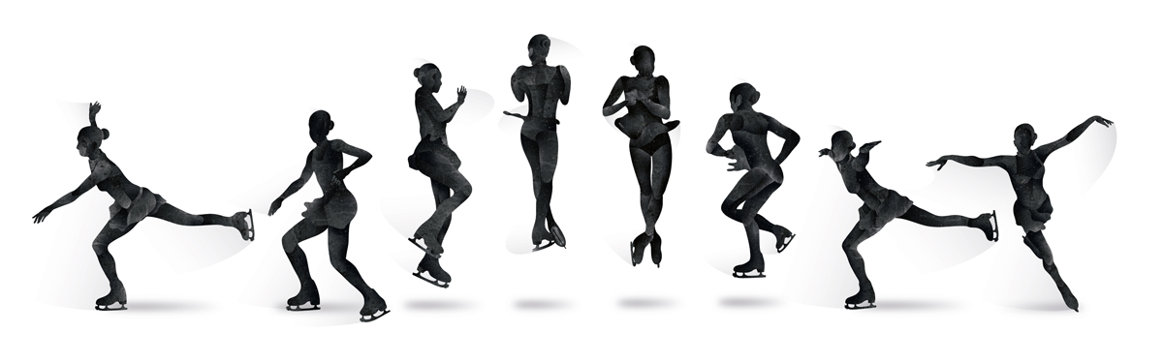
How does an ice skater create Angular Momentum?
- How do they create an eccentric force?
- What axis do they rotate around?
- What is their Distribution of Mass like before they enter the spin? How does this affect MI and the Angular Velocity? What speed is the spin at this point?
- What does the performer do as they jump to reduce MI? What happens to Angular Velocity and speed of the spin in mid-air?
- As they prepare to land, what does the performer do in order to increase stability? How does this affect MI and Angular Velocity?
- Why does the spin reduce as they land? Think about the change in Newton’s 1st Law here..

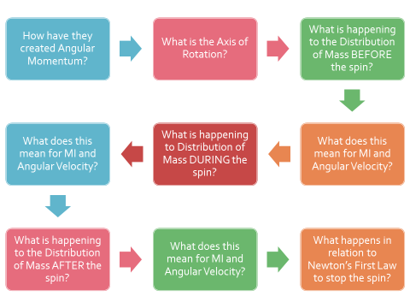

Complete a biomechanics analysis of the somersault and the skier round the pole
A slalom skier rotating around the pole to change direction:

