Drugs in Sport

- Note the names of the most prolific drug scandals over the last ten years.

-------------------------------------------------------------------------------------------------------------------------------------------------------------------------------------------------------------------------------------------------------------------------------------------------------------------------------------------------------------------------------------------------------------------------------------------------------------------------------------------------------------------------------------------------------------------------------------------------------------------------------------------------------------------------------------------------------------

- List the performance enhancing drugs that are being used in sport.
Match up the sports suited to each substance.
----------------------------------------------
----------------------------------------------
----------------------------------------------
---------------------------------------------
---------------------------------------------
----------------------------------------------
----------------------------------------------
----------------------------------------------
----------------------------------------------
---------------------------------------------
---------------------------------------------
----------------------------------------------
----------------------------------------------
---------------------------------------------
---------------------------------------------
----------------------------------------------
----------------------------------------------
---------------------------------------------

What are the advantages of taking legal supplements? Give an example where this has caused an issue for an athlete.

- Can you think of any legal supplements?
---------------------------------------------
----------------------------------------------
----------------------------------------------
---------------------------------------------
---------------------------------------------
----------------------------------------------
----------------------------------------------
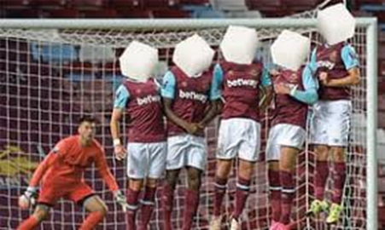
- What are the disadvantages of taking legal supplements?
------------------------------------------------------------------------------------------------------------------------------------------------------------------------------------------------------------------------------------------------------------------------------------------------------------------------------------------------------------------------------------------------------------------------------------------------------------------------------------------------------------------------------------------------------------------------------------------------------------------------------------------------------------------------------------------------------------------------------------------------------------------------------------------------------------------------------------------------------------------------------------------------------------------------------------------------------------------------------------------------------------------------------------------------------------------------------------
- Describe some of the reasons that athletes feel the need to take performance enhancing drugs. Give examples.
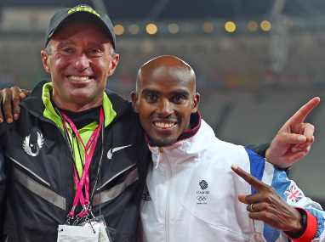
-----------------------------------------------------------------------------------------------------------------------------------------------------------------------------------------------------------------------------------------------------------------------------------------------------------------------------------------------------------------------------------------------------------------------------------------------------------------------------------------------------------------------------------------------------------------------------------------------------------------------------------------------------------------------------------------------------------------------------------------------------------------------------------------------------------------------------------------------------------------------------------------------------------------------------

- Click on the image of the shot putter and watch the video. Min 1-10 then 35-40 Describe the political pressure and give some examples with reference to specific Games or years. Click on the image of Putin to see what happened to the Russian athletes who were part of the systematic doping programme.
------------------------------------------------------------------------------------------------------------------------------------------------------------------------------------------------------------------------------------------------------------------------------------------------------------------------------------------------------------------------------------------------------------------------------------------------------------------------------------------------------------------------------------------------------------------------------------------------------------------------------------------------------------------------------------------------------------------------------------------------------------------------------------------------------------------------------------------------------------------------------------------------------------------------------------------------------------------------------------------------------------------------------------------------------------------------------------------------------------------------------------------------------------------------------------------------------------------------------------------------------------------------------------------------------------------------------------------------
- Other pressures
------------------------------------------------------------------------------------------------------------------------------------------------------------------------------------------------------------------------------------------------------------------------------------------------------------------------------------------------------------------------------------------------------------------------------------------------------------------------------------------------------------------------------------------------------------------------------------------------
- What are the consequences of taking banned substances?
------------------------------------------------------------------------------------------------------------------------------------------------------------------------------------------------------------------------------------------------------------------------------------------------------------------------------------------------------------------------------------------------------------------------------------------------
- What strategies are in place to prevent drugs cheats?

-------------------------------------------------------------------------------------------------------------------------------------------------------------------------------------------------------------------------------------------------------------------------------------------------------------------------------------------------------------------------------------------------------------------------------------------------------------------------------------------------------

