**Physiological Factors Affecting Performance**

**Assessment 2**

**NAME:___________________**

1. In order for a muscle to contract, one or more motor units will be stimulated and will follow the ‘all or none’ law.

**(iv)** Describe the structure of a motor unit.

………………………………………………………………………………………………………..

………………………………………………………………………………………………………...

**[1]**

**(v)** What is the ‘all or none’ law?

………………………………………………………………………………………………………..

………………………………………………………………………………………………………...

**[1]**

**(vi)** What is the effect of stimulating more motor units?

………………………………………………………………………………………………………..

………………………………………………………………………………………………………...

**[1]**

1. Name **the** agonist and **the** antagonist at the hip at the point of take off during a vertical jump.

……………………………………………………………………………………………………………….

……………………………………………………………………………………………………………….

[**2 Marks**]

1. **Fig.2 shows a gymnast holding a position on the rings.**



**Fig 2.**

Name two muscles in the rotator cuff group which aid the stability of the shoulder joint.

……………………………………………………………………………………………………………….

……………………………………………………………………………………………………………….

[**2 Mark)**

1. **Fig.3** shows a person in the crucifix.

[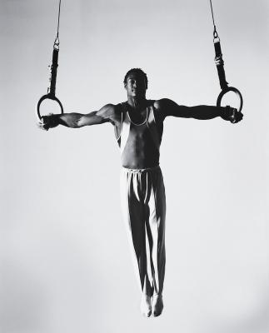](http://www.google.co.uk/url?sa=i&rct=j&q=&esrc=s&source=images&cd=&cad=rja&uact=8&ved=0ahUKEwjF2rnx_q7PAhUJPBQKHRAbB_8QjRwIBw&url=http://livehealthy.chron.com/train-iron-cross-gymnastics-9661.html&bvm=bv.133700528,d.ZGg&psig=AFQjCNHPoAbEfvv5VdWQUuSBXizoVV4jbQ&ust=1475046577593962)

**Fig 3.**

State the type of contraction a the shoulder *lowering into*  the crucifix and state the muscle that is working.

……………………………………………………………………………………………………………….

……………………………………………………………………………………………………………….

[**2 Marks**]

1. Consider the following statements:

**“Horizontal flexion is the movement of the limbs away from the midline of the body parallel to the ground.”**

**“Rotation is the movement whereby articulating bones turn about their longitudinal axis in a screwdriver action.”**

1. Which of the following is true?

**Put a tick (☑) in the box next to the correct answer.**

1. Both Statements are true.  **☐**

**B.** The first statement is true, the second is false. **☐**

**C.** The first statement is false, the second is true. **☐**

**D.** Both statements are false.  **☐**

**[1 Mark]**

1. **Fig.1 shows a performer completing a sit-up**.

**Fig 1.**

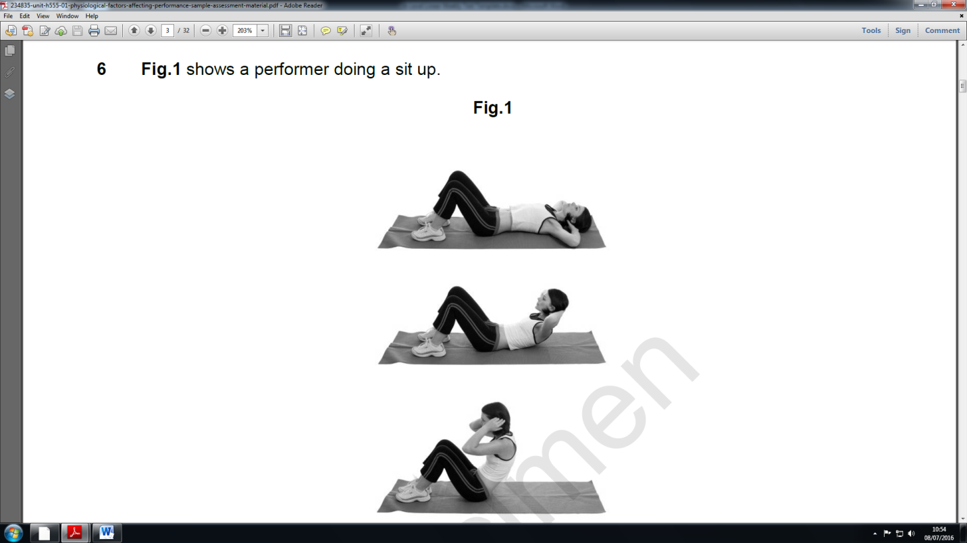

1. Complete the table below to show movements that take place in the spine during the upward and downward phases.

|  |  |  |  |
| --- | --- | --- | --- |
| **Phase** | **Agonist** | **Movement Produced** | **Type of contraction** |
| Upward |  |  |  |
| Downward |  |  |  |

**[3 Marks]**

1. Two netballers were arguing about the positioning of netball and the muscle fibres.

Discuss the suggestion from their teacher that there are many factors to consider and that they may both be correct.

…………………………………………………………………………………………………………….

.……………………………………………………………………………………………………………

.……………………………………………………………………………………………………………

.……………………………………………………………………………………………………………

…………………………………………………………………………………………………………….

.……………………………………………………………………………………………………………

.……………………………………………………………………………………………………………

.……………………………………………………………………………………………………………

…………………………………………………………………………………………………………….

.……………………………………………………………………………………………………………

**[5]**

1. The muscle fibre type that would be used during a maximal strength contraction is fast glycolytic (type lIb). Give 2 structural and 2 functional characteristic of this fibre

………………………………………………………………………………………………………………………………………………………………………………………………………………………………………………………………………………………………………………………………………………………………………………………………………………………………………………………………………………………………………………………………………………………………………………………………………………………………………………………………………………………………………………….……………

**(4 marks)**

1. Using your understanding of the energy systems state the relevant recovery time ratios for slow oxidative and fast glycolytic muscle fibres with sporting examples.

…………………………………………………………………………………………………………………………………………………………………………………………………………………………….……………………………

**(2 marks)**

**Total = 24/**