MINI MOCK ASSESSMENT 1

ANSWERS

**PHYSIOLOGICAL ASSESSMENT**

1. What is the effect of stimulating more motor units?

**Increased strength / force of contraction of the muscle [1 Mark]**

1. Which of the following is true?

**Put a tick (☑) in the box next to the correct answer.**

1. **Acetylcholine is a chemical neurotransmitter which helps to transmit nerve impulses across the synaptic cleft** **☑**

**B.** Acetylcholine is also known as a fast glycolytic muscle fibre ☐

**C**. Acetylcholine prevents oxygen being released to a muscle ☐

**D**. Acetylcholine supports a muscle fibre to recover quicker **☐**

**[1 Mark]**

1. **Fig.1 shows a gymnast holding a position on the rings. (2 marks)**

**. Name two muscles in the rotator cuff group which aid the stability of the shoulder joint.**

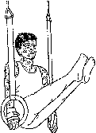**Fig. 1**

|  |  |  |
| --- | --- | --- |
|  | **Accept** | **Do not accept** |
| Teres Minor | **Closely spelled alternatives** | **Any alternatives** |
| Supraspinatus |
| Infraspinatus |
| Subscapularis |

1. **In fig 2 an athlete completes a long jump. State the plane**

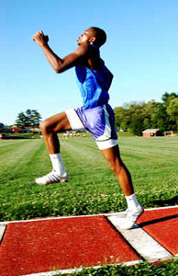

**of movement and the muscles acting as the agonist at the**

**left shoulder.**

**A: Plane= sagittal plane**

**Anterior deltoid**

**(2marks)**

1. **Sit ups are an exercise used to strengthen the iliopsoas muscle. Explain the types of muscular contraction being used in the iliopsoas muscle during the upward phase and the downward phase of a sit up. (4 marks)**

Both upward and downward phases must be visited   
(upward phase) Sub-sub max 4

* Concentric/ isotonic contraction   
   flexion at the hip   
   iliopsoas is the agonist/prime mover   
   muscle shortening under tension   
   origin moves towards insertion

(downward phase)

Eccentric/(isotonic) contraction (if not given before in point 10)   
 extension at the hip   
 muscle lengthens (under tension)   
 acting as a brake against gravity/controlling downward movement   
 origin moves away from insertion

1. **.** In terms of fibre type, the composition of muscle is largely genetically determined and can influence the activities in which people participate.

Identify two structural and two functional characteristics of a slow oxidative muscle fibre.

**If a person has a high percentage of slow oxidative fibres what type of physical activity are they more likely to participate in? (5 marks)**

Fibre type

**1 mark per point max 2 structural characteristics:**

• fewer fibres per motor neurone;

• more mitochondria;

• more myoglobin;

• more fat stores;

• type of myosin ATPase (slow);

• smaller in diameter.

**1 mark per point max 2 functional characteristics:**

• high aerobic capacity/low anaerobic capacity;

• slow contractile speed;

• high fatigue resistance;

• low motor unit strength.

**1 mark per type of physical activity:**

• any related endurance type activity.

1. **During the upward and downward phases of a press up. Explain the role of the triceps brachii in both the upward and downward phases of a press up. 4(marks)** 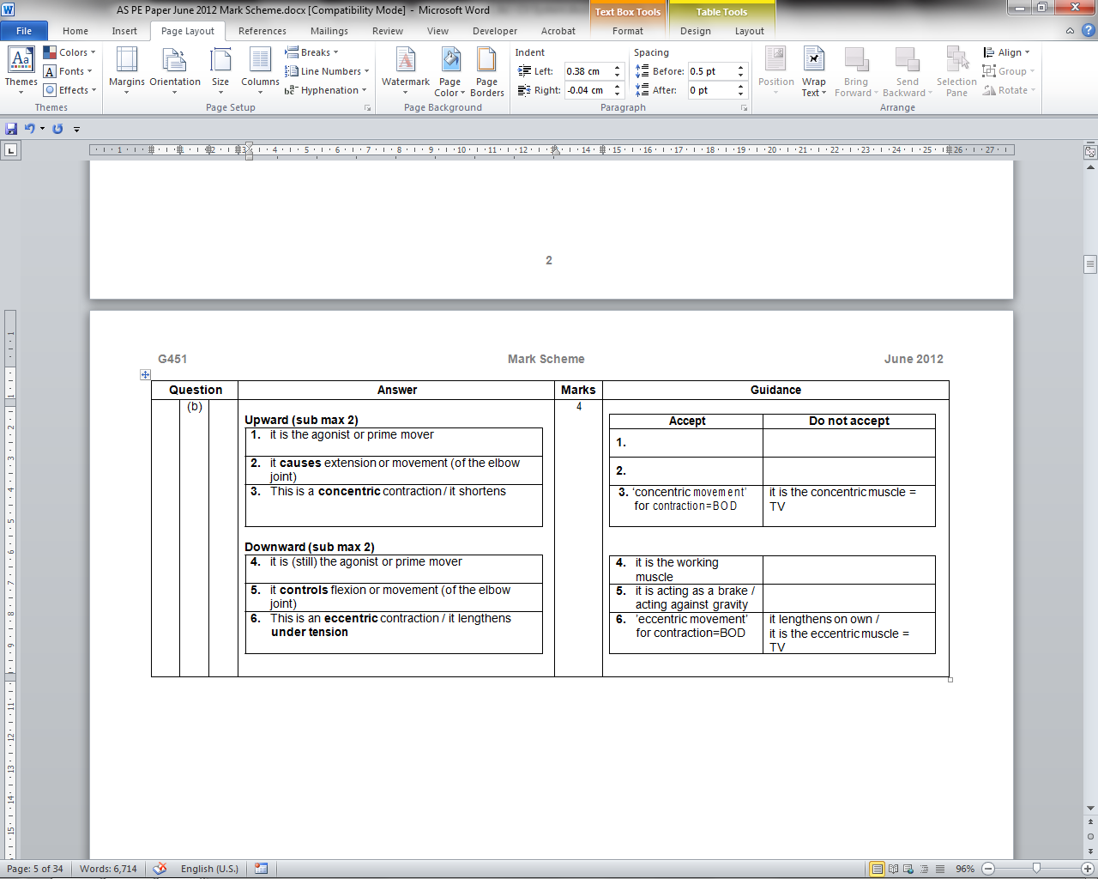
2. **What type of muscle contraction is occurring in the biceps brachii during the downward phase of the bicep curl?**

**(1 mark)**  accept first answer only.

Eccentric or isotonic eccentric (isotonic on own =TV)

**Psychological Factors Affecting Performance**

**ANSWERS**

**NAME:___________________ /40**

**Q1**

Using a practical example, describe what is meant by a complex skill in physical activity.

**A complex skill is a skill that has many sub-routines which needs to be performed in the correct sequence/ is a skill that is affected by the unstable environment / is a skill with large amounts of information to process / is a skill with a short amount of time to evaluate the situation**

**[2 Marks]**

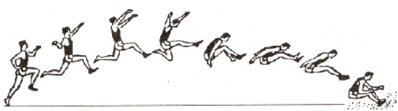**Q2**

**Fig.1**

Fig 1.shows the different phases of a long jump. Using this example, explain how movement skills can be learned and practiced using the part progressive method.

**Progressive-part – practicing each sub-routine of a skill, in a consecutive order (chaining) e.g. the long jump – first the run-up, then the run-up and jump, then the run-up, jump and the landing etc.**

**[3 Marks]**

**Q3**

The learning of movement skills is divided into three phases.

Identify the three phases of learning movement skills, and describe each phase using practical examples.

**Cognitive phase – learners are inconsistent, full or errors / trial and error, they need demonstrations and plenty of guidance**

**Associative phase – skill learning becoming more consistent, kinaesthesis being developed, the longest stage of learning (some learners never move past this stage)**

**Autonomous phase – skills have become grooved / habitual, skills are consistent, learner can concentrate on tactics instead of motor skills**

**[6 Marks]**

**Q4**

Suggest ways of optimising positive transfer as a coach**.**

**Put a tick (☑) in the box next to the TWO answers you think are correct.**

1. Offer no form of demonstration **☐**

**B.** Using similar skills to promote transfer **☑**

**C**. Ensure clear and specific demonstrations **☑**

**D**. Teach two extremely similar skills in quick succession  **☐**

**[2 Marks]**

**Q5**

Describe the theory of operant conditioning when applied to the learning of motor skills.

**A stimulus is presented to a learner, e.g. a coach placing a target on a tennis court**

**The learner, through trial and error attempts to provide the correct response e.g. the tennis player will repeatedly serve until they hit the target**

**If the response is correct, e.g. the target is hit, then positive reinforcement is used e.g. praise from the coach or a tangible reward**

**If the response is incorrect, e.g. target is not hit, then negative reinforcement or punishment may be used e.g. performer to complete ten press-ups etc.**

**(Answer MUST be applied to a motor skill)** [**6 Marks]**

**Q6** Explain one factor which would influence the selection of the most appropriate and effective practice methods to improve the performance of movement skills.

**The classification or type of skill / the nature of the task itself**

**The skill level or ability level of the performer (or fitness / maturation level of the performer)**

**The motivation of the performer to reproduce the skill required**

**The availability of resources to the coach / performer**

**The environment or the situation in which the skill is performed**

**[1 Mark]**

**Q7**



**[10 Marks]**

