**B**HASVIC

**SOCIO-CULTURAL STUDIES RELATING TO**

**PARTICIPATION IN PHYSICAL ACTIVITY**

**Sport & culture**

***AUSTRALIA***



AS PHYSICAL EDUCATION G451

NAME : TUTOR GROUP : __________

**Learning Objectives**

By the end of this section of the unit, students will have a good specific knowledge of the USA, and will understand:

1. Describe characteristics of Australia (young nation; sparsely populated; colonial influence and immigration);
2. Explain the nature of sport in Australia (social and cultural reasons for sport being a high status national pre-occupation);
3. Analyse the game of Australian rules football (origins; factors that shaped its development, including commercialism and impact of media).

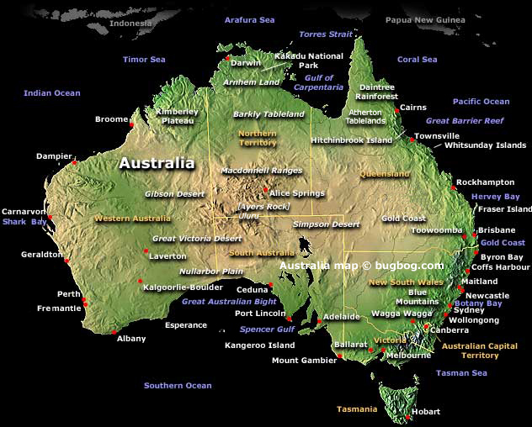

**What do you know about Australia and would you like to live there? What are the characteristics of Australia?**

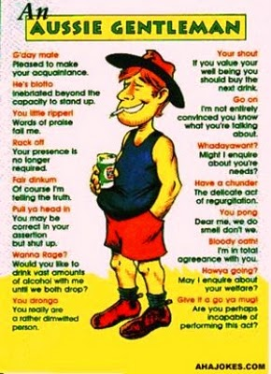

**Characteristics of Australia and how this can relate to sport**

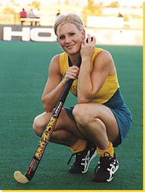

____________________________________________________________________________________________________________________________________________________________________________________________________________________________________________________________________________________________________________________

____________________________________________________________________________________________________________________________________________________________________________________________________________________________________________________________________________________________________________________

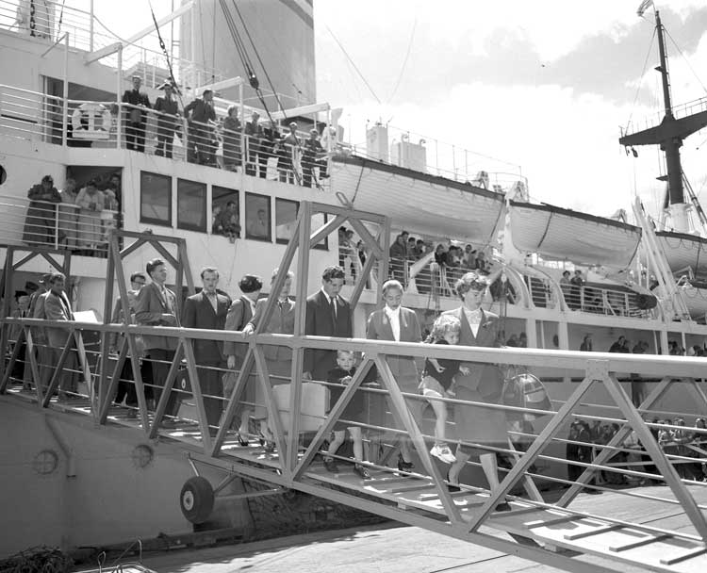

__________________________________________________________________________________________________________________________________________________________

_________________________________________________________________________________________________________________________________________________________________________________________________________________________________________________________________________________________________________________________________________________________________________________________________

____________________________________________________________________________________________________________________________________________________________________________________________________________________________________________________________________________________________________________________

__________________________________________________________________________________________________________________________________________________________

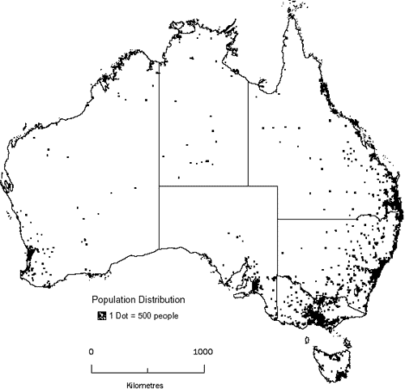



1. What is a ten pound pom?

____________________________________________________________________________________________________________________________________________________________________________________________________________________________________________________________________________________________________________________

**How was Australia populated and what were the effects of this colonisation?**

Read page 247 to answer this question and give you a better understanding of the impact on aboriginals.

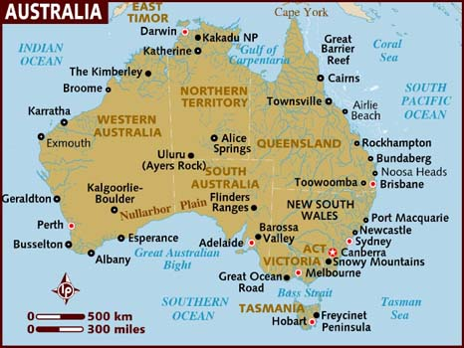

Australian Policy 1970___________________________________________________________________________________________________________________________________________________________________________________________________________________________________________________________________________________________________________________________

Aboriginal

________________________________________________________________________________________________________________________________________________________________________________________________________________________________________________________________________________________________________________________________________________________________________________________________________________________________________________________________________________________________

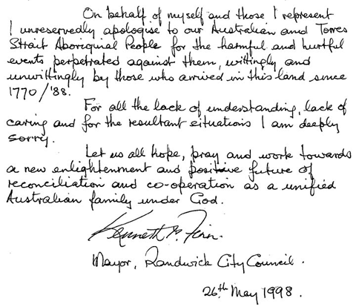

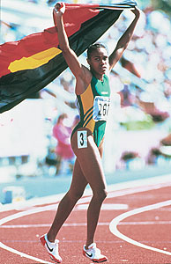

Cathy Freeman and the new policy of reconciliation.

________________________________________________________________________________________________________________________________________________________________________________________________________________________________________________________________________________________________________________________________________________________________________________________________________________

|  |
| --- |
| **Exam tip: Note how sport is being used to highlight the point. Always refer back to the influence of sport on society, or society on sport.** |

**The nature of sport in Australia**



Why do Aussies love beating us so much?

________________________________________________________________________________________________________________________________________________________________

Why is sport so popular in Australia?

___________________________________________________________________________________________________________________________________________________

_______________________________________________________________________________________________________________

_____________________________________

_________________________________________________________________________________________________________________________________________________________________________________________

____________________________________________________________________________________________________________________________________________________

____________________________________________________________________________________________________________________________________________________

_________________________________________________________________________________________________________________________________________________________________________________________

_________________________________________________________________________________________________________________________________________________________________________________________

__________________________________________________________________________________________________________________________________________________

**Why is it that Australia has become relatively successful at sport in the International arena and what provoked the change?**

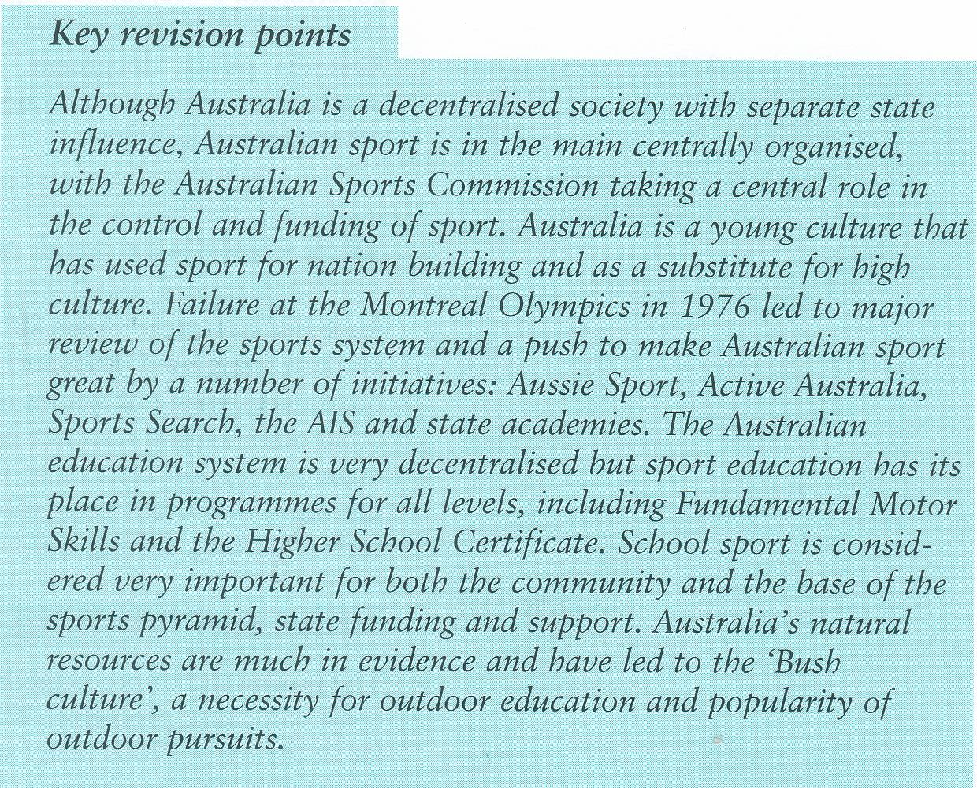

**What is the ASC?**

**What is the AIS – set up, aim, run by and functions?**

**Structure of Elite Sport**





|  |
| --- |
| **Exam tip: when answering a question think of a comparative to enhance your point. Can you think of where this model of elite development is being mirrored?** |

Make notes on the changes that took place to the approach of elite sports.

What impact did this have on mass participation?

Identify possible comparatives that could be made.

________________________________________________________________________________________________________________________________________________________________________________________________________________________________________________________________________________________________________________________________________________________________________________________________________________________________________________________________________________________________________________________________________________________________________________________________________________________________________________________________

________________________________________________________________________________________________________________________________________________________________________________________________________________________________________________________________________________________________________________________________

_______________________________________________________________________________________________________________________________________________________________________________________________________________________________________________

**Australia identifies talent?**

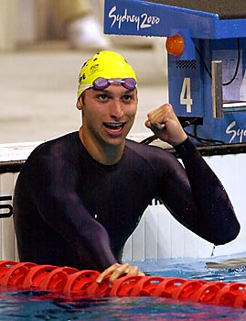

_________________________________________________________________________________________________________________________________________________________________________________________________________________________________________________________________________________________________________________________________________________________________________________________________________________________________________________________________________________________________________________________________________________________________________________________________________________________________________________

**Effect on mass participation**

_______________________________________________________________________________________________________________________________________________________________________________________________________________________________________________________________________________________________________________________________________________________________________________________________________________

________________________________________________________



________________________________________________________

________________________________________________________

________________________________________________________

________________________________________________________

Notes:

**What are the characteristics of Aussie Rules (ARF)?**

Look at some you tube clips of Aussie rules to understand the characteristics.

________________________________________________________________________________________________________________________________________________________________________________________________________________________________________________________________________________________________________________________________________________________________________________________________________________________________________________________________________________________________________________________________________________________________________________________________________________________________________________________________

________________________________________________________________________________________________________________________________________________________________________________________________________________________________________________________________________________________________________________________________

________________________________________________________________________________________________________________________________________________________________________________________________________________________________________________________________________________________________________________________________________________________________________________________________________________________________________________________________________________________________________________________________________________________________________________________________________________________________________________________________

________________________________________________________________________________________________________________________________________________________________________________________________________________________________________________________________________________________________________________________________

**What is AUSSIE RULES (or ‘FUDY’) and how did it evolve?**

“Read this fool” 

|  |
| --- |
| **Exam tip: How your ten mark answer is written can have an effect on your overall score. This question is a good opportunity to practice putting across differing points using link words.** |

Look at page 249/250 for some ideas regarding the origin and development of the game.

________________________________________________________________________________________________________________________________________________________________________________________________________________________________________________________________________________________________________________________________________________________________________________________________________________________________________________________________________________________________

________________________________________________________________________________________________________________________________________________________________________________________________________________________________________________________________________________________________________________________________________________________________________________________________________________________________________________________________________________________________

________________________________________________________________________________________________________________________________________________________________________________________________________________________________________________________________________________________________________________________________________________________________________________________________________________________________________________________________________________________________

________________________________________________________________________________________________________________________________________________________________________________________________________________________________________________________________________________________________________________________________________________________________________________________________________________________________________________________________________________________________

________________________________________________________________________________________________________________________________________________________________________________________________________________________________________________________________________________________________________________________________________________________________________________________________________________

**Homework**

**Q Explain how the development of Aussie rules and the commercial impact mirror the USA and American football.** Here we should be making similar points as well as different ones. So we must use linking words. Have a look at the ones in the box and see where you can use them.

|  |
| --- |
| However, on the other hand, contrary to this. These are used to make a different point.  If you wish to add to your point then you can use. Furthermore, moreover. There are more, so use these as you see fit. |

________________________________________________________________________________________________________________________________________________________________________________________________________________________________________________________________________________________________________________________________________________________________________________________________________________________________________________________________________________________________

________________________________________________________________________________________________________________________________________________________________________________________________________________________________________________________________________________________________________________________________________________________________________________________________________________________________________________________________________________________________

________________________________________________________________________________________________________________________________________________________________________________________________________________________________________________________________________________________________________________________________________________________________________________________________________________________________________________________________________________________________

________________________________________________________________________________________________________________________________________________________________________________________________________________________________________________________________________________________________________________________________________________________________________________________________________________________________________________________________________________________________

________________________________________________________________________________________________________________________________________________________________________________________________________________________________________________________________________________________________________________________________________________________________________________________________________________

________________________________________________________________________________________________________________________________________________________________________________________________________________________________________________________________________________________________________________________________________________________________________________________________________________________________________________________________________________________________

________________________________________________________________________________________________________________________________________________________________________________________________________________________________________________________________________________________________________________________________________________________________________________________________________________________________________________________________________________________________

(10)

Review: How many points have you made?

Does each point flow from one to another?

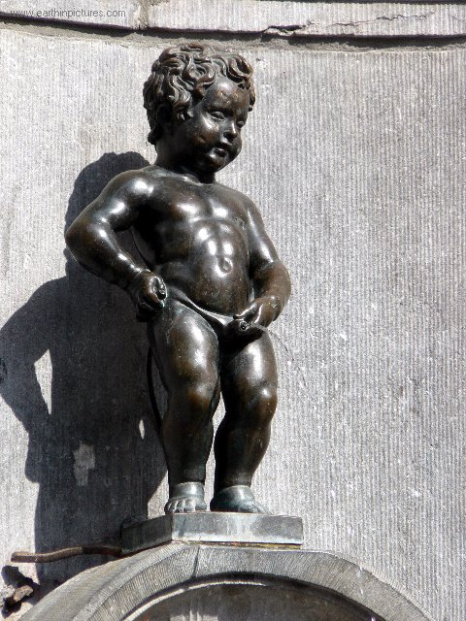

|  |  |
| --- | --- |
| **P** | Make your **POINT (BLACK)** |
| **E** | **EXPLAIN** your point **(RED)** |
| **E** | **EGs** – develop the point with Egs **(GREEN)** |
| **D** | Develop your explanation **(BLUE)** |
| **Write in FULL sentences.**  Use accurate technical language.  IF asked – give +/- (2 sides to a discussion). | |

|  |  |
| --- | --- |
| **P** | Make your **POINT (BLACK)** |
| **E** | **EXPLAIN** your point **(RED)** |
| **E** | **EGs** – develop the point with Egs **(GREEN)** |
| **D** | Develop your explanation **(BLUE)** |
| **Write in FULL sentences.**  Use accurate technical language. | |

**Use page 250 identify what you think are the three most important factors that are aiding the development of Aussie rules Fuddy and explain why.**

|  |
| --- |
| Again a great opportunity to enhance your writing skills. Here we are not looking for a comparative but a justification. |

Command word/s

Subject =

Subject qualifier=

________________________________________________________________________________________________________________________________________________________________________________________________________________________________________________________________________________________________________________________________________________________________________________________________________________________________________________________________________________________________

________________________________________________________________________________________________________________________________________________________________________________________________________________________________________________________________________________________________________________________________________________________________________________________________________________

________________________________________________________________________________________________________________________________________________________________________________________________________________________________________________________________________________________________________________________________________________________________________________________________________________________________________________________________________________________________

________________________________________________________________________________________________________________________________________________________________________________________________________________________________________________________________________________________________________________________________________________________________________________________________________________

________________________________________________________________________________________________________________________________________________________________________________________________________________________________________________________________________________________________________________________________________________________________________________________________________________

**How is commercialism evident in Aussie Rules?**

* Most highly spectator sport - commercialism
* Multi-millions Aus$ business, with National comp and network of comps
* Good media promotion / commercial breaks product (like USA)
* Business enterprise and financial backing –high status sports stars -advertising, sponsorships, endorsements
* Broadcast media rose rapidly to Aus% 5.5million after the commission took over and put the rights to tender. Revenues soared to Aus$100million+ with new 5yr contracts with 7, 10 networks and Foxtel.
* AFL that runs the AR competition has 1 broadcasting contract that earns it Aus$20million pa. Compared to 120 other sports bodies (out of 130), who get nothing through TV broadcasts.

**What are the effects of commercialism in Aussie Rules?**

1. Media coverage boosts game at **grass roots – future players** and spectators
2. **Facilities** upgraded
3. More **exciting competitions** can be staged
4. **Compare structure of ARF and AF – set pieces, restarts, tackles, violence, punishment and nature of the sport – scoring and pitch. What cultural reasons.**
5. **Commercialism = threatening to destroy original nature of sport**. Becoming more a spectacle engineered by public relations and mass consumption experts to market the game for the consumer-oriented society. The more local nature of the game changing to city or state conglomerations.
6. **Higher media rights payments and sponsor revenue** to boost AFL revenue from just under Aus$90 million in 1997 to about Aus$270 million currently.
7. About Aus$120million of that flows through 16 clubs and through them to **player payments – risen** from $22,000 to $220,000.
8. Some also allocated $5million **special payments to financially weaker clubs** for survival (Melbourne’s Western Bulldogs and the Kangeroos).
9. Also **revenue supports AFL development programmes** – the financially stronger AFL is both directly and indirectly underpinning the re-development of club facilities and games venues.

**REVISION Questions**

What do you know about Australian topography?

Who were the native people of Oz? What were they like and what activities did they do?

1800s colonisation by the British – what impact did it have socially and recreationally on the natives?

What does the bush culture have to do with the high status in sport?

What was the role of sport in creating a ‘new identity’?

What is the Government structure?

What was the sporting infrastructure like pre and post 1980s?

What happened after the Oz 1976 Montreal Olympics performance?

What is ‘Sportsearch’?

How did Australian Rules Football evolve?

What are the characteristics of the game and how do these link to the culture?

Currently, what role does commercialism have in ARF?

What is the status of sport in Oz and why?

What does STRETCHY B stand for?

Add words to this list if you think they will be vital to you. These are your studies.

|  |  |
| --- | --- |
| Key words : | |
| Australia  Aborigines  Colonisation  Captain Cook  British convicts  British Middle class  ‘Mother Country’  New identity  ‘All Golds’  Aussie Rules  Commercialism  Status | Topography  Sport infrastructure  Australian Institute of Sport (AIS)  Australian Sports Commission (ASC)  Climate |

Notes