CARDIOVASCULAR SYSTEM 1
HEART STRUCTURE AND FUNCTION

Content
At the end of this topic you should be able to: | Notes | Learnt
Describe the cardiac cycle (diastole and systole)

Describe the conduction system of the heart

Describe the relationship between stroke volume, heart rate, cardiac output and resting values for each

Explain the changes that take place to stroke volume, heart rate and cardiac output during different intensities of physical activity

Explain the regulation of heart rate during physical activity (neural, hormonal and intrinsic)

The key is relating all of the elements above to exercise so that you understand it. Some elements are learning of words that are new, but try and think of different ways to remember them.

At the beginning of the year we tried different methods of remembering, mind maps, visualisation, and flash cards. Use what works for you, however, if you want a different grade from before then you must try something different.

Old Chinese proverb says,
“If you do what you’ve always done you will get what you’ve always got”.

Describe the structure of the heart

Define Systemic circulation:

Define Pulmonary circulation:

The heart consists of two dual pumps separated by the septum.
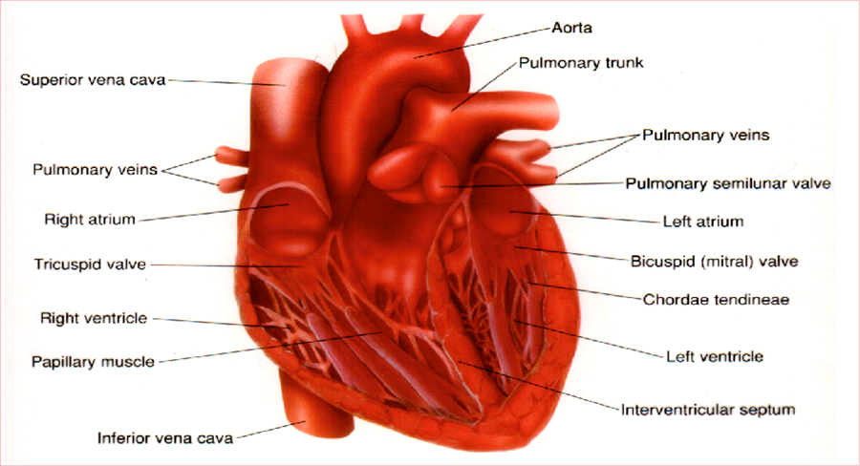

Describe the path of blood through the heart
Left side of the heart

Right side of the heart

Describe what you understand from the term myogenic.___________________________________________________________________________________________________________________________________________________________________________________________________________________________________________________________________________________________________________________________________________________________________________________________________________________________________________

Heart anatomy and Cardiac cycle
- Place the cones and outline the basic chambers of the heart. Ensure that you use red for oxygenated and blue for de-oxygenated transport of blood. Label each of the sections of the heart. Once this is complete each take a photo from on the balcony.
- Using the diagram write the names of the valves and place them onto the floor diagram. Again once you have checked this with me take a photo of this from the balcony.
- Walk through the diagram explaining what happens at each stage. You might need the summary sheet to help you.
- Q What is the main difference between the diastole and the systole phases of the cardiac cycle?
______________________________________________________________________________________________________________________________________________________________

- Conduction system
Using the diagram and the description on the conduction of the cardiac impulse, place the white cones at the significant points of every stage. Take a photo of each of these important stages.

- By the end of this exercise you should have a photo of each of the important stages of the cardiac cycle and the conduction of the cardiac impulse.

Notes: Draw a flow diagram.
Notes on cardiac cycle.

Diastole 0.5 secs
Using your knowledge take it in turns to agree on what should be written into each of the section.
Conduction:

Cause/ event

Effect

Systole 0.3 secs

Atrial systole
Conduction:

Cause/ event

effect

Conduction:

Ventricular systole
Cause/ event

effect

Heart conduction
- Draw a basic heart and label its four chambers.
- Draw and number (in order) the structures involved in conducting the cardiac impulse through the heart. Use arrows to represent routes.
- Complete a bulleted flow table with your diagram relating the information in the diagram.

Cardiac cycle
The cardiac cycle represents the mechanical event of one heartbeat. At rest one heart beat takes about 0.8 secs and is repeated about 72 times a minute.
The cardiac cycle consists of two phases, relaxation and contraction.
- Diastole=……………………………………………………………………………………………………………………………………………………………………………………………………………………………………………………………………………………………………….
- Systole………………………………………………………………………………………………………………………………………………………………………………………………………………………………………………………………………………………………………….
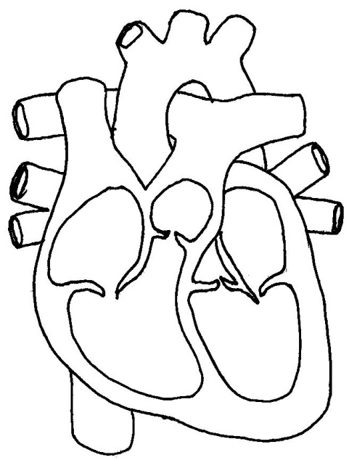
Diastole Phase

Atrial Systole Phase Ventricular Systole Phase
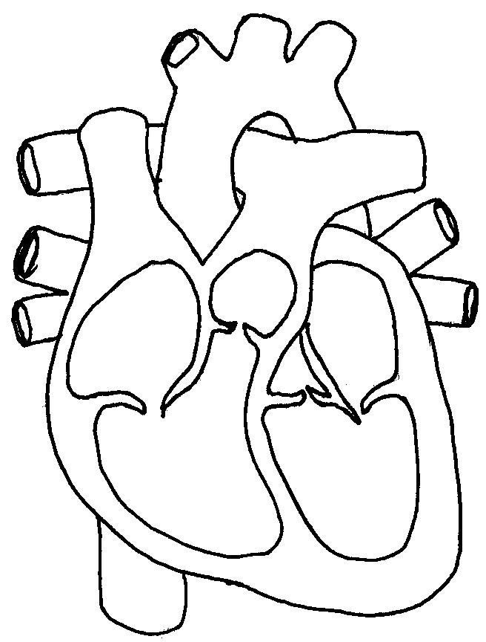

 |  | Phases | Explanation
1 |  | Atrial diastole  0.5sec
2 | Ventricular diastole  (PASSIVE FILLING)
3 |  | Atrial systole  (0.3sec)
4 |  | Ventricular systole  (0.3sec)

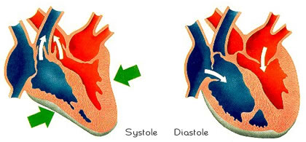

The cardiac cycle explains how the heart pumps blood to the working muscles.
- Describe how the conduction system of the heart controls the cardiac cycle in the diastole and systole stages.
.................................................................................................................................
.................................................................................................................................
.................................................................................................................................
.................................................................................................................................
.................................................................................................................................
.................................................................................................................................
.................................................................................................................................
..................................................................................................................................
[4]
- The figure below shows a marathon runner during a five mile training run.
(i) Describe how the conduction system of the heart controls the cardiac cycle to ensure enough blood is ejected from the heart during the training run.
....................................................................................................................................................
....................................................................................................................................................
...................................................................................................................................
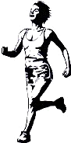
.................................................................................................................................
…………………………………………………………………………………………………………………………..
………………………………………………………………………………………………………………………….
………………………………………………………………………………………………………………………….
…………………………………………………………………………………………………………………………..
…………………………………………………………………………………………………………………………. [4]
Exam tip: You may be required to sketch a diagram to summarise the structural route of the cardiac impulse.

------------------------------------------------------------------------------------
------------------------------------------------------------------------------------
-------------------------------------------------------------------------------------
What is Bradycardia?
What is hypertrophy?

Stroke volume and Cardiac output
The basics.
Heart rate ___________________________________________________________________________________________________________________________________________________________________________________________________________________________________________________________________________________________________________________________________________________________________________________________________________________________________________________________________________________________
Stroke volume is: ____________________________________________________________________________________________________________________________________________________________________________________________________________________________________________________________________________________________________________________________________________________________________________________________
Cardiac output
____________________________________________________________________________________________________________________________________________________________________________________________________________________________________________________________________________________________________________________________________________________________________________________________
Bradycardia
______________________________________________________________________________________________________________________________________________________________________________________________
Hypertrophy
______________________________________________________________________________________________________________________________________________________________________________________________
EDV is: ______________________________________________________________________________________________________________________________________________________________________________________________
ESV is:
______________________________________________________________________________________________________________________________________________________________________________________________

SV HR and how to calculate the Q or cardiac output

Definition | Number of ventricular contractions in one minute | Volume of blood ejected from the heart in one ventricular contraction | Volume of blood ejected from the heart in one minute.
Untrained | 70bpm | 70/72ml | 5000ml (5 ltr)
Trained | 50 bpm | 100ml | 5000ml
Your stats

Record resting HR, assume the volume of blood per beat and note your potential Q or cardiac output.

Q9 Suggests reasons as to how and why HR decreases and SV increases in a trained athlete compared to an untrained athlete.
………………………………………………………………………………………………………………………………………………………………………………………………………………………………………………………………………………………………………………………………………………………………………………………………………………………………………………………………………………………………………………………………………………………………………………………………………………………………………………………………………………………………………………………………………………………………………………………………………………………………………………………………………………………………………………………………………………………………………………………………………………………………………………………………………………………………………………………………………………………………………………………………………………………………………………………………………………………………………………………………………………………………………………………………………………………………………………………………………………………………………………………………………………………………
(4)
Diagram to explain EDV ESV and Cardiac output

Cardiac response to exercise
Using a practical example describe what you understand by the term sub-maximal.
………………………………………………………………………………………………………………………………………………………………………………………………………………………………………………………………………………………………………………………………………………………………………………………………………………………………………………………………………………………………………………………………………………………………………………………………………………………………………………………………………………………………
Using a practical example describe what is meant by maximal exercise
………………………………………………………………………………………………………………………………………………………………………………………………………………………………………………………………………………………………………………………………………………………………………………………………………………………………………………………………………………………………………………………………………………………………………………………………………………………………………………………………………………………………

Heart rate response to exercise

1.2.9.a 1.2.9.b 1.2.9.c
HR response to sub max exercise HR response to maximal exercise HR response to fluctuating intensity

………………………………………………………………………………………………………………………………………………………………………………………………………………………………………………………………………………………………………………………………………………………………………………………………………………………………………………………………………………………………………………………………………………………………………………………………………………………………………………………………………………………………………………………………………………………………………………………………………………………………………………………………………………………………………………………………………………………………………………………………………………………………………………………………………………………………………………………………………………………………………………………………………………………………………………………………………………………………………………………………………………………………………………………………………………………………………………………………………………………………………………………………………………………………………………………………………………………………………………………………………………………………………………………………………………………………………………………………………………………………………………………………………………………………………………………………………………………………………………………………………………………………………………………………………………………………

Stroke volume response to exercise

When an athlete starts running, their SV increase linearly as the running speed/intensity increases, but only up to 40/60% of their maximal running speed. This suggest that SV maximal values are reached during sub-maximal exercise.
Explain why the SV then reaches the plateau at around 120-140ml per beat during exercise. What other factor will rise if the SV is no longer increasing?
Stroke volume

Treadmill speed
………………………………………………………………………………………………………………………………………………………………………………………………………………………………………………………………………………………………………………………………………………………………………………………………………………………………………………………………………………………………………………………………………………………………………………………………………………………………………………………………………………………………………………………………………………………………………………………………………………………………………………………………………………………………………………………………………………………………………………………………………………………………………………………………………………………………………………………………………………………………………………………………………………………………………………………………………………………………………………………………………………………………………………………………………………………………………………………………………………………………………………………………………………………………
To understand why the Stroke volume increases we need to identify the factors that determine it.
Heart capacity to fill
……………………………………………………………………………………………………………………………………………………………………………………………………………………………………………………………………………………………………………………………………………………………………………………………………………………………………………………………………………………………………………………………………………………………………………………………………………………………………………………………………………………………………………………………………………………………………………………………………………………………………………………………………………………………………………………………………………………………………………………………………………………………………………………………………………………………………………………………………………………………………………………………………………………………………………………………………………………………………
Frank Starling (Starling Law)
Hearts capacity to empty.
……………………………………………………………………………………………………………………………………………………………………………………………………………………………………………………………………………………………………………………………………………………………………………………………………………………………………………………………………………………………………………………………………………………………………………………………………………………………………………………………………………………………………………………………………………………………………………………………………………………………………………………………………………………………………………………………………………………………………………………………………………………………………………………………………………………………………………………………………………………………………………………………………………………………………………………………………………………………………

Cardiac response to exercise

Draw, label and explain the response to exercise.
Fig: 1.2.11

……………………………………………………………………………………………………………………………………………………………………………………………………………………………………………………………………………………………………………………………………………………………………………………………………………………………………………………………………………………………………………………………………………………………………………………………………………………………………………………………………………………………………………………………………………………………………………………………………………………………………………………………………………………………………………………………………………………………………………………………………………………………………………………………………………………………………………………………………………………………………………………………………………………………………………………………………………………………………

Untrained Rest Submax max
HR | 70bpm | 100-130bpm | 220-age
SV | 70 ml | 100-120 bpm | 110-120 ml
Q | 5 ltr/min | 10-15 ltr/min | 20-30 ltr/min
Take part in the class practical and insert the values for heart rate and then calculate the SV and Q.
For the sub-max SV insert an extra 60% of the resting SV value.

Q10 During aerobic exercise the performer requires the heart to pump more blood to the working muscles.
Define stroke volume and give a value for maximal stroke volume during exercise.
Explain how a performer is able to increase stroke volume during exercise. ……………………………………………………………………………………………………………………………………………………………………………………………………………………………………………………………………………………………………………………………………………………………………………………………………………………………………………………………………………………………………………………………………………………………………………………………………………………………………………………………………………………………………………………………………………………………………………………………………………………………………………………………………………………………………………………………………………………………………………………………………………………………………………………………………………………………………………………………………………………………………………………………………………………………………………………………………………………………………………………………………………………………………………………………………………………………………………………………………………………………………………………………………………………………………………………………………………………………………………………………………………………………………………………………………………………………………………………………………………………………………………………………………………………………………………………………………………………………………………………………………………………………………………………………………………………………………………………………………………………………………………………………………………………………………………………………………………………………………………………………………………..
[5]

11. Cardiac output is a determining factor during endurance activities.
Describe how cardiac output is increased during endurance activities.
[4]
……………………………………………………………………………………………………………………………………………………………………………………………………………………………………………………………………………………………………………………………………………………………………………………………………………………………………………………………………………………………………………………………………………………………………………………………………………………………………………………………………………………………………………………………………………………………………………………………………………………………………………………………………………………………………………………………………………………………………………………………………………………………………………………………………………………………………………………………………………………………………………………………………………………………………………………………………………………………………………………………………………………………………………………………………………………………………………………………………………………………………………………………………………………………………………………………………………………………………………………………………………………………………………………………………………………………………………………………………………………………………………………………………………………………………………………………………………………………………………………………………………………………………………………………………………………
12. Describe the changes that take place to stroke volume from rest to maximal exercise levels. (3 marks)
………………………………………………………………………………………………………………………………………………………………………………………………………………………………………………………………………………………………………………………………………………………………………………………………………………………………………………………………………………………………………………………………………………………………………………………………………………………………………………………………………………………………………………………………………………………………………………

Heart rate

Maximal
Sub-maximal

Prior Work recovery

Analysis of graph.
Explain the variations that take place on the amazing graph in each of the sections, prior, during and after work. Make clear reference to the stroke volume, heart rate and other relevant elements of the CV system.
_______________________________________________________________________________________________________________________________________________________________________________________________________________________________________________________________________________________________________________________________________________________________________________________________________________________________
_______________________________________________________________________________________________________________________________________________________________________________________________________________________________________________________________________________________________________________________________________________________________________________________________________________________________
_______________________________________________________________________________________________________________________________________________________________________________________________________________________________________________________________________________________________________________________________________________________________________________________________________________________________
_______________________________________________________________________________________________________________________________________________________________________________________________________________________________________________________________________________________________________________________________________________________________________________________________________________________________
_________________________________________________________________________________________________________________________________________________________________________________________________________________________________________________________

Application of Knowledge of Stroke volume, heart rate, cardiac output.
Trained athlete
Fast paced athlete | 190 | 130 | 25
Cycling | 185 | 120 | 22
Swimmer | 170 | 135 | 23

Explain why the swimmer has the greatest stroke volume. (think about body position). As well as other factors.
……………………………………………………………………………………………………………………………………………………………………………………………………………………………………………………………………………………………………………………………………………………………………………………………………………………………………………………………………………………………………………………………………………………………………………………………………………………………………………………………………………………………………………………………………………………………………………………………………………………………………………………………………………………………………………………………………………………………………………………………………………………………………………………………………………………………………………………
Why has the cyclist the lowest SV of the three trained athletes?
…………………………………………………………………………………………………………………………………………………………………………………………………………………………………………………………………………………………………………………………………………………………………………………………………………………………………………………………………………………………………………………………………………………………………………………………………………………………………………………………………………………………………………………………………………………………………………………………………………………………………………………………………………………………………………………………………………………………………………………………………………………………………………

- During aerobic exercise the performer requires the heart to pump more blood to the working muscles. Define stroke volume and give a value for maximal stroke volume during exercise. Explain how a performer is able to increase stroke volume during exercise. (5 marks)

……………………………………………………………………………………………………………………………………………………………………………………………………………………………………………………………………………………………………………………………………………………………………………………………………………………………………………………………………………………………………………………………………………………………………………………………………………………………………………………………………………………………………………………………………………………………………………………………………………………………………………………………………………………………………………………………………………………………………………………………………………………………………………………………………………………………………………………………………………………………………………………………………………………………………………………………………………………………………………………………………………………………………………………………………………………………………………………………………………………………………………………………………………………………………………………………………………………………………………………………………………………………………………………………………………………………………………………………………………………………………………………………………………………………………………………………………………………………………………………………………………………………………………………………………………………

Exam Answers
7 5 marks, 1 mark per point
Correct phase of conduction system must link to correct phase of cardiac cycle / Conduction system must be in correct order
1 (atrial diastole)
Atria fill with blood during atrial diastole or relaxation phase / repolarisation occur
Do not accept diastole on own, resting stage
2 (ventricular diastole)
(pressure builds in the atria) blood travels (passively) into the ventricles during ventricular diastole or relaxation phase of ventricles
Do not accept diastole on own
3 (SA Node)
CS1
Sinoatrial node or S A node or SAN initiates or sends an impulse
Do not accept pace maker for SA node, SA nerve, heart is myogenic = Vg
4 (atrial systole)
....impulse spreads across atria causing atrial systole or contraction of both atria / atrial depolarisation
Do not accept systole on own (remaining blood)
This causes the remaining blood in the atria to be pushed (actively) into the ventricles
6 (AV node)
CS2
....impulse reaches AV or atrio ventricular node or AVN
Do not accept AV nerve
7 (B of H P fibres)
CS3
.... impulse distributed or continues down the bundle of His / impulse distributed throughout or to the purkinje or purkyne fibres
8 (ventricular systole)
....this causes ventricular systole or depolarisation or contraction of both ventricles (from the bottom upwards)
Do not accept systole on own
Additional Guidance
CS1: links with Contraction of the atria (points 4 & 5)
CS2 and CS3: link Contraction of the ventricles (point 8)
CS1, CS2, CS3 must be in order (5)

Q8. Impulse initiates from SA (sino atrial) node
- This causes atria to contract/atrial systole/blood ejected from the right and left atria/atrial polarisation.
- Impulse received by AV (atrioventricular) node
- Impulse conducted down Bundle of His
- Up the Purkinje fibres
- This causes ventricles to contract/ventricular systole/blood ejected out of right and left ventricles/ventricular depolarisation
The atria/ventricles relax to allow the heart to refill with blood.

Q9 Q Suggests reasons as to how and why HR decreases and SV increases in a trained athlete compared to an untrained athlete.
A Greater size and force of contraction will increase the Stroke volume as well as the trained venous return allowing more blood to be in the heart prior to the ventricular contraction.
Hypertrophy of cardiac muscles increasing the force of contraction, therefore, SV and cardiac output, in turn this will reduce the amount of beats required to transport the same amount of blood as the untrained person.
Q10 During aerobic exercise the performer requires the heart to pump more blood to the working muscles.
Define stroke volume and give a value for maximal stroke volume during exercise.
Explain how a performer is able to increase stroke volume during exercise.
5 marks in total
2 marks max:
1 mark for definition:
The amount of blood ejected by the left ventricle/each ventricle in one beat.
1. mark for value:
2. 100-220 ml/100-220cm3
sub max 3
1. Increase in venous return
2. Due to skeletal muscle pump/respiratory pump/valves
3. Stretches cardiac muscle/heart wall/increases end diastolic volume
4. Leads to an increased force of contraction/increased myocardial contractility
5. Starling’s Law/Stroke volume is dependent upon venous return
6. Chemoreceptors detect change in pH
7. Increased sympathetic control
8. Impulse travels down cardiac accelerator nerve
9. The release of adrenaline
- Cardiac output is a determining factor during endurance activities. Describe how cardiac output is increased during endurance activities. (4 marks)

4 marks max
1. Increase in heart rate
2. Increase in stroke volume
3. Adrenaline/nor adrenaline/epinephrine released
4. Increase in venous return/more blood returning to the heart/increase muscle pump/ increase respiratory pump/venomotor control
5. Stretches wall of right atrium which increases firing of SA node
6. Greater stretching of cardiac walls increase force of contraction/Starling’s Law
7. Information sent from proprioceptors/baroreceptors/ chemoreceptors/thermoreceptors to cardiac control centre (CCC)
8. Increase in sympathetic control/impulse sent down cardiac accelerator nerve
9. Increase in temperature which speeds up nerve impulse

12 Describe the changes that take place to stroke volume from rest to maximal exercise levels. (3 marks)

- During aerobic exercise the performer requires the heart to pump more blood to the working muscles. Define stroke volume and give a value for maximal stroke volume during exercise. Explain how a performer is able to increase stroke volume during exercise. (5 marks)

5 marks in total
2 marks max:
1 mark for definition:
The amount of blood ejected by the left ventricle/each ventricle in one beat.
1. mark for value:
2. 100-220 ml/100-220cm3
sub max 3
1. Increase in venous return
2. Due to skeletal muscle pump/respiratory pump/valves
3. Stretches cardiac muscle/heart wall/increases end diastolic volume
4. Leads to an increased force of contraction/increased myocardial contractility
5. Starling’s Law/Stroke volume is dependent upon venous return
6. Chemoreceptors detect change in pH
7. Increased sympathetic control
8. Impulse travels down cardiac accelerator nerve
9. The release of adrenaline

