BHASVIC

Mass Participation Sporting Excellence in the UK

Contemporary Sporting Issues

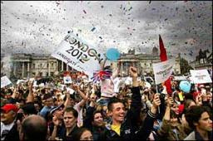

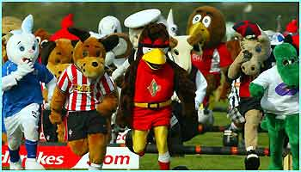

NAME :

Area  of study | Contents &  command words | Learnt / notes
Funding of physical activity | - demonstrate knowledge and understanding of public funding; private funding; voluntary funding (including the National Lottery).
Bodies influencing and promoting participation in physical activity as part of a balanced, active and healthy lifestyle; the promotion of health, fitness and wellbeing and/or sporting excellence: | - demonstrate knowledge and understanding of UK Sport
 | - demonstrate knowledge and understanding of the United Kingdom Sports Institute (UKSI) and devolved National Institutes of Sport;
 | - demonstrate knowledge and understanding of home country organisations (Sport England, Sports Council Northern Ireland, sportscotland, Sports Council for Wales);
 | - demonstrate knowledge and understanding of current government and national governing body initiatives;
Excellence and participation in the UK | - explain sports development (the sports development pyramid; continuum from mass participation to sporting excellence);
 | - explain opportunity, provision and esteem (with reference to both participation in physical activity and the achievement of sporting excellence);
 | - evaluate critically social and cultural factors that affect participation in physical activity and the achievement of sporting excellence by young people, the elderly, people with disabilities, women and ethnic minority groups;

Key Words :

Amateur  Professional  Working Class Professional  Gentleman Amateur  Sport England  Sports Council for Wales  Sportscotland  Sport Northern Ireland  Home Country Organisations  UK Sport  UKSI  EIS  Professional Approach to Sport  Volunteers  Government role  DCMS  NGBs  YST  Private Sector Funding  Public Sector Funding  Voluntary Sector Funding  Kite-marking | Target groups  Women  Young people  Ethnic minority group  Elderly  Disabled  Opportunity (O)  Provision (P)  Esteem (E)  Myths  Stereotype  Prejudice  BOA  IOC  TASS  LTAD  World Class performance Programme (x4)  APAs  Mission 2012  Talent Identification  PESSCLS  UK Ambassadors

PEE / Command words / Marking Process

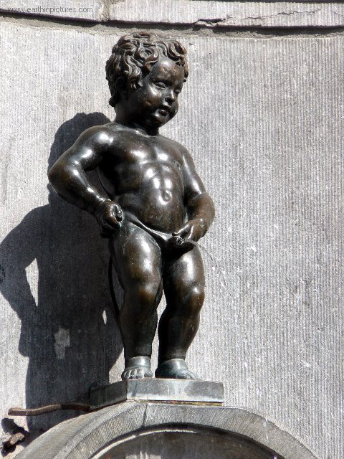
Have you ‘PEED’ ON IT!!
P | Make your POINT
E | EXPLAIN your point
E | EGs – develop the point with Egs
D | Develop your explanation
Write in FULL sentences.
Use accurate technical language.
IF asked – give +/- (2 sides to a discussion).

Mass participation & Sporting Excellence Overview

What is the ‘Participation Continuum’?

MP |  | SE
 | Who does it?
 | What are the characteristics?
 | Benefits?
 | Disadvantages

Summary of funding for Physical activity

Sport does not come for free and gold medals cost money. There are three types of funding that you need to be aware of which are below. Each one will have some impact on the either mass participation or elite sports.

Funding from donations or charities, some private clubs.
Funding from business, companies and investors, often by the way of sponsorship
Funding from Government and local authorities, also National lottery
Funding from Government and local authorities, also National lottery

Q1 Can you explain the attitude of the government and how it has changed towards sports over recent years?

____________________________________________________________________________________________________________________________________________________________________________________________________________________________________________________________________________________________________________________________________________________________________________________________________________________________________________________________________________________________________________________________________________________________________________________________________________________________________________

See page 256/241
Funding For Mass participation
Main Sources of Funding

What are the 3 main sources of ‘funding’ for Mass participation (p258)

Funding source | How income (£) is gained | What funding is used for
Scrap Sports Development and coordinators!

London 2012 Olympics hit with £27m of cuts

Rocketing childhood obesity levels and type two diabetes are already blighting the nation, and there are fears the loss of facilities and healthy living programmes will render the situation beyond repair.

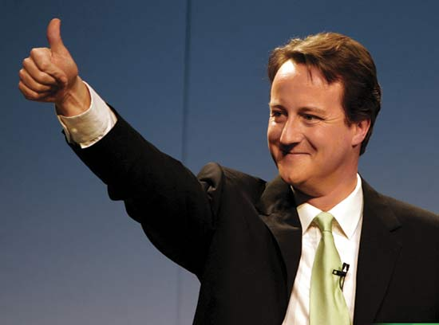
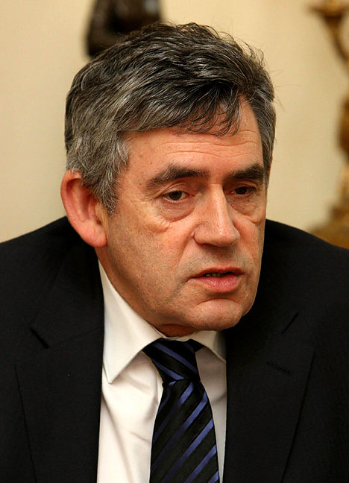

Gordon Brown said, “ We are … funding … £34 million for a new national sports foundation … (which) will bring together public and private finance for new local sports facilities and grassroots participation” (Budget speech as Chancellor of the Exchequer, 2006).

Participation Pyramid

What is the ‘Participation Pyramid’?

Name of each level | Characteristics of each Level  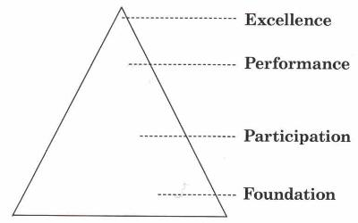

Where would you place YOURSELF in the PERFORMANCE PYRAMID?

Department for Culture Media and Sport

What is the job of the: DCMS
______________________________________________________________________________________________________________________________________________________________________________________________________________________________________________________________________________________________________________________________________________________________________________________________________________________________________________________________________________________________________

Who does the DCMS give the Governments money to?

Lottery & Mass Participation | Lottery & Sporting Excellence

National Lottery Sporting Excellence
See page 260
Sporting excellence

How much money does the Lottery give to sports funds every year? Who are they distributed to?
___________________________________________________________________________________________________________________________________________________________________________________________________________________________________________________

What sporting excellence programme’s are supported by the lottery? Explain what they do and how they obtain their funding.
__________________________________________________________________________________________________________________________________________________________________________________________________________________________________________________________________________________________________________________________________________________________________________________________________________________________________________________________________________________________________________________________________________________________________________________________________________________________________________________________________________________________________________________________________________________________________________________________________________________________________________
____________________________________________________________________________________________________________________________________________________________________________________________________________________________________________________________________________________________________________________________________
Can you think of examples of world class events that have been brought to the country over recent years?

- _________________________________________
- _________________________________________
__________________________________________

Think of as many benefits bringing a large sporting event to this country would have on sport, social, environment, or financial. Be specific..

Another reason it’s a good idea is…….

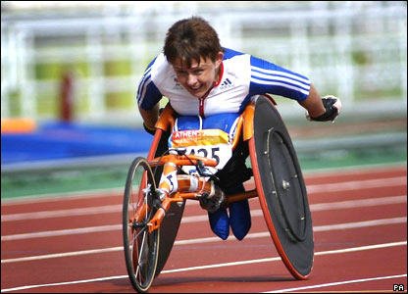

National Lottery Mass Participation

P262
What does the funding from the National lottery that is allocated for mass participation go towards?

_________________________________________________________________________________________________________________________________________________________________________________________________________________________________________________________________________________________________________________________________________________________________________________________________________________________________________________________________________________________________________________________________________________________________________________________________________________________________________________________________________________________________________________________________________________________

Below is a brief list of the main organizations that receive funding regarding mass participation.
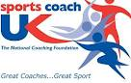
- Sports England

- Sports Coaching

- National Governing Bodies.

Q Using examples explain why some national governing bodies receive different levels of funding.
______________________________________________________________________________________________________________________________________________________________________________________________________________________________________________________________________________________________________________________________________________________________________________________________________________________________________________________________________________________________________
___________________________________________________________________________________________________________________________________________________________________________________________________________________________________________________
UK Sport

Below there are some of the strategies that are put in place by UK sports for mass participation. Not many, however, their main job is to look at sporting excellence. In the box below identify what UK sports does.

Sporting excellence | Mass participation
Sport Action Zone – targeting of socio-economic deprived areas
Sports Development Officers – encourage participation in sport specific areas and range of sports

Awards for All/funding of local facilities/resources (lottery funding)

Active Communities (Tops etc)

Looking closer at some of the things UK sports does, try and answer the questions below.

- What are the National institutes for sport?

_____________________________________________________________________________________________________________________________________________________________________________________________________________________________________________________________________________________________________________________________________________________________________________________________________________________

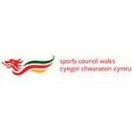

- What do the institutes provide?

What does the English Institute for Sport do?
(p267)

- ______________________________________________________________________________________________________________________________________________________

- ______________________________________________________________________________________________________________________________________________________

- ______________________________________________________________________________________________________________________________________________________

- ______________________________________________________________________________________________________________________________________________________

- ______________________________________________________________________________________________________________________________________________________

The UK Sport Research & Development team goal, supported in delivery by the EIS, is to maximise performance gains in securing medals through an innovative approach to delivering performance solutions.
Sport Medicine Working with approximately 1700 elite athletes, the EIS delivers day-to-day support in training and at competition Explore for yourself how athletes maximise the impact of sport science and medicine and get behind the scenes of the team working behind some of Britain’s best athletes.

Expertise
Sites for English Institues of Sport

Have a look at the Bath English Institute for Sports web page. Have a look at in the zone and tell me in your own words what the power to podium is all about.

_____________________________________________________________________________________________________________________________________________________________________________________________________________________________________________________________________________________________________________________________________________________________________________________________________________________
_____________________________________________________________________________________________________________________________________________________________________________________________________________________________________________________________________________________________________________________________________________________________________________________________________________________

Talent identification:

A role of UK sports is to identify the talent of the future. So are you the next gold medalist for Great Britain?
Tall and Talented
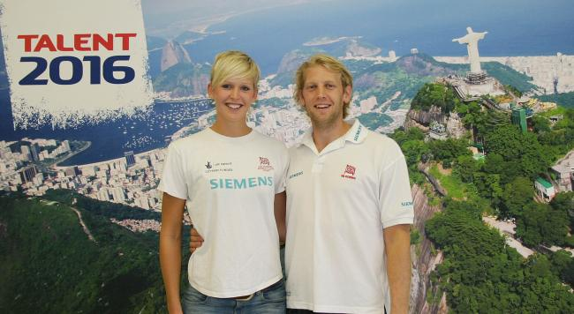
Talent 2016 Ambassadors Victoria Thornley and Andy Hodge
David Tyrrell
Introducing an exciting initiative to find the next generation of Olympic gold medalists with the drive and passion to succeed in rowing and basketball.
If you are:
- Aged between 15 and 22 years old
- Exceptionally tall (men over 190cm and women over 180cm
- Competing in any sport at a MINIMUM of county/regional level
- Mentally tough and competitive
Up for a once in a lifetime opportunity to become part of Britain’s sporting elite
- Quick, agile and skillful AND/OR fit, powerful and strong

Insert article about cyclist who went to take part and was ID as a potential cyclist.

Sport England

Sport England is the government agency that’s responsible for community sports in England. It is funded by the government and the national lottery.

What does sport England want?
_____________________________________________________________________________________________________________________________________________________________________________________________________________________________________________________________________________________________________________________________________________________________________________________________________________________
__________________________________________________________________________________________________________________________________________________________________

What does Sport England do?
- .
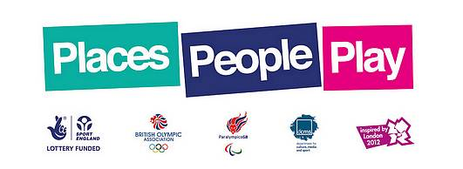
- .
- .
- .
- .

Using Places People Play explain how sport England is developing mass participation.
________________________________________________________________________________________________________________________________________________________________________________________________________________________________________________________________________________________________________________________________________________________________________________________________________________________________________________________________________________________________________________________________________________________________________________________________________________________________________________________________________

What do you understand by the term Gold Challenge?
____________________________________________________________________________________________________________________________________________________________________________________________________________________________________________________________________________________________________________________________________

Mass participation | Sporting excellence
Sport England

In the table below come up with as many initiatives as you can that sport England would be connected to.

Q Using examples of initiatives explain how sport England is developing mass participation. (3)
_____________________________________________________________________________________________________________________________________________________________________________________________________________________________________________________________________________________________________________________________________________________________________________________________________________________

Q Why does Sports England not give the same amount of money to every sport? (3)
_____________________________________________________________________________________________________________________________________________________________________________________________________________________________________________________________________________________________________________________________________________________________________________________________________________________

Q What do the organizations below have in common?

___________________________________________________________________________________________________________________________________________________________________________________________________________________________________________________

Government initiatives
Schools:

Quick task
What is the Government target for participation in physical activity for adults and ‘youths’?

Adults__frequency________________________intensity________________________
__time_____________________________type__________________________

Youths F______________________I_______________________________________

__T_____________________T_______________________________________

The Government are in charge of the National Curriculum and they have set targets for physical activity. How long did you have to take part in physical activity in?

Key stage1 ____________________
Key stage2_____________________
Key stage3_____________________
Key stage4_____________________

There are different requirements for each stage however; the themes that run through them all are Competence, Performance, Creativity, and Health.

Exam tip: You will not be asked a detailed question about specific strategies, however, you could be asked about current strategies. So you must know the names of current strategies the Government, through the DCMS, have set up.

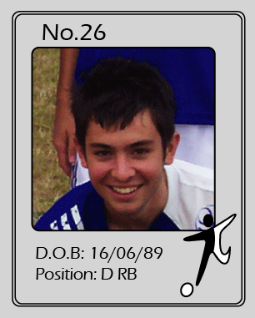

Q Of the initiatives above identify the ones that are designed to encourage mass participation and ones that are to develop sporting excellence.
Gov. initiatives Mass participation | Gov. initiatives Sporting Excellence
Q Explain why the government is interested in developing mass participation as well as sporting excellence. Ensure you use examples within your answer. (4)
_____________________________________________________________________________________________________________________________________________________________________________________________________________________________________________________________________________________________________________________________________________________________________________________________________________________
_____________________________________________________________________________________________________________________________________________________________________________________________________________________________________________________________________________________________________________________________________________________________________________________________________________________
__________________________________________________________________________________________________________________________________________________________________
TIP: Relate to a balanced, healthy active lifestyle.
National Governing Bodies

Exam tip; You will not be given a general question on NGB you will have to know about the initiatives.

- Funding: NGB get there funding from the home country councils (sports England) and from the funds they can raise from club fees that people pay. They will have targets set by the sports councils and if they are not reached they can get their funding cut.

A National Governing body must have a Whole Sports Plan

Identify what a whole sports plan is and identify what the strategy must include:
- .
- .
- .
- .

Q Explain why the government won’t give the same amount of money to every National Governing Body. What would be the reasons for this? Please use examples to explain your answer.
_____________________________________________________________________________________________________________________________________________________________________________________________________________________________________________________________________________________________________________________________________________________________________________________________________________________
__________________________________________________________________________________________________________________________________________________________________
_________________________________________________________________________________
___________________________________________________________________________________________________________________________________________________________________________________________________________________________________________________

Identify how your NGB is trying to develop mass participation and sporting excellence.
NGB Mass participation | NGB Sporting Excellence

British Olympic Association/International Olympic Committee

The British Olympic association in the National Olympic committee for Britain and is part of the IOC. It is the Pivot around which team GB revolves before, during and after the Olympic games.
- BOA does not get it’s funding from government
- Has no political interest
- Is completely dependent on commercial sponsorship and fundraising.

Its main aim is the organisation responsible for the UK’s participation in the Olympic Games.
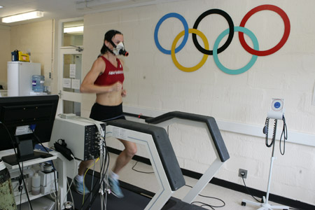
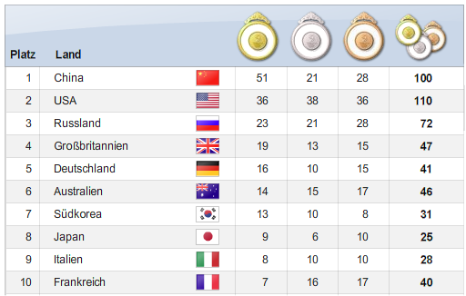

From the list on page 316 identify three of the main programmes that the BOA run.

- _______________________________________________________________________________________________________________________________________________________________________________________________________________

- _______________________________________________________________________________________________________________________________________________________________________________________________________________

- _______________________________________________________________________________________________________________________________________________________________________________________________________________

Looking at Page 315 what is the role of the International Olympic Committee.

- _______________________________________________________________________________________________________________________________________________________________________________________________________________

- _______________________________________________________________________________________________________________________________________________________________________________________________________________

- _______________________________________________________________________________________________________________________________________________________________________________________________________________

CONTEMPORARY ISSUES SECTION 2

Factors affecting Participation

O.P.E.
Fill out the table:
 |  | Explanation | Egs
 | OPPORTUNITY
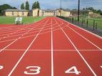 | PROVISION
 | ESTEEM

Can you explain how the home countries are trying to develop provisions for mass participation?
Place the different parts of the answer below into different sections of the development grid.

A The Home Country’s are organisations dedicated to developing mass participation, for example Sports England. One of its strategies is People Play Places. Within this strategy bids will be received to re-develop run down club houses, playing fields, tracks or other provision based support. Thus trying to encourage people to start or continue to take part in physical activity as part of a balanced active healthy life style. (3)

As you can see from above one of the main
reasons for reduction in participation is
OPE.

There are several issues around OPE.
You need to be able to give examples of how OPE
Can influence mass participation and sporting excellence.
Don’t be vague or elaborate too much, get to the point,
Use an example if needed and move on.

MASS PARTICIPATION | SPORTING EXCELLENCE
Opportunity

MASS PARTICIPATION | SPORTING EXCELLENCE
Provision

MASS PARTICIPATION | SPORTING EXCELLENCE
Esteem

This type of opportunity should be available for everyone, However, this is not the case. Within society there are different groups.

Can you identify some of those groups?
_____________________________________________________________________________________________________________________________________________________________________________________________________________________________________________________________________________________________

There are certain hierarchical layers to society which can at times prevent some and push others towards either mass participation or the pursuit of excellence. Put the groups you have above in order of greatest opportunity to the least.
____________________________________________
____________________________________________
____________________________________________
____________________________________________
____________________________________________
____________________________________________

Discrimination

A word that I’m sure you are all familiar with; however, can you describe what it is? Don’t give me an example, tell me what it is.
______________________________________________________________________________________________________________________________________________________________________________________________________________________________________________________________________________________________________________________

1) We are going to look at several groups within society and identify potential stereotypes or myths.

2) Furthermore, you must identify how society and culture have an impact of the group mentioning possible barriers.

3) Finally what are the measures in place to increase participation and sporting excellence?
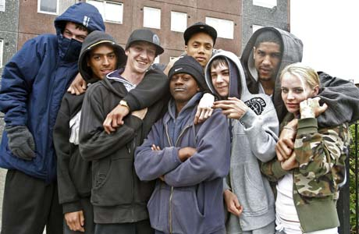

Young People

stereotypes or myths | Impact of Social cultural possible barriers | Increase participation and sporting excellence?
Within your groups you have to pick one of the groups below and investigate the myths around them and identify the impact of society and the potential barriers for participation.

Imagine for one minute that you’re old, Identify the problems that you face regarding physical activity.

Elderly People
stereotypes or myths | Impact of Social cultural possible barriers | Increase participation and sporting excellence?

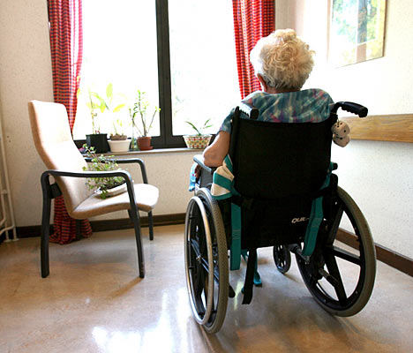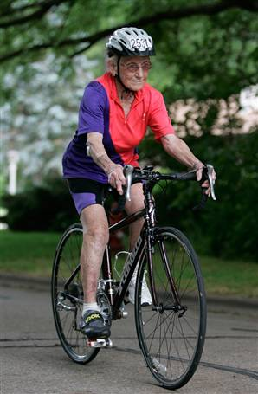

Notes:
________________________________________________________________________________________________________________________________________________________________________________________________________________________________________________________________________________________________________________________________________________________________________________________________________________________________________________________________________________________________________________________________________________________________________________________________________

Women
Media Coverage

Stereotype
Opportunity Provision Esteem

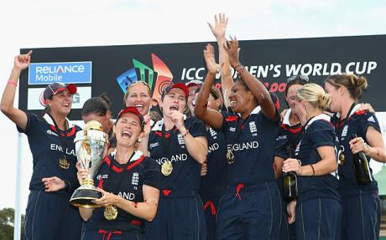

Impact of Social cultural possible barriers | Increase participation and sporting excellence?

Ethnic minority

General information:
_________________________________________________________________________________________________________________________________________________________________________________________________________________________________________________________________________

3. Possible measures to increase participation
___________________________________________________________________________________________________________________________________________________________________________________________________________________________________________________________________________________________________________________________________________________________________________________

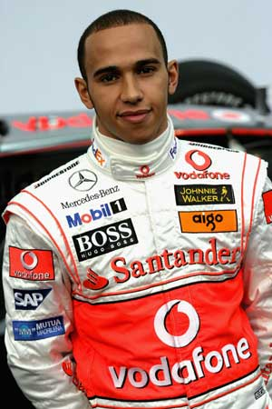

Perception | Reality

People with disabilities
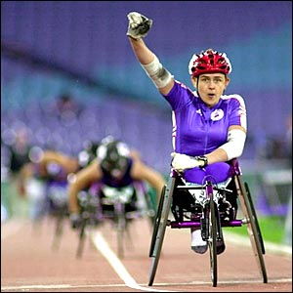

1Myths and stereotypes
____________________________________________________________________________________________________________________________________________________________________________________________________________________________________________________________________________________________________________________________

Integration  Mixing |  | Separation  Dividing people
Advantages | Disadvantages | Advantages | Disadvantages

Recent events have helped to increase the awareness of the ability of disabled people. What other strategies are being used to increase mass participation and sporting excellence.
Mass participation | Sporting Excellence
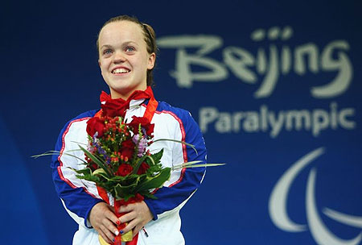
National Lottery
Sports England
UK Sports
National Governing Bodies

Schools
Government Initiatives
Sports Coaching
British Olympic Association/ IOC

