  [](http://www.right2write.co.uk/Images/OCR_logo.gif)

**ACQUIRING MOVEMENT SKILLS**

**The development of motor skills and the use of different practice methods to ensure effective involvement in physical activity.**

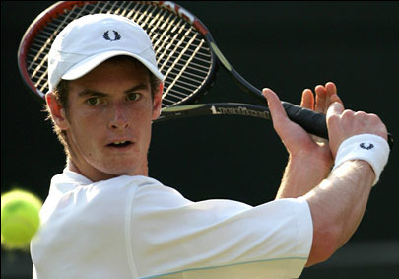

**Name: _______________________ Tutor Group:_______**

**AS PHYSICAL EDUCATION**

**BOOKLET 2 LJW**

The development of motor skills and the use of different practice methods to ensure effective involvement in physical activity.

**Learning Objectives**

**At the end of this booklet you should be able to:**

|  |  |  |
| --- | --- | --- |
| Learning Objective | **Notes** | **Learnt** |
| * **Identify Fitts and Posner’s phases of learning** |  |  |
| * **Apply these phases to practical activities** |  |  |
| * **Describe different types of guidance used in different phases of learning to improve performance** |  |  |
| * **Evaluate critically these different types of guidance** |  |  |
| * **Describe methods of practice** |  |  |
| * **Explain the role of mental practice and rehearsal as compared to physical practice rehearsal** |  |  |
| * **Explain the appropriate use of practice methods to maximise effectiveness** |  |  |
| * **Evaluate critically different types of practice methods and their application to the performance of movement skills.** |  |  |

**Stages of Movement Skill Learning that Affect Participation and Performance in Physical Activity**

All human beings have tremendous capabilities for learning. As a student of Physical Education and Sport, it is not enough to simply recognise that learning has or has not taken place. You should have a more in-depth understanding of the theories and principles associated with the underlying learning process and be able to apply this understanding to the practical learning situation.

**Task 1**

**Learning has been defined as:**

*“the more or less permanent change in behaviour that is reflected in a change in performance.”*

(B. Knapp)

“a change in the capability of the individual to perform a skill that must be inferred from a relatively permanent improvement in performance as a result of practice or experience.” (R. Magill)

“a set of processes associated with practice or experience leading to relatively permanent changes in the capability of skilled performance.” (R. Schmidt)

1. From the definitions above select the main characteristics associated with learning and record them below.
   * ______________________________________________________
   * ______________________________________________________
   * ______________________________________________________

What methods do we use to judge if a skill has been learned?

* + ______________________________________________________
  + ______________________________________________________
  + ______________________________________________________

### Why do we need to evaluate if learning has occurred?

* + ______________________________________________________
  + ______________________________________________________
  + ______________________________________________________

While ‘learning’ is said to be a permanent change in behaviour, as a sports performer it is not always possible to execute each skill correctly every time.

This may be due to a number of factors. Can you think of any?

* + ______________________________________________________
  + ______________________________________________________
  + ______________________________________________________

### Phases/Stages of Motor Skill Learning

There are also different stages or phases of the learning process. There have been many attempts to identify these different stages that performers go through when learning motor skills and from this it has been agreed that whatever the number or names of these phases, they are not separate or distinct, but they gradually merge into each other as a person moves from being a novice to proficient.

### Three-Stage Model

Paul Fitts and Michael Posner (Fitts and Posner 1967) identified one of the better-known models.

The three phases identified are:

* Cognitive
* Associative
* Autonomous

While each of these phases has certain characteristics associated with it, movement from one phase to the other is seen as developmental and gradual, along a continuum. The rate at which a performer progresses through the phases is different for each individual.

**1 2 3**

**Cognitive Phase Associative Phase Autonomous Phase**



**BEGINNER HIGHLY SKILLED**

Cognitive Phase

* **_____________________________________________________________________________________**
* **_____________________________________________________________________________________**
* **______________________________________________________________________________________**
* **_____________________________________________________________________________________**
* **_____________________________________________________________________________________**
* **_____________________________________________________________________________________**

Apply it to an example!

____________________________________________________________________________________________________________________________________________________________________________________________________________________________________________________________________________________________________________________________________________________________________________________________

Problems linked to the **COGNITIVE PHASE**

* **______________________________________________________________________________________**
* **_____________________________________________________________________________________**
* **_____________________________________________________________________________________**

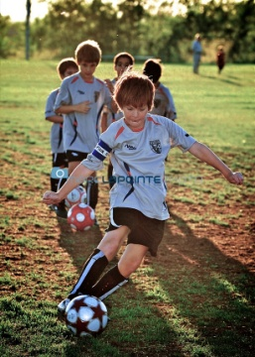

Associative Phase

* **_________________________________________________________________________________________**
* **______________________________________________________________________________________**
* **______________________________________________________________________________________**
* **_____________________________________________________________________________________**
* **_____________________________________________________________________________________**
* **_______________________________________________________________________________________**

Apply it to an example!

____________________________________________________________________________________________________________________________________________________________________________________________________________________________________________________________________________________________________________________________________________________________________________________________

____________________________________________________________________________________________

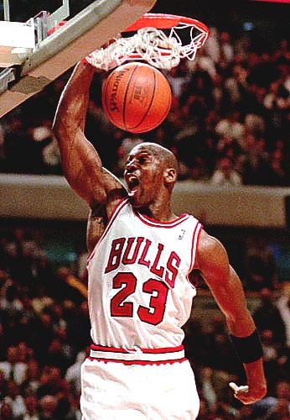Autonomous Phase

* **______________________________________________________________________________________**
* **_____________________________________________________________________________________**
* **_____________________________________________________________________________________**
* **_____________________________________________________________________________________**
* **______________________________________________________________________________________**
* **______________________________________________________________________________________**

Apply it to an example!

____________________________________________________________________________________________________________________________________________________________________________________________________________________________________________________________________________________________________________________________________________________________________________________________

Once the player has reached this phase of learning it does not mean that learning is over. Although the performer is very capable, small improvements can still be made in terms of style and form, and many other factors associated with psychological aspects of performance, which can help develop learning even further;

For example:

* Self evaluation of performance;
* Mental practice;
* Stress management;
* Personal motivation.

Task 3

Use the criteria for each phase to judge your own level of learning. Place on the continuum where you would classify yourself in relation to your performance of the following skills:

1. Headstand
2. Throwing a cricket ball
3. Kicking a ball
4. Shooting a netball
5. Jogging
6. Backward roll in gymnastics
7. Dribbling in hockey

**Cognitive Phase Associative Phase Autonomous Phase**

Select **two** examples from the previous task and justify why you have placed them where you have.

Motor Skill 1:__________________________

Justification:____________________________________________________________________________________________________________________________________________________________________________________________________________________________________________________________________________________

Motor Skill 2:__________________________

Justification:____________________________________________________________________________________________________________________________________________________________________________________________________________________________________________________________________________________

**Types of Guidance and their Impact on Effective Performance and Participation in a Balanced, Active and Healthy Lifestyle**

Guidance is information given to the learner or performer in order to help them limit possible mistakes. While guidance is usually given to beginners when skills are unfamiliar, they are used continually in various forms at all stages of learning and performance. We are going to look at the types of guidance and when they are used in relation to the phases of learning we have just covered.

The four types of guidance used by a coach in the learning process are:

* Visual
* Verbal
* Manual
* Mechanical

What factors do you think a coach would consider before deciding which type of guidance to use?

* **____________________________________________________________________**
* **_____________________________________________________________________**
* **_____________________________________________________________________**

Visual Guidance

This is the most popular and effective form of guidance when used to teach motor skills in sport.

Types of **VISUAL GUIDANCE**:

* ___________________________________________________________________
* ___________________________________________________________________
* [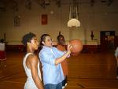](http://images.google.co.uk/imgres?imgurl=http://sitemaker.umich.edu/edgarg/files/coach_garza1.jpg&imgrefurl=http://sitemaker.umich.edu/edgarg/relationships_within_and_outside_of_school&h=2112&w=2816&sz=280&hl=en&start=57&usg=__WLKKAR7mBYlD0dli2eUoKr-sDFo=&tbnid=okUTo_o3DjBE4M:&tbnh=113&tbnw=150&prev=/images%3Fq%3Dcoach%2Bdemonstrating%26start%3D40%26gbv%3D2%26ndsp%3D20%26hl%3Den%26safe%3Doff%26sa%3DN)___________________________________________________________________

What stage of learning is it used for and why?

_____________________________________________________________________________________________

_____________________________________________________________________________________________

_____________________________________________________________________________________________

_____________________________________________________________________________________________

For **VISUAL GUIDANCE** to be effective it is important that:

* _____________________________________________________________________________________
* _____________________________________________________________________________________
* _____________________________________________________________________________________
* _____________________________________________________________________________________
* _____________________________________________________________________________________
* _____________________________________________________________________________________

Drawbacks of VISUAL GUIDANCE

* _____________________________________________________________________________________
* _____________________________________________________________________________________
* _____________________________________________________________________________________
* _____________________________________________________________________________________

Apply it to an example!

____________________________________________________________________________________________________________________________________________________________________________________________________________________________________________________________________________________________________________________________________________________________________________________________

Verbal Guidance

**VERBAL GUIDANCE** is used:

* [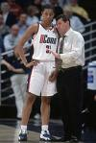](http://images.google.co.uk/imgres?imgurl=http://i.cdn.turner.com/sivault/image/2002/03/16/001250741.jpg&imgrefurl=http://vault.sportsillustrated.cnn.com/vault/photo/featured/Basketball/X65138/1900-01-01/2100-12-31/IMG109639/dd/635/8/6111/index.htm&h=974&w=653&sz=68&hl=en&start=23&usg=__3e5vhIdLYX19YPg43iw3bZCG5Ns=&tbnid=hZIwjIxr5iLeVM:&tbnh=149&tbnw=100&prev=/images%3Fq%3Dsports%2Bcoach%2Btalking%26start%3D20%26gbv%3D2%26ndsp%3D20%26hl%3Den%26safe%3Doff%26sa%3DN)_____________________________________________________________________
* _____________________________________________________________________
* _____________________________________________________________________

What stage of learning is it used for and why?

_____________________________________________________________________________________________

_____________________________________________________________________________________________

For **VERBAL GUIDANCE** to be effective it is important that:

* ______________________________________________________________________________________
* _____________________________________________________________________________________
* _____________________________________________________________________________________
* _____________________________________________________________________________________
* _____________________________________________________________________________________
* _____________________________________________________________________________________

Drawbacks of VERBAL GUIDANCE

* _____________________________________________________________________________________
* _____________________________________________________________________________________
* _____________________________________________________________________________________
* _____________________________________________________________________________________

Apply it to an example!

____________________________________________________________________________________________________________________________________________________________________________________________________________________________________________________________________________________________________________________________________________________________________________________________

Manual Guidance

[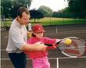](http://www.bristol.gov.uk/ccm/cms-service/stream/image/?image_id=9967011)

____________________________________________________________________________________________________________________________________________________________________________________________________________________________________________________________________________________________________________________________________________________________________________________________

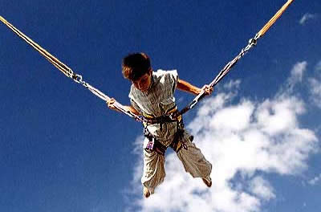Mechanical Guidance

____________________________________________________________________________________________________________________________________________________________________________________________________________________________________________________________________________________________________________________________________________________________________________________________

What stage of learning would **MANUAL** and **MECHANICAL GUIDANCE** be used for and why?

_____________________________________________________________________________________________

_____________________________________________________________________________________________

_____________________________________________________________________________________________

_____________________________________________________________________________________________

Drawbacks of MANUAL/MECHANICAL guidance

* ______________________________________________________________________________________
* _____________________________________________________________________________________
* _____________________________________________________________________________________
* _____________________________________________________________________________________

Apply it to an example!

____________________________________________________________________________________________________________________________________________________________________________________________________________________________________________________________________________________________________________________________________________________________________________________________

Task

For each of the activities below suggest the most appropriate forms of **guidance** to use when introducing the skills to a group of **novices**. **Justify your answers.**

* High Jump

____________________________________________________________________________________________________________________________________________________________________________________________________________________________________________________________________________________________________________________________________________________________________________________________

* Back crawl in swimming

____________________________________________________________________________________________________________________________________________________________________________________________________________________________________________________________________________________________________________________________________________________________________________________________

* Set plays in rugby

____________________________________________________________________________________________________________________________________________________________________________________________________________________________________________________________________________________________________________________________________________________________________________________________

* Badminton smash shot

____________________________________________________________________________________________________________________________________________________________________________________________________________________________________________________________________________________________________________________________________________________________________________________________

* Gymnast vault

____________________________________________________________________________________________________________________________________________________________________________________________________________________________________________________________________________________________________________________________________________________________________________________________

Task

Would you only use one form of guidance or a mixture when teaching a skill? Why?

Explain your thoughts below using an example.

_____________________________________________________________________________________________

_____________________________________________________________________________________________

_____________________________________________________________________________________________

_____________________________________________________________________________________________

___________________________________________________________________________________________

_____________________________________________________________________________________________

_____________________________________________________________________________________________

___________________________________________________________________________________________

***\* EXAMINER’S TIP:***

You need to know the **advantages** and **disadvantages** of each method of guidance and which **phase of** **learning** they are most **appropriate** for. Make sure you can give **practical examples** of the use of each method of guidance.

**Practice Methods and their Impact on Effective and Efficient Performance of Movement Skills**

We have previously looked at different ways a coach can teach a particular skill in relation to whether it should be broken down or not, additionally a coach needs to make a decision on when to practise and how often.

As ever, there are no easy answers. Decisions regarding questions as to which type of practice will be most effective depend on the:

* Individuals stage of learning;
* Nature of the task;
* Nature of the specific situation;
* Time available.

#### MASSED Practice

* _____________________________________________________________________________________
* _____________________________________________________________________________________

|  |
| --- |
| **MASSED PRACTICE is better when:** |
| **The INDIVIDUAL is:** |
| **The TASK is:** |

**DISADVANTAGES to MASSED PRACTICE:**

* _____________________________________________________________________________________
* _____________________________________________________________________________________
* _____________________________________________________________________________________

#### DISTRIBUTED Practice

* _____________________________________________________________________________________

|  |
| --- |
| **DISTRIBUTED PRACTICE is better when:** |
| **The INDIVIDUAL is:** |
| **The TASK is:** |

**ADVANTAGES to DISTRIBUTED PRACTICE:**

**Rest Intervals allow for:**

* _____________________________________________________________________________________
* _____________________________________________________________________________________
* _____________________________________________________________________________________
* **This is seen as the most effective method of practice and maintains motivation!**

#### FIXED Practice

* _____________________________________________________________________________________

|  |
| --- |
| **FIXED PRACTICE is better when:** |
| * **E.G.** |

#### VARIED Practice

* _____________________________________________________________________________________

|  |
| --- |
| **VARIED PRACTICE is:** |
|  |

**TASK:** Select an appropriate skill and explain how you would vary practice conditions to practice

the same skill.

_____________________________________________________________________________________________

_____________________________________________________________________________________________

_____________________________________________________________________________________________

_____________________________________________________________________________________________

___________________________________________________________________________________________

_____________________________________________________________________________________________

_____________________________________________________________________________________________

___________________________________________________________________________________________

_____________________________________________________________________________________________

___________________________________________________________________________________________

#### http://www.mytpijpc.com/images/smash-zone/gb-hockey-stick-dribbling.jpg

#### MENTAL Practice or MENTAL REHEARSAL

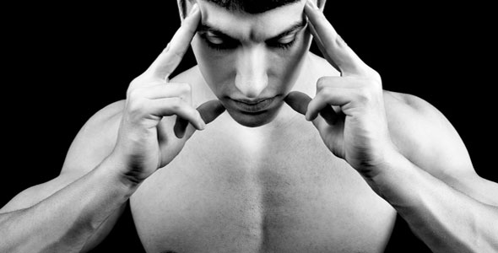

* _______________________________________________________________________________________________________________________________________________________________________________

|  |
| --- |
| **MENTAL PRACTICE /REHEARSAL is:** |
| * **E.G.** |

**DISADVANTAGES to MENTAL PRACTICE/ REHEARSAL:**

* _____________________________________________________________________________________
* _____________________________________________________________________________________

#### References

[www.bbc.co.uk/science/humanbody](http://www.bbc.co.uk/science/humanbody)

[www.nln.co.uk](http://www.nln.co.uk)

[www.medicdirectsport.com/exercisetheory](http://www.medicdirectsport.com/exercisetheory)

[www.pponline.co.uk](http://www.pponline.co.uk)

[www.sportdevelopment.org.uk/talentid](http://www.sportdevelopment.org.uk/talentid)

[www.pennhealth.com](http://www.pennhealth.com)

OCR PE, Carnell et al, Heinemann 2008

OCR PE for AS, Thompson et al, Hodder Education, 2008

Acquiring skill in sport, Honeybourne, Routledge, 2008

Skill Acquisition in sport, Williams et al, Routledge, 2008