AS P.E Respiratory system
The association and disassociation curve

Name ………………………………………………………………………
Teacher……………………………………………………………………………..

- Complete the table below by looking at partial pressure and diffusion.

Partial pressure | Capillary blood | Direction of diffusion | Muscle tissue | Diffusion gradient
02 resting | 100 |  | 40 | 60
 | 100 |  | <5
Co2 resting
 | 40 |  | 80

State how Haemoglobin supports the transfer of 02.
………………………………………………………………………………………………………………………………………………………………………………………………………………………………………………………………………………………………………………………………………………………………………………………………………………………………………………………………………………………………………………………………………………………………………………………………………………………………………………………………………………………………………………………………………………………………………………………………………………………………………………………………………………………………………………………………………………………………………………………………………………………………………………………………………………………………………………………………………………………………………………………………………………………………………………………………………………………………………………………………………………………………………………………………………………………………………………………………………………………………………………………………

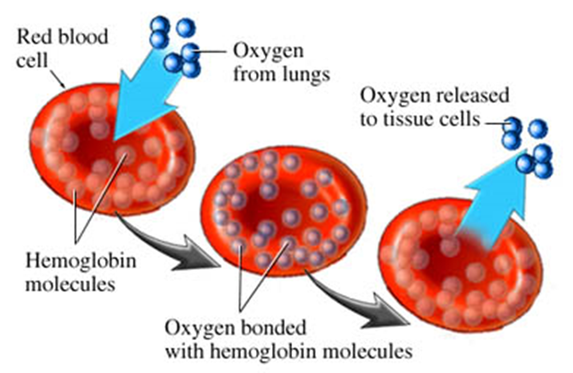
At the site of external respiration explain the binding process of 02, association with haemoglobin.
……………………………………………………………………………………………………………………………………………………………………………………………………………………………………………………………………………………………………………………………………………………………………………………………………………………………………………………………………………………………………………………………………………………………………………………………………………………………………
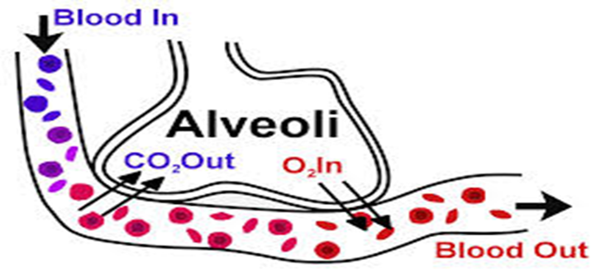

At the site of internal respiration explain the process of dissociation.
……………………………………………………………………………………………………………………………………………………………………………………………………………………………………………………………………………………………………………………………………………………………………………………………………………………………………………………………………………………………………………………………………………………………………………………………………………………………………
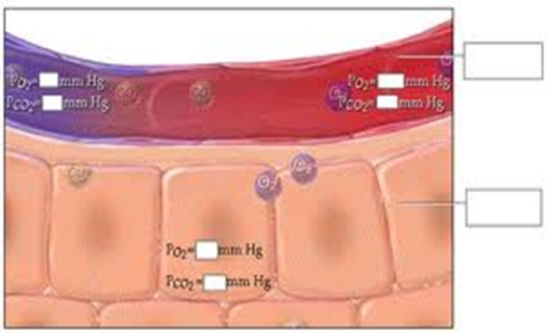

Dissociation and association of 02.
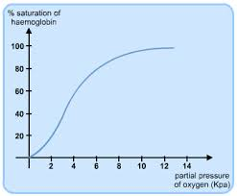

Draw the working model of association as well as dissociation.

1. Give two ways in which oxygen is transported in the blood.
Describe the effect of smoking on the transport of oxygen in the blood.
.................................................................................................................................
.................................................................................................................................
.................................................................................................................................
.................................................................................................................................
.................................................................................................................................
.................................................................................................................................
.................................................................................................................................
.................................................................................................................................
.................................................................................................................................
.................................................................................................................................
[5]

During endurance activities at altitude there may be a reduction in performance.
Why do the changes in pressure at altitude reduce performance?

.................................................................................................................................
.................................................................................................................................
.................................................................................................................................
.................................................................................................................................
.................................................................................................................................
.................................................................................................................................
.................................................................................................................................
.................................................................................................................................
.................................................................................................................................
.................................................................................................................................
5

Respiratory system AS P.E
Altitude and the impact of 02 transport

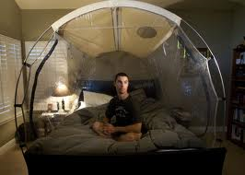

Name………………………………………………………………
Teacher…………………………………………………………………………………

Respiratory system practical application of the association of 02 and c02
Starter task:
State the factor that influence the Bohr shift.
Explain how each of these factors impact on the transportation of 02. (6)
.................................................................................................................................
.................................................................................................................................
.................................................................................................................................
.................................................................................................................................
.................................................................................................................................
.................................................................................................................................
.................................................................................................................................
.................................................................................................................................
.................................................................................................................................
.................................................................................................................................
.................................................................................................................................
.................................................................................................................................
.................................................................................................................................
.................................................................................................................................

5)
Increase in PH
Increase in C02 PP
Decrease in 02 PP
Increase in Temp

Association of 02 and C02
1) Draw a complete model of the association and dissociation within the respiratory system at rest.
2) Draw the same model with the influence of exercise.

Complete the model of altitude and its impact of 02 transport.

Resulting in

Decrease in 02 and

Causing a reduction

Decrease P02 causes

The net effect is

Decrease P02

EFFECTS OF ALTITUDE ON THE RESPIRATORY SYSTEM

Short term effects

LONG TERM EFFECTS

Complete a drawing of the impact of altitude on 02 transport.

1. During endurance activities at altitude there may be a reduction in performance.
Why do the changes in pressure at altitude reduce performance?
.................................................................................................................................
.................................................................................................................................
.................................................................................................................................
.................................................................................................................................
.................................................................................................................................
.................................................................................................................................
.................................................................................................................................
.................................................................................................................................
.................................................................................................................................
.................................................................................................................................

[4]
Q Use fig 1 to help explain the difficulties that an endurance performer might experience when performing at altitude without a period of acclimatisation.

Altitude | Pressure atmospheric | Partial pressure
Sea level | 760 | 159.2
2,000 | 596 | 124.9
4,000 | 462 | 96.9

(5 marks)
Candidate 1
At sea level partial pressure oxygen is 159.2. The atmospheric pressure is 760mmh, so therefore more oxygen is being able to diffuse into the bloodstream towards the working muscles.

At 4000mm where the partial pressure is 96.9 and the atmospheric pressure is 462mmhg, not enough oxygen will be able to diffuse, so the body will generate more hyamaglobin for the oxygen to saturate again.

Positive:

Negative:

Score:

Q Use fig 1 to help explain the difficulties that an endurance performer might experience when performing at altitude without a period of acclimatisation.

Altitude | Pressure atmospheric | Partial pressure
Sea level | 760 | 159.2
2,000 | 596 | 124.9
4,000 | 462 | 96.9

(5 marks)
Candidate 2
The table shows the PPO2 decreases as altitude increases and this results in less O2 transport to the working muscles so the athlete will not be able to work as hard or as long as they could at sea level. This is because they have not had the time to adapt and increase their red blood cell production which increases their 02 transport and which would increase their aerobic performance.

Positive:

Negative:

Score:

Q Use fig 1 to help explain the difficulties that an endurance performer might experience when performing at altitude without a period of acclimatisation.

Altitude | Pressure atmospheric | Partial pressure
Sea level | 760 | 159.2
2,000 | 596 | 124.9
4,000 | 462 | 96.9

(5 marks)
Candidate 3
The PP of 02 at altitude decreases so when they inspire the PP of 02 is lower in the air in the alveoli than at sea level. This means the diffusion gradient is reduced so less 02 is diffused into the alveoli capillaries. This reduction in 02 transport will reduce the supply of 02 to the working muscles.

The haemoglobin will not be as saturated The net effect is that aerobic performance is reduced. The athlete will have to increase their rate of breathing and depth of breathing to compensate but overall they will either have to slow down or are likely to fatigue quicker than they would at sea level. A negative impact could be hyperventilation due to increased breathing rate.

Positive:

Negative:

Score:

H.W
Note the respirator adaptations after performing physical activity. (long term adaptations).
Respiratory structure

Breathing mechanics

Respiratory volume

Outcome

What is IMT and is there any merit in you and I doing it?
Is there any merit in high performance athletes doing it?

Asthma
Symptoms

Measurement

Triggers

How can you manage asthma?

Negative effects of smoking.

