Contemporary Issues part

Drugs the Media, sponsorship

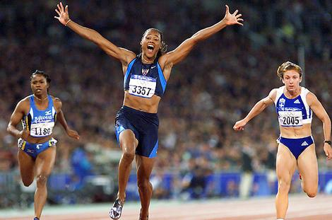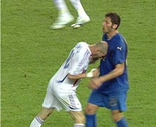

Social Cultural Studies

Name ____________________________________________________

Teacher __________________________________________________

The Use of Drugs and Sport

Reason for use

Consequence

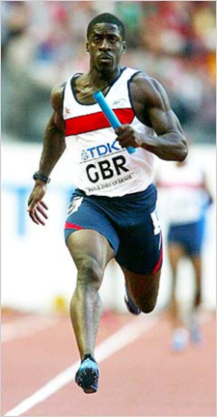

Using an example explain the reasons for someone taking drugs and explain the consequences of the actions. (5)

Black = point Green = example red = develop blue = explain.

So with this question ensure that you identify the subject qualifier, and the subject matter. Use examples and expand on the question.

____________________________________________________________________________________________________________________________________________________________________________________________________________________________________________________________________________________________________________________________________________________________________________________________________________________________________________________________________________________________________________________________________________________________________________________________________________________________________________________________________________________________________________________________________________________________________________________________________________________________________________________________________________________________________

Possible arguments allowing drugs | Arguments against drugs in sport

Debate tip: Ensure that your point is clear and has an example.
Know both sides of the argument.
Don’t just waffle.

Solutions
______________________________________________________________________________________________________________________________________________________________________________________________________________________________________________________________________________________________________________________________________________________________________________________________________________________________________________________________________________________________________________________________________________________________________________

What is happening to prevent drugs in sports?

100%ME – programme promoting drug free competitive sport in UK – by info on anti-doping and by promoting pos attitudes and values in sport

WADA – World Anti-Doping Agency – promotes, coordinates and monitors fight against doping in sport at international level with the support of technology.
____________________________________________________________________________________________________________________________________________________________________________________________________________________________________________________________________________________________________________________________________________________________________________________
__________________________________________________________________________________________________________________________________________________________________________________________

Impact of Modern Technology
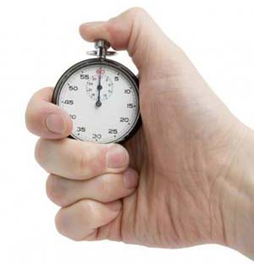

Hockey
Football

100m Sprint
Swimming

Marathon

Badminton

Can you note down the technology that is used in these sports?

- _______________________________________________________________

- ________________________________________________________________

- ________________________________________________________________

- ________________________________________________________________

- ________________________________________________________________

- __________________________________________________________________

Could you put these into categories?

- ________________________________________________________________

- ________________________________________________________________

- __________________________________________________________________

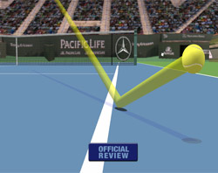

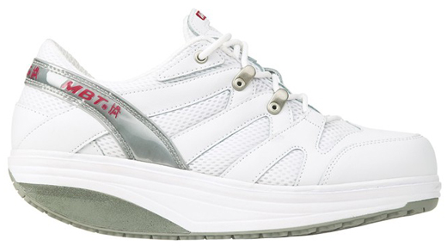

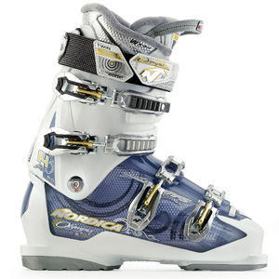

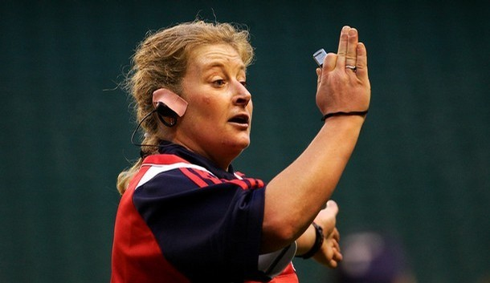

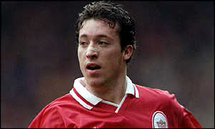
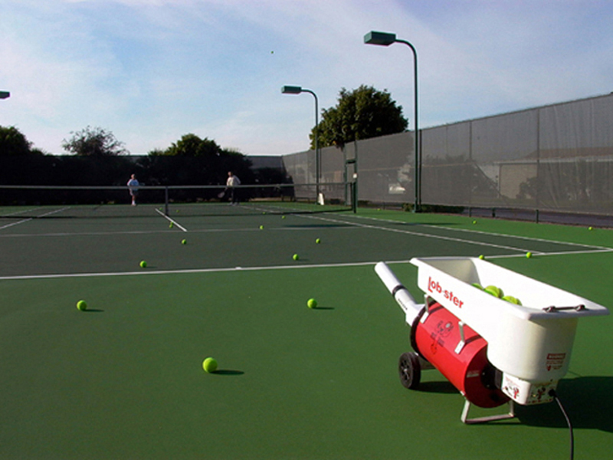

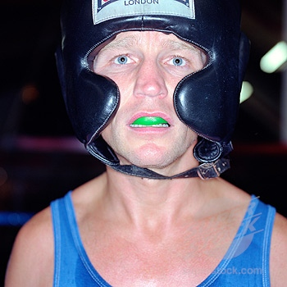

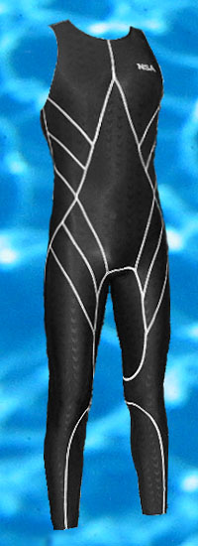
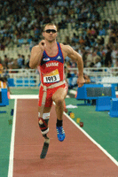
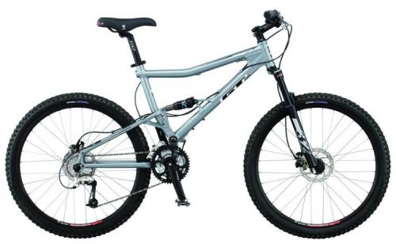

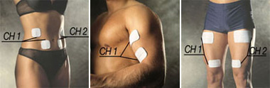
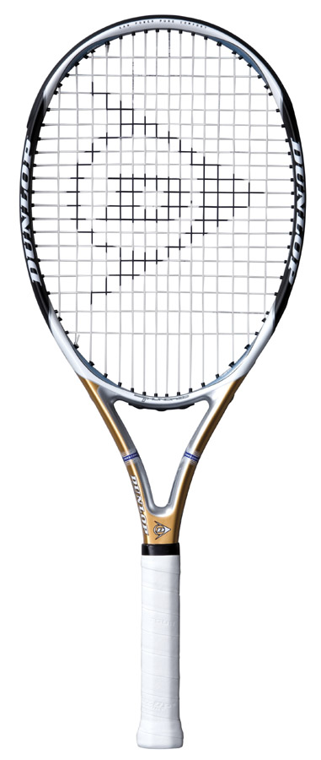

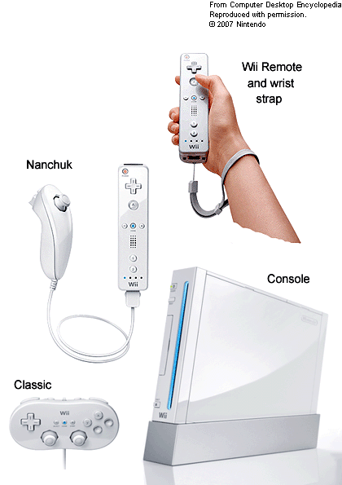

Phone task

Who can find out the winning times for the men’s 100m in Beijing and compare this to the games held in London in 1948.

_______________________________________

_______________________________________

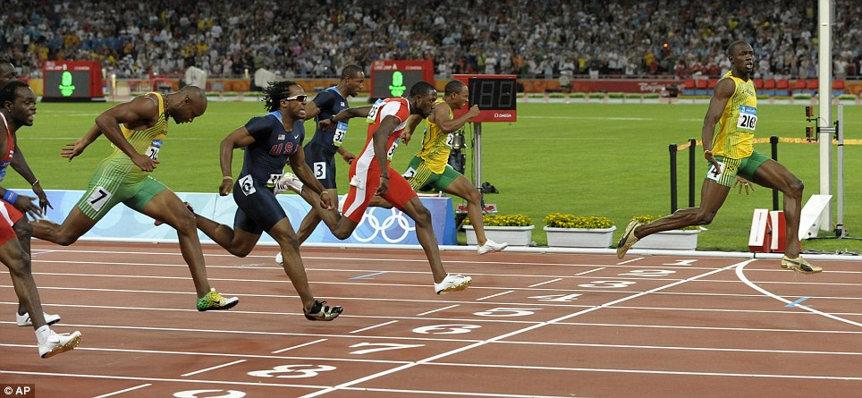

Looking at the picture above identify using examples the different types of technology used. (4)

................................................................................................................................................................................................................................................................................................................................................................................................................................................................................................................................................................................................................................................................................................................................................................................................................................................................................................................................................................................................................................................................................................................................................................................................................................................................................................................................................

The role and impact of media on sport.

Pair’s task: Word tennis game. Try and think of as many types of media as you can. State yours and then your partner must state theirs until one person pauses or hesitates. To make it harder you can’t say umm’.

Once you have had a few goes each write down your combined answers

_______________________
_______________________
_______________________
_______________________
_______________________
_______________________
_______________________

Could you put these into categories?

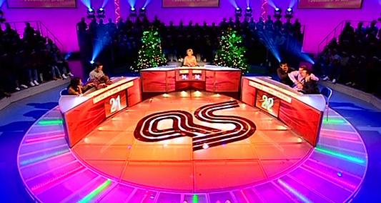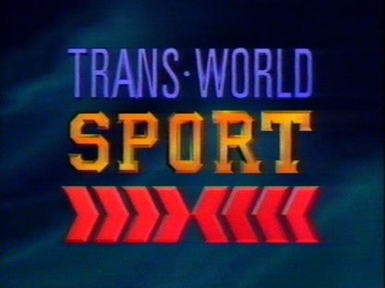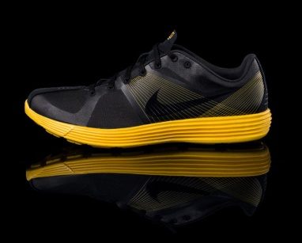

Olympic year is almost here – but are we ready for it?
As the clock ticks down towards London 2012, we look at 10 key areas and the progress that has been made. (guardian 2011)

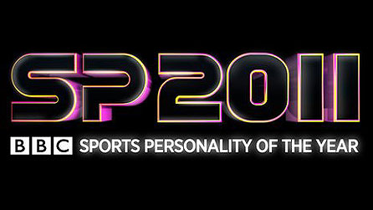

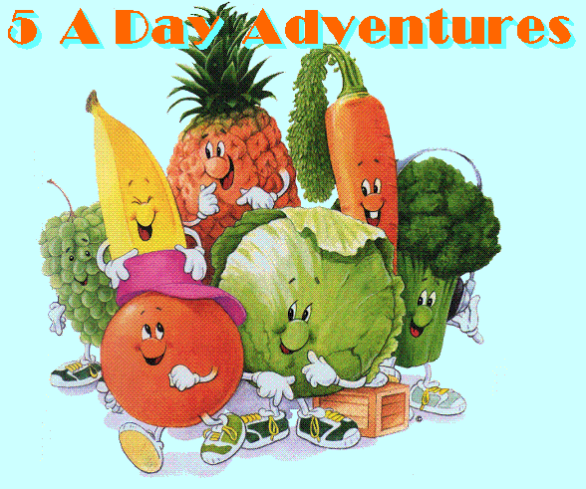

POSITIVE IMPACT OF THE MEDIA

Remember you won’t be able to remember all of these so think of ones that will stick in your head. Don’t get caught focussing on one sport e.g. football.

NEGATIVE IMPACTS OF THE MEDIA ON SPORT

Looking at the newspapers there any similar characteristics of each group. Place each article in either informs educate, entertain or advertise.

Educate | Inform | Entertain | Advertise

These are the main roles of media based on the findings of Van Wely.

Take notes on each of the areas and ensure that you use sporting examples that are relevant to you or the articles that you have looked at.

Educate...............................................................................................................................................................................................................................................................................................................................................................................................................................................................................................................................................................................................................................................................................................................................................................................................................................................................................................................................................................................................

Inform...............................................................................................................................................................................................................................................................................................................................................................................................................................................................................................................................................................................................................................................................................................................................................................................................................................................................................................................................................................................................

Entertain............................................................................................................................................................................................................................................................................................................................................................................................................................................................................................................................................................................................................................................................................................................................................................................................................................................................................................................................................................................................

Advertise...............................................................................................................................................................................................................................................................................................................................................................................................................................................................................................................................................................................................................................................................................................................................................................................................................

To complete the next set of tasks and understand the true development of sport you must read the articles below. These are taken directly from the text book on page 303. However, some elements have been removed.

Background

Media has certainly had an effect on sport i think no one can be in any doubt. However, to what extent is the more important questions and why? In the 1950 less than one in ten households owned a television. Twenty years later, 1-10 did not. Most homes today have more than one television and with the access to personal computers whose internet access is 24hrs a day to the outside world. T.V companies once paid very little to sports bodies to buy ‘entertainment’ and information for their audiences. However, as the examples show above, they are now willing to pay, thousands if not millions.
Quick task. Quickly try and break down what this sentence is saying or suggesting? Can you think of the reasons why?

“The media is a broad term as we have looked at, but T.V has a profound effect on modern sports High level professional sports is now a media commodity driven by market forces. It is a big earner that, in some ways, has had to bow to its master.”

What it’s saying
The reasons why

Examples of media dictating sport
- ......................................................................................................
- ......................................................................................................
- ......................................................................................................
- ......................................................................................................
- ......................................................................................................

Ones that you may not have are the 1984 LA Olympics Marathon was re-scheduled on the hottest part of the day.

Did anyone mention third or fourth round play-offs to get to the finals?

Can anyone explain what that is and then can anyone else suggest the reasons why?
......................................................................................................
So it is clear that there is an interrelationship between media and sport and the third party is........................SPONSORS

This is important to remember and it’s called the Golden Triangle.

- The key thing to note is that each one is now dependant on the other. They are mutually dependant. Some have suggested that this is a match made in heaven or an unholy alliance.

This is the key question but we need to ensure that we answer it at all levels and not just what happened to Roman Abramovik and Chelsea.

Group task

Read the articles Background, BSkyB , cricket and football and sponsorship. All are on page 304based on the two true different scenarios. Briefly decide if sponsorship in sport is partnership with the devil or bringing sports to the masses.

Conclusion
.................................................................................................................................................................................................................................................................................................................................................................................................................................................................................................................................................................................................................................................................................................................................................................................................................................................................................................................................................................................................................................................................................................................................................................................................................................................................................................................................................................
Read this to save work: You will not be asked “what is sponsorship?” What are the advantages and disadvantages of sponsorship? However, you will need to make reference to them when answering another related question.

The Performer
So we need to identify how the golden relationship is of an advantage and disadvantage to both the performer and sponsor.

The Sponsor

Group Task
Each group of four is to pick two arguments gather notes, and evidence from your previous work or knowledge and use the book where appropriate, put forward for your reasons for your answer. The other group who will be permitted to either add to the points made or give a different point. However, you will not be permitted to say “Oh we had the same as them.”

- Has all sport benefitted from its new found partners, media and sponsors?
- Has sport saved sport from economic ruin and allowed our athletes to compete on a world stage?
- Can sport retain its true traditional nature and values (first taught at rugby school) while benefiting from the money offered by commercialism? Should it even try to?

This last question is one that I want to you to break down and tackle as a 10 marker.
First do the basics of identifying the:
Command Word Subject Subject/qualifier

- Q Has the dependency of each section of the golden triangle reduced or increased mass participation?

- So we will be looking for five points that suggest that the golden triangle has increased mass participation and five that say it has reduced it. Good luck. The key thing is don’t spend too long on each point or section and don’t be vague.
- ..............................................................................................................................................................................................................................................................................
- ..............................................................................................................................................................................................................................................................................
- ..............................................................................................................................................................................................................................................................................
- ..............................................................................................................................................................................................................................................................................
- ..............................................................................................................................................................................................................................................................................
- ..............................................................................................................................................................................................................................................................................
- ..............................................................................................................................................................................................................................................................................
- ..............................................................................................................................................................................................................................................................................
- ..............................................................................................................................................................................................................................................................................
Ok so we have the main points in there but what else can we add that shows depth of knowledge or development on point. Have a look at the apply it box at the bottom of 303. A use of a comparative will hopefully help your point. See page 306.
Netball Vs Football
There is a huge problem with sponsorship not being even and low profile sports not getting anything. Many netball players are still amateur. They fail to attract sponsorship because they fail to attract media coverage.
In tennis there are rumours of corruption. I’m sure that you can think of other examples. Furthermore, Amir Khan’s fight is rife with controversy.
The belief by some that bigger stars get better treatment, so they return to the particular tournament.

1. Explain the links between high level sport, sponsorship and the media.
[6]
.................................................................................................................................................................................................................................................................................................................................................................................................................................................................................................................................................................................................................................................................................................................................................................................................................................................................................................................................................................................................................................................................................................................................................................................................................................................................................................................................................................

3.(i) Identify two roles of the media. (2)
........................................................................................................................
........................................................................................................................

(ii) Discuss both positive and negative effects of the media on sport.
[4]
.................................................................................................................................................................................................................................................................................................................................................................................................................................................................................................................................................................................................................................................................................................................................................................................................................................................................................................................................................................................................................................................................................................................................................................................................................................................................................................................................................................

5. The winning of More Medals is affected by many factors
What are the possible effects of:
• Funding
• The UKSI (United Kingdom Sports Institute)
• The media on elite performance? (6)

.................................................................................................................................................................................................................................................................................................................................................................................................................................................................................................................................................................................................................................................................................................................................................................................................................................................................................................................................................................................................................................................................................................................................................................................................................................................................................................................................................................

Violence in Sport

In groups identify where you can see aggression in sport.
(Revision now you have a list of examples of aggression in sport.)

............................................................................................................................................................................................................................................................................................................................................................................................................................................................................................................................................................................................................................................

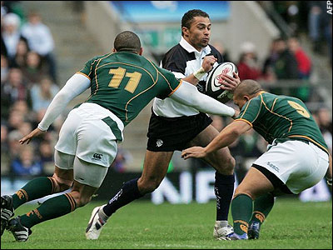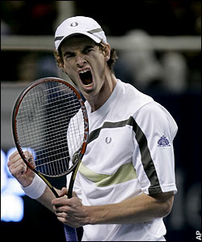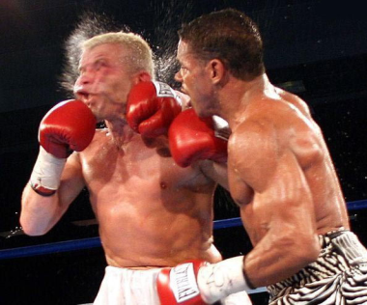

Controlled aggression is a fundamental part of many sports. Sometimes it can spill over into uncontrolled situations where fist may fly. So the question is can you think of examples where aggression spills over?

................................................................................................................................................................................................................................................................................................................................................................................................................................................................................................................

Aggression is not a new thing in sport

Prior to 1850 ‘mob football’ was a violent and primitive form of football as you see it today. Such games are still played as traditions in Ashbourne and are a good example of surviving ethnic sports.

After 1850 as you know the main influence on sport was..................................So the games were changed and the gentlemanly code of conduct was applauded. The late Victorian public school boys played the game to the letter of the law and showed great................................................

Today there is a belief that the middle class amateur attitudes have been squeezed out of the game. The stakes are high, pressure intense and gamesmanship is commonplace.
Violence for participants

Here we are trying to investigate the possible causes for violence of players. So what would cause you to lose your cool, to boil your blood enough to commit a violent act?

Cheating
....................................................................................................................................................................................................................................................................................................................................................................................

Health
....................................................................................................................................................................................................................................................................................................................................................................................
Legality
....................................................................................................................................................................................................................................................................................................................................................................................
Role-modelling
....................................................................................................................................................................................................................................................................................................................................................................................
Violence by Spectators

Violence on the terraces is not new either. Hooliganism and aggression at sports events has been around as long as the violence within the games. The constant fighting of the Irish immigrant Hooligan family during the Victorian period introduced a new word into the English language.

The hooligans as you identify them today forcefully raised their heads as a social problem in the late 1960’s. The connection was with aggressive behaviour from predominantly white, urban, unskilled males teenagers and mainly at football matches.

Crowd Violence

Possible causes
....................................................................................................................................................................................................................................................................................................................................................................................
....................................................................................................................................................................................................................................................................................................................................................................................
...........................................................................................................................
Heysel-1985
....................................................................................................................................................................................................................................................................................................................................................................................
....................................................................................................................................................................................................................................................................................................................................................................................
...........................................................................................................................

Hillsborough -1989
....................................................................................................................................................................................................................................................................................................................................................................................
....................................................................................................................................................................................................................................................................................................................................................................................
...........................................................................................................................

Possible solutions to violence of fans

Possible solutions to violence of players

An enduring problem

As young sports people the question is, is violence in sport still an issue? (6)

So how do we start to answer the question?
....................................................................................................................................................................................................................................................................................................................................................................................
....................................................................................................................................................................................................................................................................................................................................................................................
...........................................................................................................................
....................................................................................................................................................................................................................................................................................................................................................................................
....................................................................................................................................................................................................................................................................................................................................................................................
............................................................................................................................
Revision checklist

Performance enhancing product | Notes | Revised
explain the reasons for the use of drugs in sport;
• describe the consequences of the use of drugs in sport (with particular
reference to health, wellbeing and role modelling for young people);

• describe possible solutions to the problem of the use of drugs in sport;

• explain the impact on performance(s) in sport of modern technological
products (with reference to particular products and activities).
Sports Sponsorship and Media
explain the roles of the media (informing; educating; entertaining; advertising);

• evaluate critically the impact of the media on sport (with particular
reference to its role in promoting balanced, active and healthy
lifestyles and lifelong involvement in physical activity);
• explain the relationship between sport, sponsorship and the media
(‘golden triangle’).
Violence in sport
• demonstrate knowledge and understanding of violence in sport (players and spectators);
• describe possible causes and solutions.

