  [](http://www.right2write.co.uk/Images/OCR_logo.gif)

**AS PHYSICAL EDUCATION: G451**

**ANATOMY AND PHYSIOLOGY**

[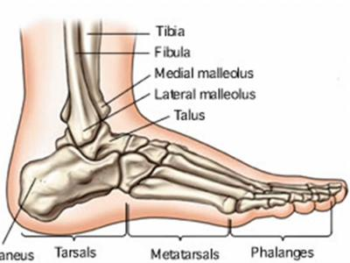](http://www.google.co.uk/url?sa=i&rct=j&q=&esrc=s&frm=1&source=images&cd=&cad=rja&docid=MDuiqsVbsffnPM&tbnid=DnQOzhGOu8-r-M:&ved=0CAUQjRw&url=http://playrific.com/m/9824/bones-in-the-body-by-animaniacs-lyrics&ei=AeElUqiqMYGH0AWdjoFg&bvm=bv.51495398,d.ZG4&psig=AFQjCNFS3o0TgXdhgUd6axq9v8pLOfq25Q&ust=1378300514771282)

**The Skeletal Systems**

**NAME: …………………………………………………. TUTOR: …………………….**

|  |  |  |
| --- | --- | --- |
| **At the end of this topic you should be able to:** | **Notes** | **Learnt** |
| Describe an overview of the skeletal system to include its functions, the axial and appendicular skeletons as well as types of bone and cartilage |  |  |
| Understand, describe and give examples of the different types of joint found in the body |  |  |
| Use a variety of anatomical terms to describe a moving body during physical activity |  |  |
| Analyse a range of sporting techniques in terms of joint movements |  |  |
| Identify the major muscles associated with the main joints of the human body and explain their role as an agonist or an antagonist with reference to specific movements in physical activity |  |  |
| Carry out a full movement analysis of specific movements in physical activity |  |  |
| Understand the difference between concentric, eccentric and isometric muscular contraction |  |  |
| Distinguish between the three types of skeletal muscle fibre in the body and apply their characteristics to suggest reasons why certain individuals choose to take part in specific types of physical activity |  |  |
| Recognise the considerable benefits of a warm up and cool down in skeletal muscle |  |  |
| Discuss the advantages of lifelong involvement in an active lifestyle in relation to bone, joint and muscle health and evaluate certain disorders of bones, joints and muscles that can result from different types of physical activity |  |  |

**To demonstrate knowledge and understanding of joints movement and muscles**

**Label the skeleton below:**

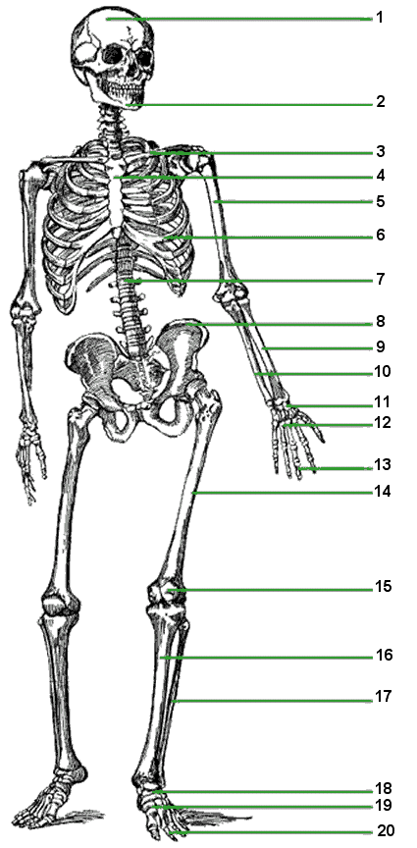

**22**

**21**

**23**

**Functions of the skeleton:**

**The skeleton is made up of 206 bones. It comprises of the axial and appendicular skeleton.**

The *axial* skeletons main purpose is to: ________________________________________________________________________________________________________________________________________________________________________________________________________________________________________________

The *appendicular* skeletons main purpose is to: ________________________________________________________________________________________________________________________________________________________________________________________________________________________________________________

**Colour the axial and the appendicular skeleton**

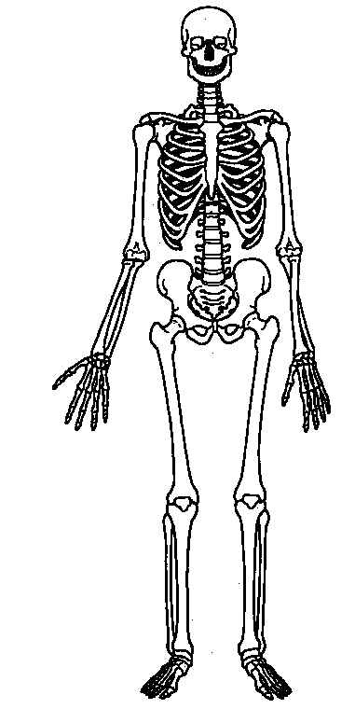

**TYPES OF BONE**

|  |  |  |  |  |
| --- | --- | --- | --- | --- |
| **BONE TYPE** | **STRUCTURE** | **FUNCTION EXAMPLES** | | |
| **Long Bone**  **http://www.iheartnoahides.com/wp-content/uploads/2008/08/a4femur.jpg** |  |  | |  |
| **Short Bone**  **http://upload.wikimedia.org/wikipedia/commons/thumb/d/db/RightHumanPosteriorDistalRadiusUlnaCarpals.jpg/800px-RightHumanPosteriorDistalRadiusUlnaCarpals.jpg** |  |  | |  |
| **http://www.thedisabledlist.com/files/images/sternum.gifFlat Bone** |  |  | |  |
| **Irregular Bone**  **http://www.sjhsyr.org/sjhhc/images/vertebrae.gif** |  |  | |  |
| **Sesamoid Bone**  **http://www.twojeez.com/wordpress/wp-content/uploads/2009/06/patella.jpg** |  |  |  | |

**Q Compare and contrast the structure and function of different types of bones. (4)**

**So you need to do four comparatives for 4 marks. E.g., long bones are located in the limbs or the appendicular skeleton, whereas flat bones tend to be located in the axial skeleton.**

**________________________________________________________________________________________________________________________________________________________________________________________________________________________________________________________________________________________________________________________________________________________________________________________________________________________________________________________________________________________________________________________________________________________________________________________________________________________________________________________________**

**________________________________________________________________________________________________________________________________________________________________________________________________________________________________________________________________________________________________________________________________________________________________________________________________________________**

**BONE GROWTH**

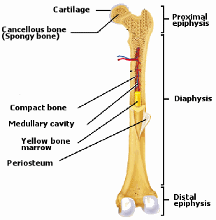

|  |  |
| --- | --- |
| **Structure** | **Function** |
| Articular cartilage |  |
| Epiphysis |  |
| Diaphysis |  |
| Epiphyseal plates |  |
| Compact bone |  |
| Bone marrow |  |

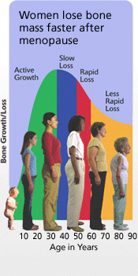

**What can you do to reduce the loss in bone density as you age?**

**How can the knowledge of bone development affect our decision to take part in physical activity?**  Page 37 book

**Growth plate and physical activity**

Read page 37 and make notes on the causes of growth pate injuries in children. Is the impact of the same activity on adults? Can you explain why?

**________________________________________________________________________________________________________________________________________________________________________________________________________________________________________________________________________________________________________________________________________________________________________________________________________________**

**________________________________________________________________________________________________________________________________________________________________________________________________________________________________________________________________________________________________________________________________________________________________________________________________________________**

[**http://www.youtube.com/watch?v=5Hp-2PUGkfs**](http://www.youtube.com/watch?v=5Hp-2PUGkfs)

**Osteoporosis**  page 36 book

**1) What is Osteoporosis and how does physical activity impact on maintaining bone density?**

**________________________________________________________________________________________________________________________________________________________________________________________________________________________________________________________________________________________________________________________________________________________________________________________________________________**

**________________________________________________________________________________________________________________________________________________________________________________________________________________________________________________________________________________________________________________________________________________________________________________________________________________**

**________________________________________________________________________________________________________________________________________________________________________________________________________________________________________________________________________________________________________________________________________________________________________________________________________________**

**Reduction in bone density can lead to issues around posture as well as physical activity.**

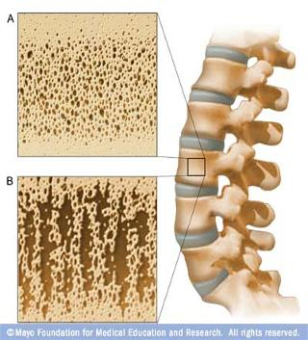

**Impact of sports on bones**

**Issues 1**

**What is it?**

**Cause**

**Effect**

**Who’s at risk?**

**Looking at each of the sheets and identify the impact of participation in each of the different types of activities.**

**Should they take part in it? If not why not? If yes then why yes?**

**E.g., what is the impact on ___________________ if you take part in contact sports?__________________________________________________________________________________________________________________________________________________________________________________________________________________________________________________________________________________________________________________________ ________________________________________________________________________________________________________________________________________________________________________________________________________________________________________________**

**What is the impact on ______________________ if you take part in high impact sports?__________________________________________________________________________________________________________________________________________________________________________________________________________________________________________________________________________________________________________________________**

**What is the impact on ___________________if you take part in low impact repetitive sports/activities?_______________________________________________________________________________________________________________________________________________________________________________________________________________________________________________________________________________________________________________________________________**

**Impact of sports on bones**

**What is it?**

**Cause**

**Effect**

**Who’s at risk?**

**Issue 2**

**Should they take part in it? If not why not? If yes then why yes?**

**E.g., what is the impact on ___________________ if you take part in contact sports?**

**________________________________________________________________________________________________________________________________________________________________________________________________________________________________________________________________________________________________________________________________________**

**What is the impact on ______________________ if you take part in high impact sports?**

**________________________________________________________________________________________________________________________________________________________________________________________________________________________________________________________________________________________________________________________________________**

**What is the impact on ___________________if you take part in low impact repetitive sports/activities?**

**________________________________________________________________________________________________________________________________________________________________________________________________________________________________________________**

**Impact of sports on bones**

**What is the positive effect of taking part in physical activity?**

**This should cover peak bone density and use examples. Explain your answer. What would be another reason for exercise being positive for a healthy balances active lifestyle?**

**________________________________________________________________________________________________________________________________________________________________________________________________________________________________________________________________________________________________________________________________**

**________________________________________________________________________________________________________________________________________________________________________________________________________________________________________________________________________________________________________________________________**

**________________________________________________________________________________________________________________________________________________________________________________________________________________________________________________________________________________________________________________________________**

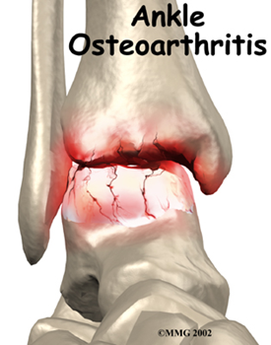

**What is osteoarthritis**

**Cause**

**Effect**

**Who’s at risk?**

**E.g., what is the impact on osteoarthritis including bone spurs if you take part in contact sports?**

**________________________________________________________________________________________________________________________________________________________________________________________________________________________________________________________________________________________________________________________________________**

**E.g., what is the impact on osteoarthritis if you take part in high impact sports?**

**________________________________________________________________________________________________________________________________________________________________________________________________________________________________________________________________________________________________________________________________________**

**What is the impact on osteoarthritis if you take part in low impact repetitive sports/activities?**

**________________________________________________________________________________________________________________________________________________________________________________________________________________________________________________________________________________________________________________________________________**

**give examples?**

**Notes:**

|  |  |
| --- | --- |
| **Impact of High Impact Activities on BONES** | |
| **General Positive Impact** | **General Negative Impact** |
| * **Strength training increases bone density** * **Should be a gradual increase / overload in intensity – caution** * **Can increase PEAK bone density during adolescence - minimise risk later in life** * **Important for aging people to maximise bone density and osteoblast stimulation** |  |
| **Impact of High Impact Activities if suffering from Osteoporosis** | |
|  | * **Greater risk of bone fractures** * **Especially jumpers, basketball (hard surfaces), runners** |
| **Impact of High Impact Activities if suffering from Growth Plate Problems** | |
|  | * **Greater risk of displacement and damage at the growth / epiphyseal plate** |

|  |  |
| --- | --- |
| **Impact of Contact Activities on BONES** | |
| **General Positive Impact** | **General Negative Impact** |
| * **With some caution, can increase bone density** |  |
| **Impact of Contact Activities if suffering from Osteoporosis** | |
|  | * **Greatest risk of fractures** * **Especially rugby, kick-boxing** |
| **Impact of Contact Activities if suffering from Growth Plate Problems** | |
|  | * **Greatest risk of stress fractures and displacements / fractures** |

|  |  |
| --- | --- |
| **Impact of Repetitive / Low Impact Activities on BONES** | |
| **General Positive Impact** | **General Negative Impact** |
| * **strengthens bones and reduces risk of fracture** * **PA very important in maintaining healthy bones – especially in childhood and adolescence** | * **Excessive repetition puts excessive stress on bones and the epiphyseal plates** * **May develop bones stress fractures** |
| **Impact of Repetitive Activities if suffering from Osteoporosis** | |
| * **In moderation, can stimulate greater bone density - caution** | * **Especially jogging, throwers, racket sports** |
| **Impact of Repetitive Activities if suffering from Growth Plate Problems** | |
| * **Lower impact activities may not over-stress the weaker plate areas** |  |

**Joint stability**

**E.g., what is the impact on joint stability if you take part in contact sports?**

**________________________________________________________________________________________________________________________________________________________________________________________________________________________________________________________________________________________________________________________________________**

**E.g., what is the impact on joint stability if you take part in high impact sports?**

**________________________________________________________________________________________________________________________________________________________________________________________________________________________________________________________________________________________________________________________________________**

**What is the impact on joint stability if you take part in low impact repetitive sports/activities?**

**________________________________________________________________________________________________________________________________________________________________________________________________________________________________________________________________________________________________________________________________________**

**Give examples**

**Notes:**

**Posture**

**E.g., What is the impact on posture if you take part in contact sports?**

**________________________________________________________________________________________________________________________________________________________________________________________________________________________________________________________________________________________________________________________________________**

**E.g., what is the impact on posture if you take part in high impact sports?**

**________________________________________________________________________________________________________________________________________________________________________________________________________________________________________________________________________________________________________________________________________**

**What is the impact on posture if you take part in low impact repetitive sports/activities?**

**________________________________________________________________________________________________________________________________________________________________________________________________________________________________________________________________________________________________________________________________________**

**Give examples**

**Notes:**

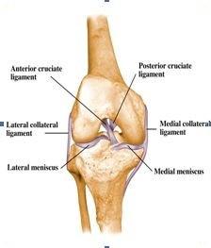

Joint stability refers to the resistance offered by various musculo-skeletal tissues surrounding a joint.

**JOINTS**

**Identify the joints in the skeleton. Describe the purpose of different joints in relation to sporting activity. There are three types of joints:**

|  |  |  |
| --- | --- | --- |
| **Joint** | **Description** | **Example** |
|  |  |  |
|  |  |  |
|  |  |  |

**There are six types of synovial joints:**

|  |  |  |
| --- | --- | --- |
| **Joint and example** | **Structure** | **Movement/ stability** |
|  |  |  |
|  |  |  |
|  |  |  |
|  |  |  |
|  |  |  |
|  |  |  |

**THE STRUCTURE OF A SYNOVIAL JOINT**

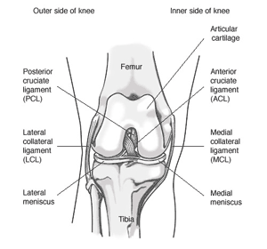

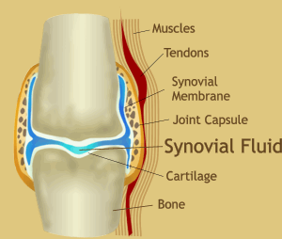

|  |  |  |
| --- | --- | --- |
| **Feature** | **Structure** | **Function** |
| **Ligament** |  |  |
| **Synovial Membrane** |  |  |
| **Synovial Fluid** |  |  |
| **Articular Cartilage** |  |  |
| **Joint Capsule** |  |  |

**How do you mobilise joints in a warm up routine? What is the importance of this?**

________________________________________________________________________________________________________________________________________________________________________________________________________________________________________________________________________________________________________________________________________________________________________________________________________________________________________________________________________________________________________________________________________________________________________________________________________________________________________________________________________________________________________________________________________________________________________________________________________________________________

Notes:

**Define the joint actions:**

|  |  |
| --- | --- |
| 1. **http://chestofbooks.com/health/body/massage/Massage-Original-Swedish-Movements/images/Fig-68-Standing-Flexion-and-Extension-of-the-Leg.pngFLEXION** |  |
| 1. **http://www.weight-lifting-workout-routines.com/leg-extensions.jpgEXTENSION** |  |
| 1. **ABDUCTION**   **http://content.answers.com/main/content/img/oxford/Oxford_Sports/0199210896.abduction.1.jpg** |  |
| 1. **http://www.wbsgallery.org.uk/wbsGallery_main/main.php?g2_view=core.DownloadItem&g2_itemId=17361&g2_serialNumber=1ADDUCTION** |  |
| 1. **CIRCUMDUCTION**   **http://content.answers.com/main/content/img/oxford/Oxford_Sports/0199210896.circumduction.1.jpg** |  |
| 1. **http://content.answers.com/main/content/img/oxford/Oxford_Sports/0199210896.pronation.1.jpgPRONATION** |  |
| 1. **http://content.answers.com/main/content/img/oxford/Oxford_Sports/0199210896.supination.1.jpgSUPINATION** |  |
| 1. **HORIZONTAL FLEXION**   **http://www.abcbodybuilding.com/anatomy/Adductionhoriziontal.jpg** |  |
| 1. **http://www.cs.cmu.edu/~cline/exer/HorizontalAbduction.gifHORIZONTAL EXTENSION** |  |
| 1. **http://comps.fotosearch.com/comp/LIF/LIF116/rom-shoulder-rotation_~RSHOULR.jpgROTATION** |  |
| 1. **PLANTAR FLEXION**   **http://comps.fotosearch.com/comp/LIF/LIF125/lateral-view-foot_~3D502003.jpg** |  |
| 1. **http://comps.fotosearch.com/comp/LIF/LIF125/lateral-view-foot_~3D502003.jpgDORSI FLEXION** |  |
| 1. **http://academic.scranton.edu/faculty/KOSMAHLE1/courses/pt351/lect351/laterafl.jpgLATERAL FLEXION** |  |

**Define and give examples of the anatomical terms:**

|  |  |  |
| --- | --- | --- |
| **TERM** | **DEFINITION** | **EXAMPLE** |
| **Anterior** |  |  |
| **Posterior** |  |  |
| **Superior** |  |  |
| **Inferior** |  |  |
| **Medial** |  |  |
| **Lateral** |  |  |

**Joints perform different actions. List the relevant actions:**

|  |  |
| --- | --- |
| **Joint** | **Joint Action** |
| **http://www.hughston.com/hha/b.wrstfx1a.jpgWrist** |  |
| **http://www.benessere.com/fitness_e_sport/images/63_gomito.jpgRadio-ulnar** |  |
| **http://www.eorthopod.com/sites/default/files/images/elbow_arthro_anatomy01.jpgElbow** |  |
| **http://stemcelldoc.files.wordpress.com/2009/01/shoulder-joint.jpgShoulder** |  |
| **http://4.bp.blogspot.com/_cLbr1ziwRS4/SBuzuYiNYyI/AAAAAAAAAVc/5jo-_E3WCK8/s320/Shoulder+joint.jpgShoulder Girdle** |  |
| **http://static.spineuniverse.com/displaygraphic.php/171/spine3-BB.jpgSpine** |  |
| **http://www.eorthopod.com/images/ContentImages/hip/hip_anatomy/hip_anatomy_intro01.jpgHip** |  |
| **http://factotem.org/library/images/Knee-anatomy-physiology/right-knee-anterior-view.jpgKnee** |  |
| **http://www.nbwebexpress.com/images/fhc_images/sprains_fig1.gifAnkle** |  |

**Impact of different types of physical activity on the SKELETAL system (BONE HEALTH AND BONE DISORDER)**

**Critically evaluate the impact of different types of physical activity (contact sports, high impact sports and activities, involving repetitive actions) on the skeletal system (bones). Think about lifelong active and healthy lifestyles.**

|  |  |  |  |
| --- | --- | --- | --- |
|  | **DESCRIPTION** | **POSITIVE EFFECT OF DIFFERENT TYPES OF EXERCISE** | **NEGATIVE EFFECT OF DIFFERENT TYPES OF EXERCISE** |
| **Osteoporosis** |  |  |  |
| **Growth Plate** |  |  |  |

**Impact of different types of physical activity on the SKELETAL system (JOINT HEALTH AND JOINT DISORDERS)**

**Critically evaluate the impact of different types of physical activity (contact sports, high impact sports and activities, involving repetitive actions) on the skeletal system (joints). Think about lifelong active and healthy lifestyles.**

|  |  |  |  |
| --- | --- | --- | --- |
|  | **DESCRIPTION** | **POSITIVE EFFECT OF DIFFERENT TYPES OF EXERCISE** | **NEGATIVE EFFECT OF DIFFERENT TYPES OF EXERCISE** |
| **Osteoarthritis** |  |  |  |
| **Joint Stability** |  |  |  |

**THE MUSCULAR SYSTEM**

There are **THREE** main types of muscle within our body. **Cardiac** (the heart), **Smooth** (involuntary – e.g. the bladder/intestines), and **Skeletal** (voluntary – e.g. the biceps).

In relation to AS Physical Education we are concentrating in this section on **SKELETAL** muscle.

**SKELETAL** muscle is responsible for the body’s mechanical movement, and is central to our study of movement analysis.

**Properties of Skeletal Muscle**

* **Extensibility:**

________________________________________________________________________________________________________________________________________________________________________________________________________________________________________________

________________________________________________________________________________

* **Elasticity:**

________________________________________________________________________________________________________________________________________________________________________________________________________________________________________________

________________________________________________________________________________

* **Contractility:**

________________________________________________________________________________________________________________________________________________________________________________________________________________________________________________

________________________________________________________________________________

**Functions of Skeletal Muscle**

* Movement
* Support and Posture
* Heat production

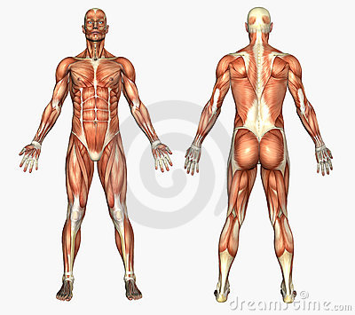 **Label the muscles and complete the table below:**

**Muscle Pairings**

You should already know the muscle pairings. This will assist you greatly in looking at muscle actions and movement analysis. As quick revision session match up the following muscles by placing them in the table below.

Supinator Biceps Brachii Latissimus Dorsi

Gluteus Medius/Minimus Gastrocnemius & Soleus Gluteus Maximus

Trapezius Wrist Flexors Quadriceps

Deltoid Pectoralis Major Wrist Extensors

Triceps Brachii Hamstrings Pronator Teres

Rectus Abdominus Iliopsoas Adductor group

Tibialis Anterior Erector Spinae

|  |  |
| --- | --- |
|  |  |
|  |  |
|  |  |
|  |  |
|  |  |
|  |  |
|  |  |
|  |  |
|  |  |
|  |  |

***\* KEY TERMS:***

**ORIGIN** – Point of attachment of a muscle that remains relatively fixed during muscular contraction

**INSERTION** – Point of attachment of a muscle that tends to move toward the origin during muscular

contraction.

**AGONIST MUSCLE** – The muscle directly responsible for the movement at a joint.

**ANTAGONIST MUSCLE**– The muscle that has an action opposite of that of the agonist and helps the

co-ordination of the movement.

**Rotator Cuff Muscles**

The **SUPRASPINATUS, INFRASPINATUS, TERES MINOR** and **SUBSCAPULARIS** muscles make up the rotator cuff.

They work to stabilise the shoulder joint to prevent the larger muscles from displacing the head of the humerus (dislocation) during physical activity.

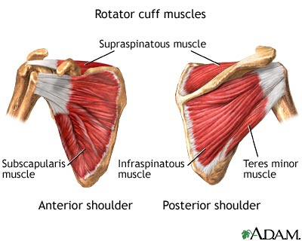

**What joint action do they cause?**

|  |  |  |
| --- | --- | --- |
| **Rotator Cuff Muscle** | **Joint Action** | **Sporting Example** |
| **Supraspinatus** | **Abduction of humerus (prevents downwards dislocation)** |  |
| **Subscapularis** | **Adduction and medial rotation of humerus** |  |
| **Infraspinatus** | **Lateral rotation and adduction of humerus** |  |
| **Teres Minor** | **Lateral rotation and adduction of humerus** |  |

***\* APPLY IT:***

Injuries to the rotator cuff may result from a sudden force or repetitive actions. Throwers are particularly at risk of injury to their rotator cuff through repetition, as the muscles work to control the acceleration of the arm after the point of release. They are therefore working eccentrically and this can produce a force of up to 80% of the body weight to travel through the tendons of the rotator cuff muscles.

**Core Stability**

The term core stability refers to the ability to prevent unwanted movement of the body’s centre. The reason why core stability is so important is due to the role of the axial skeleton in providing a base for movement of the appendicular skeleton. The axial skeleton provides the foundations for movement. The more stable these foundations, the more control there is available for co-ordinated movements of the appendicular skeleton (arms and legs).

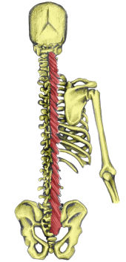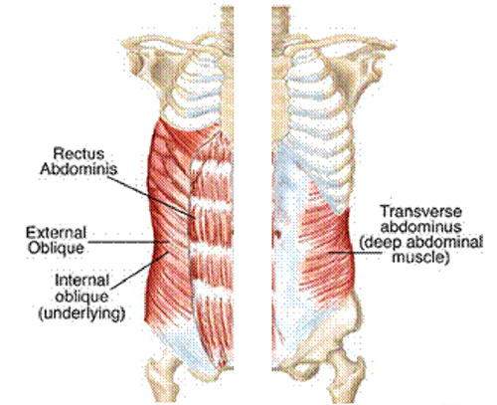

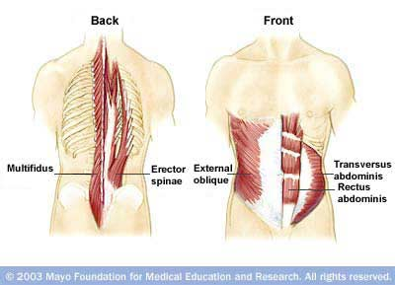

The superficial muscles that cross the spine **(RECTUS ABDOMINUS, EXTERNAL OBLIQUES and ERECTOR SPINAE)** provide large/gross movements.

The deeper muscles **(TRANSVERSE ABDOMINUS, MULTIFIDUS and INTERNAL OBLIQUES)** provide for fine control of movement and stability.

|  |  |  |  |  |  |
| --- | --- | --- | --- | --- | --- |
| **Name** | **Joint Type** | **Articulating Bones** | **Movement** | **Agonist** | **Antagonists** |
| **Knee** |  |  |  |  |  |
|  |  |  |
| **Radio-ulnar** |  |  |  |  |  |
|  |  |  |
| **Elbow** |  |  |  |  |  |
|  |  |  |
| **Ankle** |  |  |  |  |  |
|  |  |  |
| **Hip** |  |  |  |  |  |
|  |  |  |
|  |  |  |
|  |  |  |
|  |  |  |
|  |  |  |
| **Shoulder** |  |  |  |  |  |
|  |  |  |
|  |  |  |
|  |  |  |
|  |  |  |
|  |  |  |
| **Spine** |  |  |  |  |  |
|  |  |  |
|  |  |  |
|  |  |  |

**The Role of Muscular contraction**

In order to produce the vast range of movements of which it is capable, the body’s muscles either shorten, lengthen or remain the same length whilst contracting.

**Define the following terms and give sporting examples of each:**

**ISOMETRIC:**

________________________________________________________________________________________________________________________________________________________________

**ISOTONIC** contractions refer to when a muscle is moving while contracting. This can be divided further into concentric and eccentric muscle actions.

**ISOTONIC**

**CONCENTRIC ECCENTRIC**

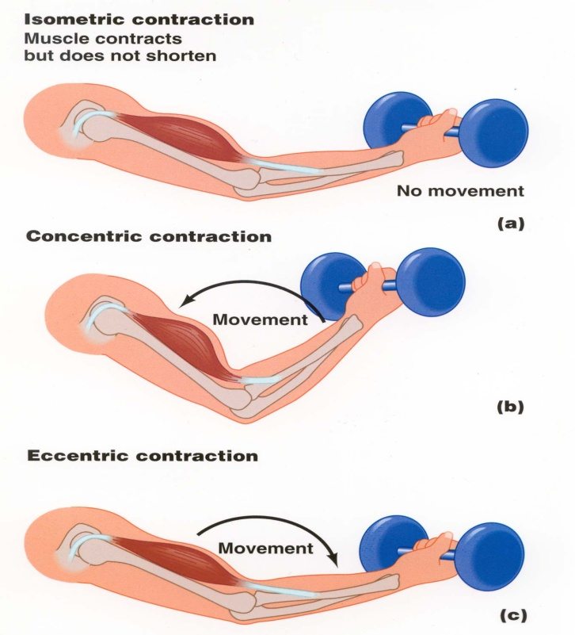

Discuss eccentric contraction in training and training methods (Plyometrics):

________________________________________________________________________________________________________________________________________________________________

________________________________________________________________________________________________________________________________________________________________

________________________________________________________________________________________________________________________________________________________________

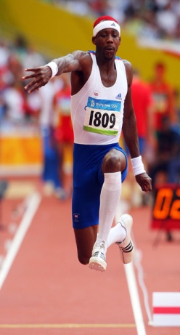

***IN CONTEXT:***

*When a muscle contracts eccentrically it is often acting as a brake to counteract the effect of gravity. So a triple jumper’s quadriceps muscles must contract eccentrically on landing during the hop-and-step phase to stop the leg from buckling and the jumper collapsing to the floor.*

**Movement analysis of physical activity**

**Choose a sporting practical activity. Carry out a movement analysis making reference to**

* Joint type
* The type of movement produced
* The agonist muscles
* The antagonist muscles
* The type of muscle contraction

1. .
2. .

5.

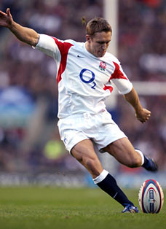

**Muscular Contraction Circuit**

**Station 1: Lateral Raise**

|  |  |  |  |  |  |  |  |  |  |
| --- | --- | --- | --- | --- | --- | --- | --- | --- | --- |
| What movement is occurring at the shoulder joint during the upwards phase of the exercise? | Agonist/Prime Mover | Type of contraction | Antagonist | Type of contraction | What movement is occurring at the shoulder joint during the downwards phase of the exercise? | Agonist/Prime Mover | Type of contraction | Antagonist | Type of contraction |
|  |  |  |  |  |  |  |  |  |  |

**Station 2: Squats**

|  |  |  |  |  |  |  |  |  |  |
| --- | --- | --- | --- | --- | --- | --- | --- | --- | --- |
| What movement is occurring at the knee joint during the downwards phase of the exercise? | Agonist/Prime Mover | Type of contraction | Antagonist | Type of contraction | What movement is occurring at the hip joint during the upwards phase of the exercise? | Agonist/Prime Mover | Type of contraction | Antagonist | Type of contraction |
|  |  |  |  |  |  |  |  |  |  |

**Station 3: Press Up**

|  |  |  |  |  |  |  |  |  |  |
| --- | --- | --- | --- | --- | --- | --- | --- | --- | --- |
| What movement is occurring at the elbow joint during the downwards phase of the exercise? | Agonist/Prime Mover | Type of contraction | Antagonist | Type of contraction | What movement is occurring at the elbow joint during the upwards phase of the exercise? | Agonist/Prime Mover | Type of contraction | Antagonist | Type of contraction |
|  |  |  |  |  |  |  |  |  |  |

**Station 4: Abdominal Crunch**

|  |  |  |  |  |  |  |  |  |  |
| --- | --- | --- | --- | --- | --- | --- | --- | --- | --- |
| What movement is occurring at the spine during the upwards phase of the exercise? | Agonist/Prime Mover | Type of contraction | Antagonist | Type of contraction | What movement is occurring at the spine during the downwards phase of the exercise? | Agonist/Prime Mover | Type of contraction | Antagonist | Type of contraction |
|  |  |  |  |  |  |  |  |  |  |

**Station 5: Plank**

|  |  |  |  |  |  |  |  |  |  |
| --- | --- | --- | --- | --- | --- | --- | --- | --- | --- |
| What movement has occurred at the elbow joint to get into the plank position? | Agonist/Prime Mover | Type of contraction | Antagonist | Type of contraction | What movement has occurred at the ankle joint to get into the plank position? | Agonist/Prime Mover | Type of contraction | Antagonist | Type of contraction |
|  |  |  |  |  |  |  |  |  |  |

**Station 6: Lunges**

|  |  |  |  |  |  |  |  |  |  |
| --- | --- | --- | --- | --- | --- | --- | --- | --- | --- |
| What movement is occurring at the front hip during the downwards phase of a lunge? | Agonist/Prime Mover | Type of contraction | Antagonist | Type of contraction | What movement is occurring at the front knee during the upwards phase of the lunge? | Agonist/Prime Mover | Type of contraction | Antagonist | Type of contraction |
|  |  |  |  |  |  |  |  |  |  |

**Station 7: Bench Press**

|  |  |  |  |  |  |  |  |  |  |
| --- | --- | --- | --- | --- | --- | --- | --- | --- | --- |
| What movement is occurring at the shoulder joint on the upwards phase of the bench press? | Agonist/Prime Mover | Type of contraction | Antagonist | Type of contraction | What movement is occurring at the shoulder joint on the downwards phase of the bench press? | Agonist/Prime Mover | Type of contraction | Antagonist | Type of contraction |
|  |  |  |  |  |  |  |  |  |  |

**Station 8: Basketball Free Throw**

|  |  |  |  |  |  |  |  |  |  |
| --- | --- | --- | --- | --- | --- | --- | --- | --- | --- |
| What movement is occurring at the elbow joint during the release of the ball on the free throw? | Agonist/Prime Mover | Type of contraction | Antagonist | Type of contraction | What movement is occurring at the wrist joint during the release of the basketball on the free throw? | Agonist/Prime Mover | Type of contraction | Antagonist | Type of contraction |
|  |  |  |  |  |  |  |  |  |  |

**Muscle fibres types in relation to choice of physical activity**

**Describe the structure and function of different muscle fibre types.**

|  |  |  |
| --- | --- | --- |
|  | **STRUCTURAL** | **FUNCTIONAL** |
| **SLOW OXIDATIVE** |  |  |
| **FAST OXIDATIVE GLYCOLYTIC** |  |  |
| **FAST GLYCOLYTIC** |  |  |

**Choose a number of sporting activities and discuss fibre type recruitment.**

|  |  |
| --- | --- |
| **Fibre types** | **Sporting activities** |
|  |  |
|  |  |
|  |  |

**Discuss and explore the genetic nature of fibre types and choice of sporting activities.**

________________________________________________________________________________________________________________________________________________________________

________________________________________________________________________________________________________________________________________________________________

________________________________________________________________________________________________________________________________________________________________

________________________________________________________________________________________________________________________________________________________________

________________________________________________________________________________________________________________________________________________________________

________________________________________________________________________________________________________________________________________________________________

________________________________________________________________________________________________________________________________________________________________

________________________________________________________________________________________________________________________________________________________________

**Warm up and Cool down**

Describe the effect of a warm up and cool down on skeletal muscle in relation to the quality of performance of physical activity.

**EFFECT OF A WARM UP ON SKELETAL MUSCLE TISSUE:**

…………………………………………………………………………………………………………

…………………………………………………………………………………………………………

…………………………………………………………………………………………………………

…………………………………………………………………………………………………………

…………………………………………………………………………………………………………

…………………………………………………………………………………………………………

**EFFECT OF A COOL DOWN ON SKELETAL MUSCLE:**

…………………………………………………………………………………………………………

…………………………………………………………………………………………………………

…………………………………………………………………………………………………………

…………………………………………………………………………………………………………

…………………………………………………………………………………………………………

…………………………………………………………………………………………………………

________________________________________________________________________________________________________________________________________________________________

________________________________________________________________________________________________________________________________________________________________

________________________________________________________________________________________________________________________________________________________________

________________________________________________________________________________________________________________________________________________________________

________________________________________________________________________________________________________________________________________________________________

________________________________________________________________________________________________________________________________________________________________

________________________________________________________________________________

________________________________________________________________________________________________________________________________________________________________

________________________________________________________________________________________________________________________________________________________________

________________________________________________________________________________________________________________________________________________________________

________________________________________________________________________________

________________________________________________________________________________________________________________________________________________________________

________________________________________________________________________________________________________________________________________________________________

________________________________________________________________________________________________________________________________________________________________

________________________________________________________________________________

**Impact of different types of physical activity on the MUSCULAR system (MUSCLE HEALTH)**

**Critically evaluate the impact of different types of physical activity (contact sports, high impact sports and activities, involving repetitive actions) on the muscular system. Think about lifelong active and healthy lifestyles.**

|  |  |  |  |
| --- | --- | --- | --- |
|  | **DESCRIPTION** | **POSITIVE EFFECT OF DIFFERENT TYPES OF EXERCISE** | **NEGATIVE EFFECT OF DIFFERENT TYPES OF EXERCISE** |
| **Posture and Alignment** |  |  |  |

**Short Term and Long Term Effects of Physical Activity on the Skeletal and Muscular Systems**

**SHORT TERM**

|  |  |
| --- | --- |
| **SKELETAL SYSTEM** | **MUSCULAR SYSTEM** |
|  |  |

**LONG TERM**

|  |  |
| --- | --- |
| **SKELETAL SYSTEM** | **MUSCULAR SYSTEM** |
|  |  |

**Developing ‘higher order’ thinking and writing skills**

First - read the exam question very carefully. This requires you to identify the command word, the subject and exactly what is being examined about the subject. Then - (if required by the command word) set off on the road to critical evaluation

|  |  |  |
| --- | --- | --- |
| Identify Describe | Explain Give reasons for | Discuss Analyse Critically evaluate |
| Brainstorm | Write….develop | Think of alternatives Develop further |
| Think of points that relate directly to the exam question | Develop key points by saying why and how they are significant to the  question  Explain significance | Critically reflect  on what you have written |
| List or ‘spider diagram’ your points/  ideas | Give examples and evidence to  support your points | Complete key points or paragraphs  with alternative evidence / a different  view |

Start here Development of a critical argument for an essay End Here

|  |  |  |  |
| --- | --- | --- | --- |
| 1. Know & understand | 2. Apply | | 3. Evaluate & synthesise |
| Key Idea | Example/evidence | Explanation | Development/critical evaluation What’s good or bad? What have others  said? What do you think? Why? |
| **Critically evaluate the impact of different types of physical activity on the skeletal system** | High impact |  | However, |
|  |  |  |  |

**References**

[www.bbc.co.uk/science/humanbody](http://www.bbc.co.uk/science/humanbody)

[www.nln.co.uk](http://www.nln.co.uk)

[www.medicdirectsport.com/exercisetheory](http://www.medicdirectsport.com/exercisetheory)

[www.pponline.co.uk](http://www.pponline.co.uk)

[www.sportdevelopment.org.uk/talentid](http://www.sportdevelopment.org.uk/talentid)

[www.pennhealth.com](http://www.pennhealth.com)