Full movement patterns for two joints on a youth.
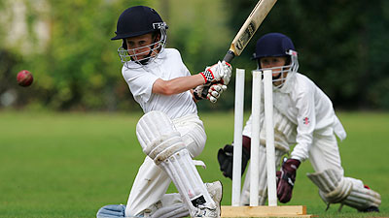
Movement pattern for joint 1
Name of the joint,
The articulating bones.
The agonist the antagonist.
The type of contraction.
The predominant muscle fibre.
Possible issues around exercise at this age relating to joints or bones and muscles.
State effect of the warm up and cool down.
-----------------------------------------------------------------------------------------------------------------------------------------------------------------------------------------------------------------------------------------------------------------------------------------------------------------------------------------------------------------------------------------------------------------------------------------------------------------------------------------------------------------------------------------------------------------------------------------------------------------------------------------------------------------------------------------------------------------------------------------------------------------------------------------------------------------------------------------------------------------------------------------------------------------------------------------------------------------------------------------------------------------------------------------------------------------------------------------------------------------------------------------------------------------------------------------------------------------------------------------------------------------------------------------------------------------------------------------------------------------------------------------------------------------------------------------------------------------------------------------------------------------------------------------------------------------------------------------------------------------------------------------------------------------------
Movement pattern for joint 2
Name of the joint,
The articulating bones.
The agonist the antagonist.
The type of contraction.
The predominant muscle fibre.
Possible issues around exercise at this age relating to joints or bones and muscles.
State effect of the warm up and cool down.
--------------------------------------------------------------------------------------------------------------------------------------------------------------------------------------------------------------------------------------------------------------------------------------------------------------------------------------------------------------------------------------------------------------------------------------------------------------------------------------------------------------------------------------------------------------------------------------------------------------------------------------------------------------------------------------------------------------------------------------------------------------------------------------------------------------------------------------------------------------------------------------------------------------------------------------------------------------------------------------------------------------------------------------------------------------------------------------------------------------------------------------------------------------------------------------------------------------------------------------------------------------------------------------------------------------------------------------------------------------------------------------------------------------------------------------------------------------------------------------------------------------------------------------------------------------------------------------------------------------------------------------------------------------------------------------------------------------------------------------------------------------------------------------------------------------------------------------------------------------------------------------------------------------------------------------------------------------------------------------------------------------------------------------------------------------------------------------------------------------------------------------------------------------------------------------------------------------------------------------------------------------------------------------------------------------------------------------------------------------------------------------------------------------------------------------------------------------------------------------------------------------------------------------------------------------------------------------------------------------------------------------------------

Full movement pattern of two joints
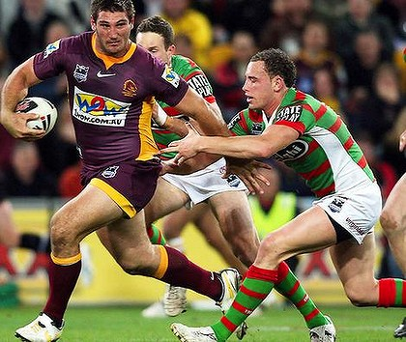
(please note you can’t use elbow and knee) Movement pattern for joint 1
Name of the joint,
The articulating bones.
The agonist the antagonist.
The type of contraction.
The predominant muscle fibre.
Possible issues around exercise at this age relating to joints or bones and muscles.
State effect of the warm up and cool down.
-----------------------------------------------------------------------------------------------------------------------------------------------------------------------------------------------------------------------------------------------------------------------------------------------------------------------------------------------------------------------------------------------------------------------------------------------------------------------------------------------------------------------------------------------------------------------------------------------------------------------------------------------------------------------------------------------------------------------------------------------------------------------------------------------------------------------------------------------------------------------------------------------------------------------------------------------------------------------------------------------------------------------------------------------------------------------------------------------------------------------------------------------------------------------------------------------------------------------------------------------------------------------------------------------------------------------------------------------------------------------------------------------------------------------------------------------------------------------------------------------------------------------------------------------------------------------------------------------------------------------------------------------------------------------
Movement pattern for joint 2
Name of the joint,
The articulating bones.
The agonist the antagonist.
The type of contraction.
The predominant muscle fibre.
Possible issues around exercise at this age relating to joints or bones and muscles.
State effect of the warm up and cool down.
--------------------------------------------------------------------------------------------------------------------------------------------------------------------------------------------------------------------------------------------------------------------------------------------------------------------------------------------------------------------------------------------------------------------------------------------------------------------------------------------------------------------------------------------------------------------------------------------------------------------------------------------------------------------------------------------------------------------------------------------------------------------------------------------------------------------------------------------------------------------------------------------------------------------------------------------------------------------------------------------------------------------------------------------------------------------------------------------------------------------------------------------------------------------------------------------------------------------------------------------------------------------------------------------------------------------------------------------------------------------------------------------------------------------------------------------------------------------------------------------------------------------------------------------------------------------------------------------------------------------------------------------------------------------------------------------------------------------------------------------------------------------------------------------------------------------------------------------------------------------------------------------------------------------------------------------------------------------------------------------------------------------------------------------------------------------------------------------------------------------------------------------------------------------------------------------------------------------------------------------------------------------------------------------------------------------------------------------------------------------------------------------------------------------------------------------------------------------------------------------------------------------------------------------------------------------------------------------------------------------------------------------------

Full movement pattern for two joints
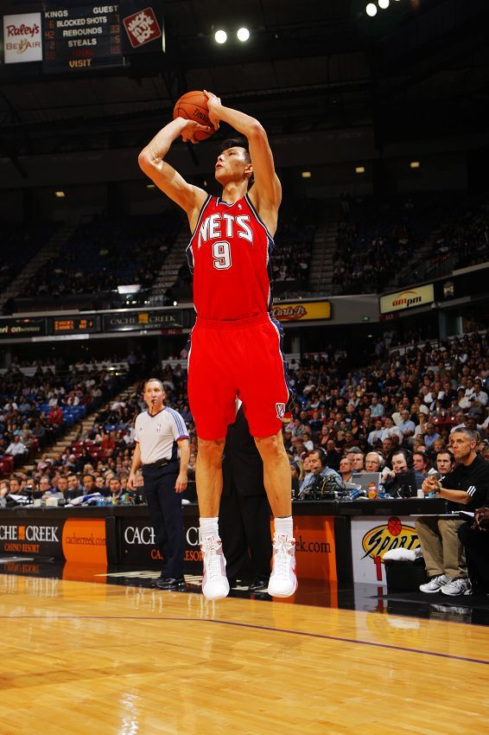
(Please note you can’t use elbow and knee) Movement pattern for joint 1
Name of the joint,
The articulating bones.
The agonist the antagonist.
The type of contraction.
The predominant muscle fibre.
Possible issues around exercise at this age relating to joints or bones and muscles.
State effect of the warm up and cool down.
-----------------------------------------------------------------------------------------------------------------------------------------------------------------------------------------------------------------------------------------------------------------------------------------------------------------------------------------------------------------------------------------------------------------------------------------------------------------------------------------------------------------------------------------------------------------------------------------------------------------------------------------------------------------------------------------------------------------------------------------------------------------------------------------------------------------------------------------------------------------------------------------------------------------------------------------------------------------------------------------------------------------------------------------------------------------------------------------------------------------------------------------------------------------------------------------------------------------------------------------------------------------------------------------------------------------------------------------------------------------------------------------------------------------------------------------------------------------------------------------------------------------------------------------------------------------------------------------------------------------------------------------------------------------------

Movement pattern for joint 2
Name of the joint,
The articulating bones.
The agonist the antagonist.
The type of contraction.
The predominant muscle fibre.
Possible issues around exercise at this age relating to joints or bones and muscles.
State effect of the warm up and cool down.
--------------------------------------------------------------------------------------------------------------------------------------------------------------------------------------------------------------------------------------------------------------------------------------------------------------------------------------------------------------------------------------------------------------------------------------------------------------------------------------------------------------------------------------------------------------------------------------------------------------------------------------------------------------------------------------------------------------------------------------------------------------------------------------------------------------------------------------------------------------------------------------------------------------------------------------------------------------------------------------------------------------------------------------------------------------------------------------------------------------------------------------------------------------------------------------------------------------------------------------------------------------------------------------------------------------------------------------------------------------------------------------------------------------------------------------------------------------------------------------------------------------------------------------------------------------------------------------------------------------------------------------------------------------------------------------------------------------------------------------------------------------------------------------------------------------------------------------------------------------------------------------------------------------------------------------------------------------------------------------------------------------------------------------------------------------------------------------------------------------------------------------------------------------------------------------------------------------------------------------------------------------------------------------------------------------------------------------------------------------------------------------------------------------------------------------------------------------------------------------------------------------------------------------------------------------------------------------------------------------------------------------------------

Full movement patterns for two joints
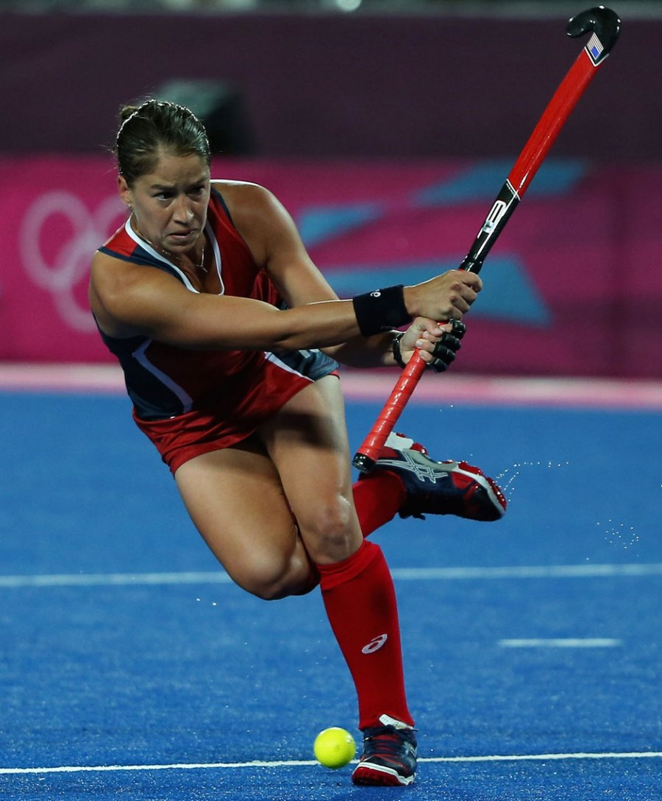
(Please note you can’t use elbow and knee) Movement pattern for joint 1
Name of the joint,
The articulating bones.
The agonist the antagonist.
The type of contraction.
The predominant muscle fibre.
Possible issues around exercise at this age relating to joints or bones and muscles.
State effect of the warm up and cool down.
-----------------------------------------------------------------------------------------------------------------------------------------------------------------------------------------------------------------------------------------------------------------------------------------------------------------------------------------------------------------------------------------------------------------------------------------------------------------------------------------------------------------------------------------------------------------------------------------------------------------------------------------------------------------------------------------------------------------------------------------------------------------------------------------------------------------------------------------------------------------------------------------------------------------------------------------------------------------------------------------------------------------------------------------------------------------------------------------------------------------------------------------------------------------------------------------------------------------------------------------------------------------------------------------------------------------------------------------------------------------------------------------------------------------------------------------------------------------------------------------------------------------------------------------------------------------------------------------------------------------------------------------------------------------------

Movement pattern for joint 2
Name of the joint,
The articulating bones.
The agonist the antagonist.
The type of contraction.
The predominant muscle fibre.
Possible issues around exercise at this age relating to joints or bones and muscles.
State effect of the warm up and cool down.
--------------------------------------------------------------------------------------------------------------------------------------------------------------------------------------------------------------------------------------------------------------------------------------------------------------------------------------------------------------------------------------------------------------------------------------------------------------------------------------------------------------------------------------------------------------------------------------------------------------------------------------------------------------------------------------------------------------------------------------------------------------------------------------------------------------------------------------------------------------------------------------------------------------------------------------------------------------------------------------------------------------------------------------------------------------------------------------------------------------------------------------------------------------------------------------------------------------------------------------------------------------------------------------------------------------------------------------------------------------------------------------------------------------------------------------------------------------------------------------------------------------------------------------------------------------------------------------------------------------------------------------------------------------------------------------------------------------------------------------------------------------------------------------------------------------------------------------------------------------------------------------------------------------------------------------------------------------------------------------------------------------------------------------------------------------------------------------------------------------------------------------------------------------------------------------------------------------------------------------------------------------------------------------------------------------------------------------------------------------------------------------------------------------------------------------------------------------------------------------------------------------------------------------------------------------------------------------------------------------------------------------------------

Full movement pattern for two joints
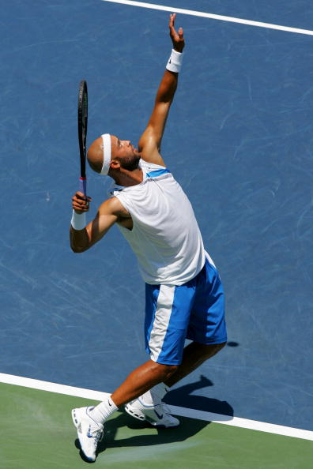
(Please note you can’t use elbow and knee) Movement pattern for joint 1
Name of the joint,
The articulating bones.
The agonist the antagonist.
The type of contraction.
The predominant muscle fibre.
Possible issues around exercise at this age relating to joints or bones and muscles.
State effect of the warm up and cool down.
-----------------------------------------------------------------------------------------------------------------------------------------------------------------------------------------------------------------------------------------------------------------------------------------------------------------------------------------------------------------------------------------------------------------------------------------------------------------------------------------------------------------------------------------------------------------------------------------------------------------------------------------------------------------------------------------------------------------------------------------------------------------------------------------------------------------------------------------------------------------------------------------------------------------------------------------------------------------------------------------------------------------------------------------------------------------------------------------------------------------------------------------------------------------------------------------------------------------------------------------------------------------------------------------------------------------------------------------------------------------------------------------------------------------------------------------------------------------------------------------------------------------------------------------------------------------------------------------------------------------------------------------------------------------------

Movement pattern for joint 2
Name of the joint,
The articulating bones.
The agonist the antagonist.
The type of contraction.
The predominant muscle fibre.
Possible issues around exercise at this age relating to joints or bones and muscles.
State effect of the warm up and cool down.
--------------------------------------------------------------------------------------------------------------------------------------------------------------------------------------------------------------------------------------------------------------------------------------------------------------------------------------------------------------------------------------------------------------------------------------------------------------------------------------------------------------------------------------------------------------------------------------------------------------------------------------------------------------------------------------------------------------------------------------------------------------------------------------------------------------------------------------------------------------------------------------------------------------------------------------------------------------------------------------------------------------------------------------------------------------------------------------------------------------------------------------------------------------------------------------------------------------------------------------------------------------------------------------------------------------------------------------------------------------------------------------------------------------------------------------------------------------------------------------------------------------------------------------------------------------------------------------------------------------------------------------------------------------------------------------------------------------------------------------------------------------------------------------------------------------------------------------------------------------------------------------------------------------------------------------------------------------------------------------------------------------------------------------------------------------------------------------------------------------------------------------------------------------------------------------------------------------------------------------------------------------------------------------------------------------------------------------------------------------------------------------------------------------------------------------------------------------------------------------------------------------------------------------------------------------------------------------------------------------------------------------------------

