AS P.E Respiratory system

Gas exchange internal and external respiration

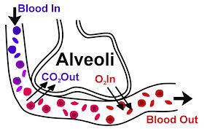

Name ……………………………………………………………………
Teacher ……………………………………………………………………

Gas exchange partial pressure and internal and external respiration
Notes:
We have looked at how the respiratory system can supply air to the lungs through pulmonary ventilation. We have studied the mechanics of inspiration and expiration. Now we need to understand how the oxygen and carbon dioxide are actually exchanged.
What is diffusion?
………………………………………………………………………………………………………………………………………………………………………………………………………………………………………………………………………………………………………………………………………………………………………………………………What is internal and external respiration?
………………………………………………………………………………………………………………………………………………………………………………………………………………………………………………………………………………………………………………………………………………………………………………………………………………………………………………………………………………………………………………………………………………………………………………………………………………………………………………………………………………………………………………………………………………………………………………………………
Complete a flow diagram of the exchange of gas from the Alveoli to the capillaries. Label this external respiration.

Complete a flow diagram of the exchange of gas from the capillaries to the working muscles. Label this internal respiration.

Exchange of gas
 | External Respiration | Internal Respiration
Where
Movement
Why?
O2
Why?
CO2

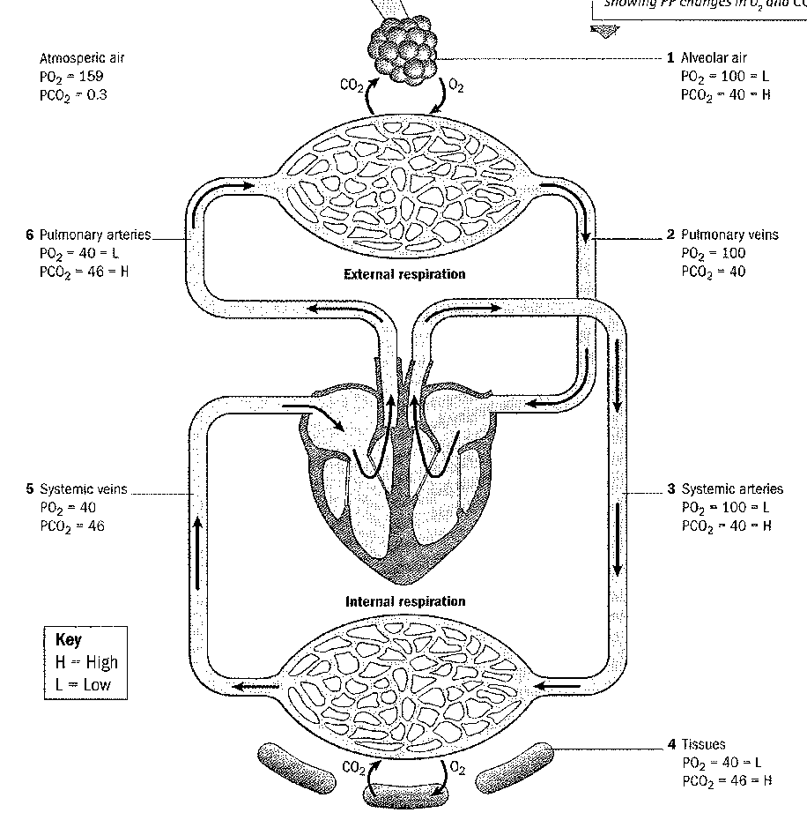
Exam tip: You need to know the role of Haemoglobin and myoglobin in gas exchange.
You also need to know how C02 is transported. (we have covered this already)

Q Describe how gas transfers from the blood to the muscles using the technical vocabulary. 4
………………………………………………………………………………………………………………………………………………………………………………………………………………………………………………………………………………………………………………………………………………………………………………………………………………………………………………………………………………………………………………………………………………………………………………………………………………………………………………………………………………………………………………………………………………………………………………………………………………………………………………………………………………………………………………………………………………………………………………
Technical vocabulary:
Haemoglobin Myoglobin Partial pressure Diffusion

Q Identify ways in which carbon dioxide is carried in the blood during aerobic performance.
[2]
………………………………………………………………………………………………………………………………………………………………………………………………………………………………………………………………………………………………………………………………………………………………………………………………………………………………………………………………………………………

Plasma haemoglobin carbaminohaemoglobin Dissolves in water/forms carbonic acid

8. During aerobic performance a large amount of carbon dioxide is produced at the muscles.
(i) How is carbon dioxide diffused from the muscle tissue into the blood during exercise?
[4]
…………………………………………………………………………………………………………………………………………………………………………………………………………………………………………………………………………………………………………………………………………………………………………………………………………………………………………………………………………………………………………………………………………………………………………………………………………………………………………………………………………………………………………………………………………………………………………………………………………………………………………

(iii) Why does an increase in carbon dioxide during exercise increase heart rate? How does this happen?
[3]
…………………………………………………………………………………………………………………………………………………………………………………………………………………………………………………………………………………………………………………………………………………………………………………………………………………………………………………………………………………………………………………………………………………………………………………………………………………………………………………………………………………………………………………………………………………………………………………………………………………………………………

(iv) Describe how the mechanics of breathing alter during exercise to expire greater volumes of carbon dioxide.
[4]
…………………………………………………………………………………………………………………………………………………………………………………………………………………………………………………………………………………………………………………………………………………………………………………………………………………………………………………………………………………………………………………………………………………………………………………………………………………………………………………………………………………………………………………………………………………………………………………………………………………………………………

Changes in gas exchange due to exercise
Having identified the process of gas exchange we need to understand the changes that take place due to exercise. Both external and internal respiration increases during exercise. However, we now need to work out why and how it occurs.

Notes on Oxygen-Haemoglobin dissociation curve.

