Mechanics of the respiratory system
Complete the labels of the diagram
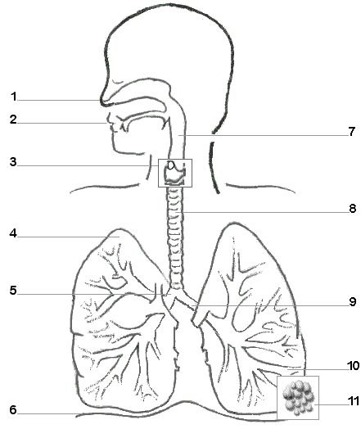
Test yourself: fill in the blanks:
 | Name | Which ones did I know
1 | Nose
2
3
4
5
6
7
8
9
10
11

Is breathing active or passive?
…………………………………………………………
Can you explain why?
…………………………………………………………………………………………………………………………………………………………………………………………………………………………………………………………………………………………………………………………………………………………………………………………………………………………………………………………………………………………………………………………………………………………………………………………………………………………………………………….
An easy way to remember the mechanics of the respiratory system. 5 easy steps.
- Muscles,
- Movement
- Thoracic cavity volume
- Lung volume to
- Inspiration or expiration
Follow the steps through and identify the process as well as the activity occurring.
Inspiration | Expiration

In answer to the question is respiration active or passive I can state that……………………………………………………………………………………………………………………………………………………………………………………………………………………………………………………………………………………………………………………………………………………………………………………………………………………………………………………………………………………………………………………………………………………………………………………………………………………………………………
Inspiration | Expiration
Mechanics of respiration after exercise.

Exam Question
With reference to the mechanics of breathing describe how the cyclist is able to inspire great amounts of oxygen during the training ride. [4]
Bullet point
- .
- .
- .
- .
Describe how the mechanics of breathing alter during exercise to expire greater volumes of carbon dioxide. [4]
Paragraph format

