ACQUIRING MOVEMENT SKILLS

Motor Control of Skills and Transfer of Learning

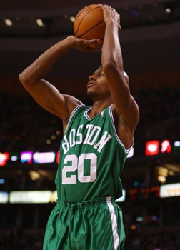

Name: _______________________ Tutor Group:_______

AS PHYSICAL EDUCATION 2013
BOOKLET 4 DTA
Motor control of skills and its impact upon developing effectiveness in physical activity.

Learning Objectives

At the end of this booklet you should be able to:

Learning Objective | Notes | Learnt
- Describe the nature and give examples of motor and executive programmes stored in the long-term memory
- Explain how motor programmes link with open loop control and the autonomous phase of learning
- Describe open and closed loop control
- Explain the role of open and closed loop control in the performance of motor skills
- Evaluate critically different types of feedback to detect and correct errors
- Understand Schema Theory and its role in developing movement skills and strategies

Motor Programmes

What is a motor programme?

____________________________________________________________________________________________
____________________________________________________________________________________________
____________________________________________________________________________________________

What are sub-routines?

__________________________________________________________________________________
__________________________________________________________________________________

Task 1

Using an example from your first sport think of an executive motor programme and come up with the sub-routines that make up that motor programme below.

* KEY TERMS:
Hierarchical – Order of importance, e.g. the EMP is more important than the sub-routines
Sequential – Sub-routines are often performed in a set order
Grooved and overlearned – This means the motor programme has been well learned and is stored in long-term memory. A response can now be made automatically and the performer will be at the autonomous stage of learning.
Adams Open and Closed Loop Control Theory

OPEN LOOP CONTROL

Level One Control

What are the main characteristics of OPEN LOOP CONTROL LEVEL 1?

- __________________________________________________________________________________________________________________________________________________________________________________________

- __________________________________________________________________________________________________________________________________________________________________________________________

- __________________________________________________________________________________________________________________________________________________________________________________________

- __________________________________________________________________________________________________________________________________________________________________________________________

- __________________________________________________________________________________________________________________________________________________________________________________________

* KEY TERMS:
Open Loop Control – A system of subconscious control that does not use or reference feedback
Memory Trace – Is the executive motor programme (EMP)

Can you give a practical example below? Do you think it relates to the phases of learning?
____________________________________________________________________________________________________________________________________________________________________________________________________________________________________________________________________________________________________________________________________________________________________________________________________________________________________________________________________________
CLOSED LOOP CONTROL

Level Two Control

What are the main characteristics of CLOSED LOOP CONTROL LEVEL 2?

- __________________________________________________________________________________________________________________________________________________________________________________________

- __________________________________________________________________________________________________________________________________________________________________________________________

- __________________________________________________________________________________________________________________________________________________________________________________________

- __________________________________________________________________________________________________________________________________________________________________________________________

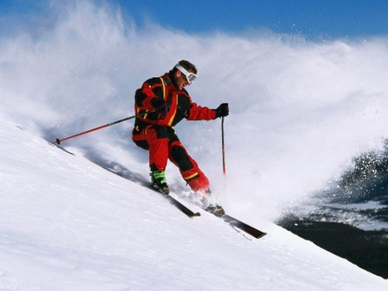

Can you give a practical example below? When do you think you use closed loop level 2 in your sporting performance? Explain your thoughts.
__________________________________________________________________________________________________________________________________________________________________________________________________________________________________________________________________________________________________________________________________________________________________________________________________________________________________________________________________________________________________________________________________________________________________________________________________________________________________________________________________________________________________
CLOSED LOOP CONTROL

Level Three Control

What are the main characteristics of CLOSED LOOP CONTROL LEVEL 3?

- __________________________________________________________________________________________________________________________________________________________________________________________

- __________________________________________________________________________________________________________________________________________________________________________________________

- __________________________________________________________________________________________________________________________________________________________________________________________

- __________________________________________________________________________________________________________________________________________________________________________________________

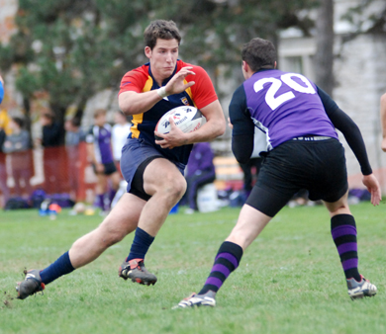
Can you give a practical example below? Do you think it relates to the phases of learning?
____________________________________________________________________________________________________________________________________________________________________________________________________________________________________________________________________________________________________________________________________________________________________________________________________________________________________________________________________________________________________________________________________________________________________________

* REMEMBER:
The feedback loop is called the PERCEPTUAL TRACE and is responsible for adjusting or correcting movement during execution and for completing the skill.
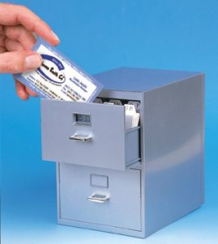
What are the main points of this theory?

- ________________________________________________________________________________________________________________________________________________________________
- _________________________________________________________________________________________________________________________________________________________________________________________

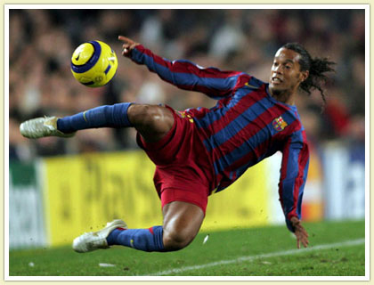

What are drawbacks to this theory?

- _______________________________________________________________________________________________________________________________________________________________________________________________________________________________________

- _______________________________________________________________________________________________________________________________________________________________________________________________________________________________________________________________________________________

- _______________________________________________________________________________________________________________________________________________________________________________________________________________________________________________________________________________________

FEEDBACK

Explanation of Feedback | Critical Evaluation of different types of feedback
Positive Feedback  Given as praise following success | - __________________________________________________________________________________________________  - __________________________________________________________________________________________________  - __________________________________________________________________________________________________
Negative Feedback  Received when the movement is incorrect (intrinsic or extrinsic) | - __________________________________________________________________________________________________  __________________________________________________________________________________________________  - __________________________________________________________________________________________________
Extrinsic Feedback  Received from external sources, coach, team-mates | - __________________________________________________________________________________________________  __________________________________________________________________________________________________  - __________________________________________________________________________________________________
Intrinsic Feedback  Sensory feedback about the physical feel of the movement (proprioceptors / kinaesthesis) | - __________________________________________________________________________________________________  __________________________________________________________________________________________________  - __________________________________________________________________________________________________  __________________________________________________________________________________________________
Terminal Feedback  Received after the move is completed (extrinsic) | - __________________________________________________________________________________________________  - __________________________________________________________________________________________________  - __________________________________________________________________________________________________
Concurrent Feedback  Received during the performance of the skill (intrinsic or extrinsic) | - __________________________________________________________________________________________________  - __________________________________________________________________________________________________  - __________________________________________________________________________________________________  - __________________________________________________________________________________________________
Knowledge of performance (KP)  Feedback on the quality of the movement | - __________________________________________________________________________________________________  - __________________________________________________________________________________________________  - __________________________________________________________________________________________________
Knowledge of Results (KR)  Feedback about the result or outcome of the movement (extrinsic) | - __________________________________________________________________________________________________  - __________________________________________________________________________________________________  - __________________________________________________________________________________________________  - __________________________________________________________________________________________________

Why is Feedback important to a sports performer?
* KEY TERMS:
Drive Reduction – Is a loss of motivation

- _______________________________________________________________________________
- _______________________________________________________________________________
- _______________________________________________________________________________
* EXAMINER’S TIP:
Be aware of the type of feedback that is required at each of the three phases of learning. Candidates should be able to explain intrinsic and extrinsic feedback and give practical examples of each to support the explanation.

- _______________________________________________________________________________
- _______________________________________________________________________________

SCHEMA THEORY

This is a theory presented as a way of dealing with the limitations of the open and closed loop theory. Schmidt proposed that schemas, rather than the memory and perceptual traces explained recall of movement patterns.

* KEY TERMS:
Schema – A store of information and experience

Generalised Movement – Adaptations of movement that will transfer to influence the performance and learning of other skills

Transfer – Transfer of learning is the influence of one skill on the learning and performance of another skill.

Schmidt believed that schemas are retained in the long-term memory as relationships with motor programmes. These relationships are termed generalised movements and they allow the performer to adapt quickly in response to a situation, or meet the demands of new situations.

Explain this theory using a practical example
____________________________________________________________________________________________________________________________________________________________________________________________________________________________________________________________________________________________________________________________________________________________________________________________________________________________________________________________________________
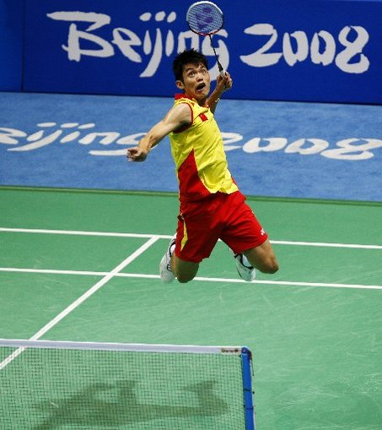
______________________________________________________________________________________________________________________________________________________________________________________________________________________________________________________________________________________________________________________________________________________________________________________________________________________________________________________________________________________________________________________________________

SCHEMA THEORY states that experience is gathered from four areas. These are termed memory items.

RECALL SCHEMAS  Has two functions:  - To store information about the production of the generalised movement  - To start or initiate the movement | - Knowledge of initial conditions  What is your situation?  Have you experienced this situation before?
- Knowledge of response specification
What can I do in this situation?
What choices do I have?

RECOGNITION SCHEMAS  Has two functions: It can  - Control the movement throughout its execution  - Evaluate the effectiveness of performance | - Knowledge of sensory consequences  How should the skill feel?  Relates to proprioception/kinaesthesis
- Knowledge of movement outcome
Knowing what the outcome of the movement will be

DEVELOPMENT OF SCHEMA ALLOWS THE PERFORMER TO ADAPT RESPONSES TO MEET THE DEMANDS OF THE NEW SITUATIONS
* EXAMINER’S TIP:
Students find the explanation and application of schema theory difficult. Learn the memory items thoroughly. Be able to explain recall and recognition schema by using practical examples to support the explanation.

What is the relevance and importance of variability of practice in relation to the SCHEMA THEORY?
Relate your explanation to a practical example.

____________________________________________________________________________________________________________________________________________________________________________________________________________________________________________________________________________________________________________________________________________________________________________________________________________________________________________________________________________
________________________________________________________________________________________________________________________________________________________________________________________

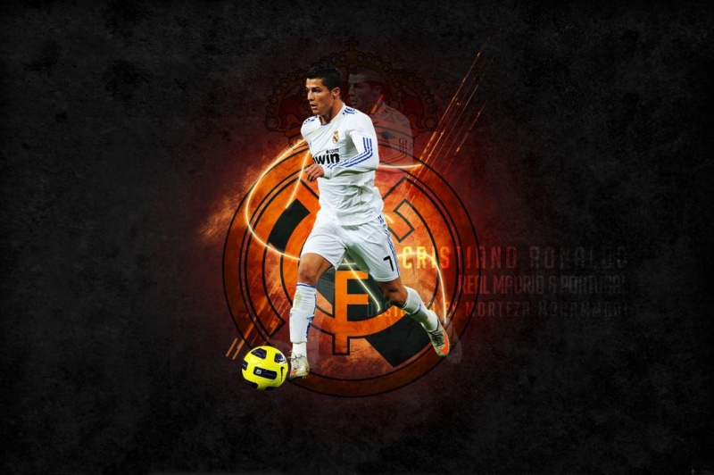

What other strategies or methods can enable SCHEMA to develop?

- _______________________________________________________________________________
- _______________________________________________________________________________
- _______________________________________________________________________________
- _______________________________________________________________________________
- _______________________________________________________________________________

Transfer of Learning to Develop Effectiveness in Physical Activity

Learning Objectives

At the end of this booklet you should be able to:

Learning Objective | Notes | Learnt
- Describe types of transfer that occur in practical performance
- Demonstrate knowledge and understanding of ways of optimising the effect of positive transfer
- Demonstrate knowledge and understanding of ways of limiting the effect of negative transfer
- Critically evaluate different types of transfer and their impact on the development of movement skills
- Explain the effects of transfer of learning on schema development and the importance of variable practice

Transfer of Learning

Transfer means the influence that one skill has on the learning and performance of another. The process is extremely important to the acquisition of movement skills because practically all learning is based on some form of transfer.

* EXAMINER’S TIP:
Understanding the link between variable practice, transfer and schema theory is a key issue.
The process of transfer is so central to learning and performance that it could be mentioned in every topic visited on the syllabus.
‘No learning takes place without transfer’ (Schmidt)

Types of Transfer
Explain the different types of transfer below linking them to a sporting example.

Positive Transfer
________________________________________________________________________________________________________________________________________________________________________________________________________________________________________________________________________________________________

Negative Transfer
________________________________________________________________________________________________________________________________________________________________________________________________________________________________________________________________________________________________

Proactive Transfer
________________________________________________________________________________________________________________________________________________________________________________________________________________________________________________________________________________________________

Retroactive Transfer
________________________________________________________________________________________________________________________________________________________________________________________________________________________________________________________________________________________________

Bi-lateral Transfer
________________________________________________________________________________________________________________________________________________________________________________________________________________________________________________________________________________________________
Key point on transfer | Explanation or example
Learning situations need to allow for positive transfer

The learner must be made aware of the transferrable elements of a previously learned skill.

Clear and concise demonstrations must be used.

The environmental conditions need to be similar to the real situation.

The elements of information processing may be similar.

The closer the practice is to the replication of the game situation, the greater is the chance of positive transfer.
Transfer will only operate successfully if previous skills have been well learned.

Diverse experiences enhance the probability of transfer.

Reinforcement ensures that positive transfer can take place.

Simplify the task during initial learning and transfer it later into the real situation.

* KEY TERMS:
Optimising Transfer – means that its effects are maximised and have a full influence on the learning and performance of motor skills.

Identical Elements Theory – the greater the number of components of practice that are relevant to the real situation it is more likely that positive transfer will take place.

How can you limit the effect of negative transfer?

- _________________________________________________________________________________________
- _________________________________________________________________________________________
- _________________________________________________________________________________________
- _________________________________________________________________________________________
- _________________________________________________________________________________________

VARIED PRACTICE

Explain below using sporting examples how varied practice links to the transfer of skills.

- __________________________________________________________________________________________________________________________________________________________________________________________

- __________________________________________________________________________________________________________________________________________________________________________________________

- __________________________________________________________________________________________________________________________________________________________________________________________

- __________________________________________________________________________________________________________________________________________________________________________________________

- __________________________________________________________________________________________________________________________________________________________________________________________

