Sport and Society

The influence of Public School

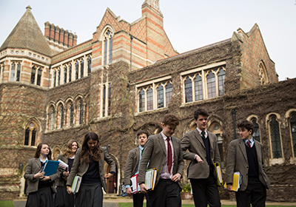

NAME:

Learning objectives

At the end of this booklet you should be able to: | Notes | Learned
Explain the role of 19th-century public schools in promoting and organising sports and games.

Promotion of ethics through sport and games

The cult of athleticism, meaning, nature, and impact

On the spread and export of games and the games ethic.

Describe the features of Public schools before the influence of Thomas Arnold.

What would it have been like to be a 1st year? What would it be like to be a 6th form student?

What was fagging in public schools? What type of sports could you play or bet on?

_________________________________________________________________________________________________________________________________________________________________________________________________________________________________________________________________________________________________________________________________________________________________________________________________________________________________________________________________________________________________________________________________________________________________________________________________________________________________________________________________________________

Narr: a small boy is dragging a bag across the floor and bumps into a sixth form student.
Small boy: “Sorry I didn’t see you.”
Sixth Form: “Well well well, what do we have here? Another little fish to have hanging on a hook I think”.
Narr: The sixth former grabs the boy by the scruff of his neck and lifts him up.
Small boy: Sir please it’s my first day here, can you tell me where my bedroom is?”
Sixth form: “I’ve no idea and even if I did you have jobs to do before you get to bed!
Narr: Sixth former leans into the boys ear.
Sixth form: “Now I’ve got to you first so from today you are mine, fag!”
Small boy: “Sir I don’t understand, I was told…..
Narr Sixth form interrupts
Sixth form: “Enough of this, fag, take my bag to my room and then fetch me some mead before I have you roasted in the hot room!”
“You see you are now my servant and you will get beaten if you don’t do as I say”.
Narr: Boy steps back with some confidence.
Small boy: “You can’t I’ll report you!”
Sixth form: “To who? The teachers know about it stupid, they practically encourage it, how else are they going to keep order around here.”

Notes on Public School before Arnold:
_____________________________________________________________________________________________________________________________________________________________________________________________________________________________________________________________________________________________________________________________________________________________________________________________________________________________________________________Thomas Arnold

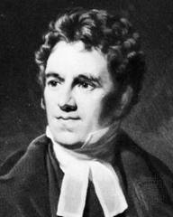
Dr Thomas Arnold was the Head of Rugby School and was disgusted at the behaviour of the boys who attended. As society was rowdy and sports involved cruelty to animals and gambling, so the boys brought these pass times to public school. Other activities involved poaching, drinking, trespassing to hunt, swimming in Farmers Rivers, fighting and betting on horses and dogs. Thomas Arnold saw it as his mission to transform the moral standing of the children. Arnold encouraged the boys to be physically active on the school grounds to highlight the more moral features of teamwork, self-discipline, loyalty and courage. The game of cricket was well established and was seen as showing the right moral code that Arnold wished to encourage.

The 6th form boys were encouraged to take responsibility for organising the house teams. Prefects would be in control forming games committees and inter-school competitions. Initially inter-school fixtures were not feasible as two schools didn’t have the same set of rules. This is still evident today with some local sports, e.g., stool ball. “It is my belief that evil will develop from idleness and disregard for each other, through organised games these boys can learn many values and lesson of life. One must do all he can to develop their moral standing through positive recreation.”

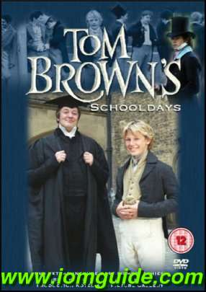

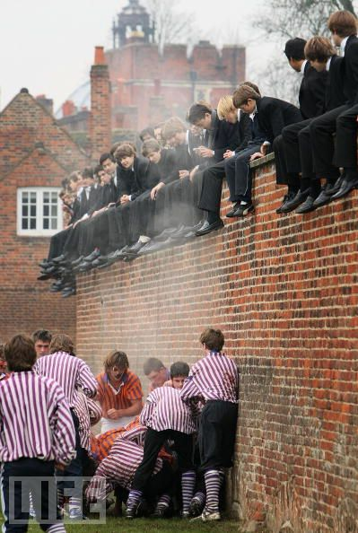

What reforms did Arnold want to bring in ?____________________________________________________________________________________________________________________________________________________________________________________________________________________________________________________________________________________________________________________________________________________________________________________________________________________________________________________________________________________________________________________________

Describe the cult of athleticism
___________________________________________________________________________________________________________________________________________________________________________________________________________________________

What was the impact of Arnold’s cult of athleticism on the boys at Rugby School?
________________________________________________________________________________________________________________________________________________________________________________________________________________________________________________________________________________________________________________________________________________________________________________________________________________________________________________________________________________________________________________________________________________________________________________________________________

Main features of Public school life and the development sports.

- Money
__________________________________________________________________________________________________________________________________________________________________________________________________________________________

- Academic staff assisted games
__________________________________________________________________________________________________________________________________________________________________________________________________________________________

- Professional coaches
__________________________________________________________________________________________________________________________________________________________________________________________________________________________

- Free time
__________________________________________________________________________________________________________________________________________________________________________________________________________________________

You can imagine if you were a boarding child as most where, that you would have a great deal of time to play and develop your skills at the new forms of sports being created.
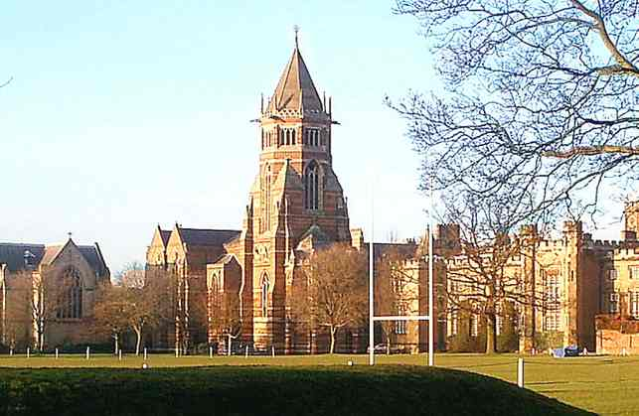
. Having the opportunity, provision and esteem was one of the main reasons sports developed so quickly in public schools.
- Space
____________________________________________________________________________________________________________________________________________________________________________________________________________________________________________________________________________________________________

- House system
____________________________________________________________________________________________________________________________________________________________________________________________________________________________________________________________________________________________________

Role Models______________________________________________________________________________________________________________________________________________________________________________________________________________________________________________________________________________________________

Rules/structure_______________________________________________________________________________________________________________________________________________________________________________________________________________________________________________________________________________________

Notes:
Victorian Schools
Working class
- Narr: An old and angry looking teacher is flapping some papers around while looking at his watch.
- The door opens and in comes a scruffy thin boy out of breath.
- Boy: Sorry I’m late sir.
- Teacher: “Silence boy! Where have you been? I haven’t got time to be standing around for scruffy dirty faced boys who can’t tell the time”
- Boy: “Sorry sir please, I finished my shift late last night and my baby brother is still sick. It wont happen again”.
- Teacher: “I’m not surprised your family are always ill living in that tiny house like mice. Go and sit down while I wait for the others to return from their play in the yard.”
- Narr; The teacher ushers the boy towards the back of the room.
- Boy: “Please sir, can’t I go out and play in the yard?”
- Teacher: “NO, it’s only a small yard and Mr smith is struggling to control so many children in such a small space. You only have a ten minute break to stretch your legs anyway.”
- Narr: The teacher moves towards his desk and shuffles some papers.
- Teacher: If it was up to me you wouldn't get a break, I don’t see the point in it.”
- Boy; “Please sir” (boy looks up from his desk.)
- Boy: “Running around keeps us fit and strong, I hear they play games in the public schools.”
- Teacher: “rubbish, you will learn nothing from ‘playing games’, now open your book and get on with some work”.
- Boy: “please sir we only have one book and you have it at the front”.

Victorian Schools
Rugby School
- Nar: Billy, a smart dressed upper 6th form boy is stood on the edge of the rugby pitch.
- A small boy is struggling with his boots as he runs along and bumps into the 6th form boy.
- Billy Sixth form boy: “Steady on little man what’s the rush?”
- Tom: “Sorry sir I'm late for cricket practice, I didn’t know what kit to wear. Can you help me please? I don’t know which pitch to meet on.”
- Billy: That’s fine little man I coach the first year cricket side as well as Mr Rigby so you won’t get lost. I just need to go put up the team sheets for next week and then we can go.”
- Tom: “Oh thanks you sir”.
- Nar: Both boys begin to walk towards the pavilion and the sixth form boy places the sheets on the notice board.
- Tom: “Do you coach all the teams?”
- Billy: “ No the paid coaches do that during out afternoons off of course, i just help out and organise the house competition.”
- Tom; “what’s that?”
- Billy: “It’s where all the years get to play against each other to see who’s best. It helps us develop our skills as well you know.”
- Tom: “forgive me but won’t all the rules be different as all the boys come from different places?”
- Billy: No we’ve written a rule book so that everyone can play the same game. Look there is Mr Rigby.”
- Rigby: “Ah master Billy, what have we here?”
- Billy: “he’s a new boy for the cricket team I believe. He got lost, not used to so many pitches apparently.”
- Rigby: “Well you better get used to it at public school boy, now what are you like at cricket?”
- Tom; “we played a bit in the village and I was the best bowler.”(said enthusiastically)
- Rigby; “well we shall see and don't worry you will have plenty of time to practice your skill during the afternoons.”
- Tom: “amazing, thanks you so much sir.”
- Nar: Tom ran off and joined the others who were warming up by the pavilion.

A meeting between a new teacher and Tom Brown observing a football match between rugby school and Eton.

Master: (awkwardly) “Now Mr Brown what kind of game is this?”
Tom: (showing no interest) “Football Sir.”

Master: “No, this is not the football I’ve seen in the villages at home.”
Tom: (a little annoyed) “Yes sir this is football but we’ve changed the game to suit a higher level of skill”.

Master: (flustered) “What do you mean? The game played was rough and hard, yes, but it showed courage and aggression, true character building”.
Tom: “Yes sir but with rules, such as lines and posts, uniforms and numbers we can play just as hard but with skill”.

(A ball is hacked through and a first year dives on the ball and kicks it away, saving a certain goal.)

Tom: (focused on the game)“Well done Billy good effort. He’s a new boy sir.”
Master: “He showed such bravery and courage to dive for the ball.”

(Tom shakes his head and rolls his eyes.)

(The ball is kicked through the goal by a player from Rugby school (Tom’s team) and the team rush to praise the player.)

Tom: “Great show boys, keep it up. Only 3 min to go and we have beaten Eton for the second year in a row”.
Master: So you play boys from other schools, why not just play together?”
Tom: “Oh we do sir in house matches, to practice. But then we made the rules the same so other schools could get a thrashing. That way we can see who the best is truly. It makes us work together at beating the other schools.”

Master: “Oh I see, like team spirit”. (The whistle blows and Rugby school win the match, players join and shake hands).
Master: “I say those boys are showing real sportsmanship to go and shake the others hands. (Nudging him with his elbow). I suppose that’s the Rugby way as well, hey tom”.

Tom shakes his head while turning away.

Organisation of sports and games

The promotion and development of sports

Complete the acronym that summarises the reasons for the development of public school sports.

Promoted
House system
Arnold
Support/teacher/coaches
Time/boarding
Inter house
Money
Ex pupils

The spread and export of games ethics

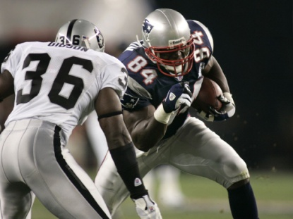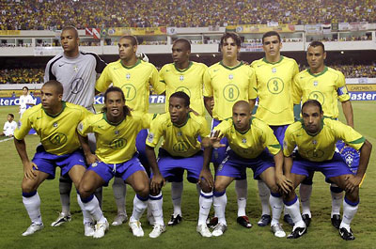

Can you identify the link between these sports? Note the reasons why.
___________________________________________________________________________________________________________________________________________________________________________________________________________________________

T_______________________
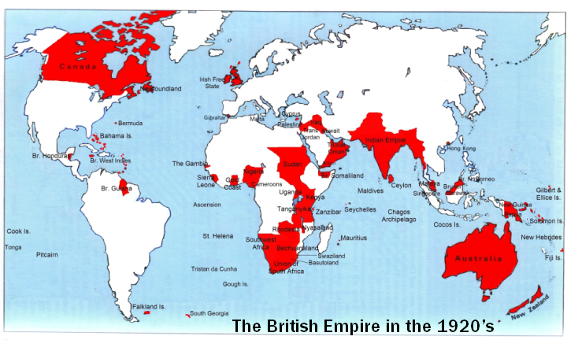

O_________________________

M_______________________

P_______________________

V________________________

I_______________________

C_______________________

National Governing Bodies
____________________________________________________________________________________________________________________________________________________________________________________________________________________________________________________________________________________________________
_________________________________________________________________________
_______________________________________________________
_______________________________________________________

Promoted
House system
Arnold
Support/teacher/coaches
Time/boarding
Inter house
Money
Ex pupils
Give a description of how each of the elements supported the development of sport in Public School and beyond.

Teachers
Officers
Melting Pot

Patrons
Vicars
Industrialists
Colonists/ clubs/community
Describe the ways that sport and the ethics were spread.

Notes:

Exam Question

……………………………………………………………………………………………………………………………………………………………………………………………………………………………………………………………………………………………………………………………………………………………………………….
……………………………………………………………………………………………………………………………………………………………………………………………………………………………………………………………………………………………………………………………………………………………………………….
……………………………………………………………………………………………………………………………………………………………………………………………………………………………………………………………………………………………………………………………………………………………………………….……………………………………………………………………………………………………………………………………………………………………………………………………………………………………………………………………………………………………………………………………………………………………………

- Explain how these schools and their ex-pupils influenced the emergence of rational sport. [5marks]

……………………………………………………………………………………………………………………………………………………………………………………………………………………………………………………………………………………………………………………………………………………………………………….
……………………………………………………………………………………………………………………………………………………………………………………………………………………………………………………………………………………………………………………………………………………………………………….……………………………………………………………………………………………………………………………………………………………………………………………………………………………………………………………………………………………………………………………………………………………………………
……………………………………………………………………………………………………………………………………………………………………………………………………………………………………………………………………………………………………………………………………………………………………………….

Describe the characteristics you could learn while at public school. Explain how these were developed within the school (5)
………………………………………………………………………………………………………………………….……………………………………………………………………………………………………………………………………………………………………………………………………………………………………………………………………………………………………………………………………………………………………………
……………………………………………………………………………………………………………………………………………………………………………………………………………………………………………………………………………………………………………………………………………………………………………….
………………………………………………………………………………………………………………………….……………………………………………………………………………………………………………………………………………………………………………………………………………………………………………………………………………………………………………………………………………………………………………

- Explain how these schools and their ex-pupils influenced the emergence of rational sport. [5marks]

- (Rules) Melting pot/development of rules
- Structure) Organisational development/fixtures/kit/areas to play
- (Time/Compulsion) Regularity of games afternoons/house sport/compulsory games
- (Respectability) Curtailment of violence/cruelty/responsibility
- (Values) Importance/values attached to team games
- (Other schools) Influenced other schools e.g. Malvern/Cheltenham/Clifton founded as middle class copies of the gentry/Clarendon schools.

Ex-pupils:
- Teaching Teaching back in original school next generation influenced
- Army/colonial Army/colonial service/taking passion for games abroad service)
- Church As parsons/social Christians/needs of parishioners met
- Industry As industrial leaders/keen to give sport to their workers
- Family Family/upbringing of own children
- Community As community leaders/provision of facilities/knowledge
- Clubs Formation of sports clubs/National Governing Bodies
Describe the characteristics you could learn while at public school. Explain how these were developed within the school (5)

Cult of muscular Christianity/ a gentleman with Christian values
The development of character through sport cult of athleticism
Physical endeavour, trying hard
Moral integrity
Being honourable, truthful/ decisions
Good sportsmanship

Through playing games
Through 6th form supporting new students/ reduction in fagging
Through inter house competition/ playing as a house
Through games against other schools/ development of school identity
Reduction in betting/ horses/ dogs/ focus on team games/ cric/rugby.

