Contemporary Issues in Sport

- Demonstrate knowledge and understanding of public funding; private funding; voluntary funding (including the National Lottery).

- Demonstrate knowledge and understanding of UK Sport.
- Demonstrate knowledge and understanding of the United Kingdom Sports Institute (UKSI) and devolved National Institutes of Sport.
- Demonstrate knowledge and understanding of home country organisations (Sport England, Sports Council Northern Ireland, sportscotland, Sports Council for Wales).
- Demonstrate knowledge and understanding of current government and national governing body initiatives.
- Evaluate critically initiatives that impact upon young people’s aspirations and their regular participation in physical activity in the UK.

- Explain sports development (the sports development pyramid, continuum from mass participation to sporting excellence).
- Explain opportunity, provision and esteem (with reference to both participation in physical activity and the achievement of sporting excellence).

- Demonstrate knowledge and understanding of public funding; private funding; voluntary funding (including the National Lottery).

- Demonstrate knowledge and understanding of UK Sport.
- Demonstrate knowledge and understanding of the United Kingdom Sports Institute (UKSI) and devolved National Institutes of Sport.
- Demonstrate knowledge and understanding of home country organisations (Sport England, Sports Council Northern Ireland, sportscotland, Sports Council for Wales).
- Demonstrate knowledge and understanding of current government and national governing body initiatives.
- Evaluate critically initiatives that impact upon young people’s aspirations and their regular participation in physical activity in the UK.

- Explain sports development (the sports development pyramid, continuum from mass participation to sporting excellence).
- Explain opportunity, provision and esteem (with reference to both participation in physical activity and the achievement of sporting excellence).

- Explain: the reasons for the use of drugs in sport; Describe the consequences of the use of drugs in sport (with particular reference to health, wellbeing and role modelling for young people).
- Describe possible solutions to the problem of the use of drugs in sport.
- Explain the impact on performance(s) in sport of modern technological products (with reference to particular products and activities).

- Explain the roles of the media (informing; educating; entertaining; advertising).
- Evaluate critically the impact of the media on sport (with particular reference to its role in promoting balanced, active and healthy lifestyles and lifelong involvement in physical activity).
- Explain the relationship between sport, sponsorship and the media (‘golden triangle’).

- Demonstrate knowledge and understanding of violence in sport (players and spectators).
- Describe possible causes and solutions.

- Demonstrate knowledge and understanding of the background (vision of De Coubertin), principles, aims and philosophy of the modern Olympic movement, summer and winter format, International Olympic Committee (IOC) and British Olympic Association (BOA).
- Explain the commercialisation of the Olympics: pre and post- 1984 (Los Angeles).
- Describe the opportunities and implications for sport and society in the UK arising from 2012, (impact of being a host nation on sport and society; benefits and drawbacks including potential for increasing participation and promoting healthy lifestyles particularly among young people),
- Explain how the Olympic Games is a vehicle for nation building e.g. China; the ‘Shop Window’ effect, government control and funding of sport, sport as a political tool

- Demonstrate knowledge and understanding of the background (vision of De Coubertin), principles, aims and philosophy of the modern Olympic movement, summer and winter format, International Olympic Committee (IOC) and British Olympic Association (BOA).
- Explain the commercialisation of the Olympics: pre and post- 1984 (Los Angeles).
- Describe the opportunities and implications for sport and society in the UK arising from 2012, (impact of being a host nation on sport and society; benefits and drawbacks including potential for increasing participation and promoting healthy lifestyles particularly among young people),
- Explain how the Olympic Games is a vehicle for nation building e.g. China; the ‘Shop Window’ effect, government control and funding of sport, sport as a political tool

Funding of Physical Activity

- Demonstrate knowledge and understanding of public funding; private funding; voluntary funding (including the National Lottery).

- Sport in the UK is funded in different ways. Describe public, private and voluntary funding of sport (3 marks)
3 marks — one for each of:
1. (Public) — money from government / local authority I national lottery I taxes I home country sports councils I UK Sport I NGBs.
2. (Private) — money from sponsorship / companies / organisations I businesses / entrepreneurs private members clubs which aim to make a profit
3. (Voluntary) — money or donations from individuals or charities I fundraising I local clubs which exist for their members / membership fees / any surplus money goes back into club

- Describe the different sources of funding for high level sport. (3 marks)

- How does public sector funding help to increase participation in physical recreation in the UK? [3 marks]

- Community provision provide facilities or equipment
- School provision - money for school facilities or equipment of staffing
- Personnel - Sports development officers / School Sport Coordinators (SSC05) / community sports coaches
- Grant aid - grants to local authorities or local clubs I discount schemes
- Events - advertising / promotional events / campaigns I holiday play schemes
- Transport - provide or subsidise transport

- Sport in the UK is funded in different ways. Describe public, private and voluntary funding of sport. (3 marks)

- Public — money from government / local authority I national lottery I taxes I home country sports councils I UK Sport I NGBs.
- Private) — money from sponsorship / companies / organisations I businesses / entrepreneurs private members clubs which aim to make a profit
- (Voluntary) — money or donations from individuals or charities I fundraising I local clubs which exist for their members / membership fees / any surplus money goes back into club

- How can both funding and the media he/p to develop sporting excellence in the UK? (6 marks)

Funding
1. (professionalism) | performers can: concentrate on sport / train full time / become professional / living or transport or subsistence costs
2. (equality) | performers can compete more equally with those from better funded countries.
3. (facilities!  equipment) | provision of or money for high level or specialist facilities or equipment or clothing
4. (training ! coaching) | provision of or money for high level training or coaching
5. (organisations) | fund: UK Sport! UKSI (ElS)/NGBs / H.C. councils ! YST! Sports Colleges
6. (events) | attracts or provides world class events or competitions
7. (talent) | scholarships ! World Class (Performance) Programme / WC(P)P! talent-development-podium or start—potential-performance / TASS / talent ID; gifted and talented
Media
8. (awareness) | raises profile or awareness of sport’s! promotes sport’s

Bodies influencing and promoting participation in physical activity as part of a balanced, active and healthy lifestyle; the promotion of health, fitness and wellbeing and/or sporting.

- Demonstrate knowledge and understanding of UK Sport.
- Demonstrate knowledge and understanding of the United Kingdom Sports Institute (UKSI) and devolved National Institutes of Sport.
- Demonstrate knowledge and understanding of home country organisations (Sport England, Sports Council Northern Ireland, sportscotland, Sports Council for Wales).
- Demonstrate knowledge and understanding of current government and national governing body initiatives.
- Evaluate critically initiatives that impact upon young people’s aspirations and their regular participation in physical activity in the UK.

- What are Sport England’s main objectives and how does it attempt to achieve them? (3 marks)

3 marks total: sub max 2 from one section

Main objectives
1 (participation) to increase participation
2 (SSS) Start, and succeed - more people, more places, more medals
3 (nation) to make England an active nation
4 (government) to deliver government’s sporting objectives/ support government targets

How Sport England Tries to Achieve them
5 (funding) provides or distributes funding or lottery funding or government funding
6 (projects/ campaign) accept any relevant project or campaign eg (Get) Active, Sporting Champions, Sport Action Zones
7 (Sharing) shares best practice/works with other organisations or NGBs

- How do the National Lottery and the United Kingdom Sports Institute (UKSI) help to develop sporting excellence in the UK? (6marks)

6 marks in total; 6 marks for 6 of: sub max of 4 from one section

National Lottery
- The ‘World Class (performance) Programme’/VVC(P)P/talent ID/talent-development- podium or start-potential-performance
- Money for: accommodation or living costs or travel/Athlete Personal Awards/grants that recognise sacrifice or dedication
- Fund: UK Sport/UKSI (EIS)/ NGBs/H.C. councils/YST/Sports Colleges
- High level facilities or equipment
- Attracting or providing world class events
- Mass participation/increasing numbers/building base of performance pyramid/clubs or teams/facilities or equipment

UKSI
- High level or specialist coaching or facilities or equipment/specialist training/high performance centres
- Sports science/nutritional advice or psychological training or acclimatisation training/performance analysis
- Give academic education/other qualifications/flexible education programmes Suitable competition/with other elite performers
- Career advice/Performance Lifestyle Advice/(formerly) ACE UK
Links with NGBs or sports colleges/talent ID
Sports medicine

- How do UK sport and home country organisations such as Sport England influence both excellence and mass participation in sport in the UK? (6 marks)
UK Sport and Home Country Organisations influences sport by:
- Promoting / aiming to get people to start/take up sport/more people/improved health
- Supporting/aiming to get people to stay in sport! supports network of clubs/of sports facilities/of coaches/of volunteers/of competitions.
- Providing advice.
- Running doping control/reducing doping/promoting fair and drugs free sport
- Attracting major sport events
- Distributing lottery funding/public investment
- Overseeing work of UKSI
- Increasing excellence/working with elite performers/increasing chances of international success/aiming for world class success
- Working closely with NGBs/working with other organisations/partnerships
- Aiming to reduce administrative bureaucracy
- Supporting overseas projects/arranging exchange visits/sharing information with other nations — in attempt to improve sport in UK.

- How do National Governing Bodies support performers at the top of the performance pyramid? [4 marks]

1. (selection) | select or manage national team / talent ID /  select for World Class Programme  (podium/development/talent)
2. (funding) | provide funding
3. (science) | provide sport science support or analysis
4. (coaching/training) | high level coaching or training /  performance directors / national coach /  train high performance coaches or officials / academies
5. (sponsorship/media) | seek sponsorship or develop commercial links / obtain media coverage / negotiate with media
6 (facilities / equipment) | give access to high level facilities or equipment.
7. (liaison) | Work with UK SPORT or UKSI or HCSCs eg Sp England or sports colleges or high level clubs
8. (competition) | organise or provide or inform about competitions / attract events / appoint officials
9. (doping/discipline) | provide anti-doping education /  give info, about 100% ME / deal with discipline
10. (education) | encourage or support academic education / provide lifestyle or career advice

- Elite performers need enormous support in order to achieve their potential and to achieve sporting excellence. What can schools do to help talented young people achieve their sporting potential? [2 marks]

- Provision - provide quality coaching or quality equipment or quality facilities
- Links - encourage club membership / encourage school- club links or links with local sports colleges or with NGB5 / PESSCL
- Inform - inform about: local centres of excellence or development squads or other opportunities
- Sports colleges - apply for sports college status
- Profile - give sport high profile in school / raise profile of elite sport in the school / celebrate success or give reward or recognition for success / focus sports / sporting champions
- Trials - enter performers for regional trials
- Funding - give advice about grants / link with Sport Aid / inform about World Class funding I give funding
- Career advice - advise on HE courses or sport related careers
- Time - be flexible re time off for competitions or training / Junior Athlete Education (JAE)
- School rep - school representation / interschool fixtures

- Describe current measures to increase sporting excellence in the UK by relevant bodies or organisations. [5 marks]

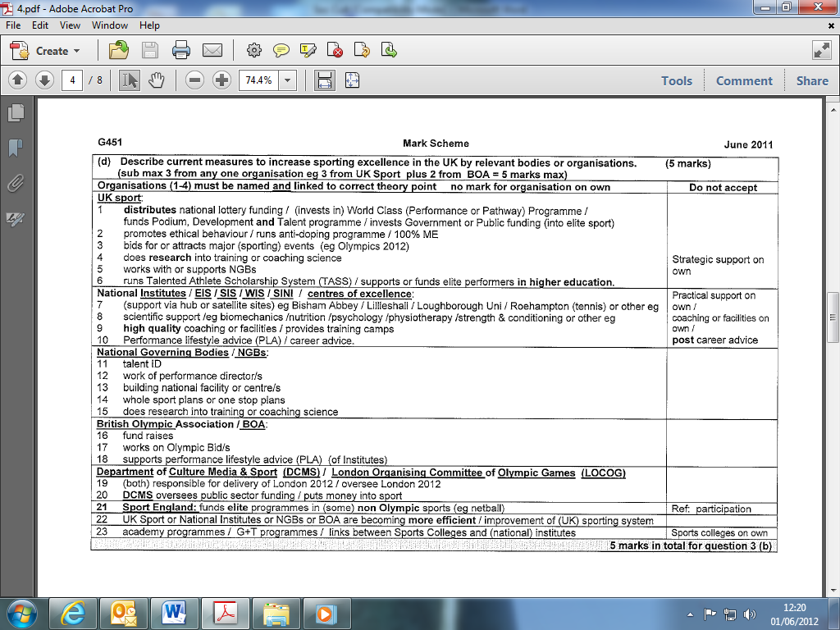

- What does the organisation UK Sport do to increase sporting excellence? [2 marks]

- UKSI - works with or oversees UKSI
- Funding - money to elite performers / provides funding for the World Class Programme / distributes lottery funding / TASS 2012
- Attracts events - bids for or attracts major events / improves international sporting profile of UK
- Ethics - promotes ethical sport or high standards of conduct or sportsmanship I runs the anti-doping programme / works to keep sport drugs free
- Sharing - shares best practice with other nations / runs an international programme to research best practise overseas
- Advice - Performance Lifestyle Advice (accept ACE UK)
- WCP - runs World Class Programme

- Describe the role of either UK Sport or one of the National Institutes of Sport. (3 marks)

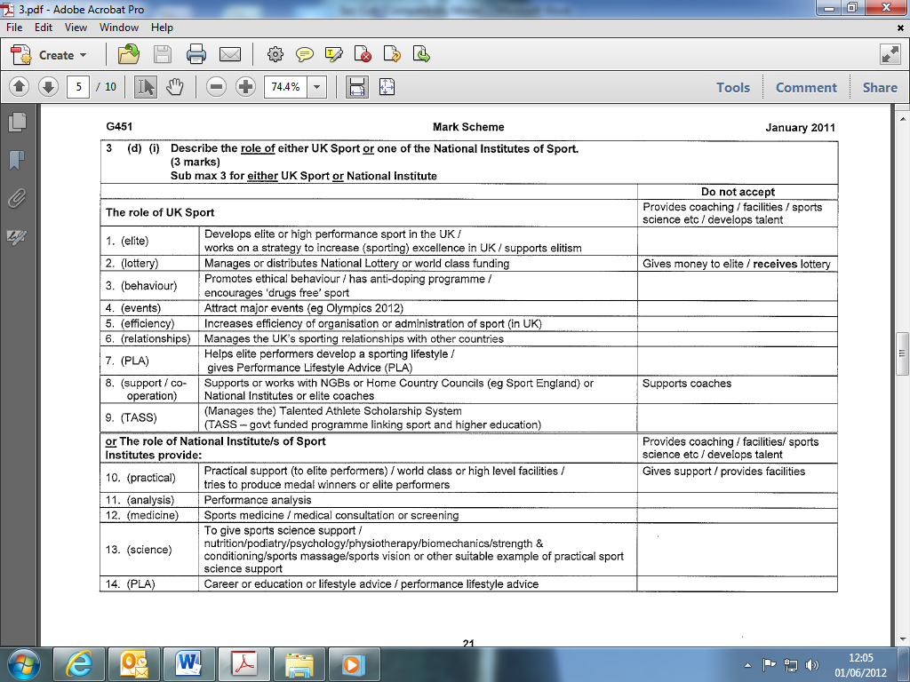

- Describe the foundation, participation and performance levels of the sports development pyramid. (3 marks)

- Describe how esteem could affect a person's placement on the sports development pyramid. (2 marks)

- In the UK various organisations are involved with physical activity. Describe the work of home country organisations (such as Sport England). Describe the work of The British Olympic Association (BOA). (5 marks)

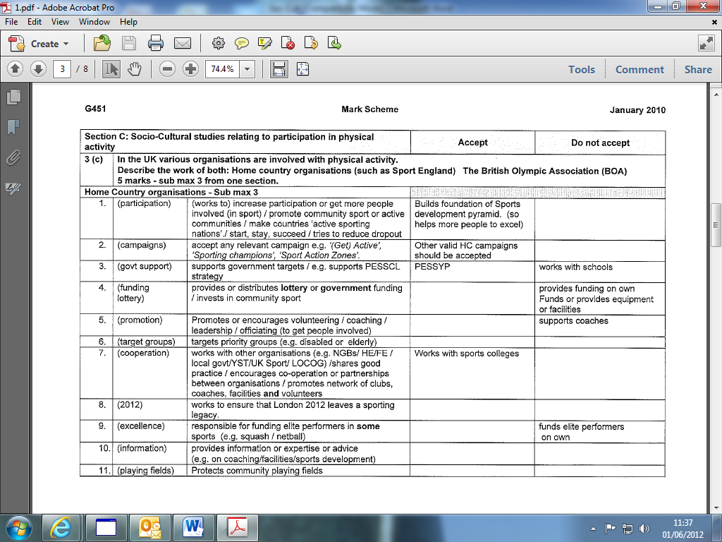

- How does the organisation sportscoach UK help improve standards of coaching? (5 marks)

- Training - provides workshops or training or courses for coaches I provides specialist high performance workshops I runs coaching for teachers scheme
- Resources - produces resource or books or videos / coachwise Ltd sells resources / funds coaching research
- Links - works with other organisation to promote coach education I works with NGBs or key funding agencies to develop coaching
- Coach development – officers; supports network of regional coach development officers
- Coaching levels - to standardise levels of coaching across sports / structures sports coaching / UKCC / aims to develop coaching system in UK in preparation for the 2012 Olympic Games I/ coaching task force
- Award - Coach of Year award

Excellence and Participation in the UK

- Explain sports development (the sports development pyramid, continuum from mass participation to sporting excellence).
- Explain opportunity, provision and esteem (with reference to both participation in physical activity and the achievement of sporting excellence).
- Evaluate critically social and cultural factors impacting upon participation in physical activity and the achievement of sporting excellence by young people, the elderly, people with disabilities, women and ethnic minority groups.
- Describe possible measures to increase participation in physical activity and achievement of sporting excellence.

- "Stereotypes are defined as a group of characteristics that we believe all members of a certain section of society share, usually based on very little fact." Honeybourne et al (2000). How does stereotyping affect an individual's access to physical activity? (4 marks)

1. Stereotypes reinforce established perceptions Correct explanation of stereotyping
2. Role models very important in wider participation
3 Stereotypes tend to focus on sports target groups
4. Negative stereotypes-rigid perception that certain groups should not play sport / Correct eg
6. Stereotypes can lead to myths such as "black men can't swim" which has a big impact on participation
7. Positive stereotypes - challenge traditional/negative stereotypes / enhance image of a group
8. Link to self esteem / confidence

- Many factors influence whether a person takes part in Sport and Physical Recreation. Outline the factors which may influence such involvement and for each factor suggest how organisations can assist in providing these requirements. (6 marks)

1. Time / leisure time Correctly applied suggestion
2. Resources / equipment / Correctly applied suggestion
3. Fitness / health - Correctly applied suggestion
4. Ability / level of skill - Correctly applied suggestion
5. Facilities / somewhere to play - Correctly applied suggestion
6. Esteem
7. Age
8. Gender/ Race / Religion / Culture
- What is meant by each of the following: Discrimination, Stereotype & Special Interest Group.

3 marks total — one for each of: sub max of one from each section

1 (discrimination)
Unfairness I prejudice; unfair treatment or unequal treatment / acting on or showing prejudice / bias or favouritism / accept relevant example of unfair treatment

2 (stereotype image)
A simplified or standardised image or view / an idea held by one person or group about another / based on attitudes! leads to myths organisation that encourage participation or opportunity or esteem by certain people / WSF/ DSE

3 (a special interest group or organisation)

- (fees) entrance fees /joining fees! club membership
- (equipment) kit / equipment(
- coaching)
- (transport)
- (childcare) childcare costs

not enough:
- (time) may not have time ! shift work! long working hours
- (self esteem) self esteem I self confidence! lower levels of self esteem
- (socio-economic status) associated with those of lower socio-economic status/ culture surrounding some facilities or activities may put others off
- (health/fitness) lower levels of health or fitness associated with those of lower

- What does the Women’s Sports Foundation do? [3 marks]

I (equality) promotes equality
2 (campaigns) campaigns /to: increase participation or increase opportunity or increase access or decrease drop out / promotes female sport
3 (Profile) raises the profile of British sportswomen or teams.
4 (information) gives advice or information on women’s sporting issues; shares examples of good practice.
5 (influence) tries to influence national or regional government or sports councils; change policies.
6 (leaders) encourage women into positions of responsibilities; eg coaching.

- How can school Physical Education departments increase the interest and participation of girls in physical activity? [4 marks]

- (KIE!F) | ensure kit or equipment or facilities are ‘suitable’
- (choice / variety) | give choice of activities ! give varied programme/ cater for wide range of interests or levels of competition
- (role models) | bring in role models or female sporting celebrities; sports person in school / emphasise achievements of females
- (visits) | organise visits or tours / eg Wimbledon
- (links) | form links with clubs or local specialist sports colleges
- (balance) | value both participation and excellence
- (staffing) | have adequate number of staff or well qualified staff / more female staff
- (status / attitudes I rewards) | ensure PE has high status in school / support from management; ensure positive attitudes towards equal opportunities; rewards for participation
- organise special or promotional events I eg taster days I
initiatives and ideas to promote participation I inter-form activities
- provide an extra curricular programme
- ‘girls only’ sessions or activities

- Why are there so few coaches and managers from the ethnic minority groups in professional football in the UK? (3 marks)

- Role models - few role models
- Discrimination - discrimination / racism / unfair treatment
- Stereotyping - stereotyping I channelling of players from ethnic minority into certain sports / centrality / channelling of players from ethnic minorities into certain roles within sports and away from management / central or most important roles in sport held by those from the central or dominant group in society
- Education - lack of educational opportunity
- Esteem - lack of self-esteem or self-belief or self- confidence
- Numbers - there may have been fewer players from ethnic minorities in football I some ethnic groups might choose to play other sports such as cricket or hockey
- Stacking - stacking I the layering of society on a discriminatory basis

- Discuss social and cultural factors that affect participation in physical activity in the UK. (10 marks)

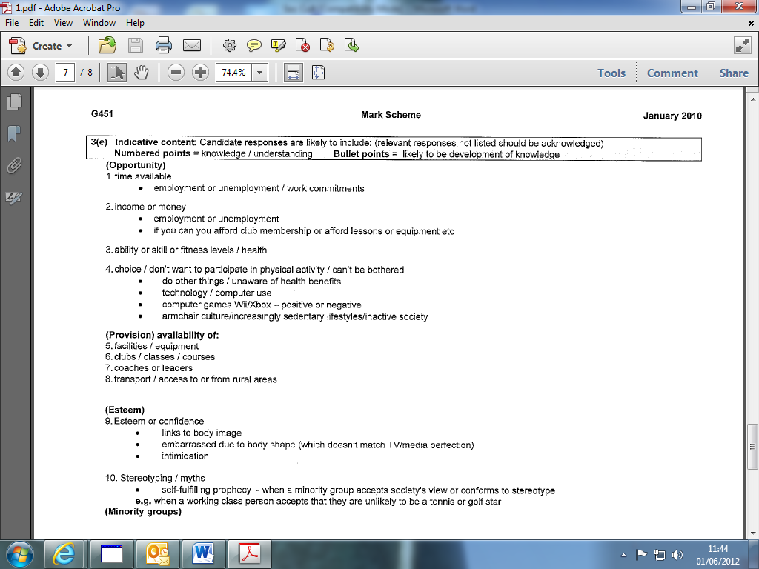
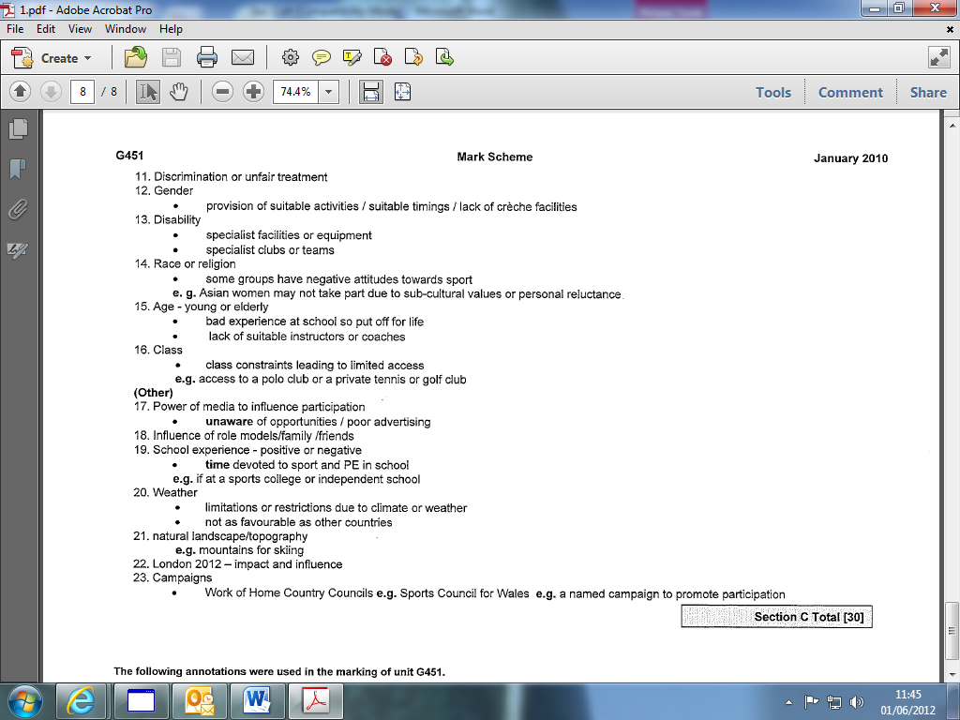

- Why is it that girls tend to drop out of physical activity in greater numbers than boys? [3 marks]

3 marks for 3 of:
I (school experience) due to bad PE experience at school; Unpleasant showers; kit; changing facilities; inadequate choice at school.
2 (community experience) inadequate choice or provision or opportunity; eg lack of clubs; lack of female sports leaders.
3 (peers) peer pressure/friends don’t participate
4 (distractions) other distractions
5 (role models) lack of role models in family or nationally; less media coverage of women’s sport.
6 (Attitudes) fear among heterosexuals that they may be perceived as homosexual; participation in some sports seen as unfeminine!; discouragement due to negative attitudes or prejudice; attitude that sport is for males! stereotyping.
7 (low esteem) low esteem; lack of confidence; they don’t think they are good enough; fear of failure; embarrassment; body consciousness.
8 (religion) some ethnic groups don’t encourage sport for women.
9 (criticism) adverse comments from coaches or teachers or Family

Discrimination in sport affects minority groups such as the elderly and those with disabilities.
Identify possible problems facing elderly people in terms of their participation in sport and physical recreation. (6 marks)

1. (money) | - limited finances/on pensions/low disposable income/no longer earning /cost
2. (transport) | - may not have car/difficulty in getting public transport
3. (fitness) | - may be more restricted physically than in younger years/less flexible/not wishing to play contact or other games.
4. (esteem) | - poor self image/self belief / believe they are not longer suited to physical activity / put off by perception that physical activity is for young people / friends don’t participate / stereotyping
5. (role models) | - Insufficient role models to encourage participation
6. (lack of choice) | - local centres offering inappropriate or unappealing options/insufficient choice
7. (instructors) | - instructors/coaches unclear of wishes and abilities of the clients / not specialised in dealing with older people
8. (school) | - poor experience at school / not wishing to give physical activity another go
9. (facilities) | - Lack of specialist/adapted facilities or equipment/under-funding
I 0. (promotion) | - Lack of media focus /advertisement information
II. (Health) | - poor health / need to seek specialist advice

- What can be done by local recreation or leisure centres to encourage more elderly people to take part in regular physical activity? [3 marks]

I (inform) inform! run campaigns ; advertise / promote view that sport is not just for young people; educate on the benefits of participation.
2 (coaches) ensure that coaches know the needs or abilities of the age group
3 (3 A’s) age or ability or attitude or groups or sessions or activities appropriate.
4 (consult) consult with or ask the age group what they would like to do
5 (taster session) offer taster sessions.
6 (social) provide a social area
7 (access) ensure that transport is available! suitable access! eg lifts.
8 (Cost) subsidise the fee/ be aware that some elderly people have low disposable income

- Access to sport and recreation is affected by a range of socio-cultural factors. Outline and explain four socio-cultural factors that can affect a person's access to sport and recreation. (6 marks)

- gender/women/females
- women have less access to sport due to problems over time, money and esteem
- age/old people/very young
- less access to sport due to problems over time, transport, money and esteem
- ethnic background/race
- less access to sport due to problems over time, transport, money and
- esteem/issues such as centrality and stacking
- social class/working class/socio economic background/unemployment
- less access to sport due to problems over time, transport, money, geography and esteem 10.
- disability/level of ability
- less access to sport due to problems over time, transport, money and esteem

- How can social class and wealth affect participation in sport and physical recreation in the UK?
Opposites should be accepted but only credited once
(access) Money for entrance fees I joining fees I club membership I childcare costs
- (equipment) Money to buy kit I equipment
- (coaching) Money to get coaching I training
- (transport) Cost of transport / car ownership
- (facilities) Opportunities to use private or voluntary or public facilities
- (social access I A wider variety of activities / education) educational opportunities
- (time) May have or create more time to participate
- (health & fitness) Greater levels of health or fitness associated with those of higher socio-economic status
- (self esteem) Self esteem I confidence higher levels of self esteem associated with those of higher socio economic status I middle class culture of participation I culture surrounding some facilities, or
activities may put others off

- Outline what is being done or could be done to give people with disabilities fairer sporting and recreative opportunity, provision and esteem. sub max 8

(funding 1) | - overcome financial disadvantage / appreciation of income levels/investment in provision for people with disabilities I increased funding to disability sports associations (e.g. disability Sport England
(strategic) | - provide adequate facilities at local level to participation / regional level for excellence/specialist facilities
(access) | - access has been improved / (Disabled Person’s Act — 1981) / local Authorities must conform to minimum access requirements / consideration of toilet and changing facilities / ramps / lifts / wide car-parking bays / suitable lift control buttons etc.
(attitudes) | - change attitudes / celebrate differences /  acknowledge abilities in modified sports /  assumptions / smash myths / break stereotypes /  promote positive image of disabled  performers/participants
(training/coaches) | - provide specialist training for coaches / continued work to increase the number of coaches with disabilities
(media) | - media must continue to focus on minority group sport
(adaptation &  modification) | - games/sports/adapted and modified to suit people with specific disabilities e.g. basketball/tennis use of larger/smaller! lighter equipment / increase team numbers
(integrate 1)  (inclusion) | - integrate at school PE level/local community level! continue to integrate at elite level / inclusive rather than segregated provision
(positive discrimination) | - disability only sessions, e.g. wheelchair baseball
(Big sports events) | - the Paralympics raises awareness of elite sport for people with disabilities / system which groups competitors with particular functional abilities to allow fair competition (at Commonwealth Games 2002, Manchester events of able-bodies and disabled were integrated)
(role models) | - Promotion of role models e.g. Tanni Gray
(campaigns) | - eg. Every Body Active/Pro-Motion
(liaison) | - liaison/co-operation between organisations /National Governing Bodies/Local authorities/disability sports organisations! media should work together
(awareness) | - providers/organisers need to be aware of specific challenges facing disabled people

- There are a number of social influences that can affect a person's access to sport and recreation.

(i) Define the term target group in relation to access to sport and recreation. (2 marks)

(ii) Identify and explain how a specific target group is affected in terms of their access to sport and recreation. (3 marks)

(iii) Give examples of reformative policies that can be used to encourage target group participation in sport and recreation. (4 marks)

2 marks for 2 of:

- A group of people identified as not participating in spoil
- Group of people/society that are denied access to a sport or recreation
- Group of people facing discrimination
- Use of an appropriate example (sub max 1)

3 marks for 3 of:

- Correctly identified group (sub max 1)
- Problems relating to time/amount of leisure
- Problems relating to income/equipment costs/facility costs
- Problems relating to access to transport/getting to a facility

Performance Enhancing Products

- Explain: the reasons for the use of drugs in sport; Describe the consequences of the use of drugs in sport (with particular reference to health, wellbeing and role modelling for young people).
- Describe possible solutions to the problem of the use of drugs in sport.
- Explain the impact on performance(s) in sport of modern technological products (with reference to particular products and activities).

- Why should coaches discourage performers from taking prohibited performance enhancing drugs? (4marks)
- cheating cheating/breaking rules/unfair advantage/immoral/against spirit or ethics or values of sport
- illegal some drugs illegal
- health dangerous to health/physiological risks/can be addictive/lowers life expectancy/can cause death! can lead to liver disorders/can lead to heart disease/can cause sexual or gynaecological problems/or equivalent suitable example
- psychological damage psychological damage/can affect moods or behaviour/personality change/ aggression/ depression
- status lowers status of or undermines sport/against sport/reduces interest in sport
- role modelling negative role modelling/bad example.
- coach coach in position of responsibility or with duty of care

- What is being done or could be done to reduce the problem of drugs in sport? (4marks)
- educate performers educate performers/make performers aware of dangers or aware of moral issues/education at schools or clubs/100% ME
- educate coaches/make coaches aware of dangers/awareness
- coaches of moral issues/100% ME (if not given above)
- punishments stricter punishments/life bans/standardisation of punishments/Olympic ban/harsher consequences/return of medals or funding/lose records
- testing stricter or random or targeted or more testing/out of season testing/more money for testing
- role models role models or Sports Ambassadors to publicise or encourage drugs free sport/’name and shame’
- research more research into dangers/research into testing
- legalise counter-culture/ make performance enhancing drugs legal/radical action
- WADA WADA/standardise world wide doping policy

- In spite of strict bans, some performers still take performance-enhancing drugs. Identify reasons for this and explain why the fight against ‘drugs and sport’ must continue. (6 marks)

6 marks for 6 of  at least 2 from each section. (Submax of 4)

(reasons for taking drugs)
1. To build muscles/increase energy/increase oxygen transportation.
2. Lose weight/ Gain weight/enable harder training/to mask injury/recover from injury/lengthen career.
3. Increase aggression/increase motivation/control arousal/steady nerves/ psychological strength.
4. Increase monetary value of winning/kudos of winning/fame/high status/society only remembers winners.
5. Win at all costs ethic/worth the risk to be the best/fear of losing.
6. Testing is only random/ineffective testing
7. Poor deterrents/Poor punishments.
8. Don’t think that drugs will affect their health.
9. Peer group/family/coach/society pressure eg sponsors
10. Because others are taking drugs/level playing field.

(why the fight)
11. Unfair advantage gained/ immoral to take drugs.
12. Cheating/rule breaking/many drugs against the rules of sport/illegal.
13. Dangerous to health etc.
14. Lowers status of sport.
15. Negative role models/bad example to young people.

- Why do some performers take performance enhancing drugs? [4marks]

(physiological 1) - physiological reasons! to: build muscles! lose or gain weight! increase energy! reduce tiredness or other physiological reasons.
(physiological 2)
- to mask or recover from injury! reduce pain! enable harder training! maintain standard.
(psychological)
- psychological reasons to: steady nerves! Control arousal! increase aggression or motivation or confidence or concentration or other relevant psychological reason
(pressure)
- pressure to win! pressure from coaches or peers or media or other suitable example ! to get into a team or event
(appearance)
- to look good! aesthetic reasons! Physical appearance
(rewards) reward! money! fame! win at all costs ethic! fear of losing
(education) lack of education! unaware of dangers
(belief) belief that every one else is doing it! Level playing field.
(escape) poor deterrents! ineffective testing! belief they will get away with it.

- Describe possible consequences of the use of drugs in sport and possible solutions to the problem of drugs in sport. (6 marks)

6 marks for 6 of: sub max 4 from one section.

Possible consequences: | Do not accept one word answers – descriptions required.
1.(physiological.) | Enhanced performance by improving strength or speed or other suitable eg
2.(fame/fortune) | (Chance for) fame or fortune
3.(role models) | Poor role modelling by giving a bad example
4.(reputation) | undermines spirit of sport/ lowers interest in sport/  / gives sport a bad name/ lowers status of sport/bad publicity/loss of sponsorship/ruined career
5.(unfair) | A false or unfair result or record / performer gains unfair advantage
6.(physiological) | Physiological damage/danger to health/ possibility of addiction or lowered life expectancy or death/accept example/s such as liver disorders or heart disease or sexual or gynaecological problems
7.(psychological) | Psychological damage/mood swings/behaviour problems/increased aggression/onset of depression/or other suitable example
8 .(law / punishment) | Law breaking  / ban or fine or being stripped of medals or other punishment.
Possible solutions:
9. (punishment) | Stricter punishments /Olympic life bans/standardisation of punishments/ /harsher consequences/return of medals or funding/ fines/ lose sponsorship / lose prize money
10. (testing) | Stricter or random or targeted or more or better or regular testing/out of season testing/more money for testing/more research into testing
11. (education) | Educate coaches or performers /make coaches or performers aware of dangers or aware of moral issues /education at schools or clubs /100% ME
(WADA) | WADA / standardise (worldwide) doping policy (especially by NGBs)
13. (role models) | role models or Sports Ambassadors to publicise or encourage drugs free sport/ ‘name and shame’
14. (counter cult) | Legalise performance enhancing drugs
15. (research) | More research into dangers

- Modern technological products are a key feature of contemporary sport. Outline advantages and disadvantages on performance in sport of using modern technology. Use examples of specific technology to support each of your points. (4 marks)

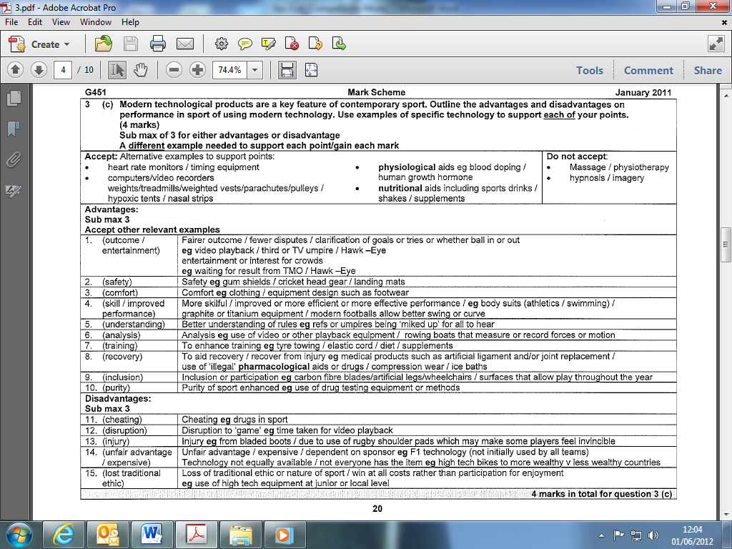

Sport, sponsorship and the media

- Explain the roles of the media (informing; educating; entertaining; advertising).
- Evaluate critically the impact of the media on sport (with particular reference to its role in promoting balanced, active and healthy lifestyles and lifelong involvement in physical activity).
- Explain the relationship between sport, sponsorship and the media (‘golden triangle’).

- Identify roles of the media.
NB: first two different responses to be marked
- Inform
- Educate
- Advertise / promote I publicise
- Entertain

Outline both positive and negative effects of the media on sport.
1 mark per point max 6:
Sub max of 3:
Positive effects:
- production of role models/copying of good behaviour/increased status of sport;
- stereotypes can be shattered;
- can increase participation;
- can highlight minority sports and sports of minority groups;
- sport now part of entertainment industry/advertisements;
- rules/timings/seasons/format/structure changed (in positive context).

Negative effects:
- focus on trivial/sensational aspects/negative behaviour/negative role models;
- stereotypes can be reinforced;
- reduction in participation/a spectating society encouraged;
- usually focuses on a few main sports/not minority
- sports/unequal coverage;
- (if not given under positive influences above) rules/timings/seasons/format/structure changed (in negative context);
- financial rewards only high at the very top/some performers may be forced to perform more frequently than is sensible or safe/decreased gate receipts.

- Discuss both positive and negative influences of the media on sport.
Positive influences - Sub max4
- role models created/copy good behaviour
- increase status of sport/increase popularity of sport/increase awareness/increase
- profile/promote sport
- stereotypes/challenged shattered/myths challenged/shattered
- participation increased
- new sports promoted/minority sports highlighted/sports of minority groups
- given coverage
- money to sport/money to clubs/sponsorship
- rules/timings/seasons/format/structure changed (in positive context).
Negative influences - Sub max4
- negative role models created/focus on trivial aspects/sensational
- spects/negative behaviour
- negative stereotypes reinforced
- passive spectatorism encouraged
- focus on a few main sports/notably football/not minority sports/unequal coverage
- can direct/influence rules/timings/structure to make the sport fit into scheduling
- financial rewards only high at the very top/unpopular sports get very little or no
- money/sports become reliant on money from media/low media coverage = low
- sponsorship/decreased gate receipts
- dangers injuries of sporting participation highlighted.

- What is meant by the term 'golden triangle'? Identify three different roles of the media giving an example of each. (5 marks)

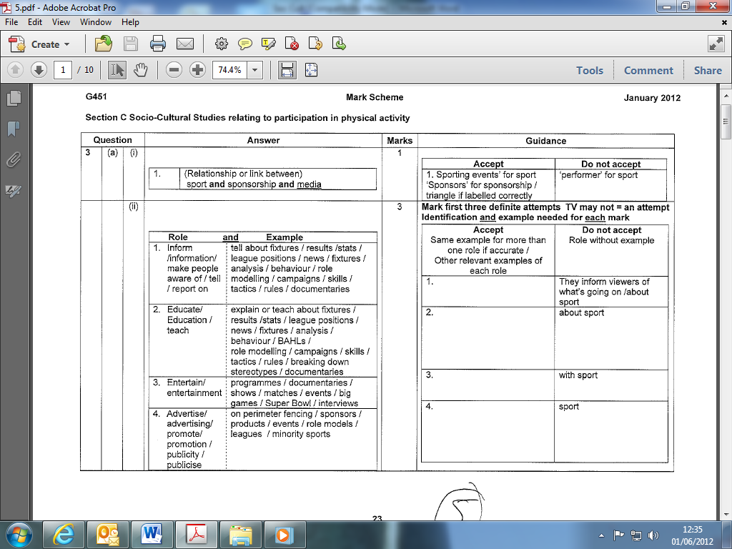

- Discuss the relationship between sport, sponsorship and the media. (1o marks)

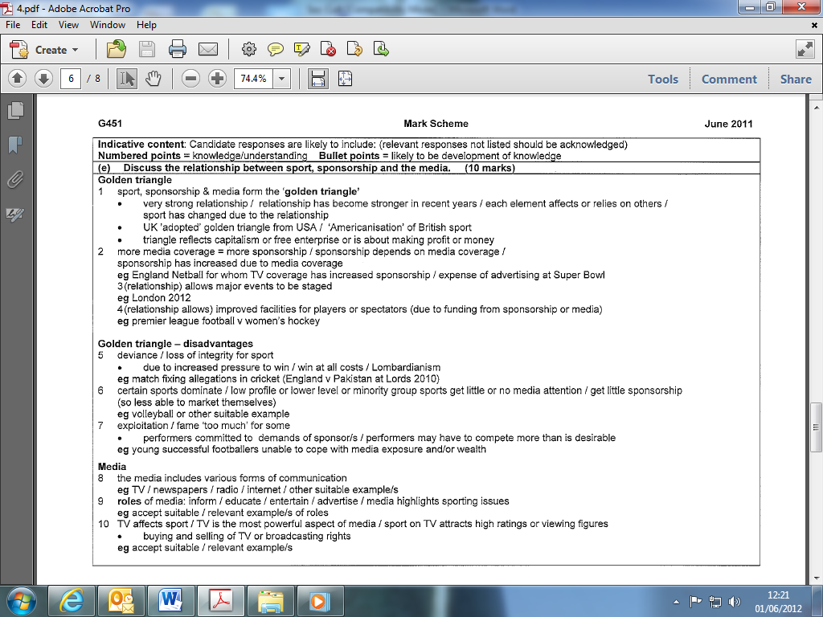

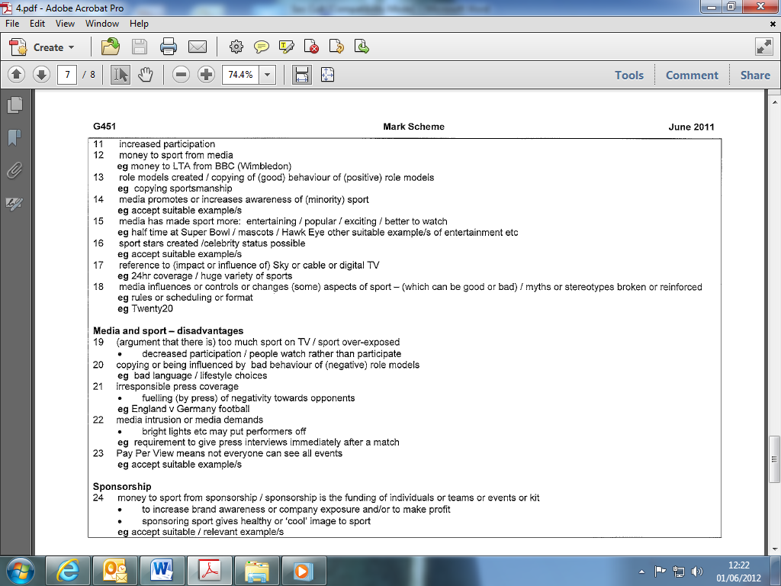

- The media can have both positive and negative effects on sport. Outline both positive and negative effects of the media on sport. [6 marks]
1 mark per point max 6:
Positive effects:
• production of role models/copying of good behaviour/increased status of sport;
• stereotypes can be shattered;
• can increase participation;
• can highlight minority sports and sports of minority groups;
• sport now part of entertainment industry/advertisements;
• rules/timings/seasons/format/structure changed (in positive context).

Negative effects:
• focus on trivial/sensational aspects/negative behaviour/negative role models;
• stereotypes can be reinforced;
• reduction in participation/a spectating society encouraged;
• usually focuses on a few main sports/not minority sports/unequal coverage;
• (if not given under positive influences above) rules/timings/seasons/format/structure changed (in negative context);
• financial rewards only high at the very top/some performers may be forced to perform more frequently than is sensible or safe/decreased gate receipts.

- Describe positive effects that the media can have on sport. (6 marks)

1 (participation) increased participation (in sport)
2 (funding) media attracts sponsors or advertising which brings money to sport / selling of TV rights; Do not accept increased funding or more money to sport on own / advertise on own
3 (role models) positive role models promote sportsmanship; Do not accept role models promoted on own
4 (myths & stereotypes) myths or stereotypes can be broken (e.g. women can’t play football or other suitable example)
5 (minorities) minority sports or sports of minority groups highlighted (eg wheelchair basketball or netball or other suitable example)
6 (entertainment) media makes sport more entertaining or attractive to spectators / rules or timings or seasons or format or structure changed to suit TV /changes to sport to speed up action or scoring (eg Twenty20 cricket); Accept excitement generates spectatorism. Do not accept entertain on own
7 (technology) impact of (media) technology (eg: slow-motion replays or ‘miked’ referees or Hawk-eye or video umpires or other suitable example) which helps officials or increases interest or understanding; Accept reference to increased entertainment if linked with technology
8 (status / promotion) sport promoted / status of sport raised / sport gets good reputation / increases status of certain clubs; Do not accept advertises club on own / raises awareness of sport

Violence in sport

- Demonstrate knowledge and understanding of violence in sport (players and spectators).
- Describe possible causes and solutions.

- Violence by spectators and players is a contemporary sporting issue. Discuss violence in sport with reference to both causes and solutions. (10 marks)

Causes of violence: Players and Spectators
- (frustration) frustration with match officials or other suitable example of frustration
- (emotional intensity) emotional intensity or importance of result or pressure/pre-match hype or psyche-up/position in league or cup or competition/monetary reward.
- (abuse/provocation) provocation or abuse or 'cheating' or rule breaking by opponents or team mates or (where relevant) from crowd/violence on pitch/racism
- (punishment) lack of punishment or deterrent
- (religion/tradition) religion/traditional rivalry/local derby/team loyalty
Causes of violence: Players
- (weapons) (potential) 'weapons' e.g. sticks or clubs
- (nature of game) nature of game/body checking or contract e.g. ice hockey or rugby
- (kit) kit or equipment that 'de-humanises' or protects
Causes of violence: Spectators
- (alcohol/drugs) alcohol/drugs
- (numbers) overcrowding /poor spectator provision/poor policing or stewarding.
- (hooligans) hooligans at football/organised violence
- (mass culture) mass culture/peer pressure/tribal nature of event/loss of individual identify or diminished
- responsibility within crowd/limited alternative outlets for energy
Possible solutions: Players:
- (rule changes) Rule changes
- (punishment) More severe punishments/accept suitable example
- (education) Education/emphasis on fair play/position as role models emphasised
- (officials) More officials/more authority for officials
- (technology) Technology/video playbacks
Possible solutions: Spectators:
- (Deterrents) Stricter deterrents or punishments (eg. remove season tickets)
- (control of alcohol) Control of alcohol
- (facilities) Improve spectator facilities/separation of fans/home and away fans to leave separately
- (CCTV) Use of CCTV or other security measures
- (liaison) Liaison of police from different areas or countries
- (family) Promotion as family entertainment/family sections within crowd

- Explain the causes of violent behaviour by both players and spectators in high level sport. (6 marks)

Players 1 | (frustration) | frustration with match officials or score or result or own performance I controversial decisions
2  3 | (emotional intensity) | emotional intensity I pre-match hype or psyche-up / importance of result / local derby I team rivalry / pressure
(abuse) | chanting or abuse from crowd
4 | (punishment) | lack of suitable punishment or deterrent
5 | (provocation) | provocation by opponent I ‘cheating’ by opponents / gamesmanship
6 | (weapons) | ‘weapons’ /eg sticks or clubs or bats
7  8 | (nature of game) | nature of game!  if body checking or contact part of game eg ice hockey or rugby
(kit) | if ‘game’ involves kit or equipment that ‘de-humanises’ opponents or officially protects them

spectators
9 | (frustration) | frustration with match officials or score or result or players
10 | (emotional intensity) | pre-match hype! media hype I emotional intensity! importance of event / pressure
11 | (abuse) | racism / provocation I verbal abuse
12 | (punishment) | lack of suitable punishment or deterrent
13 | (alcohol) | alcohol I drugs
14 | (religion/tradition) | local derby! religion I traditional rivalry! team loyalty
15 | (numbers) | over crowding! large numbers of fans I poor provision for spectators I poor policing or stewarding
16 | (hooligans) | hooligans at football / some ‘fans’ attend to cause trouble! organised violence
17  18 | (mass culture) | mass culture situation ! peer pressure I tribal nature of event! loss of individual identity in crowd ! diminished responsibility in crowd
(pitch violence) | violence or behaviour on pitch copied

- What are some of the possible causes of crowd violence at sporting events? (3 marks)

- (alcohol) alcohol! drugs
- (frustration) frustration or displeasure with match officials or score or results.
- (tradition) traditional rivalry/team loyalty/’ local derbys’/ religion.
- (abuse) verbal abuse! provocation! racism! racial discrimination
- (emotional) emotional intensity! importance of the event! over excitement! pre-match hype.
- (numbers) large numbers of fans ! overcrowding ! poor provision for spectators! poor policing or stewarding
- (hooligans) hooligans at football! some ‘fans’ more concerned with causing trouble than watching football
- (mass culture) Mass culture situation! tribal nature of event! Individuals lose identity within the crowd! peer group pressure! diminished responsibility within crowd
- (pitch violence) violence or behaviour on the pitch copied by or transmitted to spectators
- (punishment) lack of suitable punishment or deterrent.

The Olympic Games

- Demonstrate knowledge and understanding of the background (vision of De Coubertin), principles, aims and philosophy of the modern Olympic movement, summer and winter format, International Olympic Committee (IOC) and British Olympic Association (BOA).
- Explain the commercialisation of the Olympics: pre and post- 1984 (Los Angeles).
- Describe the opportunities and implications for sport and society in the UK arising from 2012, (impact of being a host nation on sport and society; benefits and drawbacks including potential for increasing participation and promoting healthy lifestyles particularly among young people),
- Explain how the Olympic Games is a vehicle for nation building e.g. China; the ‘Shop Window’ effect, government control and funding of sport, sport as a political tool.

- What are the characteristics of sport when it is used for political reasons? (3 marks)
- (political) sporting success reflects political success I government stability
- (government) Sport controlled by the government / centralised
- (funding) funded by government / supported by government I disproportionate funding
- (appeasement) used to appease population I keep people happy I feel good factor / reduce crime I social control I increased popularity of government
- (nation building) nation building / shop window effect I to increase international prestige / national pride I national image
- (country) performer competes for country not self / individual less important than politics / collectivism
- (elitism) Elitism / concentration on best / selective
- (profile) High profile I Olympic sports chosen

- The Modern Olympic Games are over 100 years old. Outline the background of the Modern Olympic Games. (6 marks)

- Critically evaluate the possible impact of hosting the Olympic Games in the UK in 2012. Your answer should include benefits and drawbacks to both sport and society. (10 marks)

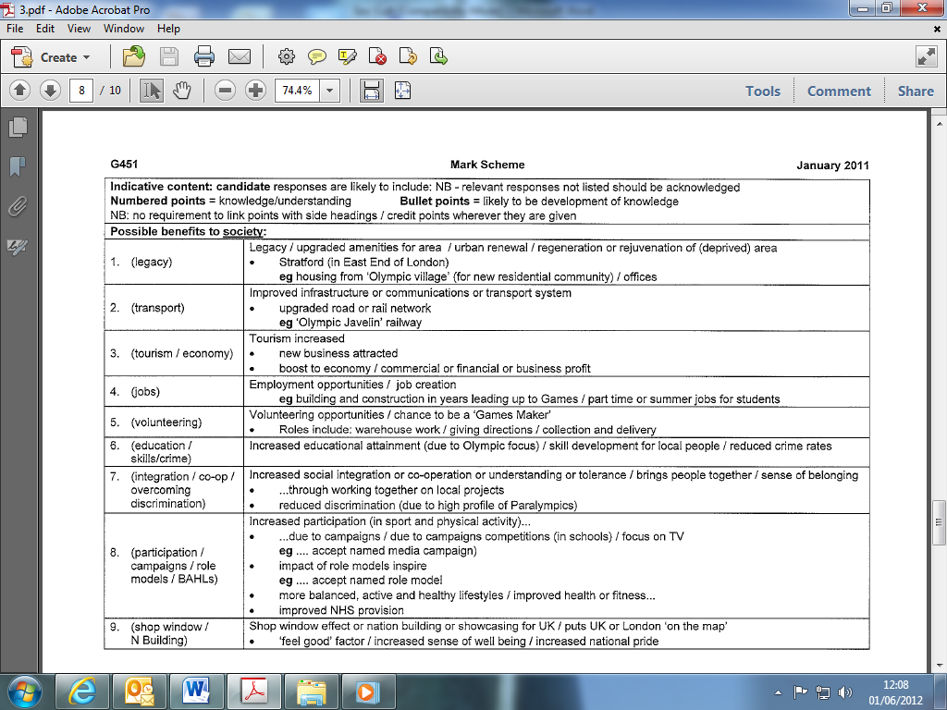

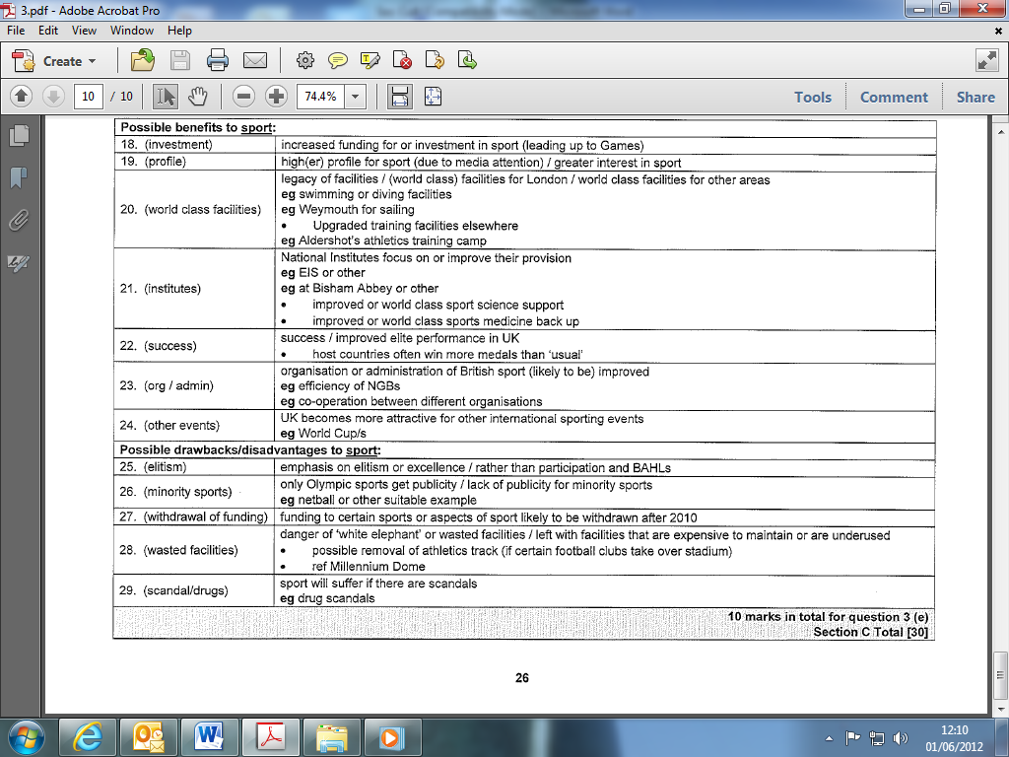

- Identify possible benefits of hosting the 2012 summer Olympic Games in Britain. (5 marks)

5 marks for five of:

Benefits to Britain as whole:
- Increased participation in sport and physical activities due to: Olympic Games inspiring young people to take up sport / role models / media coverage / encouragement on children's TV / campaigns or competitions in schools / Sport England and other home country council campaigns associated with the Games / campaigns by other sports organisations e.g. National Governing Bodies of Sport
- Health, fitness or well being improved due to participation
- Feel good factor.
- Improved communications or transport system or road and rail network
- Tourism increased / income from tourism
- New businesses created / business profit.

Benefits to Sport:
- increased funding for sport;
- Olympic standard facilities built/legacy of facilities/London left with training facilities or offices or sports science or sports medicine facilities;
- other facilities built or re-furbished throughout Britain;
- higher profile for sport/young people given a goal to aim for;
- host countries often win more medals than usual;
- organisation or administration of British sport
- improved/improved communication between sporting
- organisations.

Benefits to Local Area:
- London promoted for business;
- employment opportunities/job creation/skill development for local people;
- regeneration of area/rejuvenation of deprived area;
- for local community: reduction of crime rates/increased educational attainment/increased sense of belonging;
- housing from 'Olympic village' left/housing left for new
- residential community/3,500 new housing units available;
- increased social integration or increased co-operation through working on local projects.

- Explain how the Olympic Games can be a vehicle for nation building. (6 marks)

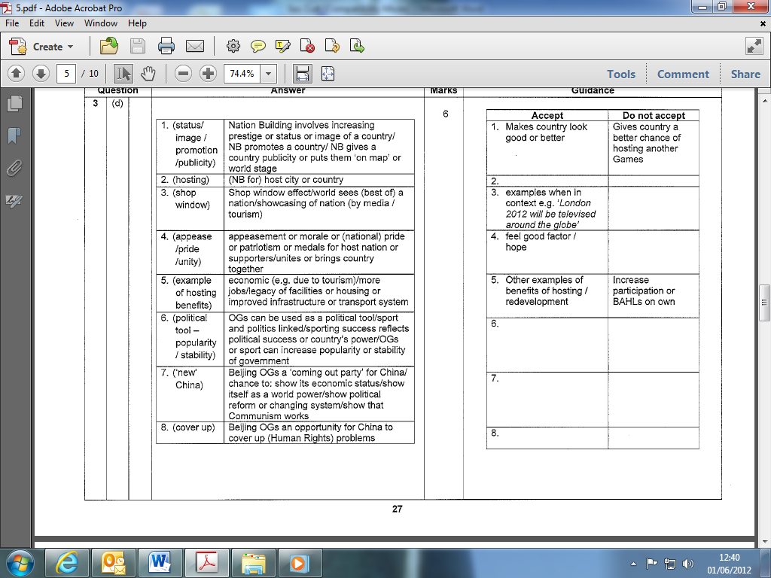

1. Explain the commercialisation of the Olympic Games since 1984 and how the Olympic Games can be a vehicle for nation building.
[10]

2. 10 marks – Levels marked question

L3  8-10 marks | A comprehensive answer:  • detailed knowledge & understanding;  • effective analysis/critical evaluation and/or discussion/explanation/development;  • clear and consistent practical application of knowledge;  • accurate use of technical and specialist vocabulary;  • high standard of written communication.  Discriminators from L2 are likely to include:  • an understanding of the background to commercialism  • understanding of the principle of nation building  • both parts of question answered well
L2  5-7 marks | A competent answer:  • satisfactory knowledge & understanding;  • analysis/critical evaluation and/or discussion/explanation/development attempted with some success.  • some success in practical application of knowledge;  • technical and specialist vocabulary used with some accuracy;  • written communication is generally fluent with few errors.  Discriminators from L1 are likely to include:  • some knowledge of the principle of nation building  • both parts of question have been answered
L1  0-4 marks | A limited answer:  • basic knowledge & understanding;  • little or no attempt to analyse/critically evaluate and/or discuss or explain;  • little or no attempt at practical application of knowledge;  • technical and specialist vocabulary used with limited success;  • written communication lacks fluency and there will be errors, some of which may be intrusive.

Indicative content: Candidate responses are likely to include: (relevant responses not listed should be acknowledged)
Numbered points = knowledge / understanding
Bullet points = likely to be development of knowledge
(explanation of): Commercialisation of the Olympic Games:
(amateurism)
1. (pre 1970s or 1980s) Olympic Games was amateur or for amateurs / athletes not paid / professionalism frowned upon
(inequality)
2. ‘Athletes’ from some countries were better funded or supported than others / gap between some countries and others
• USA - scholarship system
• ‘Eastern bloc’ - state funded /
• UK - lagged behind / athletes had full or part time jobs or other suitable example/ ‘trust funds’ set up for UK athletes

(commitment)
3. (In order to realistically compete) athletes needed to train or commit full time (scandal)
4. The move from amateurism to professionalism was associated with scandal or was not smooth / ‘shamateurism’ or fake amateurism
(IOC)
5. IOC initially against commercialisation of Games / after Montreal the IOC allowed more commercial involvement IOC gradually accepted need for commercialism / IOC decisions increasingly linked to funding issues

(Montreal ’76 / financial disaster)
6. The Montreal Games (1976) were a financial disaster / host countries under great financial pressure before commercialisation of Games
(LA 1984)
7. Los Angeles (1984) as the turning point or start of commercialisation or was the first highly commercialised Games
(Uberroth)
8. Peter Uberroth employed to commercialise Games or was responsible (for commercialisation of the Games)
(companies)
9. (Private) companies invested in or built the major facilities
• Since commercialisation the facilities have been more spectacular
(TOP)
10. Impact of The Olympic Partner (TOP) programme /TOP partners free to display Olympic logo companies became (official) sponsors or suppliers or licenses / Games attractive to sponsors
e.g. Coca-Cola/Visa/McDonald’s/Panasonic/UPS/Kodak or other suitable example
(Positive Impact)
11. (Many argue that) commercialism has saved or improved the Olympics / commercialism now the norm
(TV rights)
12. TV (or radio companies) charged (for coverage rights)
(TV)
13. The Olympics have become commercialised due to TV / commercialism linked to growing (global) TV audience / impact of ‘golden triangle’
(profit for hosting)
14. Countries or cities now see financial value in hosting Games / Olympic Games now a profit maker / companies use the Games to raise profile or make profit
• Reference to credit crunch and financial issues leading up to future Olympics

(explanation of): Olympic Games as a vehicle for Nation Building:
(Nation Building)
15. (Nation Building can increase:) prestige or status or image of country / increased national pride / country gains publicity or is ‘put on map’ or on world stage or is showcased / world ‘looks in’ and get a positive view
• Nation Building for host country (e.g. China)
• Nation Building for the country of successful visiting athletes (e.g. Ethiopia)
• So increased tourism
(shop window)
16. Shop-window effect (operates)
• Those in the host country ‘look out’ and feel appeased or get ‘feel good’ factor / ‘feel-good’ factor or appeasement for host nation or home supporters supporting home team
e.g. or Sydney 2000 or other suitable example
(political tool)
17. Olympic Games can be used as a political tool / sport and politics linked /sporting success reflects political success / sport a vehicle for achieving increased political stability or popularity / sporting success (said to) reflect power of country
e.g. of links between sport and politics e.g. Munich OGs / Berlin 1936 (Hitler and Jesse Owens)
(China - gov)
(Beijing - new China)
(Beijing - economy)
(Beijing - facade)
18. (In China the) government controls and funds (much of) sport / China has centralised system
• Beijing Olympics (2008) were a ‘coming out party’ for China / an opportunity for China to show its (alleged) changing (more open) system or (alleged) political reform or show that Communism works / to show its emergence as a world power
• Beijing Olympics (2008) were an opportunity for China to show its economic status
• Beijing Olympics (2008) were an opportunity for China to conceal human rights issues or problems or to (try to) escape from poor human rights record / countries (sometimes) hide behind a facade or behind Olympic success / a false picture can be created
[10]

