Seen question Respiratory System for Monday 16th
- Analyse the effects of smoking on the health and performance of an endurance athlete. (10 marks)

- Asthma is an increasing problem for many young people attempting to follow an active healthy lifestyle. Discuss the effects of asthma on people performing endurance activities and describe the methods available to help them control these effects. How might regular involvement in endurance activities impact on the participant's respiratory system? (10 marks)

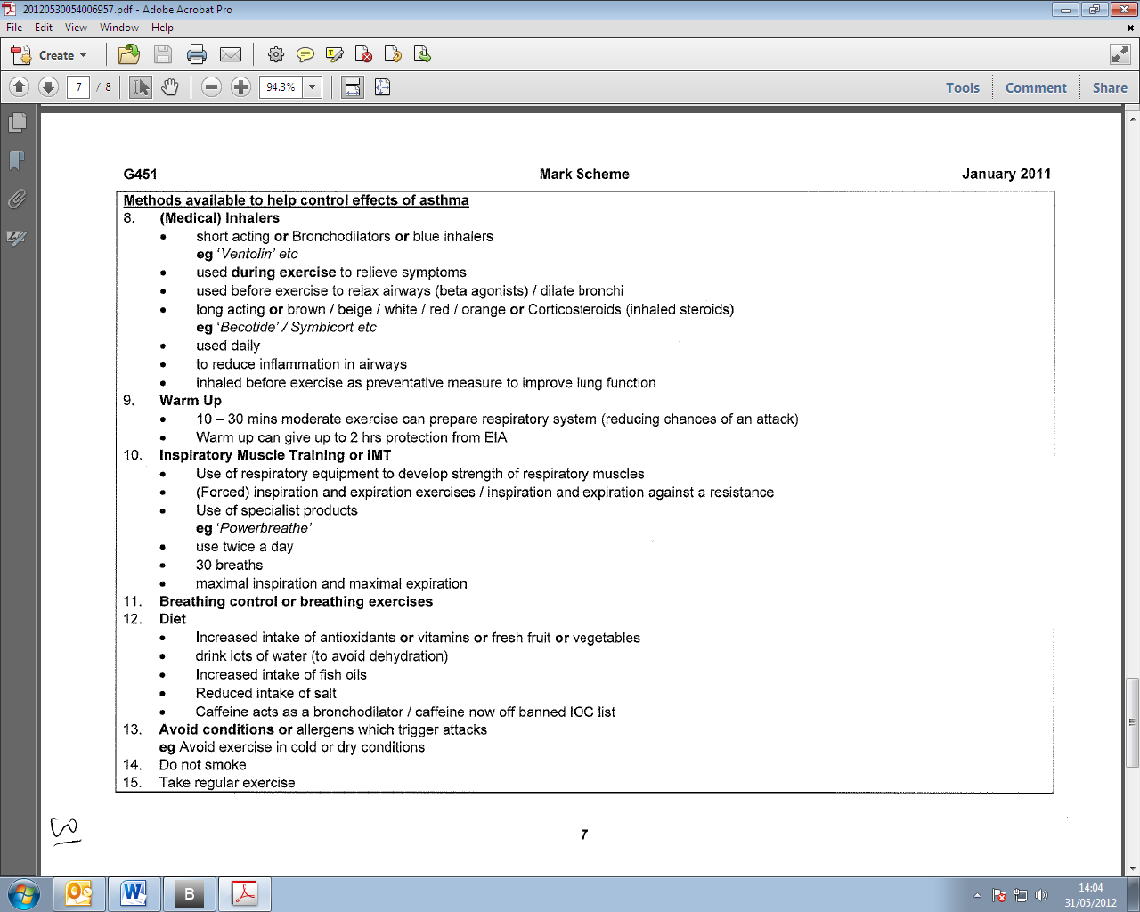
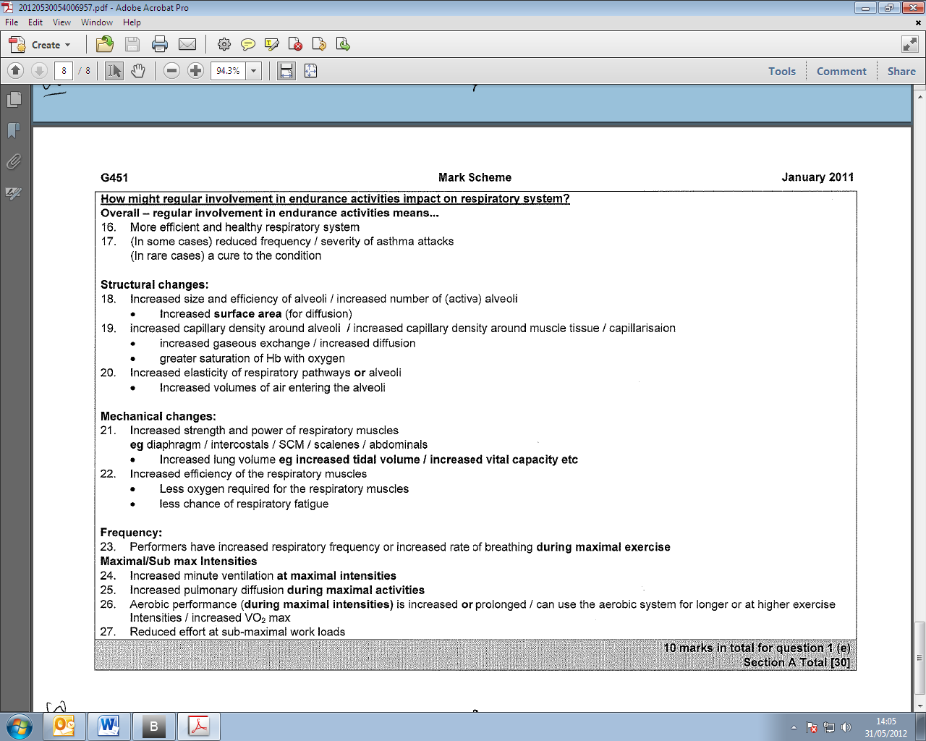
- Evaluate critically the impact of long term aerobic training and lifestyle choices on the efficiency of the respiratory system. (10 marks)

Indicative content: Candidate responses are likely to include: (Relevant candidate responses that are not listed should be acknowledged).
Numbered points refer to indicative content or knowledge
Bulleted points refer to development of knowledge
Improvements to the efficiency of the respiratory system (will be seen after a few weeks of aerobic training.)

- Increased efficiency to take in O2 or to supply O2 to muscles

Changes will be due to:

Respiratory Structures- External Respiration
- increased surface area of alveoli
- increased elasticity of lungs
- increased capillary density around alveoli
- greater amount of O2 diffused in to blood
- greater amount of CO2 diffused in to alveoli
- greater gaseous exchange/ increase pulmonary diffusion
- greater saturation of haemoglobin with oxygen

- Respiratory Structures- Internal Respiration
- increased capillary density around muscle tissue
- greater amount of O2 diffused in to muscle cell
- greater amount of CO2 diffused in to blood
- greater gaseous exchange/ increased muscle and tissue diffusion
- increased a-VO2 difference
- increased a-VCO2 difference

Improvements to Breathing Mechanisms
- strengthens respiratory muscles/ respiratory muscle hypertrophy
- diaphragm, intercostals, SCM, scalenes, abdominals
- increased efficiency of the mechanics of breathing
- increased depth of breathing
- decreased breath frequency
- reduces or delays respiratory muscle fatigue

Increases in Lung Volumes or Capacities
- increased tidal volume during maximal exercise
- increased vital capacity
- decreased residual volume
- increased inspiratory reserve volume
- increased expiratory reserve volume

These physiological adaptations would result in:
- increased VO2 max
- delays OBLA or lactate threshold/ increases endurance capabilities
- lifelong involvement in physical activity

Altitude Training
- reduced ppO2 / hypoxic conditions
- initial decrease in the efficiency of the respiratory system
- BUT increase in efficiency of respiratory system when returning to sea level
- Reference to any relevant physiological response e.g increased capillary density.
- Choice to live high or use hypoxic tents but train low

Asthma
- aerobic training can trigger EIA
- particularly in cold / dry conditions
- asthma can inhibit people from taking part in aerobic training
- Inspiratory muscle training (IMT) or aerobic training can alleviate symptoms of asthma

Smoking
- decreases the efficiency of the respiratory system / decreases respiratory health
- decreases the efficiency to supply O2 to muscles
- carbon monoxide reduces the amount of O2 absorbed in blood/
- Hb has greater affinity to CO than O2
- decreased gaseous exchange or diffusion gradient
- increases likelihood of respiratory diseases
- (e.g. shortness of breath/ coughing/ lung cancer/ emphysema etc.)
- damage to respiratory structures
- tar coats the airways and inhibits gaseous exchange/tar builds up in lungs
- impairs lung function
- narrowing of air passages causing increase in respiratory resistance

