Sport and society

Sport and physical activity as a reflection of the culture in which it exists.

A level PE

NAME: ,

Learning objectives

At the end of this booklet you should be able to: | Notes | Learned
participation in, sports and pastimes in pre-industrial Britain:
- social class
- gender
- law and order
- education/literacy
- availability of time
- availability of money
- type and availability of transport.

how social and cultural factors shaped the characteristics of, and participation in, sport in post 1850 industrial Britain:
- social class
-amateurism and professionalism
- gender/changing status of women
- law and order
- education/literacy
- availability of time / changing work conditions
- availability of money
- transport notably the railways

influence of public schools:
o on the promotion and organisation of sports and games
o on the promotion of ethics through sports and games
o the ‘cult’ of athleticism – meaning, nature and impact
o on the spread and export of games and the games ethic.

Historically sports or recreation was to develop the skills for the demands of the period in time. This has been preparing for war, to hunt for food or fitness for work.
Characteristics of Ethnic games:

Characteristics of mob football/cheese rolling

Notes on development of Mob football

………………………………………………………………………………………………………………………………………………………………………………………………………………………………………………………………………………
………………………………………………………………………………………………………………………………………………………………………………………………………………………………………………………………………………

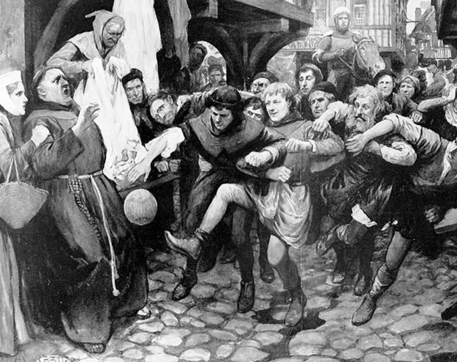

Cock fighting
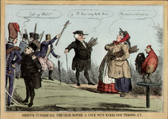
Upper class…………………………………………………………………………………………………………………………………………………………………………………………………………………………………………………………………………………………………………………………………………………………………………………………………………………………………………………………………………………………
Lower class…………………………………………………………………………………………………………………………….……………………………………………………………………………………………………………………………………………………………………………………………………………………………………………………………………………………………………………………………………………………………………………………………………………………………………………………………………………………………………………………………………………………………………………………………………………………….

Social Class influences in pre-industrial Britain

Lower class Upper class

……………………….………………………………………………………………………………………………………………………………………………………………………………………………………………………………………………………………………………………………………………………………………………………………………………………………………………………………………….………………………………………………………………………………………………………………………………………………………………………………………………………………………………………………………………………………………………………………………………………………………………………………………………………………………………………….…………………………………………………………………………………
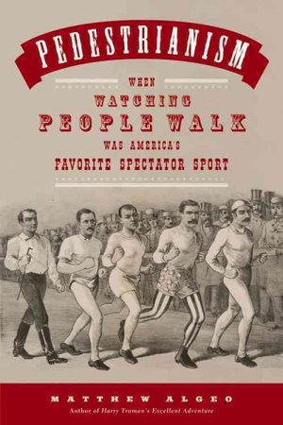
Name a famous Pedestrian participant

Gender in pre-industrial Britain

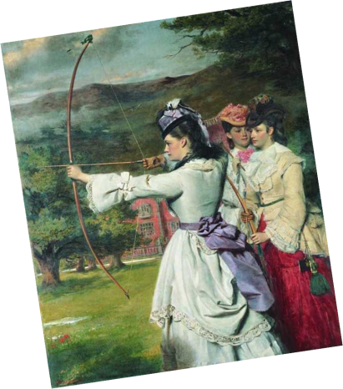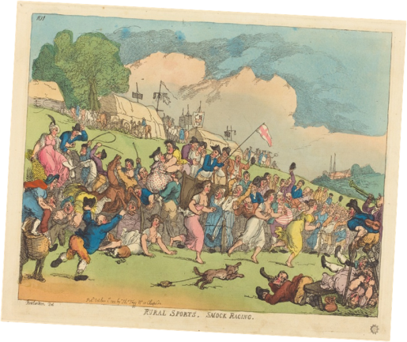

……………………………………………………………………………………………………………………………………………………………………………………………………………………………………………………………………………………………………………………………………………………….……………………………………………………………………………………………………………………………………………………………………………………………

Law and order
Notes on law and order
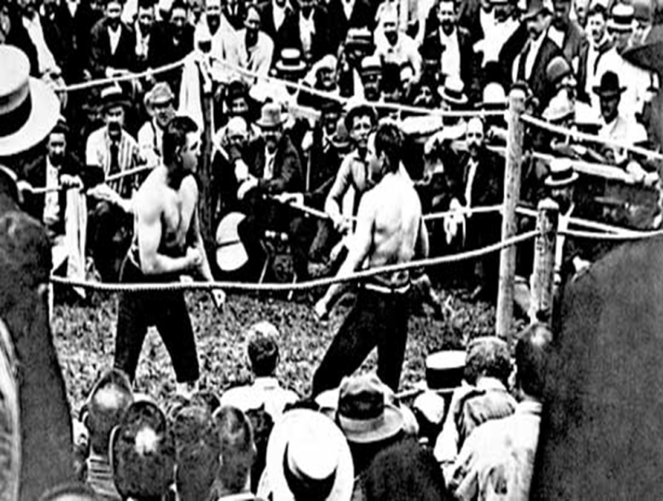

Education and literacy

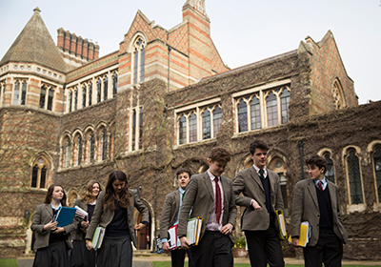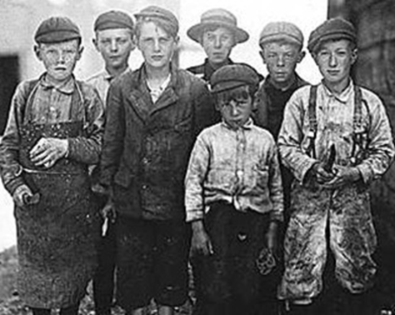

……………………………………………………………………………………………………………………………………………………………………………………………………………………………………………………………………………………………………………………………………………………….……………………………………………………………………………………………………………………………………………………………………………………………
Time in pre-industrial Britain
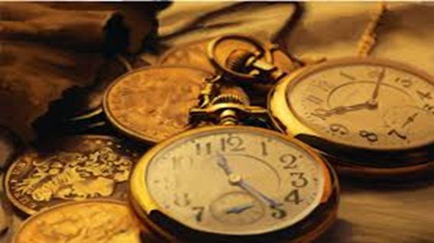
Notes:

Leisure time?

Money pre-industrial Britain
What was the impact of money on the poor and rich? Link it to pastime or recreation.

Transport
What was the impact of transport on the poor and rich? Link it to pastime or recreation.

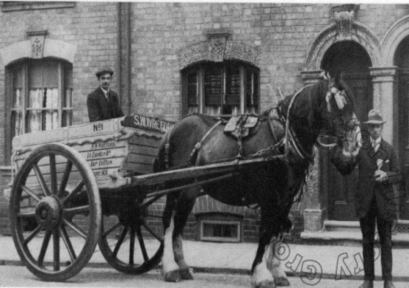
What was the impact of money on the poor and rich? Link it to pastime or recreation.

Q 1 Describe five social factors that affected the characteristics of pre-industrial sport. (5)
.....................................................................................................................................................
.....................................................................................................................................................
.....................................................................................................................................................
.....................................................................................................................................................
.....................................................................................................................................................
.....................................................................................................................................................
.....................................................................................................................................................
.....................................................................................................................................................
.....................................................................................................................................................
How social and cultural factors shaped sport and pastimes in post-1850 industrial Britain.

Background

.....................................................................................................................................................
.....................................................................................................................................................
.....................................................................................................................................................
.....................................................................................................................................................
.....................................................................................................................................................
.....................................................................................................................................................

Social Class

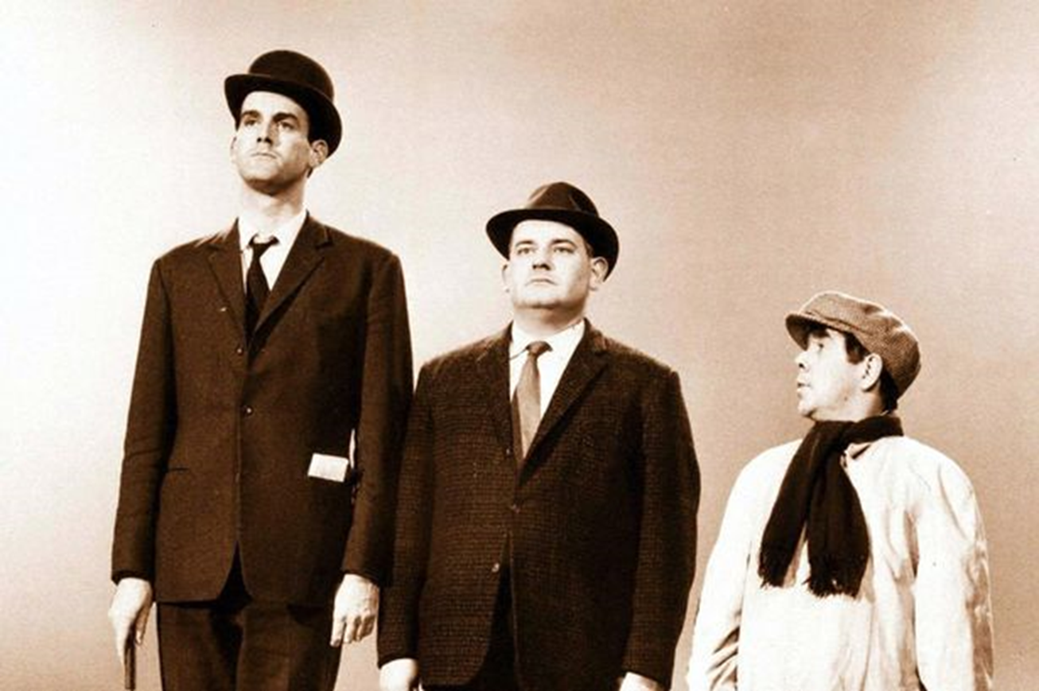

.....................................................................................................................................................
.....................................................................................................................................................
.....................................................................................................................................................
.....................................................................................................................................................
.....................................................................................................................................................
.....................................................................................................................................................
.....................................................................................................................................................
.....................................................................................................................................................
.....................................................................................................................................................

What is a Public school?
Amateurism and professionalism
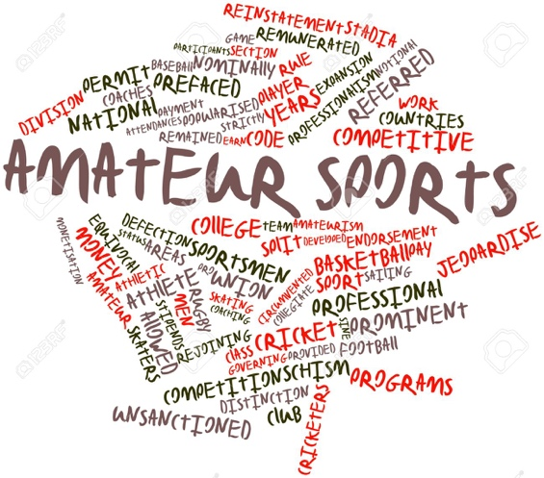
The term amateur has changed significantly over the years, especially before and after the industrial revolution.

Identify the terms amateur and professional then explain using historical examples of how this has changed.

……………………………………………………………………………………………………………………………………………………………………………………………………………………………………………………………………………………………….
……………………………………………………………………………………………………………………………………………………………………………………………………………………………………………………………………………………………….
……………………………………………………………………………………………………………………………………………………………………………………………………………………………………………………………………………………………….
……………………………………………………………………………………………………………………………………………………………………………………………………………………………………………………………………………………………….
……………………………………………………………………………………………………………………………………………………………………………………………………………………………………………………………………………………………….
Cricket match between BHASVIC and Varndean Wed 13th Sept 1804

Rules for Gentleman amateurs: All to be called gentleman or Sir
Names to appear appropriately in the programme, e.g.,
D Morris Esq. for gentlemen and D Morris.
Ensure no gentleman travels with a non-gentleman
No gentleman shall have to eat with a working class professional
Gentleman will not have to change in the same area as working class professionals.
Working class professionals will do all bowling and running, where gentleman amateurs will display themselves through fine batting.

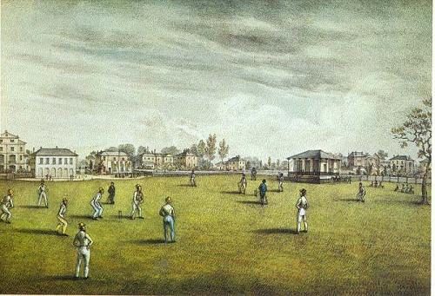
Gender and changing role of women
Looking at the two images, how do they reflect the changes in attitude towards women?

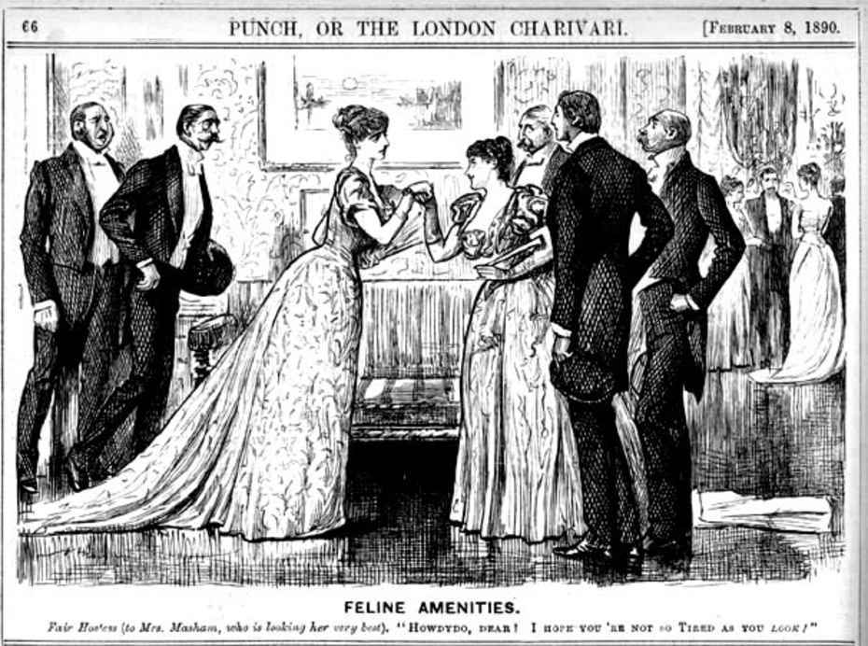
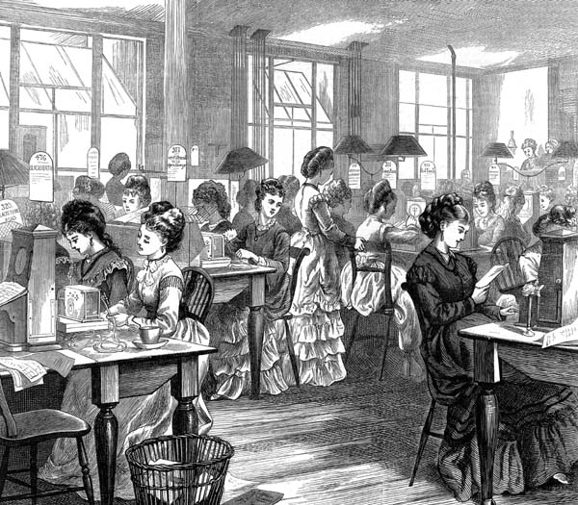

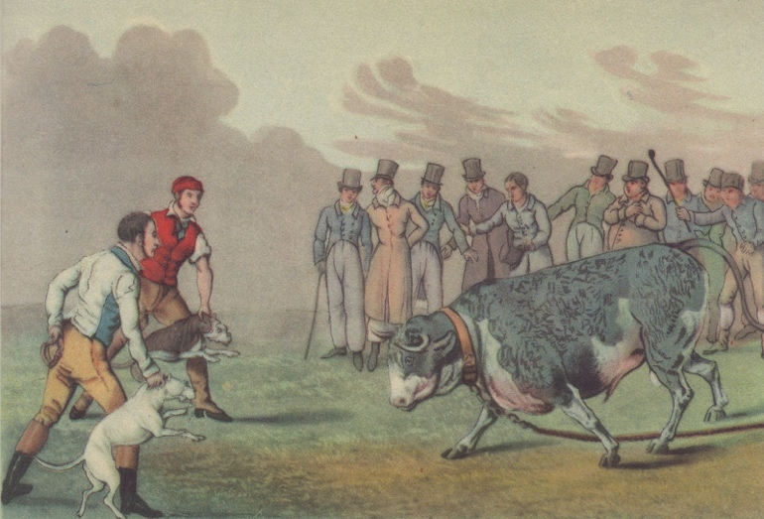
Law and order

Q how did the changes in
law and order influence activities?
……………………………………………………………………………………………………………………………………………………………………………………………………………………………………………………………………………………………………………………………………………………………………………………………………………….……………………………………………………………………………………………………………………………………………………………………………………………………………………………………………………………………………………………………………………………………………………………………………………………………………….………………………………………………………………………………………………………………………………………………………………………………………………………………………………………………………………………………………………………………………………………………………………………………………………

Education and literacy

Give an overview of the changes that took place to education and how this impacted on the rich and the poor. What are the key headlines?

…………………………………………………………………………………………………………………………………………………………………………………………………………………………………………………………………………………………………………………………………………….………………………………………………………………………………………………………………………………………………………………………………………………………………………………………………………………………………………………………………………………………………………………………………………………

What is the Forster Act and how did it change the face of education?
…………………………………………………………………………………………………………………………………………………………………………………………………………………………………………………………………………………………………………………………………………….………………………………………………………………………………………………………………………………………………………………………………………………………………………………………………………………………………………………………………………………………………………………………………………………

What was the clarendon report?
…………………………………………….………………………………………………………………………………………………………………………………………………………………………………………………………………………………………………………………………………………………………………………………………………………………………………………………

The death of English cricket was written, “in affectionate remembrance of English cricket which died at the oval in Aug 1882”.
This referred to the beating of England by Australia, where the bails were burnt and kept in an urn, taken by the victor. This gave birth the ashes test. Written report in a paper.
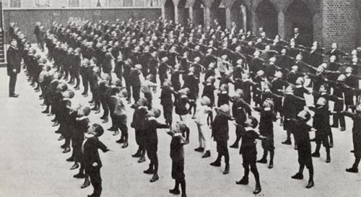

Availability of time and money

Where does west ham come from?
What about arsenal?
Do you know where your team originated?
Was it a church, school or a factory?
How did the change in time and money influence the public and sport?

…………………………………………….…………………………………………………………………………………………………………………………………………………………………………………………………………………………………………………………………………………………………………………………………………………………………………………………………………………………………………….…………………………………………………………………………………………………………………………………………………………………………………………………………………………………………………………………………………………………………………………………………………………………………………………………………………………………………….…………………………………………………………………………………………………………………………………………………………………………………………………………………………………………………………………………………………………………………………………………………………………………………………………………………………………………….…………………………………………………………………………………………………………………………………………………………………………………………………………………………………………………………………………………………………………………………………………………………………………………………………………………………………………….……………………………………………………………………………………………………………………………………………

Type and availability of transport
How can the inventions and accessibility influence recreation and sport?
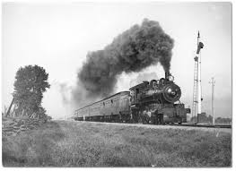
Notes:
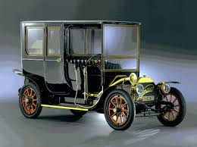

Q2 Using examples, describe two ways in which social class influenced the characteristics of sports and pastimes in pre-industrial Britain.
……………………………………………………………………………………………………………………………………………………………………………………………………………………………………………………………………………………………….……………………………………………………………………………………………………………………………………………...……………………………………………………………………………………………………………………………………………………………………………………………………………………………………………………………………………………………….……………………………………………………………………………………………………………………………………………..……………………………………………………………………………………………………………………………………………………………………………………………………………………………………………………………………………………………….……………………………………………………………………………………………………………………………………………..
[4]

Additional notes:

……………………………………………………………………………………………………………………………………………………………………………………………………………………………………………………………………………………………….…………………………………………………………………………………………………………………………………………………………………………………………………………………………………………………………………………………………………………………………………………………………………………………………………………………………………………….…………………………………………………………………………………………………………………………………………………………………………………………………………………………………………………………………………………………………………………………………………………………………………………………………………………………………………….……………………………………………………………………………………………………………………………………………

……………………………………………………………………………………………………………………………………………………………………………………………………………………………………………………………………………………………….…………………………………………………………………………………………………………………………………………………………………………………………………………………………………………………………………………………………………………………………………………………………………………………………………………………………………………….…………………………………………………………………………………………………………………………………………………………………………………………………………………………………………………………………………………………………………………………………………………………………………………………………………………………………………….……………………………………………………………………………………………………………………………………………

Answer to exam Q

Q 1 Five marks from:
• class – with different classes involved in different activities or in different roles
• gender – different activities/roles
• law and order affected the type of activity and the way it was played
• education/literacy – some activities involved more complex rules and therefore required an educated player
• availability of time – for some / peasant classes too much work time negated ability to play or some had more free time than others
• money – this enabled the playing of activities demanding more equipment / facilities / membership
• transport – this enables some to be able to travel to facilities or to be able to participate against others.

Q2
