 | External Respiration | Internal Respiration
Where
Movement
Why?
O2
Why?
CO2

Word you need to know and understand.
Diffusion Concentration or partial pressure Diffusion gradient
Draw the Dissociation Curve on the white boards.
Y axis is Saturation of 02 or Sa02. And partial pressure of 02 goes on the X axis.

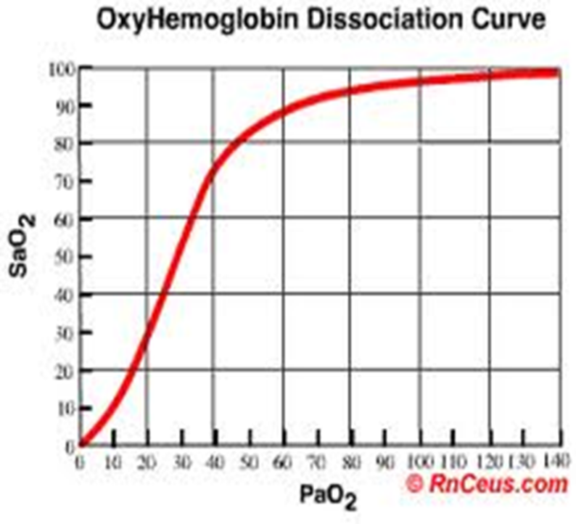

What is Haemoglobin?
____________________________________________________________________________________________________________________________________________________________________
Explain the pathway of 02 from the air to the working muscles.
___________________________________________________________________________________________________________________________________________________________________________________________________________________________________________________________________________________________________________________________________________________________________________________________________________________________________________________________________________________________________________
What has happened to the saturation of 02 in Haemoglobin when the partial pressure is 100 at the site of the alveoli?
_________________________________________________________________________________________________________________________________________________________________________________________________________________________________________________________________________________________________________________________________________________________________________________________________________________________

What has happened to the saturation of Haemoglobin when the partial pressure is 40. (think about where the Ha has been before it gets to the alveoli with a P02 that is only 40.)
_________________________________________________________________________________________________________________________________________________________________________________________________________________________________________________________________________________________________________________________________________________________________________________________________________________________
Notes:
What causes the shift to the right of the dissociation curve?
__________________________________________________________________________________________________________________________________________________________________________________________________________________________________________________________________________________________________________________________________________________________________________________________________________________________________________________________________________________________________________________________________________________________________________________________________________________________________________________________________________________________________________________________________________________________________________________________________________________________________________________
What happens if we shift the line to the right? What has happened to the dissociation in the working muscles of 02 from Ha? ____________________________________________________________________________________________________________________________________________________________________________________________________________________________________________________________________________________________________________________________________________________________________________________________________________________________________________________________________________________________________________________________________________________________________________________________
Draw a new line similar to the one on page 109.

Notes:

