Chili task 1

- Exam Question

- During the training run blood needs to be diverted away from nonessential organs to the working muscles. Explain how the vasomotor centre controls this distribution. [3 marks]

- Describe the changes that occur in the distribution of cardiac output as a performer moves from rest to exercise. Explain how the vasomotor centre controls this distribution. (4 marks)

Answer to Chili task 1
- During the training run blood needs to be diverted away from nonessential organs to the working muscles. Explain how the vasomotor centre controls this distribution. [3 marks]

- Vasodilation of arteries/arterioles/blood vessels/leading to working muscles/vascular shunt
- Opening/vasodilation of pre capillary sphincters leading to working muscles
- Vasoconstriction of arteries/arterioles/blood vessels leading to non-essential organs
- Closing of pre capillary sphincters leading to non-essential organs
- Sympathetic stimulation/’reduction

- Describe the changes that occur in the distribution of cardiac output as a performer moves from rest to exercise. Explain how the vasomotor centre controls this distribution. (4 marks)

4 marks max:
(Describe)
1. More blood is distributed to the working muscles.
2. Less blood is distributed to non-essential organs
(Explanation)
3. Vasodilation of arteries/arterioles supplying working muscles/Vascular shunt
4. Opening/vasoldilation of precapillary sphincters supplying working muscles
5. Vasoconstriction of arteries/arterioles supplying non-essential organs
6. Closing/vasoconstriction of precapillary sphincters supplying non essential organs

Chilli task 2
- Explain how the body controls the increased distribution of blood to the working muscles during exercise (6 marks)

Bullet point:

Answer to Chilli task 2
- Explain how the body controls the increased distribution of blood to the working muscles during exercise (6 marks)

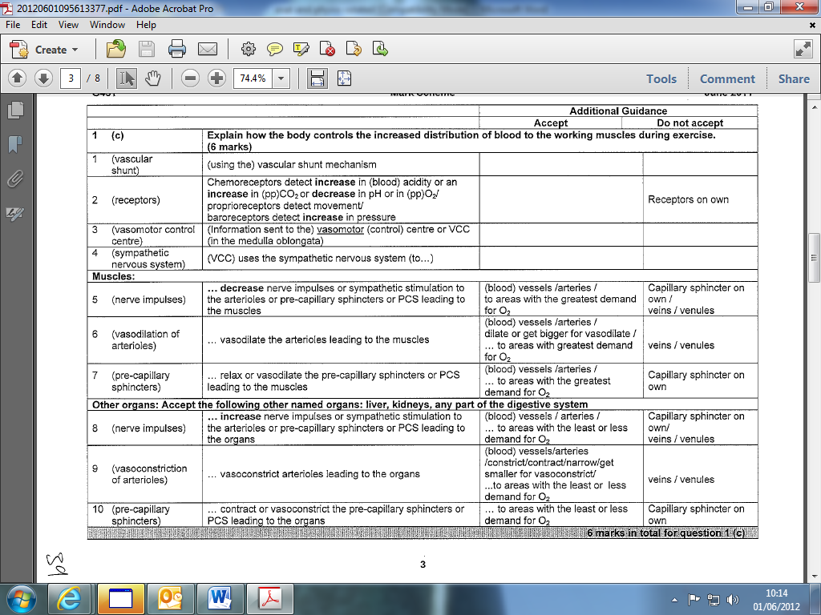

Chili task 3
- Describe the mechanism that allows for the redistribution of blood flow during exercise and explain how it is controlled. Distribution of blood flow during exercise (8 marks)

- Describe the mechanism that allows for the redistribution of blood flow during exercise and explain how it is controlled. Distribution of blood flow during exercise (8 marks)

vascular shunt mechanism
- (redistributes blood during exercise so that) areas with the greatest need receive more blood/areas with low demand receive less blood
- through vasodilation of arterioles/blood vessels feeding working
- muscles
- and vasodilation/opening of precapillary sphincters feeding working
- muscles
- through vasoconstriction of arterioles feeding others organs (e.g. liver/kidney/intestines)
- and vasoconstriction/closing of precapillary sphincters feeding these organs
- (control) (subsubmax 4)
- (vascular shunt mechanism) controlled by the vasomotor control centre NCC
- located in the medulla (oblongata) of the brain
- VCC responds to changes in blood pressure/muscle/blood chemistry
- chemoreceptors detect changes in lactic acid/carbon dioxide/oxygen/pH/ content of blood
- chemoreceptors located in muscles/aorta/carotid arteries
- baroreceptors detect changes in blood pressure
- baroreceptors located in aorta/carotid arteries
- VCC uses sympathetic nervous system
which acts on the middle layer of smooth muscle in an arteriole/the ring of smooth muscle at the opening of a capillary (precapillary sphincter)/control diameter of arterioles/precapillary sphincters

